

AMREF DIRECTORATE OF LEARNING SYSTEMS

DISTANCE EDUCATION COURSES

MALARIA PREVENTION, CONTROL
AND MANAGEMENT

UNIT 1
About Malaria

 | Allan and Nesta Ferguson Trust

Unit 1: About Malaria

A distance learning course of the Directorate of Learning Systems (AMREF)

© 2007 African Medical Research Foundation (AMREF)

This course is distributed under the Creative Common Attribution-Share Alike 3.0 license. Any part of this unit including the illustrations may be copied, reproduced or adapted to meet the needs of local health workers, for teaching purposes, provided proper citation is accorded AMREF. If you alter, transform, or build upon this work, you may distribute the resulting work only under the same, similar or a compatible license. AMREF would be grateful to learn how you are using this course and welcomes constructive comments and suggestions. Please address any correspondence to:

The African Medical and Research Foundation (AMREF)
Directorate of Learning Systems
P O Box 27691 – 00506, Nairobi, Kenya
Tel: +254 (20) 6993000
Fax: +254 (20) 609518
Email: amreftraining@amrefhq.org
Website: www.amref.org

Technical Coordinator : Joan Mutero
Cover Design : Bruce Kynes
Course revision team : Dr. Beth Rapuoda, Dr. A. Manya, Dr. R. Kiptui, Dr. K. Njagi, Dr. D. Alusala, Dr. D. Memusi, J. Moro, J. Sang, M. Wanga, P. Kiptoo, B. Mageto, and Dr Ben Midia.

The African Medical Research Foundation (AMREF wishes to acknowledge the contributions of the Commonwealth of Learning (COL) and the Allan and Nesta Ferguson Trust whose financial assistance made the development of this course possible.

CONTENTS

INTRODUCTION 1
OBJECTIVES OF THE UNIT 1
1.1 Historical Background of Malaria 2
1.2 Definition of Malaria And It’s Public Health Importance 3
What is Malaria? 3
The Public Health Importance of Malaria 4
The Public Health Impact of Malaria 4
1.3 Malaria Vectors and Their Characteristics 5
The Different Species of Malaria Causing Parasite 10
1.4 Mode of Transmission of Malaria 16
The Malaria Life Cycle 17
Clinical Classification of Malaria 21
CONCLUSION 22
GLOSSARY 23
REFERENCES 23

UNIT 1: ABOUT MALARIA

INTRODUCTION

Welcome to Unit 1 of the Malaria course. We hope the introduction to this course has already familiarized you with the magnitude of the problem of malaria and why you need to become involved in malaria treatment, control and prevention activities.

Malaria is the most common disease in Africa. It is also the number one cause of death among young children and a significant cause of miscarriages among pregnant mothers. About 95% of children brought to health facilities with fever suffer from Malaria.

A significant amount of suffering, complications and death due to malaria can be prevented through prompt and correct treatment and prevention measures.

In this unit we shall discuss the importance of malaria, its definition, causative agents, transmission and life cycle of Malaria. We shall also briefly describe the presentation of the clinical course of malaria.

Please read each section thoroughly and do the learning activities as you go along. Take the adequate time necessary to do each activity. Incase you have difficulty completing any activity, study the section again or discuss the matter with your tutor.

We hope you will find this a good learning experience, enjoy your study.

OBJECTIVES OF THE UNIT

By the end of this unit you should be able to:

- Outline the public health importance of the Malaria disease;
- List down the characteristics that differentiate malaria vectors from other mosquitoes
- List down the different species of malaria parasites that cause malaria in humans
- Describe the life cycle of the malaria parasites
- Describe and differentiate the presentation of the clinical course of malaria

1.1 Historical Background of Malaria

Ancient accounts of malaria date back to the 5th century in Greece, when the great Greek physician Hippocrates, often called “the Father of Medicine,” described the characteristics of the disease and related them to seasons and location. Later, the discovery of an association of malaria with stagnant waters led the Romans to develop drainage programs, which were among the first documented preventions against malaria. In seventh-century Italy, the disease was prevalent in foul-smelling swamps near Rome and was named mal' aria Italian for “bad air.”
However, in 1800 Charles Louis Alphonse Laveran, a French army surgeon stationed in Constantine, Algeria, was the first to notice parasites in the blood of a patient suffering from malaria. He was later awarded a nobel prize in recognition of his discovery of the malaria parasite
In 1898 Ronald Ross, a British Officer in the Indian Medical Service demonstrated that mosquitoes could serve as intermediate hosts for bird malaria. After feeding mosquitoes on infected birds, he found that the malaria parasites could develop in the mosquitoes and migrate to the insects' salivary glands, allowing the mosquitoes to infect other birds during subsequent blood meals. This discovery laid the foundation for successful research on this disease and methods of combating it.

Later in 1899, a team of Italian investigators led by Giovanni Grassi confirmed that human malaria was transmitted through the bite of the anopheline mosquito. He sent mosquitoes infected by feeding on a patient in Rome to London, where they fed on two volunteers, both of whom developed benign tertian malaria

In the 1950s, the World Health Organisation (WHO) proposed the use of Dichloro-diphenyl-trichloroethane (DDT) to eradicate malaria. However, this concept changed from malaria eradication to malaria control when the mosquitoes developed resistance to DDT. Currently the WHO has urged a more concerted effort to tackle the vectors of this disease by increasing funding and renewing partnership in the initiative known as “Roll Back Malaria”. Through this initiative, the WHO hopes to halve the number of deaths from malaria by the year 2010.

1.2 Definition of Malaria And It’s Public Health Importance

As we begin our discussion, it is important for us to know what Malaria is and its importance?

What is Malaria?
Malaria is a febrile acute infective illness caused by a protozoa or blood parasite of the genus Plasmodium. It transmitted by the bite of an infected female anopheles mosquito.

Before you read on do the following activity. It should take you 5 minutes to complete.

ACTIVITY 1
- Write down the importance of malaria:
____________________________________________________________________
____________________________________________________________________
____________________________________________________________________
- List down the public health impact of malaria
_____________________________________________________________________
_____________________________________________________________________
_____________________________________________________________________
_____________________________________________________________________
_____________________________________________________________________
_____________________________________________________________________

Now read through the text below and see if your ideas are included.

The Public Health Importance of Malaria

Malaria is a serious public health problem in many parts of the world especially in sub-Saharan Africa where 90% of the illness occur. One-fifth of the world’s population is at risk of malaria. According to WHO there are between 300 – 400 million cases of malaria illness annually (WHO1). The greatest burden and most deaths occur among African children and are on the increase. It endangers the health of women and newborns. Malaria epidemics cause high morbidity and mortality in areas where they are prone particularly in the highland areas. There has been progressive spread of malaria into areas which had been free of the disease in the recent past. Malaria is therefore, an important disease requiring special attention.

The Public Health Impact of Malaria

The disease causes widespread premature death and suffering, imposes financial hardship on poor households, and holds back economic growth and improvements in living standards. The typical consequences of malaria are: acute febrile illness, chronic debilitation, complication of pregnancy, and impairment of the physical development and learning ability of children. These represent a huge negative social impact in the high burden areas (Holding & Snow, 2001).

Time lost and physical inability to engage in productive work and contribution to economic welfare translates directly into economic loss and impacts negatively in the quality of life of individuals, their dependence and or caretakers incase of children. Malaria dramatically inhibits economic growth by restricting individual worker productivity, tourism, foreign investment, and transportation (Gallup & Sachs, 1998). Furthermore, the macroeconomic toll is severe, particularly in sub-Saharan Africa, since malaria may cost more than one percentage point of economic growth every year (Sachs & Maloney, 2002). The social and economic toll imposes substantial costs to individuals and governments. Costs to individuals and their families include: purchase of drugs for treating malaria at home; expenses for travel to, and from health clinics; lost days of work; absence from school; expenses for preventive measures; expenses for burial incase of death and other incidental expenditures. Costs to governments include: maintenance of health facilities; purchase of drugs and supplies; public health interventions against malaria, such as insecticide-treated nets; lost days of work with resulting loss of earning; and lost opportunities for joint economic ventures. Such costs can add substantially to the economic burden of malaria particularly in endemic countries and strongly impedes their economic growth.

1.3 Malaria Vectors and Their Characteristics

Malaria is a vector borne disease. The vector involved is a female anopheles mosquito with distinct characteristics that differentiates it from other types of mosquitoes. There are many species of anopheles mosquitoes but only certain species can transmit the parasite. Examples of Anopheles species that cause malaria are An. gambiae sl and An. funestus. Different species of Anopheles mosquitoes transmit malaria in different parts of the World.

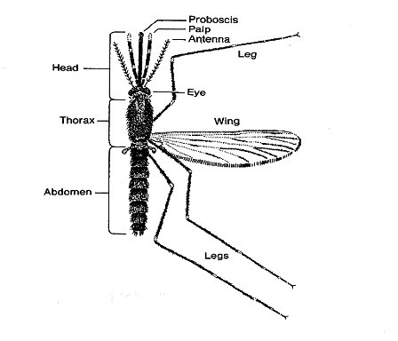
Fig 1.1: A Mosquito of the genus Anopheles.

Entomology work is important in malaria control activities. Some of the tasks which are undertaken in entomology include entomological surveys, identification of adult female anopheline mosquitoes and mapping of the high risk areas.

During entomology activities one comes across many insects and so it is important to know how to identify mosquitoes. Next we shall look at how to differentiate between mosquitoes and other insects.

How well can you differentiate an Anopheles mosquito from other Mosquitoes? Find out by doing the following activity.

ACTIVITY 2

List down the external characteristics of an adult mosquito.

- External characteristics of an adult mosquito.

- _____________________________________________________________________
- _____________________________________________________________________
- _____________________________________________________________________
- _____________________________________________________________________
- _____________________________________________________________________

Well done! We hope that your list included the following features which help us to identify adult mosquitoes. These are

- Long and segmented antennae;
- A long proboscis (the adapted mouth parts), which projects forward and which the female uses to pierce the skin when taking a blood meal;
- A body and wings covered with scales; and
- Wings with veins which show a definite pattern
There are over 2,600 known species of mosquitoes in the world. However, in Africa we are mainly concerned with two species namely, the An gambiae sl and An funestus. The life cycle of a mosquito has four distinct stages of development, egg, larvae, pupa and adult. The eggs, larvae and pupae stages are aquatic but the emerging adults are free-flying insects. Mating usually takes place immediately after the adults emerge from the pupa before females seek a blood meal. Both females and males suck nectar and other plant juices as energy sources; but females require a blood meal for maturation of eggs. Mosquitoes rest either indoor or outdoor during the day in cool humid locations to minimize moisture loss. Their biting activities take place from dusk, through out the night until just before dawn, feeding either indoor or outdoor. Mosquitoes have preference for various hosts (Human & animal) for their blood meal; however, efficient malaria vectors have preference for human blood.

How do we differentiate between an anopheline mosquito and a culicine? Please carry out the following activity.

ACTIVITY 3

How would you differentiate anopheline from culicine mosquitoes.

i) Female
anopheline…………………………………………………………………..

culicine ….…………………………………………………………………..

ii) Male
anopheline .………………………………………………………………

culicine ……………………………………………………………………

Confirm your answer as you read the following discussion.

One way that anopheline mosquitoes can be distinguished from culicines is by the length and shape of the palps, see Figure 2 below.

Females
- Female anophelines have palps as long as the proboscis
- Female culicines have palps which are much shorter than the proboscis

Males
- Anophelines have palps longer than proboscis and are club-shaped at tip
- Culicine have palps longer than proboscis, with tapered tips.

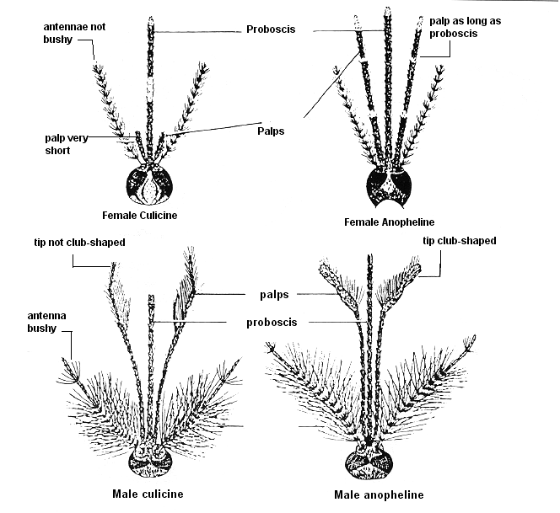
Figure 1.2: Some distinguishing features of Anopheline and Culicine mosquitoes

Another way of distinguishing anopheline and culicine mosquitoes is by observing the following:
- Culex eggs clump together forming a “raft”.
- Aedes eggs float singly, Anopheles eggs have floats.

The anopheles larvae rest parallel to the water surface, breathing with specialized hair at last segment. This is in contrast with culicine larvae which rest at an angle to the water surface and has a long siphon for breathing. The pupae for both species are active and do not feed.
The adult anopheles rests at an angle while culicine rests parallel to the resting surface respectively. Figure 1.3 illustrates these differences.
Anopheline | Culicine
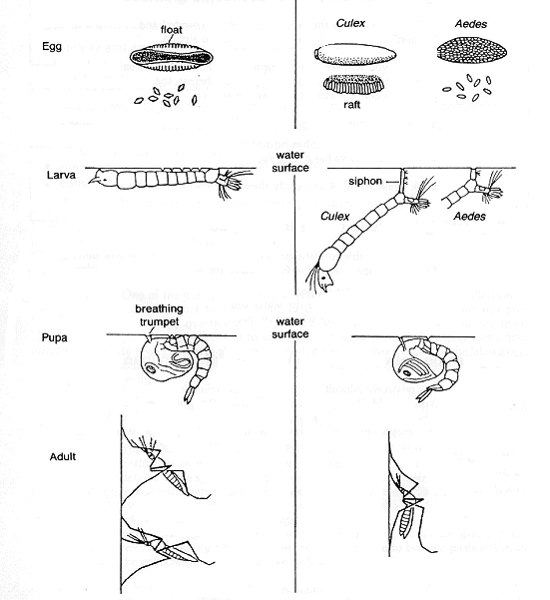
Figure 1.3: Life cycle of anopheline and culicine mosquitoes
The Different Species of Malaria Causing Parasite

It was once thought that malaria came from fetid marshes, hence the name mal aria, (bad air). However, in 1880 scientists discovered the real cause of malaria was a one-cell haemo (blood) parasite or protozoa called Plasmodium. There are four species of Plasmodium that infect humans.

Before you read on, do Activity 4 below. It should take you 10 minutes to complete.

Activity 4

List down the four (4) species of Plasmodium

i)…………………………………………………………………………

ii)……………………………………………………………………………

iii)…………………………………………………………………………

iv)……………………………………………………………………………

Outline one characteristics of each species

i)…………………………………………………………………………………

ii)………………………………………………………………………………..

iii)………………………………………………………………………………

iv)……………………………………………………………………………….

Compare your answer with the following discussion.

The four species of Plasmodium which are known to cause disease in man are:

- Plasmodium vivax (Tertian).
It is the most common species in the World. It is the largest of the malaria parasites found in humans. The length of its asexual cycle is 48 hours. Relapses are common in vivax malaria due to emergence of new blood forms from maturing secondary liver schizonts. In tropical areas, relapses may arise within three to four months of primary attack, while in subtropical areas relapses occur only after nine months or more.

- Plasmodium ovale, (Tertian)
It is a relatively a rare species with a frequency of less than 5%. It may sometimes be confused with P. vivax. The length of its asexual cycle is 48 hours. Relapses occur as in P. vivax but the disease tends to be more chronic.

- Plasmodium malariae. (Quartan)
It is a less common species whose length of its asexual cycle is 72 hours. P. malariae is associated with quartan malaria.

- Plasmodium falciparum, (Sub-Tertian)
It is the commonest species in Africa and it accounts for 95 - 98% of all malaria infections.. It is responsible for severe illness cerebral malaria and other complications and may cause death. The length of asexual cycle is about 48 hours. Fever is produced when the schizonts are mature i.e. at 48 hours interval. Sub-tertian means that diurnal periodicity is common. The liver stage of development take about 14 days.

In our environment, you may have noticed that many malaria laboratory tests report the presence of P. falciparum. This is because it is the most common cause of malaria in our environment. Indeed in Africa, Plasmodium falciparum is the most common type of malaria parasite transmitted in Africa, south of the Sahara, accounting in large part for the extremely high mortality in this region. Figure 1.4 to 1.7 below illustrate the differences between the various species of the malaria parasite.

Figure 1.4: Appearance of Plasmodium falciparum stages in Giemsa stained thin
and thick blood films
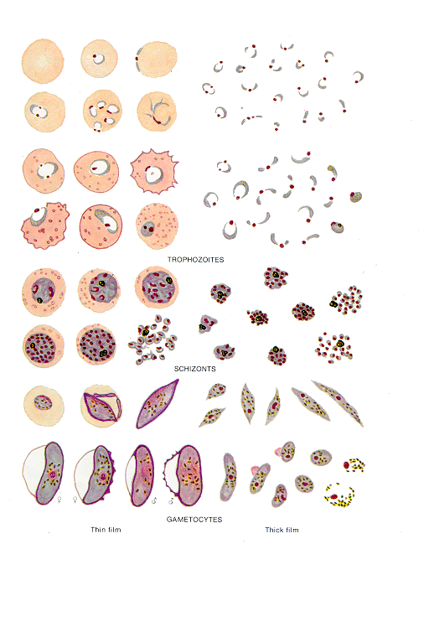

Figure 1.5: Appearance of plasmodium malariae stages in Giemsa stained thin
and thick blood films
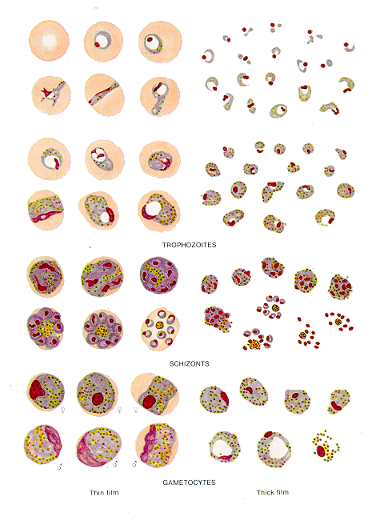

Figure 1.6: Appearance of plasmodium ovale stages in Giemsa stained thin and
thick blood films.

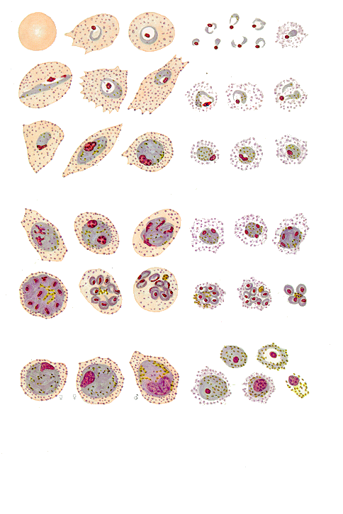

Figure 1.7: Appearance of plasmodium vivax stages in Giemsa stained thin and
thick blood films.

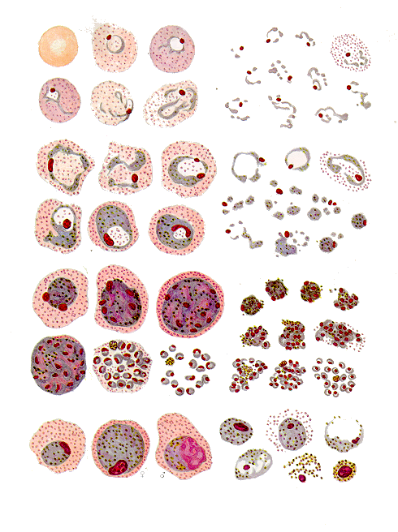
THIN THICK

Figures 1.4 to 1.7 courtesy of Malaria Parasitological Diagnosis: WHO 1991

1.4 Mode of Transmission of Malaria

Having read about the definition and the causative species of Malaria, let’s turn to the mode of transmission of Malaria.

Before you read on, here is an activity to enhance your learning process, take about 10 minutes to think about it and write out your answer.

Activity 5

How is Malaria transmitted? Name the vector involved in the transmission.

………………………………………………………………………………………..

………………………………………………………………………………………..

………………………………………………………………………………………..

………………………………………………………………………………………..

………………………………………………………………………………………..

………………………………………………………………………………………..

………………………………………………………………………………………..

………………………………………………………………………………………..

As we mentioned earlier, malaria is transmitted by the female Anopheles mosquito which requires blood for the development of its eggs. These eggs are laid on stagnant water or slow flowing water where they stay for 2-3 days before they hatch to release mosquito larvae. The larvae grow beneath the water surface and become pupa. After a few days the pupa develops into adult mosquitoes and flies away.

The development of mosquitoes from egg to larvae to adults takes 7-14 days at a temperature of 31ºC or 20 days at 20ºC. If the adult mosquito is female, it looks for a blood meal to facilitate egg development, thereby starting the development cycle all over again. If the adult mosquito is male it feeds on plant juices.

When a mosquito sucks the blood of a person who has malaria parasites in his or her blood, the mosquito picks male and female gametocytes where they undergo a series of changes to become sporozoites. The sporozoites are the infective stages of malaria parasites in the mosquito. This process called sporogonic cycle takes about 10 -14 days depending on environmental temperature. When a mosquito carrying sporozoites bites a person, it passes the parasites into the blood of that person, thereby infecting that person with malaria.

- In summary, the transmission of Malaria depends on interaction of the following factors:
  - Presence of the infective vector
  - Susceptible human host
  - Suitable environment for complete sporogonic cycle e.g P.falciparum ceases to develop below 20⁰ C while P. vivax ceases at 16⁰C

The Malaria Life Cycle

Now that you know the mode of transmission of malaria, it is important for you to also understand the malaria cycle. You have already come across some aspects of the cycle when dealing with the mode of transmission. Before you proceed, attempt the following activity.

Activity 6

In the space provided below and in your own words; describe the life cycle of the Malaria parasite.
……………………………………………………………………………..
……………………………………………………………………………..
……………………………………………………………………………..
……………………………………………………………………………..
……………………………………………………………………………..
……………………………………………………………………………..

Now read the following discussion and compare your answer with the information given.

The Malaria parasite lifecycle begins when an infected adult female Anopheles mosquito bites a human being to feed on his or her blood. As it feeds on this blood, it releases malaria sporozoites (parasites) into the blood stream of the host (human being). This is the infective bite.

Once the parasites enter the human blood stream they move quickly to the liver cells where they develop and multiply (schizogony). The infected liver cells rapture and release numerous merozoites into the blood, which invade red blood cells (RBCs). This stage takes 9-14 days. Within the RBCs the parasites develop from “rings” into blood schizonts. The schizonts then rupture the RBCs releasing numerous merozoites which invade new RBCs. When the infected red blood cells rapture, this process initiates the chills and fever which are characteristic of Malaria. Indeed, the peaks of fever experienced during malaria coincide with the release into blood circulation of malaria parasites (merozoites) from raptured RBCs.

The period between the infective bite and the onset of symptoms (i.e fever, chills etc,) is called the incubation period of malaria. As we mentioned earlier, the incubation period is usually 7-14 days but may be shorter as in P. falciparum or longer in the case of P. vivax and P. malariae. See figure 5 for an illustration of the life cycle of malaria.

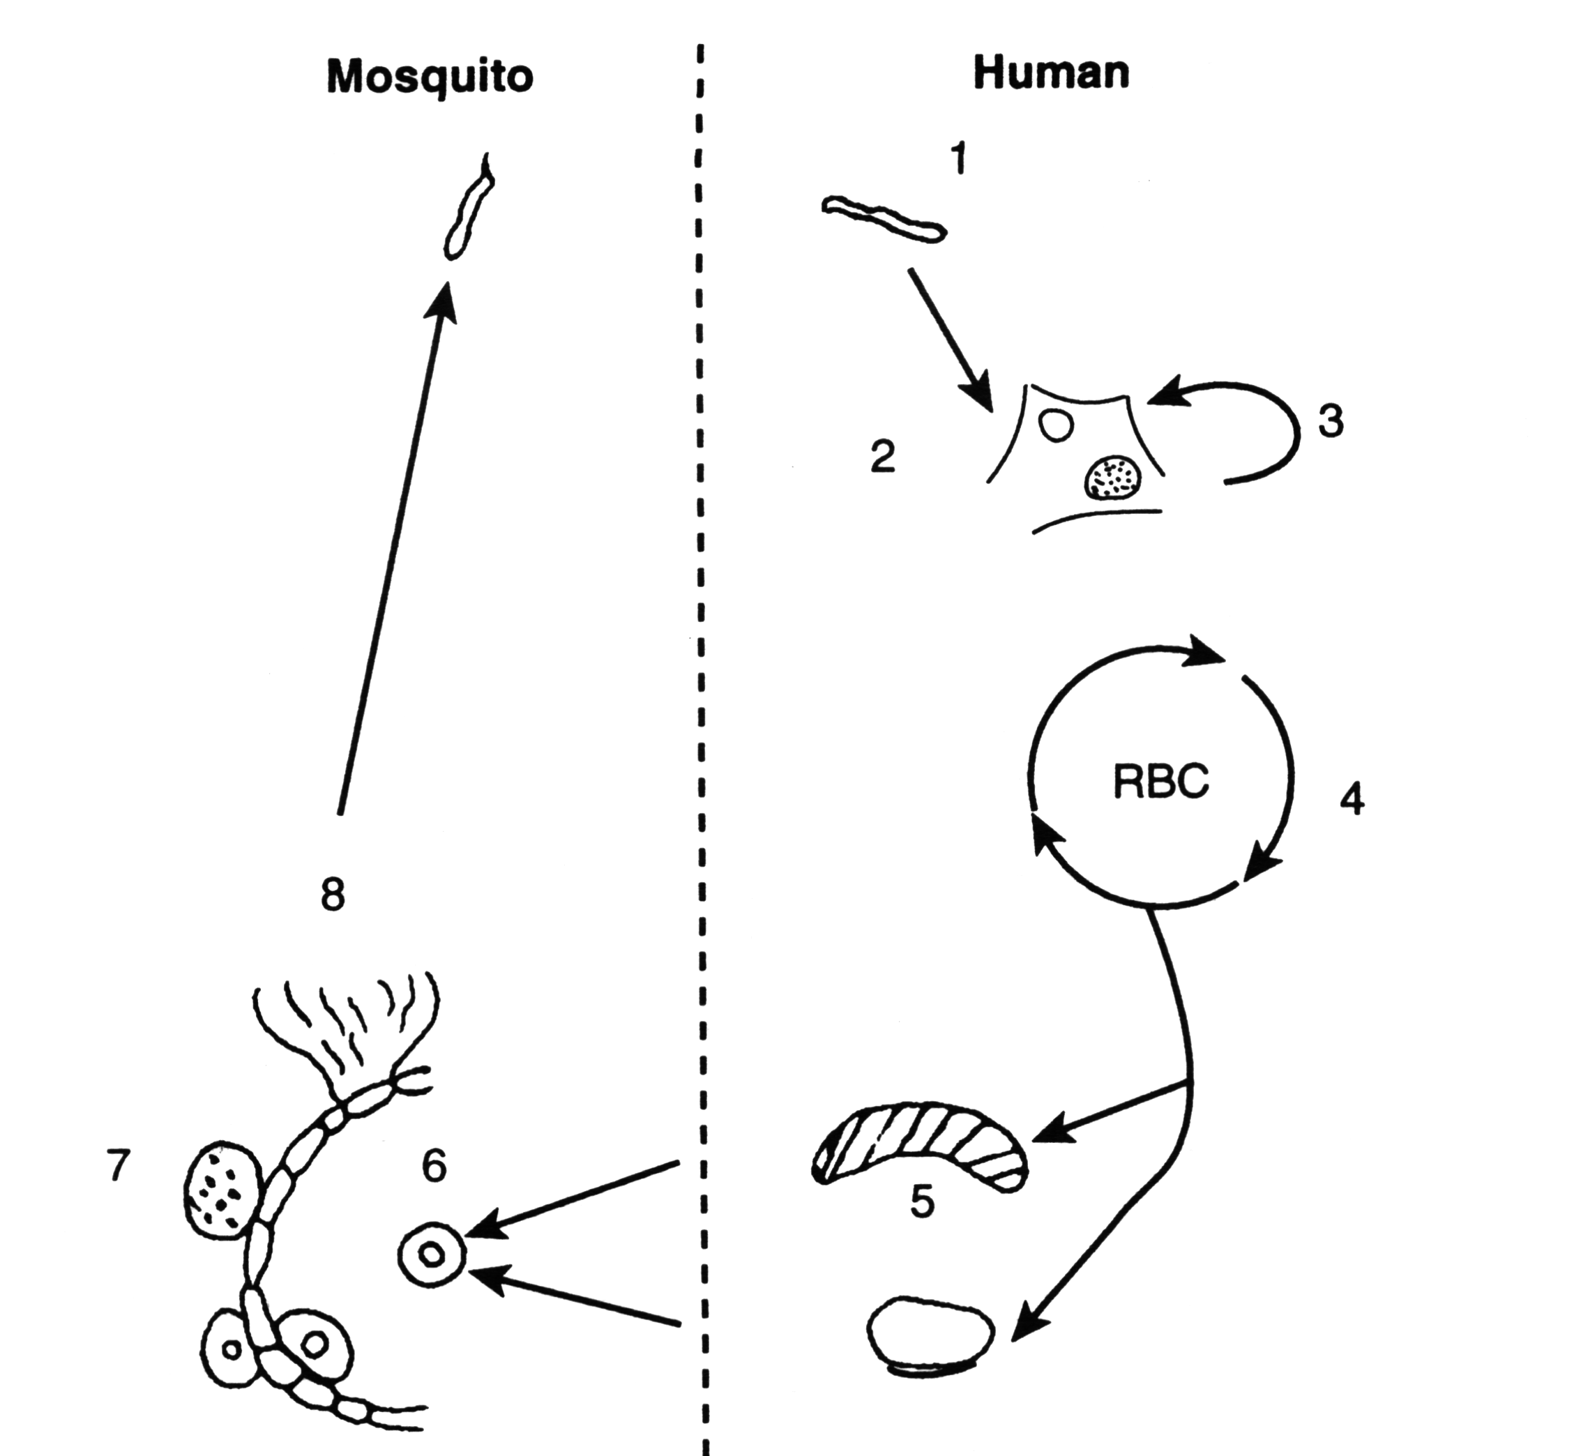
Figure 5: Life Cycle of human malaria parasite

As you can see from Figure 5, malaria parasites develop in 2 cycles: the first cycle takes place in the mosquito and the other cycle in the infected human being. The first cycle which takes place in the mosquito is called the sexual cycle, while that which takes place in the human being is called the asexual cycle. Let us briefly look at the characterstics of each cycle as numbered in the diagram.

Asexual Cycle:

This cycle takes place in the body of an infected human being and starts with the bite of an infected female Anopheles mosquito.

- Sporozoites in the mosquito salivary glands are injected into the host via the broboscis of the mosquito
- The hepatic (liver) stage: the sporozoite is taken up by the Kupffer cells of the liver and passes through into the liver cells
- Hypnozoites. This stage of the parasite occurs in P. ovale and P.vivax. The hypnozoites mature and release new merozoites responsible for recurrent infections up to 18 months after primary infection.
- Erythrocytic or blood stage. The merozoites released into the liver invade
- Gametocytes: At an unknown stage or time in the RBC cycle, “sexual” forms develop and are in turn responsible for the survival and transmission of the parasite. These male and female

Sexual cycle: takes place in the mosquito

- Sexual reproduction: the male and female gametocytes develop into gametes and then fuse in the stomach of the mosquito to form a zygote. This develops into a mobile ookinete which migrates through the wall of the stomach to form an oocyst.
- Oocyst. This matures and releases sporozoites.
- Sporozoites. These migrate to the salivary glands ready for delivery with the mosquito’s next meal.

Next, let us look at how we classify the clinical cause of malaria.

Clinical Classification of Malaria

The clinical course of malaria infection may be classified into two stages:

- uncomplicated or mild disease
- severe and complicated

 | What is the difference between these two stages?

- Uncomplicated Malaria:

It presents with fever, chills, nausea, vomiting, headache, joint pains, general malaise, and profuse sweating.

It is important to promptly diagnose and treat uncomplicated malaria for two reasons:

- To avoid the disease progressing to a severe and complicated situation;
- To reduce the number of parasite carriers within the community and hence interrupt further transmission.

- Severe Malaria:

This is a form of life threatening malaria that can affect many systems of the body as shown in the following table.

Table 1: Effects of malaria on different systems of the body

System Affected | Effects on the Organ
Central nervous System | cerebral malaria may present as convulsions, coma or mental disturbance
Respiratory system | rapid or difficult breathing
Urinary system | acute renal failure especially in adults or haemoglobinuria (black water fever)
Gastrointestinal | vomiting and diarrhoea which may cause dehydration
Circulatory | collapse (shock) with low blood pressure, anaemia, (low blood sugar) especially in children and pregnant women, bleeding

Malaria complications are life threatening so we should stop the clinical stage from progressing by early diagnosis and administration of the correct treatment.

CONCLUSION

You have now come to the end of this unit. In this unit, we defined malaria, discussed its causative organism, its life cycle and mode of transmission. We also considered the classification of the clinical course of malaria.

You should now review the learning objectives at the beginning of this unit to see if you have achieved all of them. If you have achieved them do the attached assignments and send it to us for marking. If you have any problems in understanding any of the sections, do not hesitate to consult your tutor about it.

In the next unit we shall discuss the clinical assessment of malaria.

GLOSSARY

Incubation period | Time required for the development of a malaria parasite into a mosquito. Ranges between 10 – 14 days
Insects | Insects belong to the class Insecta with the following characteristics: body divided into three sections: head, thorax and abdomen; head with one pair of antennae, a pair of large compound eyes and one/two pair/s of palps and lastly the thorax has three pairs of legs, two pairs of wings, one pair in some insects and none at all in others.
Schizogony | Refers to the asexual reproductive stage of the malaria parasite
Sporozoite | Minute active malaria parasites injected into the human host when an infective anopheline mosquito feeds on human.
Sporogony | Sexual development cycle of the malaria parasite in the mosquito
Vector | An insect or other animal that carries a disease from a plant or animal to another plant or animal of the same species which is free of the disease. Anopheline mosquitoes are the vectors of human malaria.

REFERENCES

- WHO (1999), Roll Back Malaria: Increasing the momentum.
- WHO (1992), Entomological field technique for malaria control. Learner’s.
Russell Paul, West L. and Manwell R. (1946), Practical Malariology, WB Saunders Company.

DIRECTORATE OF LEARNING SYSTEMS
DISTANCE EDUCATION PROGRAMME

Student Name: __________________________________
Assignment

Student Identification Number:_______________________

Student Postal Address: __________________________

__________________________

DISTANCE LEARNING COURSE ON MALARIA
Tutor Marked Assignment
Unit 1: About Malaria

Instructions: Answer all the questions in this assignment. When you complete them all mail the assignment or bring it in person to AMREF.

1. Outline the importance of Malaria
_____________________________________________________________________
_____________________________________________________________________
_____________________________________________________________________
_____________________________________________________________________
_____________________________________________________________________
_____________________________________________________________________

2. Outline the impact of malaria
_____________________________________________________________________
_____________________________________________________________________
_____________________________________________________________________
_____________________________________________________________________
_____________________________________________________________________
_____________________________________________________________________

3. List down the external characteristics of an adult mosquito
_____________________________________________________________________
_____________________________________________________________________
_____________________________________________________________________
_____________________________________________________________________
_____________________________________________________________________
_____________________________________________________________________

4. List down the features used in differentiating between the life stages of the anopheline and culicine mosquitoes
_____________________________________________________________________
_____________________________________________________________________
_____________________________________________________________________
_____________________________________________________________________
_____________________________________________________________________
_____________________________________________________________________

5. Outline the mode of transmission of Malaria.
_____________________________________________________________________
_____________________________________________________________________
_____________________________________________________________________
_____________________________________________________________________
_____________________________________________________________________
_____________________________________________________________________
6. Describe the life cycle of the malaria parasite.
_____________________________________________________________________
_____________________________________________________________________
_____________________________________________________________________
_____________________________________________________________________
_____________________________________________________________________
_____________________________________________________________________

7. In your opinion, why do you think malaria has become a disease of significance in the your country?
_____________________________________________________________________
_____________________________________________________________________
_____________________________________________________________________
_____________________________________________________________________
_____________________________________________________________________
_____________________________________________________________________

5. What factors influence malaria transmission in your environment?
_____________________________________________________________________
_____________________________________________________________________
_____________________________________________________________________
_____________________________________________________________________
_____________________________________________________________________
_____________________________________________________________________

Congratulations! You have come to the end of this assignment. Before you send it to your tutor, remember to check if you have written your correct address and student number.

Enjoy the rest of the course!

