DIRECTORATE OF LEARNING SYSTEMS

DISTANCE EDUCATION PROGRAMME

Unit 8
Nutrition and HIV

Allan and Nesta
Ferguson Trust
INTEGRATED HIV/AIDS PREVENTION, TREATMENT AND CARE

Unit 8: Nutrition and HIV

A distance learning course of the Directorate of Learning Systems (AMREF)

© 2007 African Medical Research Foundation (AMREF)

This course is distributed under the Creative Common Attribution-Share Alike 3.0 license. Any part of this unit including the illustrations may be copied, reproduced or adapted to meet the needs of local health workers, for teaching purposes, provided proper citation is accorded AMREF. If you alter, transform, or build upon this work, you may distribute the resulting work only under the same, similar or a compatible license. AMREF would be grateful to learn how you are using this course and welcomes constructive comments and suggestions. Please address any correspondence to:

The African Medical and Research Foundation (AMREF)
Directorate of Learning Systems
P O Box 27691 – 00506, Nairobi, Kenya
Tel: +254 (20) 6993000
Fax: +254 (20) 609518
Email: amreftraining@amrefhq.org
Website: www.amref.org

Writer: Zipporah N. Burkania, KEMRI
Cover design: Bruce Kynes
Technical Co-ordinator: Joan Mutero

The African Medical Research Foundation (AMREF wishes to acknowledge the contributions of the Commonwealth of Learning (COL) and the Allan and Nesta Ferguson Trust whose financial assistance made the development of this course possible.

Contents

Section 1: Overview of Nutrition And HIV 3
Introduction 3
Section Objectives 3
Introduction to Nutrition 3
Section 2: Nutrition and HIV 15
Introduction 15
Section Objectives 15
HIV and the Immune System 15
Relationship between Nutrition and HIV/AIDS 16
Goals of Nutrition Care and Support in HIV/AIDS 19
What are the Nutrient Requirements for PLWHAs? 22
HIV Medication And Nutrient Interaction 26
Summary 27
Section 3: Nutritional Assessment and Therapy in HIV 29
Introduction 29
Section Objectives 29
Nutrition Assessment in adults and children 30
Anthropometric Assessments 31
Paediatric Anthropometric Assessment 33
Biochemical Assessment 34
Clinical Assessment 34
Dietary assessment 35
Meal plan 36
Nutrition Intervention strategies 37
Nutrition education and counselling 37
Nutrition Follow-up 41
Summary 42
Section 4: Infant Feeding Choices for the HIV-infected Mother 43
Introduction 43
Section Objectives 43
The Role of Breastfeeding 44
Safe Infant Breastfeeding Options 49
Strategies To Support Breastfeeding For HIV Infected Mothers 50
Recommendations for nutrition care and support for the HIV positive child 54
Summary 55

ABBREVIATIONS

AFASS Affordable, feasible, accessible, sustainable, safe
ART Antiretroviral Therapy
ARVS Antiretroviral
BIA Bioelectrical Impedance Analysis
CMS Centimetres
FFQ Food Frequency Questionnaire
HA Height for Age
HIV/AIDS Human Immune-deficiency Virus/Acquired immune deficiency syndrome
LBM Lean Body Mass
MTCT Mother To Child Transmission
MUAC Mid Upper Arm Circumference
OIs Opportunistic infections
PMTCT Prevention of Mother to Child Transmission
PLWHAS People Living With HIV/AIDS
RDA Recommended daily allowance
TB Tuberculosis
UN United Nations
UNICEF United Nations Children Fund
WH Weight for height
WA Weight for age
WHO World Health Organization
UNIT INTRODUCTION
Welcome to module 8 on nutrition and HIV. In the last unit you learnt about prevention of mother to child transmission of HIV. We hope you now know how to prevent mother to child transmission of HIV, the ARVs used during PMTCT and how to take care of a HIV infected mother during pregnancy and delivery.

In this unit we shall discuss the interaction between HIV infection and nutrition and how HIV associated complications affect nutritional status. You will also learn about micronutrients, assessment of nutritional status and the nutritional care of children and adults with HIV/AIDS.

The AIDS epidemic has brought to the forefront issues related to nutrition. By killing young adults, the key earners of income, HIV/AIDS dramatically reduces households’ earning power, thereby affecting their ability to buy food and related goods and services. Illness and funeral expenses force households to spend most of their money on care and treatment with adverse consequences on food availability. In addition, in areas where agriculture is the major source of income, households affected by HIV often replace valuable and nutritious crops that are labour intensive with root crops that are fast maturing, but less profitable. In addition, livestock a source of fertilizer for crops, and milk for nutrition, may be sold to generate cash needed for immediate needs.

This unit is divided into 3 sections. The first section will give you an overview of nutrition and HIV. The second section will look at the interaction between nutrition and HIV, the third section will focus on nutrition assessment and therapy, while the fourth will discuss safe infant feeding options and guidelines for HIV infected mothers.

By the end of this unit, you should be able to assess the nutritional needs of an HIV patient and guide a HIV infected mother on safer feeding options for her baby.

Let’s start by looking at the module objectives;

UNIT OBJECTIVES

The end of this unit you should be able to:

- Define nutrition, nutrients macronutrients and micronutrients];
- Discuss how HIV infection influences nutritional status;
- Discuss the effect of nutritional status and HIV disease progression;
- Describe the nutritional assessments of PLWHAs;
- Explain the various nutrition interventions used for management of various complications of HIV/AIDS;
- Discuss infant feeding options guiding HIV infected mothers and recommendations for HIV positive children;

Section 1: Overview of Nutrition And HIV

Introduction

Welcome to the first section of our unit on nutrition and HIV. In this section we shall discuss nutrition and its relationship with HIV. In particular we shall define nutrition and nutrients. Let’s start by looking at our objectives for this section.

Section Objectives

By the end of this section you should be able:

- Define nutrition and Nutrients;
- Identify the various nutrients:
- Explain the different components of food and their role;
- Discuss the classification of nutrients and their sources;

Introduction to Nutrition

Before you proceed test your knowledge about nutrition by doing the following activity.
ACTIVITY

What is nutrition? Write down the definition below.
_____________________________________________________________________
_____________________________________________________________________
_____________________________________________________________________
_____________________________________________________________________
_____________________________________________________________________
_____________________________________________________________________
List down three main micronutrients and three main macronutrients
_____________________________________________________________________
_____________________________________________________________________
_____________________________________________________________________
_____________________________________________________________________
_____________________________________________________________________
_____________________________________________________________________

Now read through the text below and see if your ideas are included.

Nutrition is the total sum of the processes by which one acquires food, consumes/eat and how the body uses the food eaten/consumed for energy, maintenance and growth.
It can also be defined as the process of nourishing or being nourished, especially the process by which a living organism assimilates food and uses it for growth and for replacement of tissues. Another definition says it is the science or study that deals with food and nourishment, especially in humans.

What about Nutrients?

Nutrients are specific elements or chemical compounds in a variety of foods that the body requires. These elements are so many and so far about 40 are known. Nutrients are divided into
- macronutrients and
- micronutrients.

Macronutrients
There are three macronutrients namely:
- Carbohydrates
- Fats
- Proteins

These are substances needed for supply of energy, growth, metabolism and other body functions. ‘Macro’ means large, macronutrients are nutrients needed in large amounts. Although these macronutrients provide a lot of calories, the amount of calories each provides varies. For example, carbohydrates provide 4 calories per gram of carbohydrate; Protein on the other hand provides 4 calories per gram, while Fat provides 9 calories per gram.
Besides carbohydrate, protein and fat the only other substance that provides calories is alcohol. Alcohol provides 7 calories per gram. Alcohol, however, is not a macronutrient because we do not need it for survival.

Micronutrients
These are referred to as micronutrients because they are needed in small amounts by the body. Micronutrients are divided into vitamins and minerals.
Let us now discuss each macronutrient in detail.
Carbohydrates
Carbohydrates are one of those macronutrients needed in large amounts by the body. Indeed, up to 65 % of our energy comes from carbohydrates. They are the body’s main source of fuel because they are easily converted into energy. This energy is usually in the form of glucose which all the tissues and cells in our bodies can readily use.
For the brain, kidneys, central nervous system and muscles to function properly, they need carbohydrates. These carbohydrates are usually stored in the muscles and the liver, where they are later used for energy. They are also important in intestinal health and waste elimination.
The main sources of Carbohydrates are starchy foods (like grain and potatoes), and cereals. Other foods like vegetables, beans, nuts, seeds and cottage cheese contain carbohydrates, but in lesser amounts.
Proteins
Proteins are very large molecules made of amino acids. There are twenty amino acids. Eight of these amino acids are "essential," meaning that they cannot be synthesized in the body even though they are necessary for life. Essential amino acids must be consumed from sources outside the body, mainly from diet.
About 10% to 35% of calories come from protein. Proteins in our diets are needed for, growth (especially important for children, teens, and pregnant women) and immune function. They also play an important role in making essential hormones and enzymes, tissue repair, preserving the lean muscle mass, and supplying energy in times when carbohydrate are not available.
The main sources of proteins are meats, poultry, fish, cheese, milk, nuts, legumes, and in smaller quantities in starchy foods and vegetables. When we eat these types of foods our body breaks down the protein that they contain into amino acids (the building blocks of proteins).
Protein that comes from animal sources contains all of the essential amino acids needed by our body. Plant sources of protein, on the other hand, do not contain all of the essential amino acids.
Fats
Some fat is necessary for survival, although fats have received a bad reputation for causing weight gain. 20% - 35% of total calories should come from fat. Fats are a concentrated source of energy (1 gm of fat gives 9 calories). They are essential for normal growth and development. They help to cushion body organs, and maintain cell membranes. They also essential for the absorption of fat soluble vitamins, (Vitamin A, D, E, K and carotenoid) and also play a major role in providing taste and stability to foods.
Fat is found in meat, poultry, nuts, milk products, butters and margarines, oils, lard, fish, grain products and salad dressings.
Classification of Fats.
Fats are classified into 4 main types, according to fat saturation. Saturation refers to the number of hydrogen atoms attached to the fat molecule. When a fat molecule contains the maximum number of hydrogen atoms, it is said to be "saturated." It is called "hard fat," because it remains hard at room temperature.
If one pair of hydrogen atoms is missing, the molecule is said to be "monounsaturated." An example is olive oil. Monounsaturated fat is the healthiest, most easily digested form of fat. If more than one pair of hydrogen atoms is missing, it is said to be "polyunsaturated." These are the thin oils commonly used for frying and for salad dressing.
If an unsaturated vegetable fat is altered by adding hydrogen atoms, which did not exist in nature, the fat molecule is said to be "hydrogenated." Hydrogenation transforms the shape of a fatty acid to a "trans" form.
Saturated fat is found in foods like meat, butter, lard, and cream, while tran’s fat is found in margarines, fried and baked goods, snack foods. Research has shown that Saturated and Trans fats increase the risk for heart diseases. While unsaturated fats which are found in foods like olive oil, avocados, nuts, and canola oil, have been shown to decrease the risk of developing heart disease.
Micronutrients
They are often referred to as micronutrients because they are needed in small amounts by the body. Micronutrients are divided into vitamins and minerals. Vitamins are organic substances or groups of related substances which have specific biochemical functions in the body. They are essential for normal metabolism and are provided by the diet.

Vitamins are usually grouped according to their solubility, the fat soluble e.g. A, D, E, and K . These vitamins are closely associated with lipids (fats) in their fate in the body. The water soluble vitamins are the B complexes and Vitamin C.

Minerals on the other hand are essential constituents of the soft tissues fluids and. Skeleton examples of minerals include; calcium, phosphorus, potassium, zinc selenium, iron, and sodium among others. Table 1 shows a few of the key micronutrients for HIV patients and their food sources
Table 8.1: List of micronutrients, their function and food sources
Micronutrient | Function | Food sources
Vitamins
Vitamin A | Night vision  Healing epithelial cells  Normal development of teeth and bones | Spinach, tomatoes, cabbage, lettuce, pumpkins, mangoes  Liver, kidney, egg yolk, milk, butter, cheese cream
Vitamin D | Needed for absorption of calcium from small intestines  Calcification of the skeleton | Ultra violet light from the sun  Eggs, butter, oily fish e.g. sardines and salmon  Fortified oils and fats and cereals
Vitamin E | For reproduction | Wheat germ, green leafy vegetables, eggs, butter
Vitamin K | For blood clotting | Green leafy vegetables  Fruits, cereals, meat, dairy products  Bacteria in the gut
B complex | Metabolism of carbohydrates alcohol and fats  Oxidation and reduction processes in the body  Protein metabolism | Germinating parts of cereals  Milk, egg yolk, liver, kidney and heart  Whole grain cereals, meat, whole bread  Pulses fish bananas
Vitamin C | Prevention of scurvy  Aiding wound healing  Assisting absorption of non haem iron  Improving immune function  Improve male fertility, lipid metabolism | Fresh fruits(oranges, grapefruits, lemons, tomatoes) and vegetables(cabbage, broccoli, spinach)
Minerals
Calcium | Give bones and teeth rigidity  Has a role in blood clotting | Milk, cheese and dairy products  Foods fortified with calcium, e.g. flour, cereals. eggs, fish,(salmons and sardines) cabbage, broccoli
Iron | Formation of haemoglobin  Constituent of many enzymes | Meat and meat products  Eggs, bread, green leafy vegetables, pulses, dried fruits fortified breakfast cereals.
Zinc | For growth  Aids in wound healing
Potassium | Complements sodium,  Prevents diarrhoea and vomiting | Fruits (bananas are good sources) and vegetables, tubers e.g. potatoes
Phosphorus | Combines with calcium in bones and teeth  Release of energy from carbohydrates and fats  Assists absorption of carbohydrates in the small intestines  Maintaining acid-base balance | Meat, fish, milk, cheese, eggs
Sodium | Production of osmotic pressure to regulate fluid exchange between cells  Transmission of impulses in nerves for muscle contraction | common salt, meats, cheese, ham, eggs, milk, fish,

The best sources of micronutrients in our diets are fruits and vegetables, these two food groups contain essential vitamins and minerals and trace elements. They have always been referred to as protective foods. We also need to note that all the other foods are good sources of micronutrients especially animal source. An adequate micronutrient intake can only be achieved through an adequate intake of a balanced diet that includes plenty of fruits and vegetables of a minimum of 400gms of vegetables and fruits per day. The deep coloured vegetables tend to contain higher micronutrient value, e.g. spinach, cowpea leaves pumpkin leaves, while deep yellow or orange fruits such as pawpaw and mangoes are rich sources of B carotene which helps in production of vitamin A by the body.

A lack of any of the essential micronutrients from the diet may lead to deficiencies, compromising the ability to function and impairing health, these are vitamins and minerals.

Water
Water constitutes about 65 to 70 % of total body weight. It is a vital element that the body needs to sustain overall body processes which include removal of waste, assist metabolic activities, aid in transportation of nutrients as well as body temperature regulation. One is well hydrated if they pass clear urine. Our bodies also need water (6-8 glasses a day). But requirement may vary according the amount lost in sweat, vomiting, diarrhoea, and haemorrhage.

Fibre
Fibre refers to certain types of carbohydrates that our body cannot 100% digested. These carbohydrates pass through the intestinal tract intact adding bulk to the food we eat and help to move waste out of the body.
Any diet low in Fibre has been shown to cause problems such as constipation and haemorrhoids and to increase the risk for certain types of cancers such as colon cancer. Diets high in Fibre; however, have been shown to decrease risks for heart disease, obesity, and they help lower cholesterol. Foods high in Fibre include fruits, vegetables, and whole grain products. There are two types of Fibre; soluble Fibre found in fruits, and insoluble Fibre found in whole grains, cereals and legumes. Soluble figure absorbs water from the gut,
The advantage of including Fibre into diet is that it moves food through the digestive system quickly, it protects the body from absorbing toxins, which may be associated with food (pesticides, for example), it modulates the absorption of simple carbohydrates, and it keeps the walls of the intestine clean by removing toxins which are believed to cause cancer.
ACTIVITY

What are the main food sources in your community?
_____________________________________________________________________
_____________________________________________________________________
_____________________________________________________________________
Nutrients are supplied by different foods divided into six food groups. The main food sources in our communities thus include:

- Starches; Grains, cereals, breads, cereals, rice, pasta ( provide energy)
- Vegetables; all types of vegetables, green leafy,
- Fruits;
- citrus fruits; oranges, lemons
- tropical fruits; mangoes, pineapples
- wild fruits; guavas, wild berries
- Meats and meat products, poultry, dry beans, fish, eggs and nuts
- Milk and milk products; yoghurt, cheese, butter, cream
- Fats, oils and Sugars

A model of the food pyramid is shown in figure 8.1.
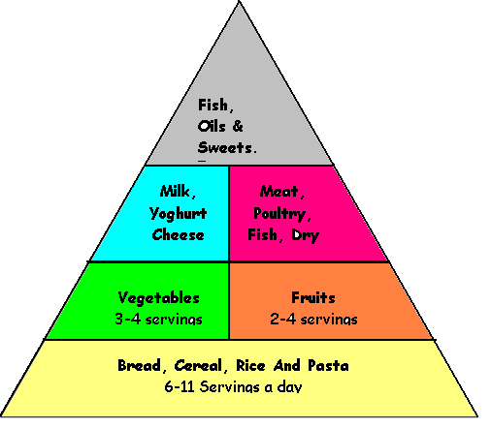
Figure 8.1: Food guide pyramid

To help you understand the pyramid, here is a guide to serving sizes. However note that each individual’s servings per day are dependent on age, gender, level of physical activity and presence or absence of infections.

The food measurements given below are general guidelines on food serving sizes sometimes called serving portions for adults.

Servings (Measurements using a 200 ml cup)

Energy foods: One serving is equivalent to:
- one slice of regular bread or
- 3 biscuits
- 1 cup cooked tubers (arrow roots, potatoes, cassava)
- ½ cup of cooked rice, or cereal or
- 1 teaspoon fat/oil
- 1 teaspoon sugar
One serving= 80 kcalories

(Proteins) Body building foods: One serving is equivalent to:
- 60-90 g cooked meat, chicken or fish
- one cup of fresh milk, fermented milk or yoghurt or
- ½ cup of cooked beans or peas or
- I egg
One serving = 7gms protein

Protective foods: One serving is equivalent to:
- ½ cup of cooked vegetables or
- one cup of raw chopped vegetables or
- one piece of whole fruit or
- 1 cup of fruit juice
One serving = 25 kcalories

Summary
In this section we discussed the definitions of nutrition, nutrients, types of macronutrients and micronutrients, their functions and food sources.

Before we proceed to the next section let’s see how well you remember what you learnt in this section. Answer the following questions on a separate sheet of paper without looking at the text.

Self Test
- What is the difference between nutrition and nutrients?
- What is the difference between macronutrients and micronutrients?
- Which are the four classifications of fats?
- Name the six food groups and their sources?
- What is Fibre?
- What is equivalent to one serving of an energy food?

Now compare your answers with the information given in the text and see how well you have done. If you had problems answering any of the questions, review the relevant text again.

In the next section we shall discuss the relationship between nutrition and HIV.

Section 2: Nutrition and HIV

Introduction

Welcome to section 2 of unit 1, remember that in section 1 we discussed the definitions of nutrition, nutrients and their roles and function in the human body, as well as their food sources. You will need this knowledge in order to understand the content of this section.

In this section we shall discuss how HIV disease can affect the nutrition status and how nutrition status can also affect the progression of HIV. It will also discuss the goals of nutrition support and the management of the medicated patient.

Section Objectives

By the end of this section, health worker will be able to :
- Understand the Relationship between nutrition and HIV;
- Define the goals of nutrition care and support in HIV;
- Understand HIV medication and nutrient interaction;
- Explain how to guide a patient on medication.

HIV and the Immune System
The relationship between nutrition and HIV/AIDS is complex. HIV infection is characterised by the progressive destruction of the immune system. This progression is usually very slow and may take up to 10 years before showing signs and symptoms. During this period CD4 cells which are defence cells are destroyed. Unfortunately unlike other infections the body can not eliminate HIV naturally. Destruction of the immune system leads to recurrent opportunistic infections, malignancies, progressive debilitation and death.

Malnutrition is one of the major complications of HIV infection and a significant factor in advanced disease.
Before you read on do the following activity.

ACTIVITY

What is malnutrition?
_____________________________________________________________________
_____________________________________________________________________
_____________________________________________________________________
_____________________________________________________________________

Now read through the text below and see if your ideas are included.

Malnutrition occurs when the body does not have enough of the required nutrients (under-nutrition) or has an excess of the required nutrients (over-nutrition).

Malnutrition usually leads to immune impairment thus compounding the effects of HIV and leading to faster progression of the disease. Therefore, malnutrition and HIV affect the body in similar ways. Both conditions affect the capacity of the immune system to fight infection and keep the body healthy. Before AIDS, the impairment of immune function caused by malnutrition was called nutritionally acquired immune deficiency syndrome, or NAIDS. The changes in the immune function resulting from malnutrition are similar to those caused by HIV and AIDS.

Relationship between Nutrition and HIV/AIDS

- HIV infection impairs nutrient intake and absorption while increasing nutrient needs;
- The risks of opportunistic infections are increased with poor nutrition thus accelerating progression of HIV into AIDS;
- The development of opportunistic infections reduce food intake leading to malnutrition in HIV;
- HIV/AIDS and malnutrition create a vicious cycle that eventually weakens the immune system.

As you can see from Figure 8.3, the relationship between HIV/AIDS and nutrition is a vicious cycle.

 | How does this relationship occur?

HIV infected individuals have higher nutritional requirements than uninfected individuals, particularly with regard to protein and energy. If they suffer from opportunistic infections, they are prone to loss of appetite, even anorexia, thus reducing their dietary intake at the very time when requirements are higher. In addition, the infection sometimes interferes with the body's ability to absorb food.

If a person who is malnourished acquires HIV, they have a higher likelihood of progressing faster to AIDS. This is because their body is already weak and cannot fight infections.

Therefore, nutritional status and the progression of HIV are strongly interrelated. HIV infection increases the body's energy needs while it diminishes appetite and decreases the body's ability to digest food and absorb nutrients. This leads to malnutrition which in turn accelerates the HIV infection. Figure 8.2 below illustrates the cycle of malnutrition and HIV infection

The nutritional needs of PLWHA are affected by many factors, such as, the stage of the disease, physiological factors and age of the person infected with the virus. In addition, the viral load count and the general health of the person also affect nutrient requirements. It is therefore very important for PLWHAs to eat foods from all the food groups with starchy foods forming the basis each meal.
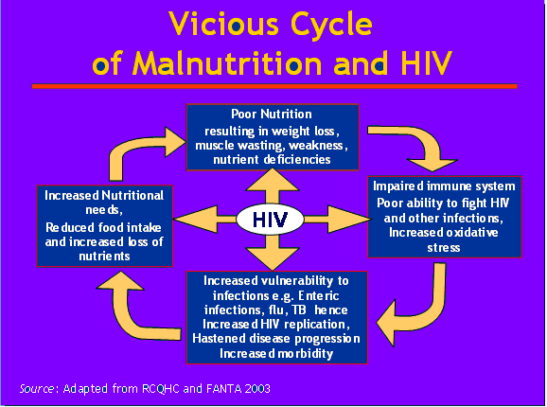
Figure 8.2: The cycle of malnutrition and infection in HIV/AIDS

Malnutrition in PLWHAs defines a state where the body does not have enough of the required nutrients (undernutrition) it usually includes, weight loss, loss of muscle mass and subcutaneous fat, vitamins and minerals.

Can you remember what we said about the quantity of micronutrients needed in our bodies in section 1? We said that micronutrients (vitamins and minerals) are needed in small amounts by the body. We also discussed the functions and sources of common vitamins and minerals.

In HIV infection micronutrients are lost through different ways. For example, during diarrhoea and vomiting a patient looses a lot of potassium and sodium which then need to be replaced through diet. In very severe cases they need to be replaced through supplementation. Malnutrition in HIV reduces the body’s ability to fight infection due to lowered immunity.

Reduced ability of the body to fight infection (reduced immunity) is also a symptom of malnutrition

Goals of Nutrition Care and Support in HIV/AIDS

Start by doing the following activity.

ACTIVITY

Write down 3 goals of nutritional support.
_____________________________________________________________________
_____________________________________________________________________
_____________________________________________________________________
_____________________________________________________________________
_____________________________________________________________________

I hope your answers included the following goals of nutritional support in HIV/AIDS:

- Improving nutritional status by maintaining weight, preventing weight loss, and preventing loss of muscle mass;
- Ensuring adequate nutrient intake by improving eating habits and building stores of essential nutrients, including carbohydrates, protein, important antioxidant nutrients, and other vitamins and minerals necessary for the functioning of the immune system;
- Preventing food-borne illnesses by promoting hygiene and food and water safety;
- Enhancing the quality of life by promptly treating infections and managing the symptoms that affect food intake to minimize the nutritional impact of secondary infections when they occur;
- Providing palliative care during the advanced stages of the disease.

Causes of Poor Nutrition in HIV/AIDS

As mentioned earlier, PLWHAs are at risk of malnutrition due to a number of factors. These include food intake, nutrient absorption and increased nutrient needs by the body. Let us now briefly look at each of these factors.

- Reduced food intake
HIV/AIDS is associated with conditions that result in reduced food intake. Most people living with HIV/AIDS get opportunistic infections (OIs) especially when their nutrition status is compromised. The most common include:
- Oral/mouth sores and ulcers
- Dysphagea-difficulty in swallowing
- Dental problems
- Esophageal sores or ulcers
- Oral thrush
Decreased food consumption may result from the following factors:
- Inability to eat or swallow because of painful sores in the mouth and throat;
- Loss of appetite leading to fatigue, depression, and other changes in the mental state;
- Side effects of medications, including nausea, loss of appetite, a metallic taste in the mouth, diarrhoea, vomiting, and abdominal cramps;
- Household food insecurity and poverty;
- Abdominal pain.

- Reduced nutrient absorption

HIV and other infections interfere with the lining of the gut and affect its ability to digest and absorb nutrients. Poor absorption of nutrients increases the incidence of opportunistic infections such as diarrhoea, which is a common cause of weight loss in people living with HIV. Poor absorption of fats, for instance, reduces the absorption and use of fat-soluble vitamins such as vitamins A and E and can occur at any stage of HIV infection in both adults and children. The malabsorption results in diarrhoea which leads to water and nutrient losses from the body. Apart from infections, certain medications also affect nutrient absorption and may also cause malabsorption resulting in nutrient losses.

Changes in metabolism
Changes in metabolism in HIV-infected people occur as a result of the immune system’s response to HIV infection. When the body mounts its acute phase response to infection, it releases pro-oxidant cytokines and other oxygen-reactive species. These cytokines have several effects, including anorexia (causing lower intake of food) and fever (increasing energy requirements).

If the infection is prolonged, muscle wasting occurs because muscle tissue is broken down to provide the amino acids with the immune protein and enzymes needed. These processes increase the energy requirements for PLWHA to 10 - 15% above the recommended level for healthy people. During the asymptomatic phase the energy requirements increase by 10 percent, while during the symptomatic phase energy requirements increase by 20 percent-30 percent over the level recommended for healthy, non-HIV-infected people of the same age, sex, and physical activity level.

The body also responds to this release of pro-oxidant cytokines by increasing the demand for antioxidant vitamins and minerals, such as vitamins E and C, beta-carotene, zinc, and selenium. These vitamins and minerals are used to form antioxidant enzymes. Oxidative stress occurs where there is an imbalance between the pro-oxidants and antioxidants, when there are not enough antioxidants to meet the demands of the pro-oxidant cytokines. This stress is believed to increase HIV Wasting syndrome, a complication of HIV that is well known to increase morbidity and mortality.

In order to understand the clinical significance and magnitude of the wasting syndrome, we assess the body composition by measuring the body weight and body cell mass assays. Body cell mass is the metabolically active tissue compartment in the body. Body cell mass measures are superior to body weight measures in the presence of HIV because they correlate better with mortality. Studies have found that there may be a progressive depletion of body cell mass in the late stages of HIV disease. Further, there is a significantly prolonged survival in patients with body cell mass of > 30 percent of body weight or serum albumin levels exceeding 3.0g/dl.

Changes in body composition
When a healthy person suffers an acute illness that reduces food intake, inadequate levels of nutrients are ingested and absorbed by the body to meet increased energy needs. As a result, weight (fat mass) may be lost first but is usually regained immediately after normal eating habits return. Fats stored in adipose tissues are catabolized to fuel the body energy needs, thus sparing amino acids needed to build or preserve lean body mass.

In the case of a person with HIV/AIDS, the opposite seems to occur. Amino acids are more readily used to fuel energy needs, while fat continues to accrue. The patient may consume adequate nutrient levels but utilizes and stores them inadequately. The patient has excess adipose tissue in proportion to lean tissue as the body converts the digested nutrients into fat instead of lean tissue. With high triglyceride levels in the blood, resting energy expenditure is increased. The underlying causes of an HIV-infected person’s inability to preserve or regain lean tissue remain unknown.

What are the Nutrient Requirements for PLWHAs?

Research has shown that the onset of AIDS and even death might be delayed in well nourished HIV-positive individuals by feeding on diets rich in protein, energy and micronutrients. These nutrients help them to develop resistance to opportunistic infections.

Common Nutrient Deficiencies in PLWHA
Before we look at the nutrient requirements of PLWHAs, let us briefly look at the common nutrient deficiencies in HIV/AIDS.
- The common nutrient deficiencies include; low levels of all macronutrients, micronutrients mainly, iron, vitamin B complex, zinc, selenium,
- Weight loss due lack of enough energy foods (starchy foods, ugali, rice, potatoes sugar, oils and fats)
- Muscle wasting as a result of inadequate proteins (meat, eggs, milk, fish, pulses)
- Low levels of micronutrients such as iron through frequent infections, potassium and sodium through diarrhoea and vomiting ,
- Weak bones as a result of reduced intake of foods high in calcium and vitamin D

Let us briefly look at the nutrient requirements of PLWHAs

Nutrient Requirements of PLWHAs

Energy needs of PLWHA
Energy needs of PLWHA increase depending on the stage of the disease and the severity of infections. The body will always need energy even in times of resting and infections. When a person has severe infection, their metabolic rate increases, and thus the body demands increased energy inputs.

A Healthy HIV-Uninfected Adult require between 1,990 and 2,580 kilocalories per day. In the case of a HIV-infected adult, they require an additional 10% calories especially during the early asymptomatic stage. This translates to about 3 extra slices of bread. As the condition advances to symptomatic stage, there is need for an additional 20% to 30% calories depending on severity which translates to an average of extra 6 slices to 9 slices of regular size bread.

HIV infected Children need 10% more energy to maintain growth if the child is asymptomatic. For children who are symptomatic, the energy needs increase by about 20-30% more per day. Children who are symptomatic and experiencing weight loss need between 50% and 100% more energy per day.

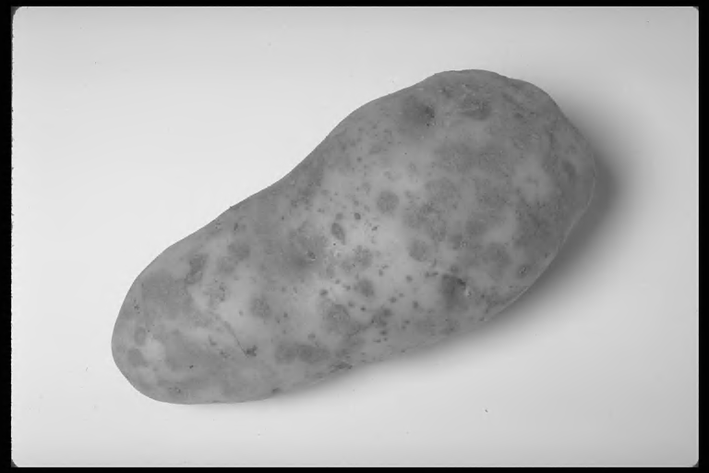 | 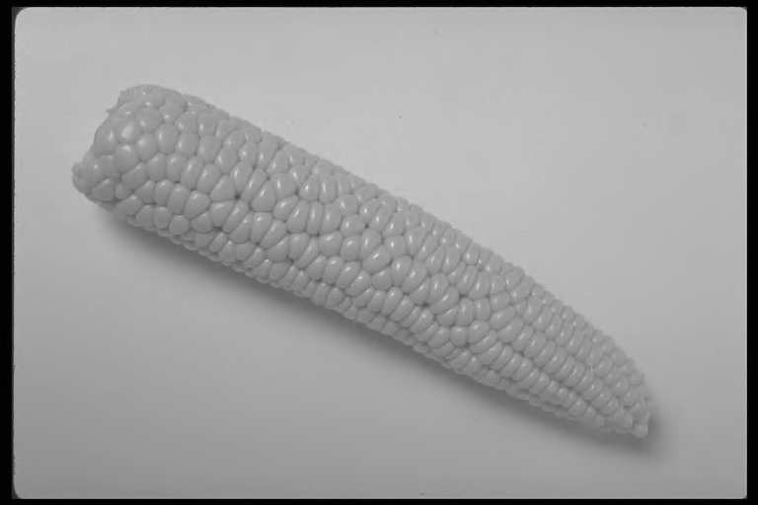 | 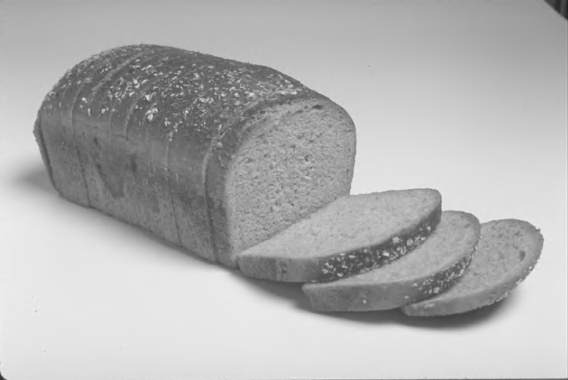
Figure 8.3: Foods that supply energy

Protein (body building foods) needs of PLWHA
As we mentioned in Section 1 of this unit, proteins are made up of amino acids. The body makes hundreds of types of proteins with the help of 20 different types of amino acids. 8 types of these amino acids, also known as essential amino acids, are critical and must be received through dietary sources. The essential amino acids are found most completely in animal food sources (eggs, milk, and meat) and to a lesser extent in plant sources.

According to WHO, there is no sufficient evidence to support any need for increased protein requirements for PLWHA over and above that of un-infected persons. This means that the HIV infected person receives the same amount of protein as the healthy uninfected individual. 12 to 15% of the total calories received by the body should be supplied by protein sources. On average, this means a range of 50 to 80 g of protein daily for adults. It is very important, however, to ensure that one is able to consume protein sources from both animal and plant sources.
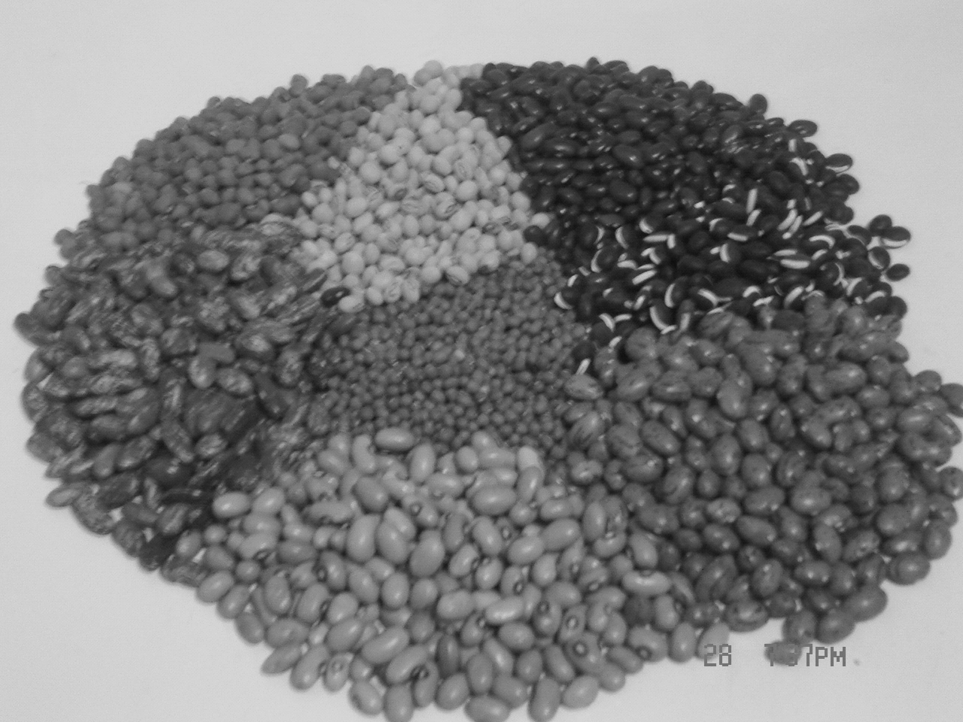 | 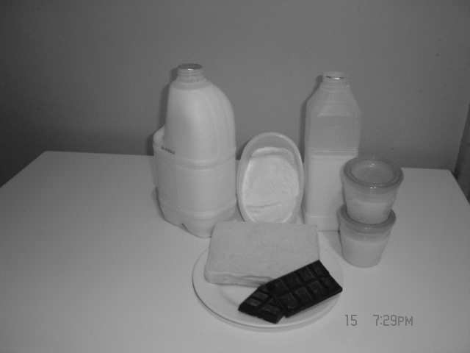 | 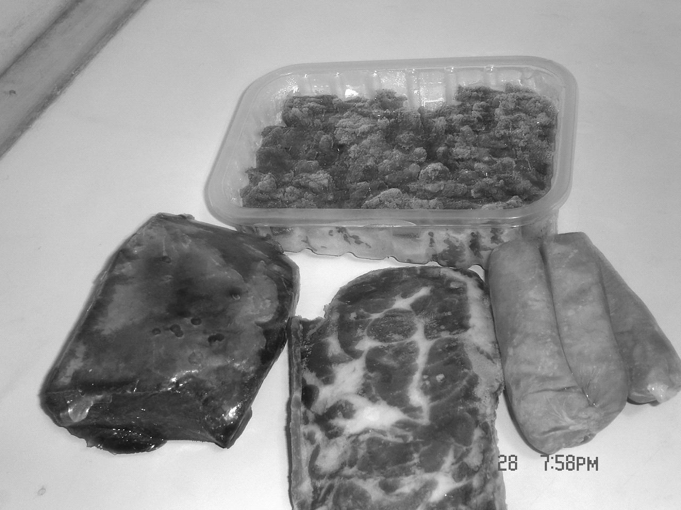
Figure 8.4: Animal and Plant protein sources

Fats and oil needs of PLWHA

Like all other people, PLWHAs diet should have fats and oils. However it is important to note that fats and oils provide more than twice the amount of calories found in carbohydrates. Therefore fats and oils should be used in moderation.
You will recall that at the beginning of this unit we discussed about fats and oils. Can you remember how many types of fats we said there are? We said that there are four main types of fats, namely, saturated, monounsaturated, polyunsaturated and hydrogenated. Of the four main types the monounsaturated fats are the healthiest and are found mainly in canola oil, olive oil, peanuts and avocados. However, a high fat intake (over 30% of daily energy requirements) has been associated with immunosuppression. This is because the white blood cells produce immune substances called cytokines and cytokines’ production is easily altered by excess fat intake, thus weakening the immune system. Excess fat also may cause steatorrhea (loose stool) and worsen diarrhoea.

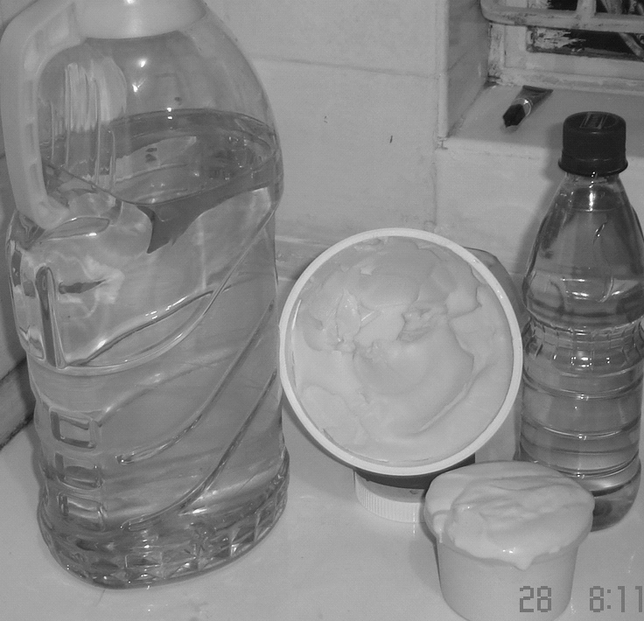
Figure 8.5: Fats and Oils

Micronutrient needs of PLWHAs

Micronutrients, vitamins and minerals have a key role in maintaining the immune function and protecting it against co-infections in HIV infected persons. In the last section we mentioned that micronutrients such as vitamin B and C are water soluble. This means that any excesses are excreted and so none are stored in the body. For this reason this group of micronutrients need to be consumed regularly. Some micronutrients such as vitamin A, D, E, K are fat soluble and the body is able to store them for some time, however regular intake of these vitamins and minerals is necessary.

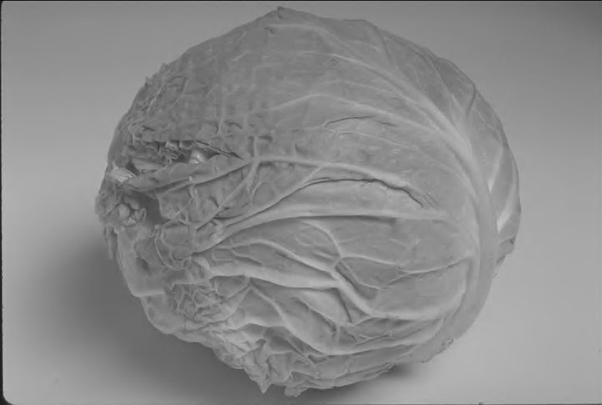 | 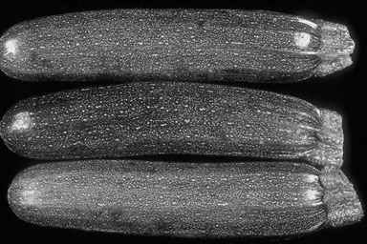
Figure 8.6: Sources of Micronutrients
The micronutrient needs of PLWHAs vary according to the co-infections. However WHO recommends 1 Recommended Dietary Allowance (RDA) for both the HIV un-infected and infected. There is no evidence to suggest increased intake of minerals and vitamins for HIV infected people, except where there is perceived or existing deficiency, multiple micronutrient supplementation is encouraged.

HIV Medication And Nutrient Interaction

Antiretroviral interaction with food and nutrition produces both positive and negative outcomes. These interactions can affect medication efficacy, nutritional status, and adherence to drug regimens. Drugs may alter nutrient absorption, metabolism, distribution and excretion thus affecting nutritional status of the patient. Most side effects affect the gastrointestinal tract e.g. anorexia/loss of appetite, change in taste, diarrhoea and food absorption. Side-effects such as fatigue, depression, loss of sleep and pain are also likely to lower food intake.

Food may also affect efficacy of medications due to altered absorption, metabolism, distribution and excretion. Below are important considerations for PLWHAs on ARVs.

Important considerations for PLWHAs on ARVs

- All patients on ART should be advised on potential side-effects and supported on how to address them (e.g. develop a drug-meal plan as shown in Table 8.2)

Table 8.2: Example of Drug meal plan
Type of drug | Time for medication | Time for meal | expected nutritional problem | nutritional remedy

- Clients on ART should be assessed for cholesterol, anaemia, lipid profile, and signs of lipodystrophy/lipoatrophy at least every 6 months.
- Patient should be advised to:
  - Drink plenty of safe water
  - Do physical exercises/activities
- If the effects are so serious there is need to change the drugs to facilitate adherence

Nutritional side effects due to ARV use include
- Elevated blood cholesterol;
- Liver damage;
- Kidney disease e.g. kidney stones;
- High triglycerides;
- Fat redistribution (lipodystrophy).

Guiding the medicated patient

All patients on medication should be:

- Given important information about medication;
- Taught on when and how to take drugs, this helps them adhere to the regimens;
- Be made aware of expected side effects, and remedies/solutions to the effects.
- Informed of potential nutrition problems with some of the drugs will affect their nutritional status, the patient should therefore be made aware of this and advised on what to do to avoid nutritional deficiencies;
- Informed of dietary changes altering action of some of the drugs are common, and advised on what changes to make;
- Advised on alcohol ingestion as the drugs efficacy will be affected by alcohol;
- Potential interaction between some drugs and between drugs and food should be explained to the patient so that they also understand the reason for the changes being made.

Summary

In this section, we have learned the relationship between nutrition and HIV, how HIV infection affects the nutritional status and how nutritional status can also affect the progression of HIV/AIDS. This section has also elaborated on the common nutrition deficiencies and their food sources and important strategies to meet nutrient requirements. Lastly we have also learned the effects of ARV on the nutritional status and how to guide the medicated patient.
It’s time for you to find out how much you can still remember by doing the following self test.
Remember not to refer to the studyguide.
Self Test

- What are the energy needs of PLWHAs?
- What are the common micronutrient deficiencies in HIV/AIDS?
- What are the best sources of micronutrients?
- List at least 3 goals of nutrition support in HIV/AIDS?
- Name 3 causes of poor nutrition in HIV/AIDs?
- List at least 2 side effects of HIV medication?

Once you finish answering each question, compare your answers with the information given in the text in this section.

In the next section you shall learn how to assess the nutritional needs of a HIV positive person and the intervention strategies and follow-up measures that you can take.
Section 3: Nutritional Assessment and Therapy in HIV

Introduction

Welcome to the third section of this unit. In the last section you learnt about the various nutrients and their sources. In this section we will learn the nutrition assessment methods that can guide you in understanding the nutritional needs of a HIV positive patient. We shall also discuss nutrition intervention strategies and follow up. This is important because different patients have different nutritional needs and it is through assessment that you can be able to identify and understand their nutritional needs.

Now let’s start with the objectives of this section.

Section Objectives

By the end of this section you should be able to:

- Define the terms anthropometric, biochemical, clinical, and dietary assessments;
- List common sources and methods for gathering anthropometric, biochemical, clinical, and dietary data;
- Describe the components of nutritional care and support;
- Define nutrition intervention;
- Explain the different types of nutrition interventions;
- Discuss the strategies needed to meet different nutrient deficiencies ;
- Explain how to cope with common nutritional problems;
- Discuss how to follow up patients in order to see the progress of interventions.

There are three main components of nutrition care and support.
  - Nutritional assessment in adults and paediatrics
  - Nutritional intervention/therapy
  - Follow-up

These three components will form the cornerstones of our discussion in this section.

Nutrition Assessment in adults and children

Why Measure?

Nutritional assessments of people living with HIV/AIDS are necessary because they experience changes in a number of ways, namely:

- body composition (decreased weight and body cell mass and even fat accumulation);
- morbidity status that may affect eating and food utilization, and;
- food intake.

Nutritional assessment measurements are conducted to identify and track body composition changes and trends in order to determine the effectiveness of nutrition therapy in slowing the progression of disease. They also offer tailored treatment and management based on the assessment results and address concerns and fears about physical health status. Body measurements are increasingly used as screening tools in clinical care.

Several factors constitute the component of nutrition assessment. Nutrition assessment does not only mean physical measurements but also an understanding of the clinical and lifestyle behaviours of the patient. They include the following:

- Anthropometric measurements of body size or proportions (weight/, height, BMI, lean body mass, body cell mass, skin-fold thickness, body circumference)
- Biochemical assessment ( albumin, Haemoglobin, CD4, CD8 counts, micronutrients, serum proteins blood sugar, lipids)
- Clinical assessment (diarrhoea, nausea, vomiting, oral sores, dysphagia, odynophagia, fever, muscle wasting, tuberculosis, anorexia, fatigue, lethargy, skin rashes)
- Diet history/food availability (food access, utilization and handling, food supplementation, appetite, eating patterns, medication,
- Lifestyle: smoking, alcohol, physical activity, caffeine
- Psychosocial factors: mood, social support systems
Let us look at each one of them in turn.

1. Anthropometric Assessments
Anthropometric assessments are physical assessments that evaluate a person’s physical composition in relation to gender and age. They check to see if a person’s body measurements, such as height/length and weight are within a desirable range of values.

Height weight

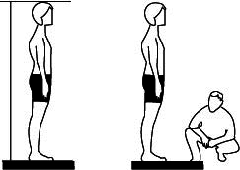
Figure 8.7: Body measures such as height and weight

The following are some of the measurements taken during Anthropometric assessments:

- Height: which is defined as the measurement of the distance from the bottom to the top of a person while upright. This measurement is usually taken vertically; (Figure 8.7) The equipment that we use to measure a persons height are a heightometer or a vertical measuring board.
- Length: this is the measurement of the distance of a person from the legs to the head while lying down. It is used in paediatrics assessment. This measurement is taken using a measuring board, or when absent a long measuring tape.
- Weight: this is the quantity of a person measured in kilograms (Kgs) or pounds (lbs). The weight of the body comprises of body muscles, fat, bones and water. I am sure you have measured your weight at some point or other. What equipment did you use? I believe you used a mechanical, electronic bathroom or chair weighing scale.
- Head, waist, arm and leg circumference: To measure circumferences you needed specific circumference tapes. However if you don’t have them, you can improvise and use flexible measuring tapes calibrated in centimetres (cms).

- Body composition measurements:
Body composition is the amount of lean body mass and body fat that makes up the total body weight. The lean body mass (LBM) includes the bones, muscles, water, connective and organ tissues. Body fat includes both essential and non-essential fat stores. Essential fat includes organs and tissues such as nerves, lungs, liver, brain, and mammary glands. The non-essential fat is primarily within the adipose tissue.

The common body composition measurements are skinfold thickness, mid upper arm circumference (MUAC), waist hip ratio and body cell mass. Figure 8.8 shows how these measurements are taken.

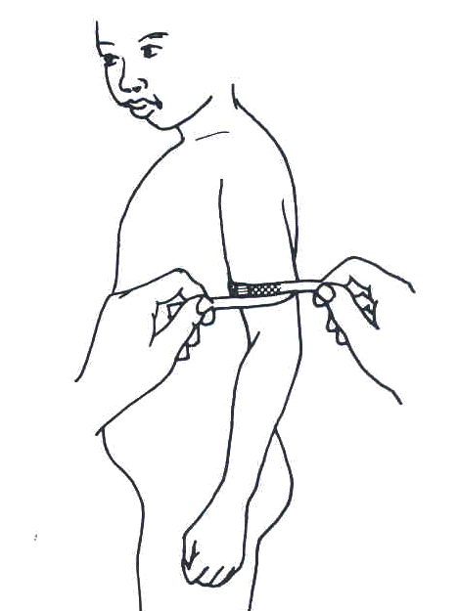  Mid upper arm circumference | 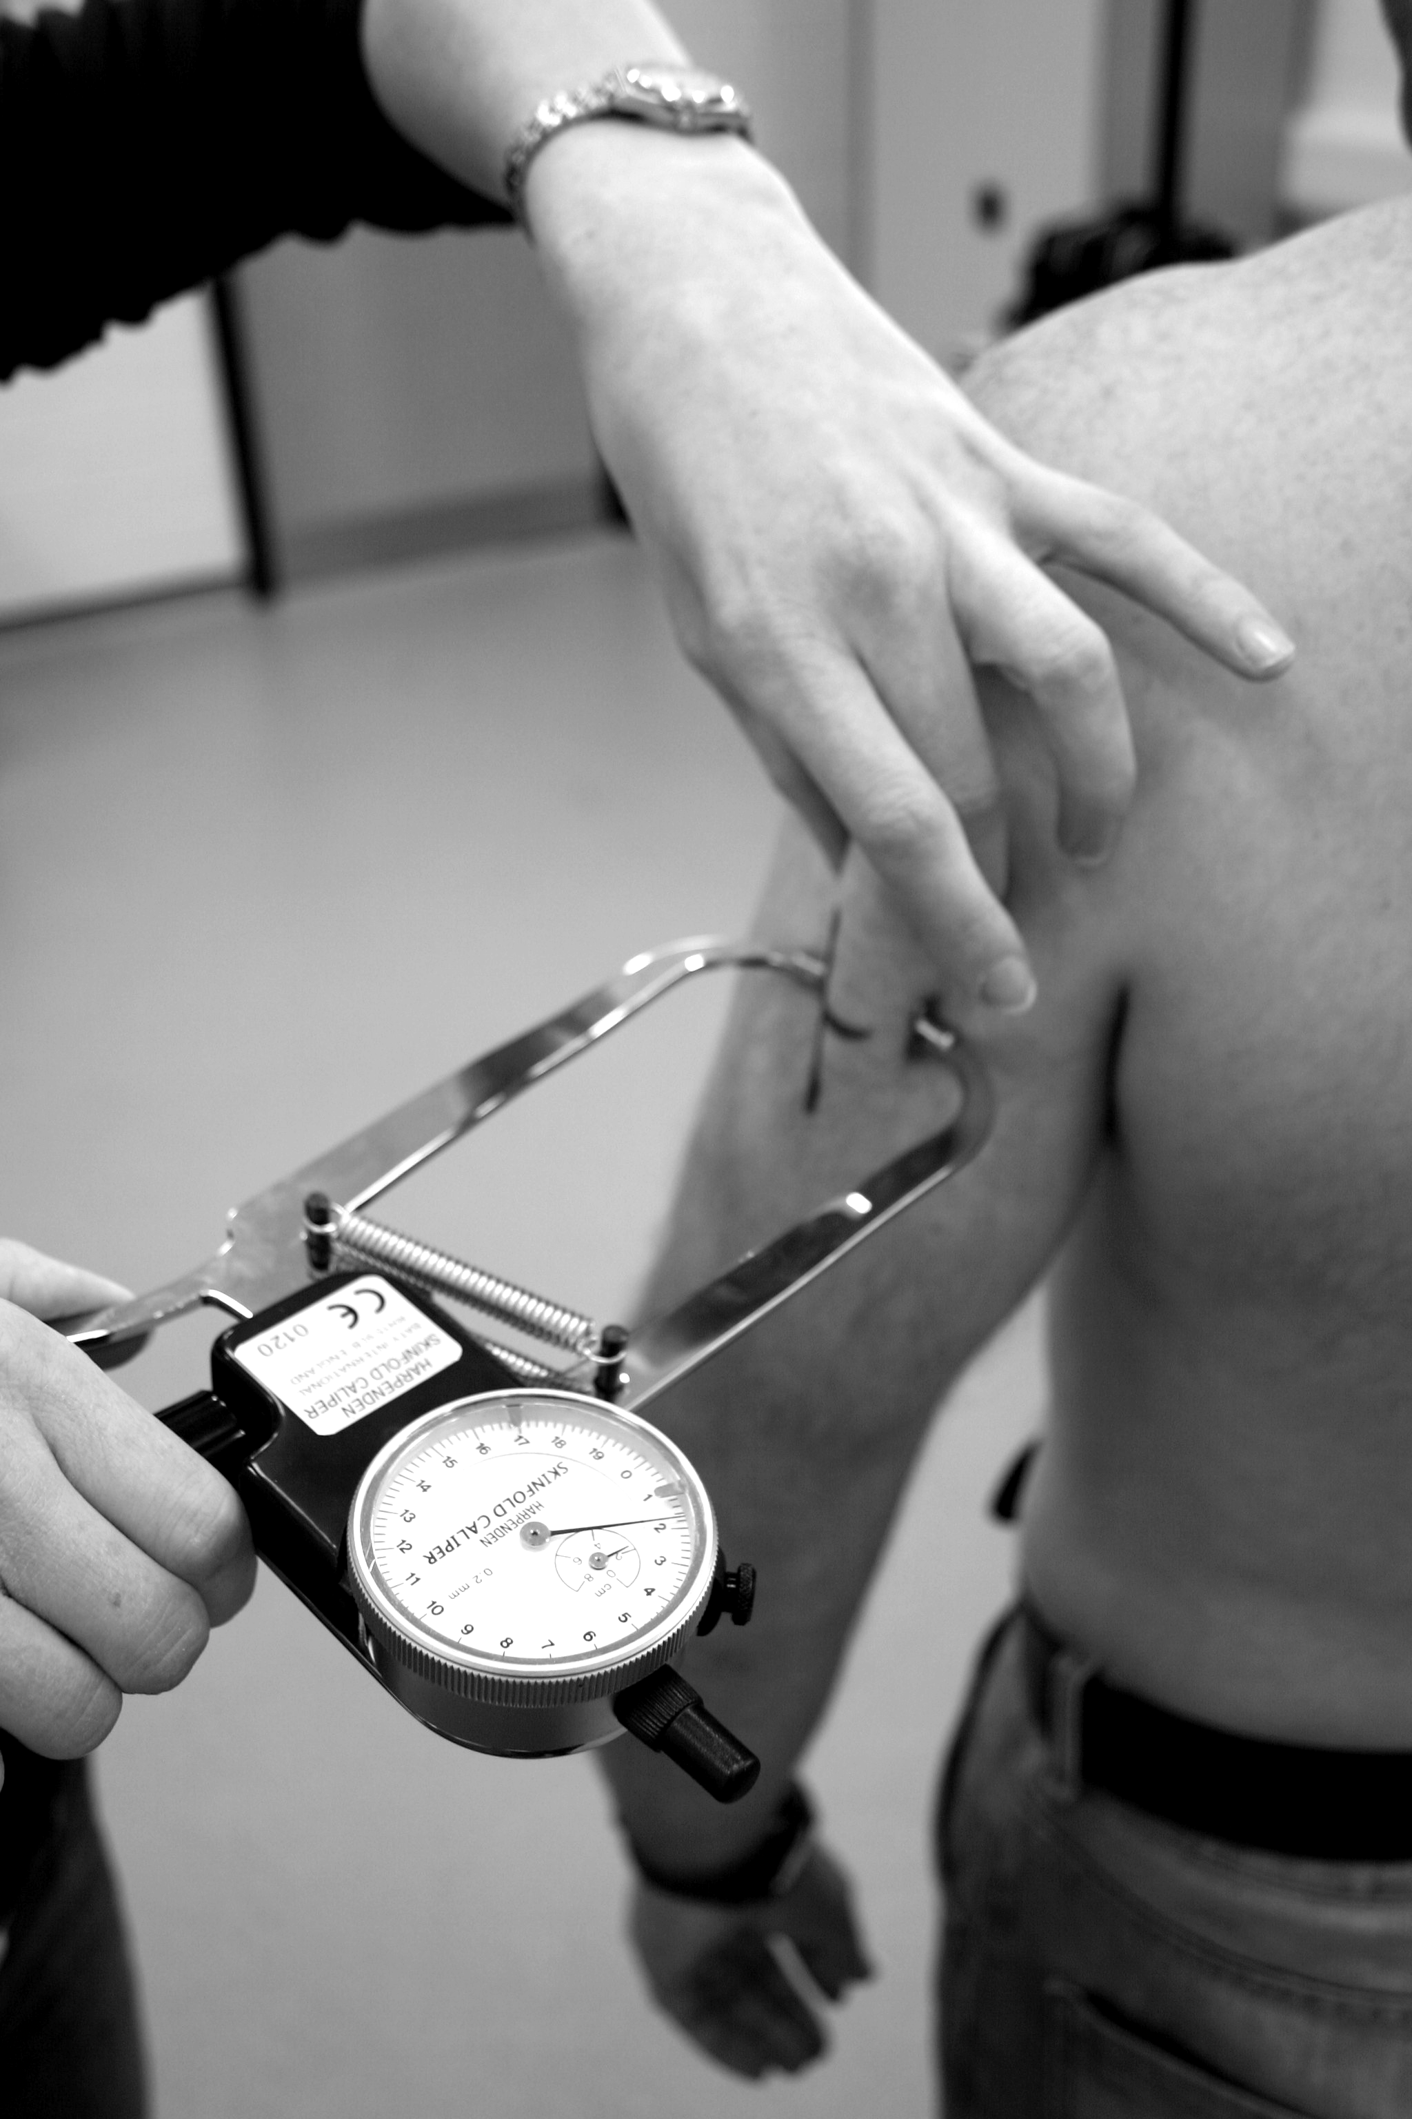  Skinfold thickness

Figure 8.8: Measuring MUAC and skinfold

To measure MUAC and Waist & Hip, one will need special MUAC tapes and Waist, Hip tapes, but one can also improvise and use measuring tapes. Skinfold thickness needs to be measured using skinfold caliper. These calipers can be made of steel or plastic.

Body cell mass is measured as Bioelectric impedance analysis (BIA), using a small portable machine which uses some current powered by a battery. The amount of current is minimal and not harmful.

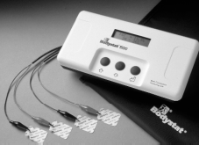
Figure 8.9: Bio-Impedance Analysis (BIA) machine

The physical principle behind the Bio-Impedance Analysis (BIA) technique is that the body's lean (muscle, bone, water) compartment, which comprises of approximately 60 -75% electrolytic water, conducts electricity far better than the body's fat compartment which is very low in body water content (between 5-10%). These two compartments have different impedance (or resistance) values to a high-frequency current signal. Water is a good conductor as compared to fat.

Body fat percentage is dependent on a person’s age, gender, weight, and height, and the tool is used on a patient while in a supine position after voiding urine. The machine has 4 electrodes; 2 electrodes are attached to the right foot and 2 to the right hand at proximal point’s 3 to 4 cms apart. Once the patients details (age, gender, weight and height) are keyed in, the readings are then taken. The higher the fat content the higher the resistance to the current.

Paediatric Anthropometric Assessment
Paediatric assessments are different from adults because children are growing in both weight and height. Children nutrition assessment is very critical in monitoring their growth. Unlike adults, children have three very crucial measurements in relation to their weight.

These are:
- Weight for height [WH] measurement which is used to assess if a child is underweight;
- Weight for age [WA] which is used to assess stunting;
- Height for Age [HA] which is used to assess wasting. The growth in weight and height is cross referenced with set standards.

HIV infected children can have a manifestation of more than one of the above conditions hence the need for adequate and timely growth monitoring to allow timely interventions where needed.

Biochemical Assessment
This assessment evaluates what nutrients are in a person’s blood and whether the nutrients are within the normal range or not. The commonly affected nutrients include,

- Iron: measured as haemoglobin, which provides a total measure of the red blood cells. Depletion of iron is associated with nutritional anaemia. Iron status is usually affected by infections such as malaria and intestinal infections.
- Serum albumin which is the body’s protector of blood volume and fluid electrolyte balance, any depletion of albumin is associated with visceral protein impairment; this test can be used as a basic screen for malnutrition. This nutrient is also affected by infection, where it will be lowered
- Pre albumin: it also provides sensitive measure of visceral body protein

Other biochemical tests include: total fat, cholesterol, blood sugar and vitamins such as vitamin A, C, B complex group.

Clinical Assessment
Clinical assessment is usually used to evaluate a person’s health history and current medical condition information. It can be gathered from interviews to the patient or the caretaker, information obtained from the medical charts or records, referrals from health care providers, in some cases from forms filled out by the applicant. There is also the need to make clinical observations of the person which include pulse rate, respiration, blood pressure, and temperature. Important information is to identify any other existing conditions in the patient and medication history. This assessment is useful to correlate with biochemical assessments.

Dietary assessment
Dietary assessment helps you to identify the patient usual diet using a simple dietary history where the patient will be able to tell what they eat, drink, their dislikes, likes, and taboos towards certain foods. Dietary history includes a person’s food history such as cultural background, economic status, psychosocial and personal problems including alcohol and smoking issue. This information is then used to compare with guidelines for healthy diet. It is important to note that it is not easy to obtain accurate information about basic food patterns. Dietary information can be obtained through.

Diet history
This includes general information of the patient’s basic eating patterns and habits. It provides a basis for nutritional counselling, education and planning for care. When taking diet history you will be able to identify patient’s food intolerances, allergies, religious and traditional taboos.

Food frequency questionnaire (FFQ)
- This is an important tool to help determine food intake over an extended period of time.
- This tool usually has two lists, one list of different types of food and a scale to show the frequency each particular food is consumed over a given period of time.
- The list of foods can be inclusive of all foods or specific selection focusing on particular food sources of nutrients related to a specific disease.

24 hour recall
- This is a tool that simply puts a patient to recall all the foods they were able to eat in the last 24 hrs.
- Depending on the situation it may include food portion sizes eaten at each meal although some patients may have difficulties to recall the quantities.
- It will reflect the number of meals a patient was able to eat the previous day, and will give a guide on adequacy.
- This tool does not include method of preparation and is purely dependent on patients or caretakers ability to recall. It is usually easier to allow patient recall what they ate from awakening to bed time, and avoiding leading with time. For example ask the patient to list the foods they ate from the time they woke up to the time they slept. Do not ask leading questions such as ‘what did you have for breakfast, lunch’ etc they are likely to mention a food even if they did not eat it at that time

Food records
Food patterns are best assessed through food records, especially when its combined with the dietary history. A 3 day food record is useful and the record should include portion sizes and methods of food preparation. Use of brand names of certain products can also help you to gather the nutritional information

Meal plan
When all the necessary information about a patient has been gathered, it is then used to prepare a meal plan for the patient.

Meal plans are individualized and depend on the stage of the illness, age sex and physical activity, nutrition assessment and history of the individual.

Lets us now prepare a meal plan for the patient with the following characteristics

Name: JA
Sex: female
Age: 25yrs
Diagnosis: HIV positive with tuberculosis
Weight: 45kgs
Height:
BMI:
Ideal weight: 60 t0 68Kgs
Energy requirements for weight gain 40kcals/ ideal weight = 2400-2700kcals
Protein requirements: 1gm/kg body weight = 60-68gms

The details of the meal plan prepared for this patient are given in the following table.
Sample meal plan
Time | Food
Early morning -7am | 1 Cup of porridge  2 teaspoons Sugar
9am | Fresh milk  2 slices Bread/2 pieces sweet potatoes  1 tablespoon Peanut butter
10 am | 1 cup fresh Fruit or 1 whole fruit
Lunch – 1pm | ½ cup beans  1 ½ cups rice/ ugali/matoke, ugali  1-2 cups vegetables
Mid afternoon- 4pm | I cup fermented milk  Available snack
Dinner | 2 pieces chicken  1c ½ cup ugali, potatoes/matoke  1 to 2 cups vegetables
Bedtime | 1 cup milk

You now know how to carry out a nutritional assessment. Next let us look at the different nutrition intervention strategies at your disposal.

Nutrition Intervention strategies

Nutrition intervention strategies are methods used to address nutritional deficiencies and needs of PLWHAs. They include, nutrition education and counselling, how to increase different nutrients in question such as macronutrients or micronutrients

Nutrition education and counselling
All nutrition interventions will require some nutrition education and counselling to the patients and the care takers. It’s important that the patient understands the concepts of nutrition and why it’s a very important intervention in their conditions. In order to meet all the micronutrient, micronutrient, dietary Fibre fluid balance as well as dealing with nutritional problems, the patient will need nutrition education and counselling.

The purpose of counselling is to guide and help the participants to explore their options and make decisions in the light of sound knowledge and personal support. This will involve close attention to personal family needs, nutrition and health problems and food choices and costs.

Nutritional counselling is a means by which an individual client/ family learns food choices and habits designed to maintain health or to treat, control or prevent illness.

Steps in nutrition counselling
To help you remember these steps we use the acronymn GATHER, which stands for:

- GREET the client and create a rapport
- ASK about their well being and their nutritional status, food intake and any nutritional problems such as vomiting, loss of appetite If the patient has been assessed share their nutritional status and interpret the measurements.
- TELL the patient about alternative choices that are available to address their nutritional problems.
- HELP the patient make informed choices. Its better done with a care taker present
- EXPLAIN to the patient the food choices being given, and barriers to these choices and ensure the patient explains the actions they will take to ensure they meet the nutritional needs.
- REASSURE and give RETURN date on the visit for follow up to be able to see if the intervention is helping the patient or not

Strategies to increase macronutrient requirements
The use of use of local staple foods is the most important way in meeting macronutrient needs. This however, does not mean that one can not have other sources of energy foods. For extra energy, patient should be advised to have at least two to three snacks between meals.

Fats and oils are useful in providing extra energy when they are used for cooking. This is because they contain concentrated energy, however they should be used moderately, if they (fats and oils) are used in excess they may cause fat malabsorption which can lead to diarrhoea.

Enriching foods: This is a strategy that helps meet energy and protein needs (macronutrients) of a patient by simply blending high energy food sources with staples. For example, adding milk and egg into porridge will increase protein intake. While adding sugar and oil or fat will increase energy content of the porridge. Blending foods is the easiest way to increase nutrient intake at household level. Other foods that can be used to improve nutritional value for patients include; peanut butter or bean paste.

Strategies to increase micronutrient requirements
Diet: A well balanced diet is the best way to meet micronutrient deficiencies. High intake of fruits and vegetables will help meet these nutrients. Animal products are also good sources of micronutrients.

Food processing: strategies such as fermentation, germination and sprouting of legumes and cereals increases nutrient bio-availability and improves digestibility.

Food fortification: this is a strategy aimed at improving micronutrient levels of most staple foods. In populations with perceived micronutrient deficiencies, those selected micronutrients will be added to the staple foods. Commonly fortified foods include maize floor and cereals which can be fortified with iron and vitamin B vitamins. Vitamin D and A are fat soluble vitamins and therefore fortified in fats and oils.

Micronutrient supplementation
Although supplements play an important role in helping people meet their micronutrient deficiencies, they should never be used to replace diet. Indeed, if one takes supplements beyond the recommended levels it can lead to toxicity. Supplementation should be restricted to one Recommended Daily Allowance (RDA), unless there is need for therapeutic intervention. This means that the patient should be frequently monitored to ensure that they are responding and the dosage adjusted accordingly.

Strategies to meet water/ fluid and Fibre needs
Fibre is found in vegetables, fruits, and cereals. It is a component of food that is not fully digested. Fibre enhances bowel movement. To meet Fibre needs, you should encourage patients to take plenty of high Fibre, fruits and vegetables. All their meals should have different types of vegetables for diversity. If the patient finds fruits expensive, you should advice them to consume the fruits in season as they tend to be cheaper.

Indigenous vegetables are the best source of micronutrients and they tend to be very high in Fibre content.

In Section 1 of this unit, we learned that there are two types of Fibre, soluble and insoluble fibre. Soluble Fibre found in fruits helps to bind water in the gut and is recommended during diarrhoea as it helps to minimize it. While insoluble Fibre found in whole grains cereals and legumes should be avoided in the presence of diarrhoea as they make the condition worse.

Table 8.3: How to Cope with Common Eating Problems
Nutritional problem | Remedy
Anorexia (Loss of Appetite) | - Stimulate appetite by eating favorite foods  - Eat small frequent meals  - Select foods that are more energy dense  - Avoid strong smelling foods  - Add flavor to foods to make it taste good  - serve the food in an appetizing manner  - Avoid gas forming foods
Nausea and Vomiting | - Patient Sits up when eating  - Drink plenty of fluids after meals and in between  - Eat dry and slightly salty foods to relieve nausea  - Use orange/lemon rind or ginger to relieve nausea  - Avoid spicy and fatty foods,  - Avoid caffeine and alcohol  - Avoid food odours  - Do not mix many type of foods
Thrush (Sores in the mouth/throat) | - Eat soft, mashed, smooth, or moist foods  - Avoid spicy, salty, acidic, or sticky foods  - Eat cold or room temperature foods  - Avoid sugary foods  - Avoid alcohol and other carbonated drinks  - Use a straw for drinking fluids  - Rinse mouth with bicarbonate of soda solution instead of brushing teeth  - Chew some garlic(with caution if on certain medication)
Weight loss | - Increase food intake by increasing quantity and frequency of consumption  - Improve quality and quantity of foods by providing a variety of foods  - Increase intake of protein and starch in the diet  - Slowly introduce fat in the diet  - Use fortified/enriched foods
Constipation | - Eat high fibre foods  - Drink plenty of fluids  - Avoid processed or refined foods
Heartburn/Bloatedness | - Eat small frequent meals  - Avoid gas forming foods  - Drink fluids
Fat malabsorption | - Elimination of any type of fats and oils in cooking or any food prepared with oil  - Avoid fatty meats  - Eat plenty of fruits and vegetables  - Eat low fat foods (boiled foods )
Fatigue/lethargy | - Drinking of high energy, high protein liquids  - Use of precooked foods to save time on preparation  - Eat plenty of snacks between meals  - Eat fresh fruits that do not require preparation
Diarrhoea | - Drinking plenty of fluids. (nutritious)  - Eat low Fibre foods  - Seek treatment of to identify cause of diarrhoea

Nutrition Follow-up

Before a patient is released by the care giver, arrangements must be made and an appointment date set for follow up of the patient to see the progress and review after intervention. All patients need a review with more nutrition education and support to help them cope with the demands of the HIV.

This follow require approximately 30 to 45 minutes per patient and involves the following:

- Periodic nutrition assessment, patient must be frequently assessed for changes in weight gain/loss, changes in biochemical parameters such as iron levels.
- Review of the nutrition intervention to identify whether it’s helpful to the patient and adjust where need be.
- Re educate the patient on what had been taught during the previous visits for example what the patient should do when they have nausea or diarrhoea to make sure that they do not miss on any important aspects that will help them deal with their nutritional problems.
- During follow up the health care provider is able to monitor and evaluate the progress of the patient in order to intervene on time if need be, and at the same time it gives an overview to show if nutrition support being offered in general is useful or not, and if not identify the problem and subsequent solution.
- Where possible during follow ups patients can be given information on support groups within their localities that will be beneficial to them.
- During follow up sessions the nutrition plan which may include meal plan is also reviewed to identify how the patient is coping, and if not what needs modification or alteration.
- In desperate situations and where systems are in place, follow ups could include home visits as well, especially in patients who are unable to reach the health facilities.

Summary
You have come to the end if section 3. In this section we looked at the three main components of nutritional care and support, namely:

- Nutritional assessment in adults and children;
- Nutritional intervention/therapy;
- Follow-up.

We hope you are now able to assess the nutritional status of PLWHA, plan an intervention or nutritional therapy and follow them up to ensure that they are progressing well.

In the next section we shall discuss infant feeding choices for the HIV-infected mother. But before then, let’s see how well you understood the work of this section. Answer the following questions on a separate sheet of paper.

 Self Test

- Define anthropometric, biochemical and nutrition assessment?
- What is body composition?
- What is a 24 hr recall?

When you finish, compare your answers with the information given in the relevant section.

Section 4: Infant Feeding Choices for the HIV-infected Mother

Introduction

Congratulations! You are now in the last section of this Unit on Nutrition and HIV. In the last section we discussed the components of nutritional care and support. In this section we shall discuss the role of breast feeding and how to help HIV infected mothers to make informed choices on infant feeding options. We shall also discuss nutritional considerations for young children with HIV/AIDS. Let’s start by looking at our objectives for this section.

Section Objectives

By the end of this section you should be able to:

- Explain the role of breast feeding;
- Discuss the role of complementary feeding;
- Compare the nutritional values of breast milk against cow milk;
- Explain the role of breast feeding in mother to child transmission of HIV;
- List the important nutrition considerations in HIV infected children.

Let’s start by finding out how much we remember about mother to child transmission of HIV.
ACTIVITY

What is the role of breastfeeding?
_____________________________________________________________________
_____________________________________________________________________
_____________________________________________________________________
_____________________________________________________________________

What infant feeding options exist for HIV-infected mothers?
_____________________________________________________________________
_____________________________________________________________________
_____________________________________________________________________
_____________________________________________________________________

Now confirm your answers as you read the following discussion.

The Role of Breastfeeding

It is well-known that breastfeeding is very good for children. It protects them against many diseases and greatly increases their chances of survival. However, breast milk can transmit HIV. Deciding on how to feed an infant can be very difficult for women because of HIV. This choice depends on whether a woman knows her HIV status and whether or not she can safely feed her baby in another way. Approaches to infant feeding form an important part of measures to prevent mother to child transmission (PMTCT) of HIV. However, there are other important ways to prevent mother to child transmission, including preventing HIV infection in women, preventing unintended pregnancies and providing long-term support to women.
Breast milk provides all the energy and nutrients a child needs for the first six months of life. Children only need other foods from the age of 6 months. There is some evidence that exclusive breastfeeding for the first six months reduces the risk of transmission of HIV from an HIV positive mother. UNICEF recommends that women who are known to be HIV negative and those who do not know their HIV status should exclusively breastfeed the baby for six months and continue for at least 24 months alongside other foods.

Feeding practices determine whether or not a child is well-nourished. A child should be provided with food that they can easily digest. Good hygiene is very important when preparing food for children. Particular care is needed to ensure that a child continues to receive nutrients when they are ill. Children need a range of nutrients including those which provide energy and a range of micronutrients. Important micronutrients include vitamin A, iron and vitamin C.

ACTIVITY

How does breastmilk compare to cow milk?
_____________________________________________________________________
_____________________________________________________________________
_____________________________________________________________________
_____________________________________________________________________
_____________________________________________________________________
_____________________________________________________________________

Now check if your comparison resembles the one captured in Table 8.4 below.

Table 8.4: breast milk compared with cow milk composition
Human breast milk | Cows milk
Has specific anti-infective properties for infants | Lacks specific anti-infective properties for infants
Has specific growth factors for infants | Lacks specific growth factors for infants
Fat
Has enough essential fatty acids | Lacks lipase an essential fatty acid
Proteins
Easy to digest more whey protein | Has more casein difficult to digest
Minerals
Adequate amount | Has too much
Vitamins
Has enough levels of required vitamins | Lacks enough A, B, and C
Iron
The present iron is easily absorbed and is adequate | Has inadequate amount which is also not easily absorbed

Role of Breastfeeding in MTCT of HIV

Breastfeeding poses a number of risk factors for MTCT of HIV. These are:

- Maternal disease status; a mother who is HIV positive and who chooses the breast feeding option, increases the chances of transmission of HIV to the infant. This is because during illness the HIV viral load increases;
- Duration of breast-feeding; the longer a HIV positive mother breastfeeds her infant the higher the chance of transmitting HIV to the infant;
- Oral disease in the infant; if the infant has oral disease then it creates an entry point for the virus from the breastmilk to the infant during breastfeeding;
- Breast disease; if the mothers has any form of breast disease, then her viral load in the breastmilk is high, therefore increasing the chances of MTCT;
- Mixed feeding; during mixed feeding the infants gut is exposed to different temperatures. The other feeds are likely to cause injury to the infants oesophagus creating an opening or entry point of the virus from the mothers milk to the infant.

What is mixed feeding?

Mixed feeding takes place when a mother introduces other food items such as porridge and cows milk into the baby's diet, while they continue to breastfeed. By so doing, there is risk of:
- Replacing breast milk with less nutritious food;
- Causing irritation to the intestinal mucosa;
- Increasing risks of diarrhoea
- Increasing the likelihood of sub clinical mastitis

COUNSEL ALL MOTHERS ON:
- Information on benefits of breastfeeding  - Prevention and management of breastfeeding problems*  - Appropriate complimentary feeding | - Good maternal nutrition and self care  - Child spacing  - Prompt treatment of infections | - Reduction of HIV infections  - Information on counseling and HIV testing  - Reinforcing risk reduction to couples

COUNSELLING AND TESTING

MOTHER NOT TESTED
- Promote and support breastfeeding
- Encourage and avail information on HIV counseling and testing
- Reinforce risk reduction**
- Offer counseling and testing on repeat visits
HIV INFECTED MOTHERS
- Information on feeding options
- Cost of options
- Information and skill on how to reduce or avoid MTCT
- Allow the mother and partner to make an informed choice
- Provide appropriate antiretrovirals to prevent MTCT
- Encourage couple or partner HIV counseling and testing
HIV UNINFECTED MOTHERS
- Reinforce risk free breastfeeding
- Encourage couple or partners Counseling and Testing (CT)
- Promote breastfeeding

HIV INFECTED MOTHERS WHO CHOOSE TO BREASTFEED
- Support and encourage exclusive breastfeeding
- Prevention and management of breastfeeding problems
- Discourage breastfeeding if cracked nipples, mastitis or abscess
- Provide relevant viral drugs
HIV INFECTED MOTHERS WHO CHOOSE NOT TO BREASTFEED
- Demonstrate safe preparation and storage of chosen milk
- Demonstrate cup and spoon feeding
- Counsel on the care of the breast to avoid engorgement
- Provide reliable family planning method by 4 weeks

* Breastfeeding problems: Abscess, mastitis, breast and nipple disease
** For women who have features of clinical AIDS, manage as positive and encourage counseling and testing

Figure 8.10: Guidelines on Counselling HIV mothers(Adopted from Kenya national guidelines on nutrition in HIV/AIDS)
This chart will help guide mothers in selecting most suitable feeding the situation.

Not AFASS
All HIV+ preg. Women/new mothers to be educated on the risk of MTCT by different means, and use of feeding options exclusive replacement or EBF to reduce risk
AFASS
Support to ensure wet nurse remains HIV negative
Demonstrate express, heat treat, and cup feed breastmilk
Demonstrate use of home prepared milk (modified animal milk)
Demonstrate preparation of commercial infant formula
Wet nursing by HIV negative woman
Treated breastmilk
Exclusive breast feeding
Counsel on exclusive breast milk options
Counsel on exclusive replacement feeding by cup
Provide multivitamins
Figure 8.11: Infant feeding options

What is AFASS?

Will Replacement Feeding be ACCEPTABLE?
- No perceived barrier to choosing the option, for fear of stigma and discrimination and social and cultural reasons The mother has adequate support to cope
- Will a mother who doesn’t breastfeed be accepted in the community?

Will Replacement Feeding be FEASIBLE?
- Adequate time, knowledge, skills, and other resources to prepare and feed the infant
- Will the mother be able to prepare fresh home formula

Will Replacement Feeding be AFFORDABLE?
- Does the mother have enough financial support for purchase/production, preparation, and use of the feeding option, including all ingredients, equipments, fuel, and clean water, without compromising nutrition of the other members of her family.

Will Replacement Feeding be SUSTAINABLE?
- Will the mother be able to sustain these feeds day and night without being tempted to breast feed due to shortage of replacement feed

Will Replacement Feeding be SAFE?
- Does the mother have access to clean water, clean utensils and proper storage facility to ensure the feeds are prepared and stored under hygienic conditions all the time

Safe Infant Breastfeeding Options

A HIV positive mother has several safe infant feeding options at her disposal. However, none of the following options are easy for the mother to practice without support, especially is she is HIV infected. They include:
- Exclusive breastfeeding;
- Wet Nursing;
- Heat-treated Expressed Breast milk;
- Replacement Feeding (home modified and commercial formula);
- Commercial formula;
- Home Modified Formulas;
- Diluting Animal Milk (Cow, Goat Camel).

Exclusive Breastfeeding
This means that a mother gives her infant breast milk only. The baby is not given water-except mineral drops or syrups consisting of vitamins, mineral suitable supplements or medicines when indicated.

WHO recommendations on infant feeding (2001)

“When replacement feeding is acceptable, feasible, affordable, sustainable, and safe, avoidance of all breastfeeding by HIV-infected mothers is recommended.
Otherwise, exclusive breastfeeding is recommended during the first six months of life.
To minimize HIV transmission risk, breastfeeding should be discontinued as soon as feasible, taking into account local circumstances, the individual woman’s situation and the risks of replacement feeding ( including infections other than HIV and malnutrition.)”

Advantages of Breast Feeding
- Breastmilk is easily digestible
- Always available
- Protects infants from infections
- Improves growth and development
- Creates emotional attachment and bonding
- Reduces risks of breast cancer and increases birth spacing

Disadvantages of Breastfeeding
- Risks of MTCT;
- Transmission increased with infection in the mother;
- Pressure from family to give other foods and water;
- Some mothers do not believe they have enough milk, and in turn result in mixed feeding which increases the chances of HIV transmission;
- Requires feeding on demand and there is poor support for this

Strategies To Support Breastfeeding For HIV Infected Mothers

Mothers who choose to breast feed need to be fully supported. Mothers need to be taught the right breast feeding techniques including proper breast attachment. The risk of cracked nipples may be reduced by improving positioning and attachment (i.e., latching onto the areola rather than nipple) as shown in Figure 8.12. . Mothers also need to know the likely infections and the effects if they are not well treated.

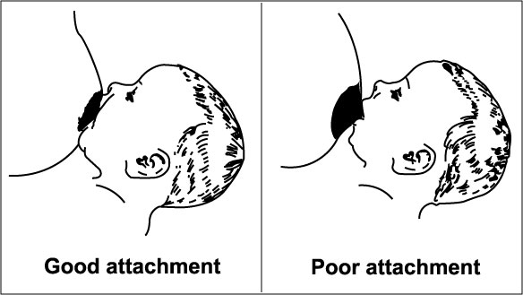
Figure 8.12 Breast attachment (Source: WHO/FCH/CAH/00.5)

Wet Nursing
This is when the infant breastfeeds from a woman other than the biological mother.

Advantages
- No risk of HIV transmission as long as wet nurse is HIV negative
- Baby gets all the benefits of breastfeeding

Disadvantages
- A wet nurse must be available to breastfeed or express milk for the infant;
- Creates Social stigma as to why real mother is not breastfeeding her infant ;
- Wet nurse is at risk of HIV infection from the infant if it is positive;
- Bonding is likely to take place between the infant and wet nurse instead of the biological mother;
- Wet nurse must be ready to be tested for HIV and remain HIV negative throughout the period she will be breastfeeding.

Heat-treated Expressed Breast milk
This is when the mother expresses the milk and boils or heat treats it to kill the virus. This is done in two ways:
- The milk is boiled for 1-2 seconds and then cooled precipitously. There is less destruction of nutrients.
- The milk is pasteurized, that is heated at 56C for 30 minutes. (Holder’s Pasteurization)

Advantages
- HIV virus is killed;
- Breast milk is cheap and always available;
- Baby benefits from all the nutrients in the breast milk.

Disadvantages
- Needs time and must be done frequently and under hygienic conditions;
- After heating the milk it must be used up in an hour because it must be stored in a cool place. This might cause wastage;
- Baby will have to drink from cup which can take time to get used;
- Social pressure asking why mother is expressing milk;
- It may not be as effective in protecting baby from other disease due to the heating effects.

Replacement Feeding (home modified and commercial formula)
This is feeding infants who are not receiving breastmilk with a diet that provides most of the nutrients infants need. There are two options
- Commercial formula or
- home modified formula

Commercial formula
Advantages
- Commercial formulas have no risk of HIV transmission;
- They have been made specifically for the infants;
- They contain most of the nutrients a baby requires;
- Other family member can help in feeding the baby because mother does not necessary have to be present.
Disadvantages
- Commercial formulas are expensive;
- They do not contain antibodies to protect baby from infections;
- They need safe drinking water and clean utensils for preparation otherwise baby is exposed to diarrhoea;
- There is need for a continuous supply otherwise mother might over dilute the formula thus exposing the infant to malnutrition;
- The feed must be made just before feeding and this can be expensive on fuel;
- Infant needs to be fed from cup and he or she may take a while to get used.

Home Modified Formulas
Where commercial formulas are not available, then home modified formulas are appropriate. The type of milk will depend on customs and availability. One can either use fresh animal milk, evaporated milk or dried milk.
Advantages
- Presents no risk of HIV transmission;
- Can be interchanged with commercial formula;
- Easy for other family members to assist in feeding the baby;
- It’s less expensive than commercial formulas.

Disadvantage
- Social stigma, as to why mother is not breast feeding and family and neighbours may question her HIV status;
- Lacks antibodies to protect baby from infections;
- Does not contain all nutrients the baby needs and therefore will require supplementation;
- The modification of animal milk needs dilution, so hygiene (safe drinking water and clean utensils and storage facilities) is essential;
- Animal milks are more difficult for infants to digest;
- It is also expensive, as family must have access to adequate milk, fuel, sugar and multivitamins for supplementation.

Diluting Animal Milk (Cow, Goat, Camel)
For the first 6 months the milk must be diluted and fortified with sugar and multivitamins
2 parts milk +1 part water and sugar to taste. It must also be boiled

Recommendations for nutrition care and support for the HIV positive child

- Provide growth monitoring and promotion
- HIV-infected children are at high risk for growth failure
- Body weight and height should be monitored regularly (at least monthly)
- Arm circumference and triceps skin fold should be monitored periodically if possible

- Improve nutritional status
- Improve diets and provide adequate overall nutrition
- HIV infected children should be given multivitamins where available, prophylactic vitamin A supplements and immunized according to local immunization policies
- Manage dietary problems such as diarrhoea, anorexia, vomiting

- Promptly treat secondary infections
Secondary infections such as tuberculosis, oral thrush, persistent diarrhoea, and pneumonia should be promptly treated. The nutritional impact of these infections should be minimized by maintaining food and fluid intake to the degree possible.

- Provide treatment for severe malnutrition
Many HIV infected children are likely to become severely malnourished. Local guidelines for the management of severe malnutrition should be followed. Enteral and parenteral nutrition should be considered, when available, if the child is unable to eat.

- Improve diet to meet needs for growth and development
The child’s diet should be reviewed at every well-child and sick child health visit. Conditions affecting appetite and food intake should be discussed and treated as appropriate. Advice on how to improve the diet, taking into consideration the child’s age, local resources and the family circumstances, should be given.

- Promote good hygiene, and food and water safety, to avoid pathogenic contamination e.g. diarrhoea
Follow the same safe and hygienic practices as those provided for adults

- Provide antiretroviral medications where available and affordable
In a US based study, use of Protease Inhibitors in HIV infected children not only decreased viral load but also had a positive effect on growth parameters including weight, weight for height and muscle mass (Miller et al., 2001).

- Solid foods should be introduced gradually to match the age and developmental characteristics of the child;
- Care givers should feed children a variety of locally available fruits and vegetables and animal products if available to increase intake of essential vitamins and minerals;
- Feeding should be done patiently and persistently with supervision and love, especially for the HIV infected child who may be frequently ill and suffering from fever, mouth sores and decreased appetite;
- Provide a daily multivitamin supplement, if available, to help prevent nutrient deficiencies.

Summary

In this section we have learned the importance of breastfeeding, the role of breastmilk in mother to child transmission of HIV, how to guide a HIV infected mother to make informed choices on appropriate feeding options and recommendations for nutrition care and support for the HIV positive child. Now take a piece of paper and answer the following questions without consulting the text in this studyguide.

 Self Test
- What is the role of breast milk?
- What is exclusive breast feeding ?
- What is AFASS ?
- What is mixed feeding?
- Give one feeding option that can be used by a HIV infected mother to avoid HIV transmission to the baby?
Once you finish answering all the questions, go back to the section and check if your answers are correct. If you had problems answering any question, go back to the relevant section and review it again.

Well, that brings us to the end of this Unit on HIV and Nutrition. We hope that you are now able to provide nutritional advice and counselling to a HIV-positive mother and especially on the feeding options available to her infant. In the next Unit we shall discuss prevention of HIV. You can now take a well deserved break before you embark on the attached assignment.

Good luck!
References

- Academy for Education Development (2004). HIV/AIDS: A Guide for nutrition Care and Support 2nd Edition. Food and Nutrition Technical Assistance Project, Washington DC

- MOH.(2005). Kenya national guidelines on nutrition and HIV/AIDs.

- WHO/UNAIDS/UNICEF guidelines for the infant feeding for HIV-infected mothers

- Williams, S. (1993). Nutrition and Diet Therapy. 7th edition Mosby year book Inc: 3-16

