DIRECTORATE OF LEARNING SYSTEMS

DISTANCE EDUCATION PROGRAMME

Unit 3
Travel Medicine In Relation to Communicable Diseases

Allan and Nesta
Ferguson Trust
COMMUNICABLE DISEASES COURSE

Unit 3: Travel Medicine

A distance learning course of the Directorate of Learning Systems (AMREF)

© 2007 African Medical Research Foundation (AMREF)

This course is distributed under the Creative Common Attribution-Share Alike 3.0 license. Any part of this unit including the illustrations may be copied, reproduced or adapted to meet the needs of local health workers, for teaching purposes, provided proper citation is accorded AMREF. If you alter, transform, or build upon this work, you may distribute the resulting work only under the same, similar or a compatible license. AMREF would be grateful to learn how you are using this course and welcomes constructive comments and suggestions. Please address any correspondence to:

The African Medical and Research Foundation (AMREF)
Directorate of Learning Systems
P O Box 27691 – 00506, Nairobi, Kenya
Tel: +254 (20) 6993000
Fax: +254 (20) 609518
Email: amreftraining@amrefhq.org
Website: www.amref.org

Writer: Dr C. N. Chunge
Chief Editor: Anna P. Mwangi
Cover design: Bruce Kynes
Technical Co-ordinator: Joan Mutero

The African Medical Research Foundation (AMREF wishes to acknowledge the contributions of the Commonwealth of Learning (COL) and the Allan and Nesta Ferguson Trust whose financial assistance made the development of this course possible.

Contents
INTRODUCTION 1
Specific Objectives 1
Section 1: TRAVEL INDUSTRY AND TRAVEL MEDICINE 1
The Travel Industry 2
Risks Related to Certain Destinations 3
The Role of the Different Categories of Health Care Providers 3
Travel Medicine 4
The Aim of Travel Medicine 4
Specific Health Risks and Methods of Spread 5
Tools to Prevent Communicable Diseases 7

Section 2: VACCINE PREVENTABLE DISEASES IN TRAVEL MEDICINE 7

Vaccines 7
Administration of the Vaccines 10
Contraindications to Vaccinations 11
Vaccine Storage 12
Some Wrong Beliefs about Vaccinations 12
Vaccines and Side-effects 13
Dangers of Avoiding Vaccination 13
The Benefits of Vaccinations 14
TABLE OF ADULT VACCINES 174

SECTION 3: CHEMOPROPHYLAXIS …………………………………………………………….16

MALARIA ……………………………………………………………………………………………..17
SIDE EFFECTS………………………………………………………………………………………...17
Failure of Chemoprophylaxis 19
Recommendations on Malaria Prophylaxis 20
The First Aid Kit for Travellers 20
Section 4: INTERNATIONAL TRAVEL HEALTH REGULATIONS (WHO 2005-2007) 21
Steps to be taken by WHO and its Member States before the IHR (2005) enter into force in June 2007 22
The Aim of the International Health Regulations 22
Pre-Travel Consultations 23
Travel Vaccines 23
The International Certificate of Vaccination 25
Section 5: Examples of Specific Important Diseases in Relation to Travel Medicine 27
Yellow Fever 28
Meningitis 28
Hepatitis 29
Typhoid 29
Tutor Marked Assignment 33

INTRODUCTION

Welcome to Unit 3 of your course on communicable diseases. In Units 1 and 2 you covered the basic concepts and principles applicable to the prevention and control of communicable diseases infections. In Unit 3 we shall focus on communicable diseases in relation to travel. Travel Medicine is a very wide topic encompassing all branches of health care, viewed from the perspective of travel. However, here we will try to restrict ourselves to those aspects of travel medicine that relate to communicable diseases only.

In this unit we will learn about prevention of diseases among travellers and what to do when prevention fails.

Specific Objectives

.By the end of this Unit you should be able to:
- Explain the relationship between travel industry and travel medicine
- Discuss vaccines as tools in the prevention of diseases in travel medicine
- Discuss chemoprophylaxis as a tool in the prevention of certain diseases
- List the items in the first aid kit for travellers
- Explain the International Travel Health Regulations as defined by WHO
- Discuss the characteristics of some predominant travel medicine related diseases.

Section 1: Travel Industry And Travel Medicine

In this section we are going to focus on the travel industry and note some health issues related to travel. We shall also define travel medicine and explain some terms related to the area of travel medicine.

The Travel Industry

The travel Industry has been increasing in its magnitude and importance, especially as international travel increases and communication techniques improve. The world is becoming a global village largely due to interaction related to economic interests. It is estimated that there are over 100 million tourist type visitors annually from Europe, America and Asia who come to the third world countries as shown on the map below. This number is likely to increase rapidly in the next few years.

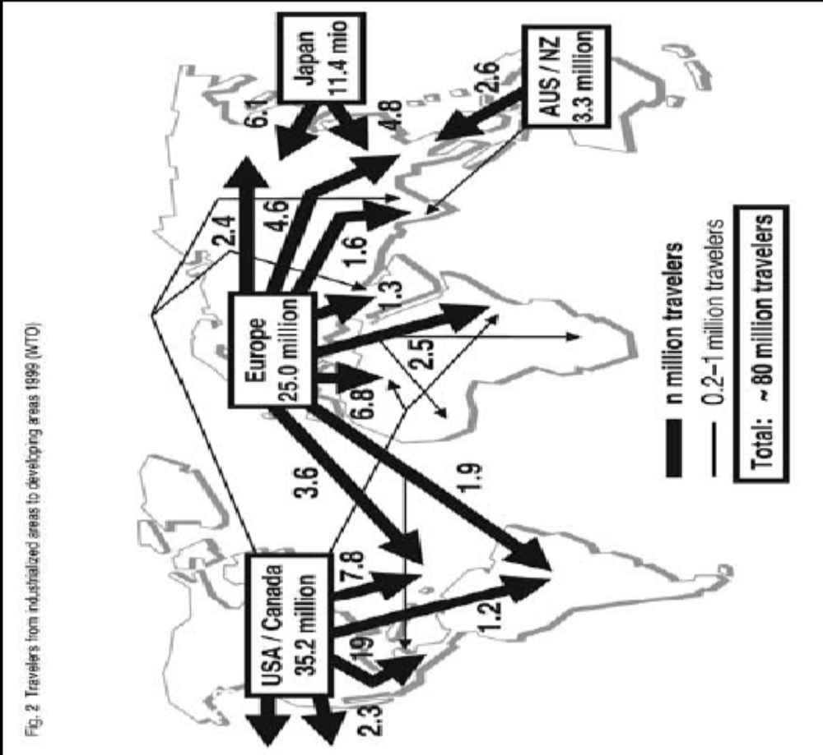

Figure 1: Major travel traffic routes and volume
From: Manual of Travel Medicine and Health, 2nd ed. Steffen R., DuPont H.L. and Wilder-Smith A. BC Decker Inc Hamilton. London 2003

Risks Related to Certain Destinations

Although some infections, such as viral infections, may be present at most destinations and therefore, present similar risks to travellers anywhere in the world, there are also certain unique situations for certain destinations. For example, yellow fever is prevalent in Africa, malaria - at the East African Coast, Schistosomiasis - in the fresh water rivers in Africa while Hepatitis A is most common in Asian cities. Therefore, special considerations need to be given to those travelling to such regions in order to enable them take or initiate preventive measures.

The travel industry has a major role to play in the broadcasting of information on health risks when travelling. However, the onus on health issues such as travel medicine should still be on the health care providers.

The Role of the Different Categories of Health Care Providers

All health care professionals should be trained and equipped to offer guidance and interventions in all situations as part of the travel medicine experience. This may involve short courses or in-service training that will not take them away from routine work for too long. It is basically a change of orientation in the professional line of thinking and approach to clients. All health institutions can also be re-oriented to provide Travel Health care and offer leadership in this area even by becoming centres of training.

Doctors do not always advise patients and clients on vaccination. That is why this process has to be made multi-sectorial so that all health providers can participate. The following is a list of doctors that are most likely to advise clients on the need for vaccination.
- travel medicine specialists & paediatricians
- public health specialists
- gynaecologists
- physicians
- general practitioners
- dermatologists
- surgeons

As can be seen, the travel medicine specialists and paediatricians are at the top of the list, while surgeons are the least likely to recommend vaccination.
These differences arise largely from deficient training. But other less important considerations are possible such as availability of time and financial limitations.

Travel Medicine
Do you know what is meant by the term travel medicine? Try to give your own definition on a piece of paper, and then compare what you have written with the definitions given below.

Travel Medicine is an emerging new interdisciplinary field in health care whose goal is to protect travellers from ill health and death by encouraging and motivating principles of prevention and treatment at personal and group levels.

Although all traditional disciplines of medical practice are included among the concerns of Travel Medicine, a large chunk of the topics are derived from Medical Microbiology, especially Tropical Medicine and Infectious Disease. This is obviously because infectious diseases are the most likely health risks facing most travellers as they spread very easily and rapidly.

The Aim of Travel Medicine

Travel medicine aims at the prevention, detection, diagnosis and Treatment of travel related diseases in order to avoid ill health and death among travellers.
In this unit, you will learn mostly about the prevention of travel related infections by using vaccines as all the other aspects of the diseases will be covered in subsequent units.

Which branches of medicine are included in travel medicine?

All the traditional disciplines of medicine can be viewed from the perspective of Travel Health and preventive measures put in place. However, tropical and infectious diseases are the most relevant to travel medicine because besides their high prevalence, incidence, rapidly occurring mortality and even morbidity, they are also easily spread. Obviously, these characteristics would adversely interfere with travel arrangements. Many people can easily and quickly die from such diseases.

Who is a traveller?

The traditional belief that a traveller is a tourist needs to be discarded so that we can look at travellers more objectively. We should take a traveller to be “Anyone who eats food or drink away from home.” We can see from this definition that many different groups of people are included in this categorisation such as: tourists, executives, students, food industry workers, hotel workers, military and other migratory groups and health workers.

Specific Health Risks and Methods of Spread

It is quite easy to contract any of the communicable diseases because there are so many different routes of infection. We need to know these routes so as to protect ourselves and our clients. We shall now summarize the methods of spread of diseases and the risks they cause as follows:
- Airborne transmission:
  - influenza, meningococcal meningitis, tuberculosis, measles, mumps, diphtheria, Ebola, Varicella, Flu.
- Feaco-oral/Water transmission:
  - hepatitis A & E, poliomyelitis, typhoid, cholera, ETEC (traveller ’s diarrhoea),
- Vector borne:
  - yellow fever, malaria, Dengue fever, Japanese encephalitis
- Sexually Transmitted Diseases:
- HIV, Hepatitis B, C
- Trauma related :
- Tetanus, gas gangrene
- Biologic warfare risk :
- Anthrax

Figures 2 and 3 illustrate how airborne diseases are spread.
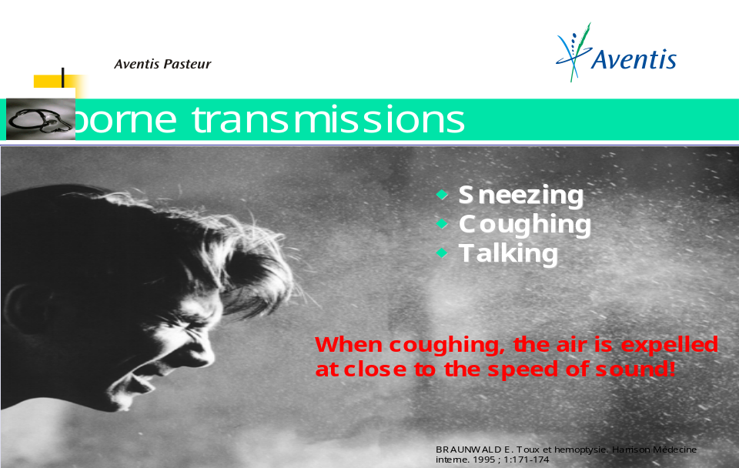

Figure 2: Sneezing, coughing and talking are the commonest ways of air-borne transmission

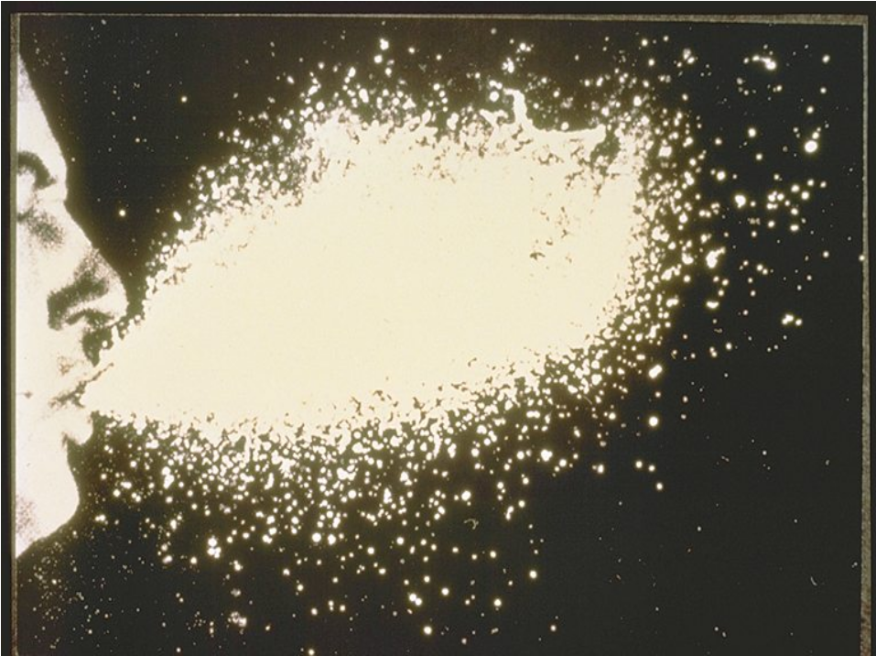

Figure 3: After sneezing droplets disperse in all directions
From: Informational leaflets by Sanofi Pasteur, 2004.

Tools to Prevent Communicable Diseases

Vaccination and Chemoprophylaxis have been a major tool in preventing illness from communicable diseases but additional tools should also be used. These include hygiene measures, personal protective measures and the carrying of a Traveller’s First Aid Kit.

Section 2: Vaccine Preventable Diseases In Travel Medicine

Let us now turn our attention to diseases in travel medicine that can be prevented through vaccination. We are also going to discuss which population groups are most at risk and should, therefore, be offered vaccines for preventive purposes.

Vaccines

Do you know what is meant by the term vaccine? Try to give your own definition on a piece of paper, and then compare what you have written with the definitions given below.

A vaccine is a substance derived directly or indirectly from the enemy (the disease causing agent) which mimics the enemy behaviour in the host. The host then produces Antibodies to fight back rapidly or to standby in readiness to defend against any future attacks by that enemy. Travel Medicine depends a great deal on vaccinations to prevent disease.

 | List all vaccine preventable diseases in travel medicine that you know and then compare your list to the one given below.

The following is a list of the vaccine preventable diseases in travel medicine:
- Yellow Fever
- Meningitis
- Diphtheria-Tetanus (dT)
- Typhoid
- Hepatitis A
- Hepatitis B
- Rabies
- Polio
- Influenza
- Pneumococcal infections
- Japanese encephalitis
- Tuberculosis
- Travellers diarrhoea and Cholera

Take Note
- Yellow Fever vaccination is mandatory, especially for international travel.

- Meningitis vaccination is sometimes mandatory, especially during Hajj.

- Typhoid vaccination is mandatory, especially in populations and individuals at high risk.



New Vaccines
Recently a new vaccine has been developed for the Human Papilloma Virus which is responsible for cancer of the cervix. It is manufactured by Merc Sharp and Dorme (MSD).

Take Note

There are no vaccines for the following diseases:
- Malaria
- HIV
- Rift Valley Fever
- Bird Flu = Avian influenza
- Gonorrhoea
- Syphilis
- Anthrax (Osama bin Laden)



Vaccines Recommended for Health Workers
Health workers are usually exposed to higher risks than the general population and should, therefore, receive all the relevant vaccinations for the following:
- Hepatitis B
- Influenza vaccine (annually for the Flu)
- Measles-Mumps-Rubella (MMR) vaccine
- Varicella (chickenpox) vaccine
- Typhoid
- Meningitis
- Cholera

Vaccines Recommended for Students
It is well known that vaccinating students protects them against school absenteeism, serious illness, and sometimes, even death. These vaccines are either recommended or mandatory depending on the school or college requirements
- dT-Polio (diphtheriaTetanusPolio)
- Pneumococcal
- Influenza
- Meningitis
- Hepatitis A
- Hepatitis B
- Measles, mumps, Rubella (MMR) - Susceptible/without antibodies
- Varicella (chicken pox)
- Typhoid
- ETEC traveller’s diarrhoea & Cholera.

Vulnerable Groups
It is important for you to note that travellers have different degrees of individual weaknesses that expose them to higher risks than normal of getting serious infections. For example:
- Infants, because their immune systems cannot easily fight off disease
- Children, because they are young and may be non-immune with regard to a particular disease, for example, Yellow Fever or Typhoid
- Immuno-depressed and the immuno-compromised individuals such as those with HIV or on renal transplants.
- Pregnant women usually carry a higher risk of failing to fight off diseases
- Malnourished individuals
- Old people, especially those with tired immune systems.
- Special professional groups (medical, military, students, nurseries, orphanages, prisoners)

Populations at Risk
The populations at risk include, for example, migratory workers, tourists/holiday makers, healthcare workers, students at all levels, NGO-workers, workers in relief agencies, military, hotel workers and workers in the food handling industry. Many times these individuals have to consume food or drinks whose preparation may not meet proper hygiene standards.

Administration of the Vaccines

This can be achieved by mouth (oral) or by injections.

Take Note
Vaccination is the act of administering a vaccine into an individual, also referred to as the recipient.

Immunisation is the process by which protective immunity against a disease is created or improved in an individual or a community by the use of vaccines.



In order to maintain sterility, sterile needles and syringes must be used each time of withdrawal, especially when using vaccines with multiple doses.

Concomitant Administration of Vaccines
All travel-related vaccines can be administered in one single session, except in cases where multiple doses are needed. This does not interfere at all with the efficacy of any vaccine. In fact, paediatric vaccines are now combined up to 5 different vaccines in one vial. You should inject each vaccine at least 2cm away from the previous one. The deltoid muscle is the most preferred. The total number of vaccines ever injected at the same time is 14.

Contraindications to Vaccinations

1. Acute illness. Individuals with acute illness should not present themselves for vaccinations although those with mild illnesses such as the common cold with low-grade fever can receive their doses.

2. Lower age limit. Infants may be unable to produce antibodies to some vaccines. They may, however, be protected by maternal antibodies. Children below 2 years do not produce antibodies against polysaccharide vaccines like Meningitis and Typhoid vaccines. However, in epidemic situations, such vaccinations can be administered to children above 6 months of age.

3. Hypersensitivity to vaccine components. Individuals who may have experienced hypersensitivity during previous vaccine administration need to be watched carefully as they receive vaccinations.

Allergy to egg proteins found in Yellow Fever, Influenza, measles-mumps-rubella [MMR], measles, and mumps vaccines is no contraindication for immunization. The vaccination must go ahead but in a setting where adverse reactions can be dealt with appropriately, using antihistamines or adrenaline and steroids.

4. Pregnancy. The risk of using live vaccines during pregnancy is largely theoretical. It is generally approved to give such vaccines after 6 months of pregnancy.

5. Lactation. Similarly, the danger of using live vaccines in lactating women is largely theoretical.

6. Altered immunocompetence. Contraindications are valid for Congenital immunodeficiency, HIV/AIDS, leukaemia, those on large doses of steroids or with altered immunocompetence. Live attenuated vaccines like Yellow Fever should only be given to those with CD4 counts above 200. The reason is that in such individuals live vaccines may lead to some form of disease.

Vaccine Storage

Do you know how to store vaccines? Try to give your own answer on a piece of paper, and then compare what you have written with the discussion given below.

You must keep vaccines in a functioning refrigerator with a thermometer to ensure that the temperature is well controlled between 0-4 degrees Centigrade. Any other temperatures will denature vaccines and render them ineffective. You must understand that people vaccinated with ineffective vaccines are not protected. Steady power supply is, therefore, vital for a Vaccination Centre.

Take Note
You should never leave vaccines lying on the table.



Some Wrong Beliefs about Vaccinations

There are some false beliefs about vaccination which need to be dispelled. You must understand and inform people that:
- Breastfeeding does not prevent vaccine-preventable diseases.
- Vaccines do not destroy the immune system. Instead, they enable it to produce the antibodies needed to fight very specific diseases.
- Vaccines do not interfere with the beneficial immunity gained from breastfeeding, good nutrition or fitness, but they augment it.
- Vaccines do not contain family planning pills and they are used world wide.
- Vaccines are not drugs and they have no long term side effects.

Vaccines and Side-effects

List all side-effects of different vaccine that you know of, and then compare your list to the discussion below.

Vaccines may have some side-effects. For example, the Yellow Fever vaccine may exhibit some side-effects in very old people. It is recommended that this vaccine should not be administered to individuals over 65 year’s age due to the increased risk of both viscerotropic and neurotropic disease complications in this age group.
Most of side-effects are quite mild, such as pain or soreness where the shot is given. Serious side effects, such as an allergic reaction known as “Anaphylaxis" occur very rarely (about 1:500,000 doses). An anaphylactic reaction includes hives, difficulty in breathing, and low blood pressure. The reaction can be treated and reversed.

Dangers of Avoiding Vaccination

What are the dangers of avoiding vaccination?

Choosing to avoid vaccines is simply a choice to take a different risk – usually much worse. Unvaccinated individuals are at a higher risk for many diseases such as meningitis, pneumonia, Yellow Fever, deafness caused by mumps, liver cancer caused by the hepatitis B virus, heart failure, kidney failure, peritonitis and of course death. There is nothing worse than dying from a disease you could have prevented. Besides, such travellers may also come back with a disease that will infect their family members.

Travellers with pre-existing conditions such as heart diseases, lung diseases, liver diseases, kidney disease, mental illness, arthritis, HIV and diabetes are at special risk of worsening their situation.

Therefore, advise your clients that when one compares the risk of vaccination to the risk of getting the diseases, taking the vaccine would be the safer choice.

The Benefits of Vaccinations

Vaccination costs less than treatment of the actual disease. For example, a typhoid vaccine like the Typhim Vi costs about Ksh 500-1000 every 3 years, whereas treatment of the disease can cost anywhere in the range of at least Ksh 12,000 which may happen even twice a year. Many work hours are lost on sick leave, especially when patients have to be hospitalized or have to lie down, thus interrupting their travel related activities. A trip overseas can be very expensive if bills incurred in sickness are not avoided. As for students, many school-hours are lost due to absenteeism resulting in poor performance at examinations.

You must also remember that the cost of death is impossible to calculate accurately.
The role of vaccines in lowering mortality is excellent and way above the contribution by antibiotics and second only to the provision of safe drinking water.

Table of Ault Vaccines

We are now going to summarise most adult vaccines in one table. We will use the names derived from Pasteur Institute because this is the original inventor of vaccines and it is still believed to hold the gold standard for vaccinations in the world. You should not attempt to memorise this table but it can be used mainly as a reference.

Table 1: A summary of adult vaccines
Vaccine name | Type | Presentation | Dose/  route of admin | Schedule and duration
Avaxim  (Hepatitis A vaccine) | Inactivated vaccine | Pre-filled syringe  Avaxim 80 U Paediatric-for 1-15 years  Avaxim(160 U) Over 15 years | 0.5 ml  i.m/sc | 2 doses 6 months Apart  No Booster
Imovax dT  (Adult vaccine for Diptheria and tetanus) | Toxoid | I dose syringe | i.m or s/c
Euvax B  (Hepatitis B vaccine) | Recombinant DNA technology | Liquid vaccine in a vial | I.M  0.5 (PED) from birth to 15 years  1 ml (ADULT) from 16 years | 3 Doses at 0, 1 , 6 months  Booster depend on risk
DUKORAL  (Cholera and ETEC diarrhoea) | Vibrio cholera inactivated  And Recombinant B subunit of toxin | Oral suspension + effervescent granules (buffer)  To be mixed with buffer-sodium bicarbonate | Oral | Cholera :  Children: 3 doses at least 1 week  apart. Booster at 6 months  Adult: 2 doses at least 1 week  apart Booster 2 years  ETEC: 2 doses both children  & Adults at least 1 week apart.  NB Children >6 yrs
MENINGOCOCCAL A+C  (Meningococcal meningitis bivalent vaccine) | Capsular Polysaccharide | Syringe (1 dose)or vial (10 and 50 dose)  +diluent | i.m or s/c | Every 3 years
Menomune  (Meningococcal A,C, Y ,W135)  Tetravalent vaccine | Polysaccharide vaccine | 1 dose vial | S/C only | Every 3 years
TYPHIM VI  Typhoid vaccine | Capsular Polysaccharide | Liquid vaccine  1 dose syringe  20 dose vial | i.m or s/c | Every 3 years
STAMARIL  Yellow fever vaccine | Live attenuated | Powder +diluent  Single dose syringe  Ten dose vials | i.m or s/c | 10 years
VERORAB  Rabies vaccine | Inactivated | Powder + diluent for reconstitution in vial | i.m
VAXIGRIP  Influenza(Flu) | Split, inactivated | Pre-filled syringe  0.5 ml-From 3 yrs of age  0.25 ml from 6-36 months | i.m or sc | Children below 8 yrs 2 doses  1 month apart if first time, then  1 dose annually.  Adults - Annually
PNEUMO 23  Streptococcal Pneumonia invasive serotypes | Capsular polysaccharide | 1 dose syringe | i.m or sc | Every 5 years

We are now going to turn our attention to the second tool that could be used for the prevention of communicable diseases: chemoprophylaxis

Section 3: CHEMOPROPHYLAXIS

We can define chemoprophylaxis as the prevention of disease by taking or swallowing appropriate drugs to kill the agents before they can produce illness in the body. This practice is not recommended for many diseases. Malaria is the disease where chemoprophylaxis is most commonly used. Most travellers can however, be advised to carry with them some medicine for treatment just in case they become ill where there is no laboratory or a doctor.

Table 2 gives you a simplified list of possible medicines that could be employed for prevention of the diseases common amongst travellers.

Table 2: Diseases and relevant prophylactic medicines
Disease | Medication
Travellers diarrhoea  and cholera | Quinolones like Ciprofloxacin, Sulphur drugs such as Septrin, Doxycycline,
Anthrax | Quinolones to be taken only in very exceptional cases such as during terrorist threats, etc.
Trypanosomiasis | Injections of intramuscular Pentamidine 5mg/month
Filariasis | Diethylcarbamazine 100mg/week during the stay
Amoebiasis | Gabbroral or any Nitroimidazoles. This is not recommended because it is bad practice
Malaria | See below as this is the most important disease where chemoprophylaxis is most commonly used.

Malaria

There are only four drugs currently recommended. Any one of the following four drugs can be used:
- Mefloquine (Mephaquine/Larium)
- Malarone
- Doxycycline
- Sulphur-Pyrimethamine (S-P)

Side-Effects

Which ones of the prophylaxis drugs listed here for malaria have side-effects?

Mefloquine
The side-effects of Mefloquine include:
- Irritability (the person may become easily annoyed)
- Depression
- Melancholy (sadness)
- Nightmares
- Confusion, restlessness and a feeling of Deja vu
- Being argumentative or rowdy
- Husband battering
- Headaches and dizziness

The usual remedy for most of the above side effects is to drink enough liquids to improve re-hydration.

Doxycycline
The side-effects of Doxycycline include:
- Elimination of pimples which is actually desirable in most people.
- Photosensitivity
- Hyperacidity in the stomach
- Dysostosis in children
- Prevention of cholera and typhus

If you use a good brand of Doxycycline such as Zadorin or Vibramycin, the client will get better protection and less side-effects. You must advise people to take this medicine at least one hour before food.

Sulphur-Pyrimethamine (S-P)
The unwanted effects of S-P prophylaxis may include:
- Jaundice just before labour so its use must be halted
- Stevens-Johnson Syndrome (in less that 5% of those on it)
- Renal stones can form if dehydration occurs

Take Note
Malarone has basically no side effects. Very, very occasionally some hypersensitivity has been suspected but not confirmed yet.



Table 3 presents some drugs that are suitable for prophylaxis for adults, children and in pregnancy.
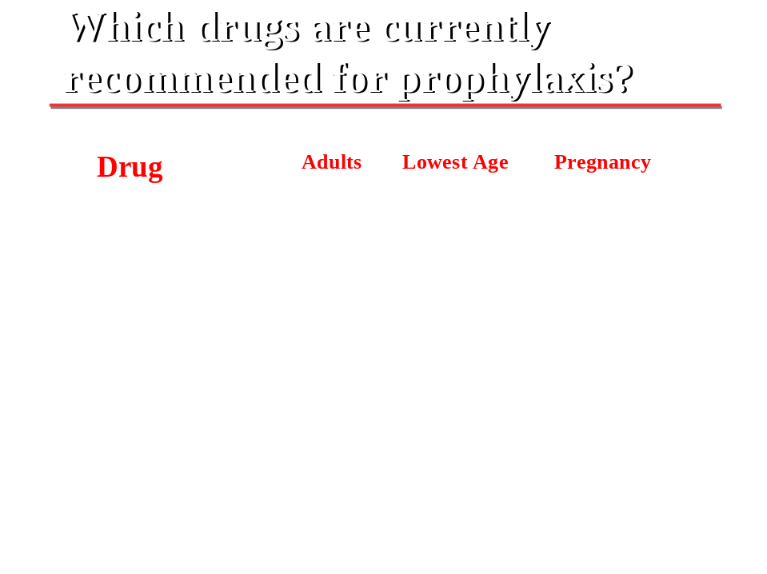

Table 3: Drugs currently recommended for malaria prophylaxis

Take Note
The only reason travellers are recommended to start medicine early before travel is to assess the possibility of side effects. Otherwise, you can advise them to take the medicines on the day of travel and stop as follows:

Mefloquine: 1 wkly & for 3-4 wks after returning
Malarone: 1 daily & for 1wk after returning
Doxycycline: 1daily & for 3-4 wks after returning
S-P: 2wkly & for 3-4 wks after returning
(ITP Schedules in pregnancy)



Failure of Chemoprophylaxis
Data on percentage failure rates for each drug are unavailable. Failure can be attributed to various factors as listed below. Study these and make sure you remember them. Causes for the failure of chemoprophylaxis could be due to:
- Development of resistance
- Non-compliance (non-adherence)
- Poor drug quality (safety and efficacy)
The consequences of this failure may lead to the client presenting with altered clinical symptoms which makes diagnosis difficult and in some cases may result into incorrect treatment.

Recommendations on Malaria Prophylaxis

If possible, avoid taking very small children and pregnant women to malaria prone areas. Even when on prophylaxis, always take with you some Artemisinine Based Combination Therapies (ACT’s).

Related to chemoprophylaxis is the first aid kit for travellers. We are now going to look at the items this kit should contain.

The First Aid Kit for Travellers

Travellers should be advised to always have a first aid kid, especially if they are travelling to more remote areas where medical facilities are not readily available or where certain communicable diseases are known to be prevalent. Table 4 summarizes what the traveller’s kit should contain and for what diseases.

Table 4: First aid kit for travellers
Disease | Medicine
Colds and coughs supplies | Antihistamines, cough suppressants, sore throat relief tablets, decongestant tablets, saline nasal spray, antiseptic gargles and lozenges
First aid supplies | Adhesive strips, adhesive tape, cotton balls, hydrocortisone cream, non-adherent pad, triple antibiotic ointment, bandages, sterile gloves, scissors, burn gel, tweezers, insect sting relief swabs, sun-screens. Laxatives, Antifungal, ear drops, soothing eye drops, oral re-hydration salts, condoms and a thermometer.
Anti-malarials | For prophylaxis Malarone, Larium, Doxycycline and Metakelfin  For treatment: ACTs such as Coarten, Arsucam, Duo-Cotecxin).
Fever and pain supplies | Paracetamols, Olfen/Ibuprofen tablets, acetaminophen tablets, thermometer strips.
Allergy drugs | Claritine, Prednisone tablets, Dexamethasone for Bee/Scorpion stings and Crotamiton Hydrocortisone creams for all insect bites.
Gastrointestinal treatments | Diarrhoea medication (Ciprofloxacin, Augmentin, Zinnat), oral re-hydration tablets, antimotion/nausea medication, antacid tablets, Anti-worm medicines (Zentel). Anti-protozoal drugs for Amoebiasis and Giardiasis (Gabbroral or Metronidazole), Laxatives
Travel accessories | Eyeglass repair kit, eyeglass cleaner towelettes, sun screen, sewing kit, disinfectant towelettes, insect repellent.
Dental kit (optional) | Alcohol preps, acetaminophen tablets, temporary tooth filling paste, cotton swabs, dental floss, finger cots, salt, disposable tooth brush.

Section 4: International Travel Health Regulations (Who 2005-2007)

Write down what you know about the International Health Regulations and then compare to the discussion below.

The International Health Regulations (IHR) are an international legal instrument which is legally binding on all World Health Organisation (WHO) member states who have not rejected them (or, subject to the procedure foreseen in the IHR, who have made reservations) and on all non-member States of WHO that have agreed to be bound by them.
The International Health Regulations (IHR1969) were first adopted in 1969. The purpose was to ensure maximum security against the international spread of diseases with a minimum interference with world traffic. The IHR (1969) only apply to three infectious diseases: cholera, plague and yellow fever.
Because of their narrow scope of application and other limitations, the IHR(1969) were revised by the WHO Member States in May 2005 when the World Health Assembly adopted The Revised International Health Regulations (IHR2005). The current IHR (1969) will be replaced by the IHR(2005) when the latter comes into force on 15 June 2007.
The purpose and scope of the IHR (2005) are to prevent, protect against, control and provide a public health response to the international spread of disease in ways that are commensurate with and restricted to public health risks, and which avoid unnecessary interference with international traffic and trade. The IHR (2005) also establish a single code of procedures and practices for routine public health measures at international airports and ports and some ground crossings.

Steps to be taken by WHO and its Member States before the IHR (2005) enter into force in June 2007
Prior to June 2007, member states are encouraged to take appropriate measures to guarantee the full and effective implementation of the Regulations. This will include developing, strengthening and maintaining the public health capacities required under Annex 1 of the IHR (2005), and mobilizing the resources necessary for that purpose; adopting the necessary legal and administrative provisions and preparing for the use of the decision instrument (Annex 2 of the Regulations) for the assessment and notification of events occurring within their territory that may constitute a public health emergency of international concern. WHO will, in turn, strengthen its own internal capacity to fulfil its obligations under the IHR (2005), including, supporting countries in the detection, assessment and response to public health risks and emergencies.

The Aim of the International Health Regulations

The International health regulations have been instituted with the aim to:
- Prevent ill health morbidity (acute/chronic/psychological), mortality, costs and lost man-hours
- Prevent unnecessary panic that would adversely affect travel, making it extremely inconvenient
- Avoid economic losses that would result from rapid spread of health hazards
- Ensure that disease outbreaks are controlled in an orderly and timely fashion.
To achieve these aims, travellers should be informed that they need certain preparations and precautions to be taken before, during and after they travel.

Pre-Travel Consultations

The following contact personnel must be sensitised and required to give advice to travellers about disease prevention:
- Travel agents
- Tour operators
- Airline booking officers
- Hotel industry staff
- Health providers

It is becoming increasingly fashionable for would be travellers to consult the Internet and get for themselves the information required. You must give information on the following topics to the travellers who come to you.
- Vaccinations
- Malaria prevention
- Insect bites and precautions
- Food/Water/Drinks (hygiene)
- Sexually Transmitted Diseases
- Jet-lag and special needs travellers
- Environmental and climate risks
- Safety, Security and insurance cover

If the travellers have been well informed and advised by any of those contact agents, then they should proceed to seek the required travel vaccination.

Travel Vaccines

Travel vaccines are divided into 3 categories:
- Mandatory (M): International Certificate of Vaccination is required
  - Yellow Fever vaccine
- Recommended (R) for all travellers to certain countries
  - Meningitis vaccine ACYW135 (Saudi Arabia) for Hajj travellers
  - dTPolio to North and South America
- Recommended (r) for travellers to certain areas
  - Influenza and Pneumococcal vaccines for at risk subjects: >65 yrs
  - Varicella for travellers to USA who do not have antibodies
  - Rabies in Latin America

The Vaccination Schedule
The following vaccination schedule should be observed.

Vaccine Age Doses Protection (Years)
Yellow fever >6m 1 10
Typhoid >2y 1 3
Hepatitis A >1y 2(1) 10(3-5)
Hepatitis B 3 10
Meningitis ACYW >2y 1 3-5
Rabies 12m 3 5
Tetanus 1 5

Vaccines and Pregnancy

Which vaccines can be used safely in pregnancy?

The following vaccines can be safely administered to pregnant women:
  - Live attenuated vaccines such as Yellow Fever can be used after the sixth month of pregnancy
  - A live vaccine like Oral Polio is safe because it enters the system like food.
  - Killed, inactivated vaccines or toxoids are quite safe
  - Polysaccharide vaccines such as Typhoid and Meningitis ACYW135 are generally safe due to their general mode of action, but adequate studies are still being carried out scientifically.

After the vaccine has been administered, the traveller then should be issued with a certificate of vaccination.

The International Certificate of Vaccination

The vaccination requirements for Yellow Fever, Meningitis, Cholera, and Smallpox have changed as follows:

Smallpox: A certificate is no longer required

Cholera A certificate is no longer required

Yellow Fever A certificate is required and it is mandatory

Yellow Fever International Vaccination Certificate
The yellow fever international vaccination certificate is the only certificate that should be required for international travel. Some countries have imposed requirements in excess of the International Health Regulations and are thus asking for certificates for Cholera (Congo DRC) or Meningitis (Saudi Arabia). Yellow Fever vaccination is strongly recommended to all travellers to the countries where the disease occurs in man or is assumed to be present in primates. The certificate should be similar in many respects such as:
- It must be received from a designated international vaccination Centre.
- It must be signed and stamped by a duly authorised person.
- The vaccine used must be of high quality approved by WHO.
- The vaccine must be administered 10 days prior to travelling in order to allow adequate immunity status to develop.
- It must be valid for 10 years and in the event of re-vaccination another period of 10 years commences afresh. There is no harm in re-vaccinating before the 10 year period is over in all doubtful cases.
- Any amendment or erasure on the certificate makes it invalid.

Note that not all Travel Vaccination Centres are authorised to issue the Yellow Fever International Vaccination Certificate. The list of the approved centres in each country can be obtained from the respective Ministries of Health.

Travel Vaccination Centres

List what you consider would constitute a good travel medicine or vaccination centre?

A good Travel Vaccination Centre will have most of the following features installed:
- Pleasant staff members who must be clean, polite and gentle
- Literature to read/TV/Computer games and magazines to read while waiting to be served
- Vaccines arranged in a refrigerator
- Literature giving details and instructions for the vaccines
- Vaccination Certificates
- Sterile needles, syringes, swabs
- Gloves and face masks
- Hand washing or sterilization basin facility
- Refreshments for clients and even soothing music if possible
- Examination couch, especially for men clients to lie down, they tend to collapse
- Flexibility in handling clients and reasoning out unclear situations
- Clear record books for Yellow Fever separately from the other vaccines
- A receipt book and pens
- Anti-allergy drugs such as prednisone, piritons and adrenaline.
- A telephone and Internet connections, if possible.

Networking and Where to get Vaccinations and information
Vaccinations can be administered in any health facility, such as hospitals, Health Centres, private medical clinics, airports in Africa or even pharmacies. But because of the need to network and keep abreast with the latest information and developments in this field, a decision was taken to set up and link up all Travel Vaccination Centres. This kind of networking helps to keep high standards and quality of care given to both the clients and the vaccine storage. Uniform certificates can then be issued in order to minimise confusion by any inspecting authorities at ports of entry. There is also need to source vaccines from central reputable organisations in order to ensure that good quality vaccines are used.

Take Note

Advise your clients that, for the sake of their own health, they should not find themselves in any of the following situations:
- Travelling on false certificates
- using fake books and stamps.
- Coming late for vaccination, then demanding a backdating. This must be discouraged because most vaccines require a bit of time before the protective antibodies are produced by the body.



On the other hand, if you are in-charge of an entry/exit point, please make sure the inspection of vaccination certificates is done professionally. Be aware of the “my booklet is lost syndrome” because it is usually a lie.

Section 5: Examples Of Specific Important Diseases In Relation To Travel Medicine

We are now going to discuss in some more detail some diseases that are of particular concern in travel medicine. You will learn more about these diseases, as well as some others in subsequent units of this course.

Yellow Fever

Endemic areas for yellow fever are the continents of Africa, Central and South America. Urban Yellow Fever occurs in South America. Sub clinical cases may occur in 15% of the population of those areas. Yellow fever kills over 60-80% of its symptomatic victims.

Why is the vaccine for yellow fever the only compulsory vaccine?

This is because yellow fever is a fulminating rapid disease that can kill victims within 7 days due to multiple organ failure with jaundice.

Since the vectors, the primates and humans exist in Asia, but the disease is still absent on that continent, there is general fear of spreading it into that region. Hence the serious demand for vaccination certificates for those travelling to Asia.

Transmission from man to man creates the epidemic with the main vector being the Aedes aegypti mosquito.

The vaccine is a live attenuated vaccine protecting recipients for 10 years.

Meningitis

Meningitis is normally an acute illness caused by airborne bacteria called Meningococci also called Neisseriae miningitidis which belongs to the genus Neisseriae. It is rapidly fatal and must be treated quickly. Epidemics normally occur in the Meningitis belt of North Africa, predominantly in Southern Sudan and the surrounding countries. It attacks mainly the young people below the age of 25 years but indeed, anyone can be killed by this disease.

The vaccine is a polysaccharide derived from the antigenic surface coat of the bacteria. It protects recipients for 3-5 years.

Children below the age of 2 years may not benefit from this vaccine as they have immature immune systems incapable of reacting to polysaccharide stimulation.

Hepatitis

Hepatitis A and E are transmitted by the faeco-oral route and are usually non-fatal, especially among those with intact immune system and also among those without a pre-existing liver problem.

Hepatitis B and C are transmitted predominantly by sexual contacts, blood transfusions and contaminated needles and syringes. They can lead to liver failure, cirrhosis and cancer in a proportion of patients. Sub-clinical cases can occur. There are many carriers in Africa. It is estimated that up to 30% of the Kenyan population are carriers and this could be one of the major reason why much donated blood is rejected.

Typhoid

It is better to call this disease Typhoid Fever or Salmonellosis as it is caused by Salmonella typhi. Typhoid fever is a severe infection caused by a bacteria, it is not just a diarrhoeal disease but a septicaemia and a general toxic infection.

It can manifest as an acute illness, a chronic illness or just remain in a carrier state such as occurs in food handlers. Figure 4 illustrates the clinical evolution of typhoid fever.

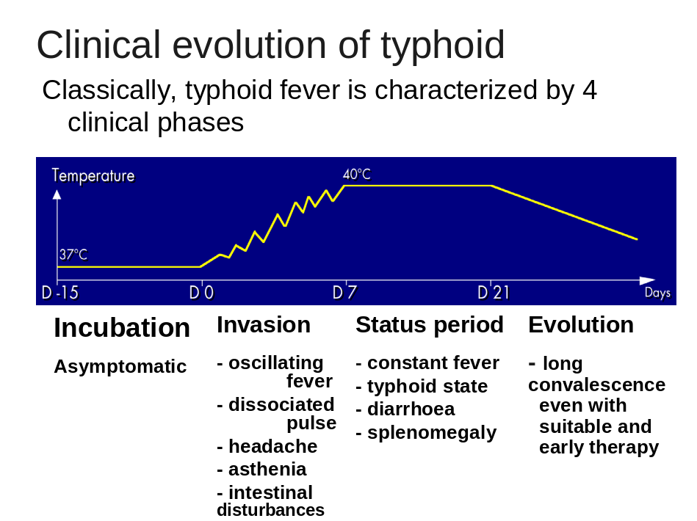

Figure 4: The 4 clinical phases of typhoid fever evolution

Children, young adults and all students are at the highest risk of this disease so they need vaccinations to help them concentrate on their studies. Other travellers at special risk include: tourists, businessmen, migrant workers, military personnel serving In endemic areas or subject to rapid deployment to endemic areas, and also professionals who become exposed in hospitals, laboratories, and the food industry.

Vaccination is useful, protecting up to 75-95% of the population in endemic areas.

Take Note

Advise travellers that typhoid vaccination is not 100% effective and it is not a substitute for the careful selection of food and drink.


You must give booster doses to your clients every 3years.

Summary

You have now come to the end of Unit 3 on travel medicine in relation to communicable diseases. You are now aware that the field of Travel Medicine is growing internationally and there is need to address disease issues that affect travellers.

You have learned that there are diseases that are particularly dangerous to the traveller and that effective vaccines are available to prevent them. Therefore, Vaccination Centres have a major role to play in the prevention of diseases. It is important that vaccines are stored safely in refrigerators.

Chemoprophylaxis is another tool in the prevention of communicable diseases and has a role to play, predominantly in Malaria.

The spread of communicable disease can easily become international, and that is why the World Health Organisation has instituted the International Health Regulations according to which the Yellow Fever Certificate is the only mandatory health certificate for all international travellers and has special requirements about its structure and issuance. Smallpox and Cholera certificates are no longer mandatory but might be required by some specific countries.

You also learnt that there may be some considerations to be made in vaccinating certain groups at risk such as children, immuno-suppressed and advances age people.

Furthermore, you noted that there are many modes of disease spread and that different parts of the world have some unique situations necessitating special requirements. For example, since Yellow Fever is absent in Asia, the authorities in those countries are very strict while inspecting arrivals for a valid yellow fever certificate.

Finally, you also learnt that a First Aid Travel Kit is useful a useful kit in the traveller’s luggage and pre-travel consultations with a health provider are advised.

Now go back to the beginning of this Unit and read the objectives. Have you achieved them? If you feel that you have, then you are ready to do your tutor marked assignment. However, if you are not quite confident, then you should read through the relevant sections once more! Good luck!

REFERENCES

Steffen R, DuPont HL and Wilder-Smith A., Manual of Travel Medicine and Health 2nd ed., BC Decker Inc Hamilton: London, 2003.
_________ International Travel and Health. Vaccination Reqirements and Health Advice. WHO: Geneva, 1997.
_________Schedule of Travel Vaccinations. Aventis Pasteur Inc. 2003.



DIRECTORATE OF LEARNING SYSTEMS
DISTANCE EDUCATION COURSES

Student Number: ________________________________  Name: _________________________________________  Address: _______________________________________  _______________________________________________ | 

COMMUNICABLE DISEASES COURSE
Tutor Marked Assignment

Unit 3: Travel Medicine In Relation to Communicable Diseases

Instructions: Answer all the questions in this assignment.

- The following statements are either true or false. For each statement, circle “T” if the statement is “True” or “F” if the statement is “False”.

- Travel Medicine is about treating people
who fall ill on a journey T F

- A communicable disease is one that can communicate T F

- The main aim Travel Medicine is prevention diagnosis
and treatment of diseases among travellers. T F

- Communicable diseases are all transmitted by the
airborne route T F

- A Vaccination Centre in Travel Medicine administers
all vaccines. T F

- There is no vaccine for malaria and Gonorrhoea T F

- Match correct answer in the right hand column to its correct statement on the left.
Yellow Fever Those below 2 years need not be vaccinated but food handlers should be vaccinated.
Typhoid Vaccination may cause viscerotropic disease among t the elderly.
Meningitis A high percentage of the general public are carriers.
Hepatitis B Brain complications occur rapidly during epidemics
HIV There is no vaccine for this disease

- Which vaccines are recommended for Health workers in a local setting? Please, circle the correct choices.
- Hepatitis B
- Influenza vaccine (annually for the Flu)
- Measles-Mumps-Rubella (MMR) vaccine
- Varicella (chickenpox) vaccine
- Typhoid
- Meningitis
- Cholera
- Yellow Fever
- Rabies

- In the spaces provided, indicate whether the statement is True or False.
- Yellow Fever vaccination should be administered at least 10 days prior to travelling -----------
- Concomitant administration of all travel vaccines is allowed on the same day ------------
- Acute illness is a contraindication to the giving of a vaccine --------------
- Those above the age of 65 years should be exempted form Yellow Fever vaccination --------------
- Hypersensitivity to egg protein should not stop you from vaccinating the person -----------
- Those who avoid vaccinations can get worse disease --------------
- The Travel Industry is increasing rapidly in the entire world -------------

- Which is NOT a route of administration of travel vaccines? Please, circle the correct choices

- The Oral route
- Anal route
- Intramuscular injections
- Subcutaneous injections
- Intra-nasal
- Directly on the eye ball

- The following diseases are found in Asia. ? Please, circle the CORRECT choices

A. ----------- Schistosomiasis
B. ----------- Yellow Fever
C. ----------- Dengue
D. ----------- Tuberculosis
E. ----------- Hepatitis A
F. ----------- Typhoid Fever

- The following list shows doctors who are likely to advise clients on the need for vaccination.

- Travel medicine specialists and paediatricians
- Public health specialists
- Gynaecologists
- Physicians
- General practitioners
- Dermatologists
- Surgeons
Why do you think surgeons are at the bottom of this list?
  - their training was deficient: Yes-------- No --------
  - they love money only Yes-------- No --------:
  - they have no time: Yes-------- No --------
  - they just want to cut patients: Yes-------- No --------

- Which statement is INCORRECT for the International Certificate of Vaccination? Please circle the INCORRECT choices.

- Smallpox: A certificate is no longer required
- Cholera A certificate is no longer required
- Yellow Fever: A certificate is required and it is mandatory
- The International Certificate of vaccination can be received from any Health institution
- There is a proper way of signing the certificate.
- The vaccine used must be WHO approved.

- Name the 3 categories into which the Travel vaccines are divided
……………………………………………………………………………………………………………………………………………………………………………………
…………………………………………………………………………………………

- Which ones of the following vaccines provide the longest surviving immunity in the recipient? Please encircle all correct choices.
- Yellow Fever
- Hepatitis A
- Hepatitis B
- Flu vaccine
- Typhoid
- Meningitis

- Why are the polysaccharide vaccines not effective in children below 2 years of age? Please encircle all correct choices.
- They have no immunity
- They have weak immunity
- They do not process the vaccine properly to produce protective antibodies.
- The milk destroys the vaccine
- They do not give the vaccine time to work since they are too playful.
- There are too many side-effects at this age.

- Which vaccines can be used safely in pregnant travellers? Please encircle all correct choices.

- Live attenuated vaccines such as Yellow Fever can be used after 6 months
- Live vaccines like oral Polio are safe because they enter the body just like food.
- Killed, inactivated vaccines or toxoids are quite safe
- Polysaccharide vaccines such as Typhoid and Meningitis ACYW135 are generally safe due to their general mode of action, but adequate studies are still being carried out scientifically.
- None of the above

- Define Chemoprophylaxis.
……………………………………………………………………………………………………………………………………………………………………………………
…………………………………………………………………………………………………………………………………………………………………………………...
- In which ones of the following diseases can chemoprophylaxis be attempted? Please write Yes or No in the spaces provided.

1. ------Travellers Diarrhoea

2. ----- Cholera

3. ----- Anthrax

4. ----- Trypanosomiasis

5. ----- Filariasis

6. ----- Amoebiasis
7. ----- Malaria
8. ----- Typhoid

- Which are the four drugs recommended for malaria prophylaxis? Please encircle the correct choices.

- Mefloquine (Mephaquine/Larium)
- Malarone
- Amodiaquine
- Doxycycline
- Sulphur-Pyrimethamine (S-P)
- Paludrine
- Fansidar

Congratulations! You have now come to the end of this unit. Remember to indicate your Student Number, names and address before sending the assignment. Once you complete this assignment, post or bring it in person to AMREF Training Centre. We will mark it and return it to you with comments.

Our address is:
AMREF Distance Education Project
P O Box 27691-00506
Nairobi, Kenya
Email: amreftraining@amrefhq.org

