DIRECTORATE OF LEARNING SYSTEMS
DISTANCE EDUCATION PROGRAMME

Unit 14
Meningitis

Allan and Nesta
Ferguson Trust
COMMUNICABLE DISEASES COURSE

Unit 14: Meningitis

A distance learning course of the Directorate of Learning Systems (AMREF)

© 2007 African Medical Research Foundation (AMREF)

This course is distributed under the Creative Common Attribution-Share Alike 3.0 license. Any part of this unit including the illustrations may be copied, reproduced or adapted to meet the needs of local health workers, for teaching purposes, provided proper citation is accorded AMREF. If you alter, transform, or build upon this work, you may distribute the resulting work only under the same, similar or a compatible license. AMREF would be grateful to learn how you are using this course and welcomes constructive comments and suggestions. Please address any correspondence to:

The African Medical and Research Foundation (AMREF)
Directorate of Learning Systems
P O Box 27691 – 00506, Nairobi, Kenya
Tel: +254 (20) 6993000
Fax: +254 (20) 609518
Email: amreftraining@amrefhq.org
Website: www.amref.org

Writer: Peter M. Waithaka
Cover design: Bruce Kynes
Technical Co-ordinator: Joan Mutero

The African Medical Research Foundation (AMREF wishes to acknowledge the contributions of the Commonwealth of Learning (COL) and the Allan and Nesta Ferguson Trust whose financial assistance made the development of this course possible.
Content

Unit 14: Meningitis 1
Introduction 1
Objectives 1
What is Meningitis? 1
Causes of Meningitis 2
Epidemiology of Meningitis 3
Mode of Transmission 4
Clinical features 6
Common Clinical Tests 6
Diagnosis 8
Investigations 8
Treatment 10
Bacterial meningitis treatment 11
Viral meningitis 12
Fungal meningitis 12
Prevention and Control 12
Summary 13

Unit 14: Meningitis

Introduction

Welcome to this unit on Meningitis. In the last Unit we discussed acute respiratory infections, which we divided into upper and lower tract infections. We hope you are now well equipped to manage and prevent these common infections. In this unit you will lean how to diagnose various types of meningitis and manage patients with bacterial and fungal meningitis.

Let’s start by looking at our objectives for this unit.

Objectives

By the end of this unit you should be able to:

- Describe meningitis and its causative agencies;
- Outline the epidemiology of meningitis and its mode of transmission;
- Describe the clinical features, diagnosis and treatment;
- Explain the prevention and control of meningitis.

What is Meningitis?

The name meningitis is derived from the term meninges (pia and arachnoid membranes). Meninges are the protective membranes covering the central nervous system. When these membranes are inflamed we use the term meningitis. While some forms of meningitis are mild and resolve on their own, meningitis is a potentially serious condition owing to the proximity of the inflammation to the brain and spinal cord.

 | From your anatomy can you remember how many layers make up the meninges? List the names of the meninges on a piece of paper.

The meninges comprise of three layers namely;

- PIA MATER;
- ARACHNOID;
- DURA MATER.

Figure 14.1 shows the meninges of the central nervous system.

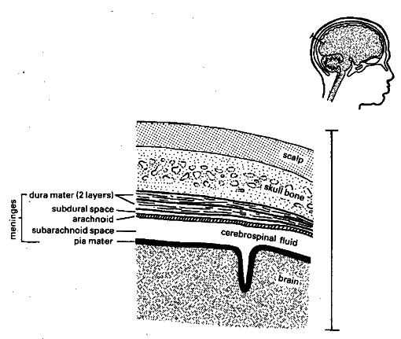

Figure 14.1: Meninges of the central nervous system

Causes of Meningitis

Most cases of meningitis are caused by microorganisms (infectious meningitis) such as;

- viruses,
- bacteria,
- fungi, or
- parasites,

These microorganisms spread into the blood and into the cerebrospinal fluid (CSF).
Non-infectious causes of meningitis, though not common, include:

- cancers, (neoplastic conditions e.g carcinomatous meningitis);
- systemic lupus erythematosus;
- certain drugs;
- physical injury (subarachinoid haemorrhages).

The most common cause of meningitis is viral or aseptic mengitis, which often runs its course within a few days. It may also be associated with other clinical entities such as mumps, poliomyelitis and measles.

Bacterial meningitis is the second most frequent type and can be serious and life-threatening. Acute bacterial meningitis may be caused by the following (in order of frequency):

Pneumococci – Streptococcus pneumoniae
Haemophilus influenza – Haemophilus incluenzae
Meningococci – Neisseria mengitidis
Coliforms - Escherichia coli
Salmonella – Salmonella typhi
Staphylococci – Staphylococcus aureus
Streptococci - Streptococcus pyogenes

Neisseria meningitidis ("meningococcus") and Streptococcus pneumoniae ("pneumococcus") are the most common pathogens in patients without immune deficiency. Meningococcal disease is more common in children. Staphylococcus aureus may complicate neurosurgical operations, and Listeria monocytogenes is associated with poor nutritional state and alcoholism.

The incidence of Haemophilus influenzae (type B) has been much reduced by immunization in many countries. Mycobacterium tuberculosis (the causative agent of tuberculosis) rarely causes meningitis in Western countries but is common and feared in countries where tuberculosis is endemic.

These bacteria however are common in some age groups and the table below will help you make a better diagnosis.

Table 14.1: Causative and predisposing factors in meningitis (AMREF, 2007, Communicable Diseases Manual)

Causative Organisms | Age group most at risk | Predisposing condition
Pneumococci | Adults | Mastoiditis, otitis media, sinusitis, pneumonia, haed injury, pe\uerperium, pregnancy
H. Influenzae | Children | Respiratory tract infection, otitis media, mastoiditis
Meningococcus | Children and young adults | Over crowding
M. Tuberculosis | Children | Malnutrition, HIV
Salmonellae | < 2 years | Diarrhoea or septicaemia
Virus | Children | Epidemics of mumps, measles, polio, chckenpox and other viruses.

Epidemiology of Meningitis

Epidemiology refers to the study of distribution and determinants of disease conditions. Bacterial meningitis remains a serious threat to global health, accounting for an estimated annual 170,000 deaths worldwide. Even with antimicrobial therapy and the availability of sophisticated intensive care, case fatality rates remain at 5–10% in industrialized countries. All forms of meningitis occur in Africa. Meningococcal meningitis can occur sporadically or in the form of epidemic outbreaks, especially in crowded institutions such as barracks, refugee camps and prisons. Very large epidemics often sweep across Africa along the so called “Meningitis Belt”, an area stretching from Senegal in the west to Ethiopia in the east, and also moving into Sudan, northern Uganda, Ethiopia, northern Kenyan, northern Tanzania.

In 1996, Africa experienced the largest recorded outbreak of epidemic meningitis in history, with over 250 000 cases and 25 000 deaths registered. Between that crisis and 2002, 223,000 new cases of meningococcal meningitis were reported to the World Health Organization. The countries most affected countries have been Burkina Faso, Chad, Ethiopia and Niger; in 2002, the outbreaks occurring in Burkina Faso, Ethiopia and Niger accounted for about 65% of the total cases reported in the African continent. Furthermore, the meningitis belt appears to be extending further south. In 2002, the Great Lakes region was affected by outbreaks in villages and refugees camps which caused more than 2,200 cases, including 200 deaths.

In major African epidemics, attack rates ranges from 100 to 800 per 100 000 population, but individual communities have reported rates as high as 1000 per 100 000. While in endemic disease the highest attack rates are observed in young children, during epidemics, older children, teenagers and young adults are also affected.

About 10-20% of those who survive a meningitis attacks develop complications such as epilepsy, mental retardation or sensorineural deafness.

Three species, Haemophilus influenzae, Streptococcus pneumoniae and Neisseria meningitidis, are responsible for most cases of bacterial meningitis occurring beyond the neonatal period.
Major African epidemics are associated with N. meningitidis serogroups A and C and serogroup A is usually the cause of meningococcal disease in Asia. Outside Africa, only Mongolia reported a large epidemic in the recent years (1994-95).

Next you will learn about the mode of transmission of meningitis.

Mode of Transmission

The bacteria that cause meningitis is transmitted from person to person through droplets of respiratory or throat secretions.

You could be having an idea on how this disease is transmitted. Write on a piece of paper and then read the content below to confirm.

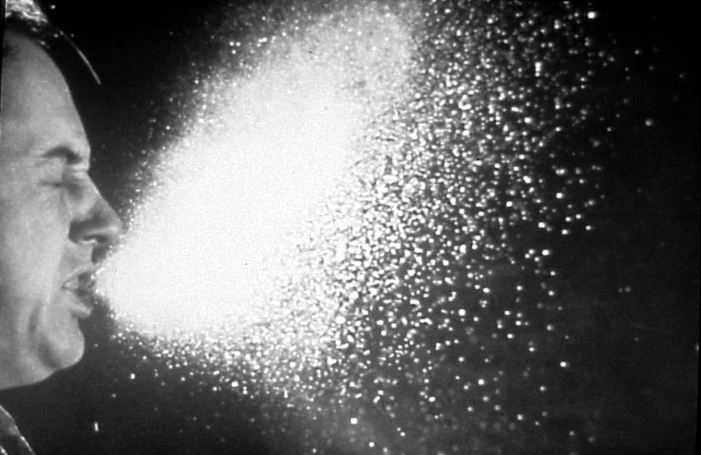
Figure14.2: A person sneezing

Transmission is also facilitated by close and prolonged contact such as;

- Living in close quarters or dormitories (military recruits, students);
- Living in poorly ventilated houses;
- Large population displacement e.g pilgrimage, traditional market, refugee camps;
- Traveling in crowded buses or trains;
- Kissing;
- Sneezing and coughing on someone;
- Sharing eating or drinking utensils;
- Seasons such as the dry season (due to dust).

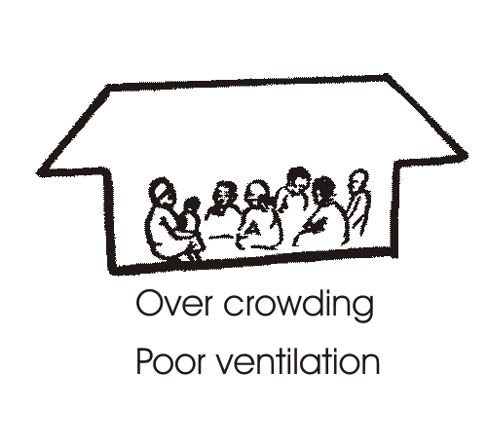
Figure 14.3: Overcrowding and poor ventiliation facilitates transmission of meningitis. (Source: AMREF,2007, Communicable Diseases Manual)

As you can see the list is long and am sure you can still add other conditions that facilitate the transmission of meningitis to boost your list.

 | - N. meningitis only infects humans; there is no animal reservoir.  - The average incubation period is 4 days, ranging between 2 and 10 days.

Disease Carrier State

The bacteria can be carried in the pharynx and sometimes, for reasons not fully known, overwhelm the body’s defences allowing infection to spread through the bloodstream and to the brain. It is estimated that between 10 to 25% of the population carry N.meningitidis at any given time, but of course the carriage rate may be much higher in epidemic situations.

Clinical features

Clinical features refer to the signs and symptoms associated with a disease, which are later confirmed by diagnostic measure. The onset of meningitis is acute with headache, fever, and often rigors. The headache becomes severe and spreads down the neck. There may bepain in the back and limbs. In children convulsions are common at the onset. The patient is irritable, becomes confused and drowsy, and later comatose.

In summary, the most common clinical features in meningitis include:

- Headache;
- Neck stiffness (nuchal rigidity) or in ability to flex the neck forward;
- Others include:
- Fever
- Altered mental status
- Photophobia (inability to tolerate bright light)
- Phonophobia (inability to tolerate loud noise)
- Irritability
- Delirium (in small children)
- Seizures (in about 20-40% of cases)
- Swelling of the fontanelle (in infants 0-6 months)
- Rash (petachial rash) common in meningiococcal meningitis, may precede other symptoms. The rash consists of numerous small, irregular purple or red spots on the trunk, lower extremities, mucous membranes, conjunctiva, and occasionally on the palms of hands and soles of feet

Common Clinical Tests

There are two clinical tests that can be done to diagnose meningitis clinically. They include Kernin’s sign and Brudzinski’s sign.

Have you heard of these tests before? Describe how they are performed on a separate piece of paper and then compare your answers with the following information.

Kerning’s sign

Ask the patient to lay supine and then to flex both hips and knees. If pain is elicited when the knees are passively extent is a positive Kernings sign indicating nuchal rigidity and meningitis.

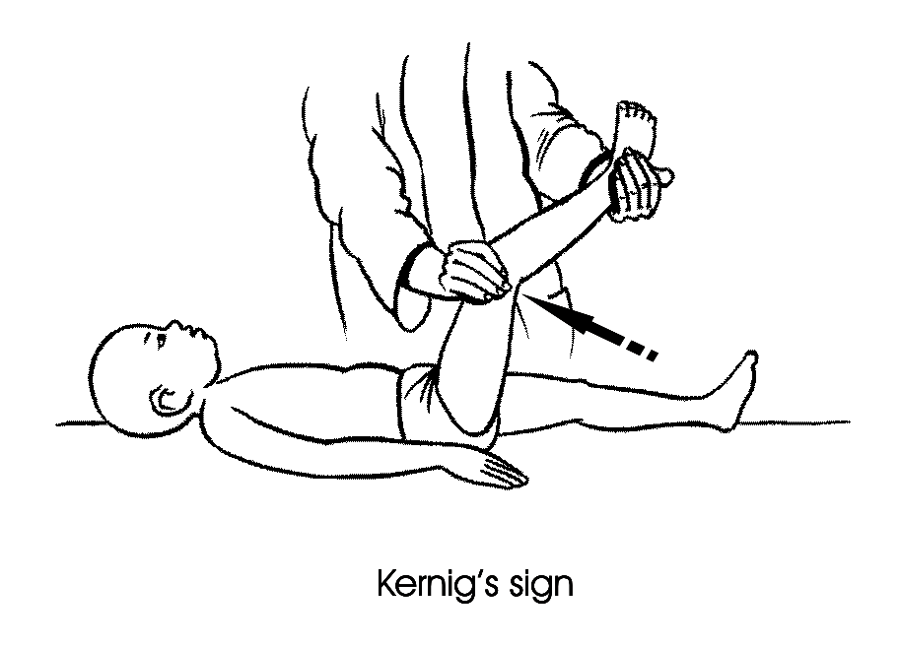
Figure 14.4: Illustration of Kerning’s sign test. (Source: AMREF, 2007, Communicable Diseases Manual.)

Brudziski’s sign

This one is commonly done among infants. Flex the infants neck forward. Observe to see whether there is involuntary knee and hip flexion. If they flex we call it Brudziki’s sign positive, indicating meningitis.

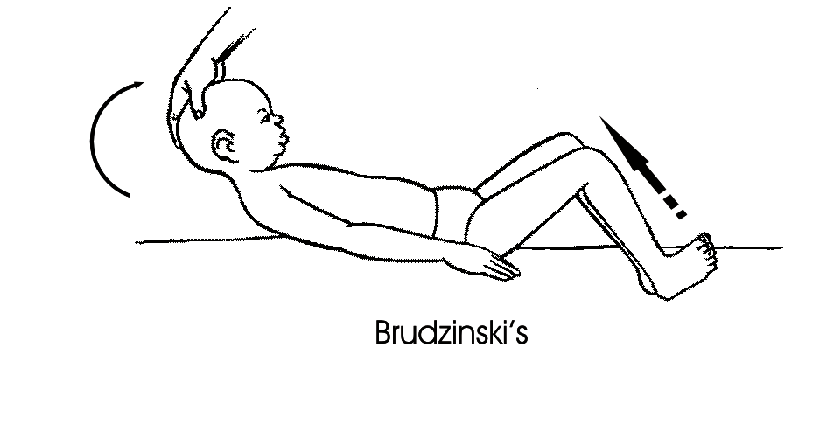
Figure 14.5: Illustration of Brudzski’s sign. (Source: AMREF, 2007, Communicable Diseases Manual.)

Diagnosis

The most common symptoms are stiff neck, high fever, sensitivity to light, confusion, headaches and vomiting. Even when the disease is diagnosed early and adequate therapy instituted, 5% to 10% of patients die, typically within 24-48 hours of onset of symptoms. Bacterial meningitis may result in brain damage, hearing loss, or learning disability in 10 to 20% of survivors. A less common but more severe (often fatal) form of meningococcal disease is meningococcal septicaemia which is characterized by a haemorrhagic rash and rapid circulatory collapse.
The diagnosis of meningococcal meningitis is suspected by the clinical presentation and a lumbar puncture showing a purulent spinal fluid; sometimes the bacteria can be seen in microscopic examinations of the spinal fluid. The diagnosis is confirmed by growing the bacteria from specimens of spinal fluid or blood. More specialised laboratory tests are needed for the identification of the serogroups as well as for testing susceptibility to antibiotics.

Meningitis is a medical emergency, and referral to hospital is indicated.

Investigations

Investigations include:

- Blood test
- electrolytes,
- liver and kidney function,
- inflammatory markers
- complete blood count.

- Chest X-ray
- Celebral spinal fluid analysis through a lumber puncture. (This procedure should be done by a qualified person). The patient should be examined to check if they are at risk of fatal brain herniation.
- CT scan or MRI is better done prior to lumber pucture to rule out the risks. MRI is better prefered due to its superiority in demonstrating areas of cerebral edema, ischemia, and meningeal inflammation.

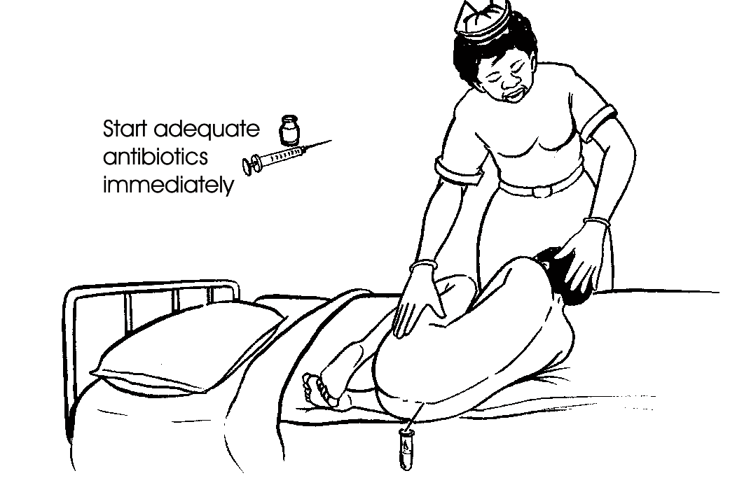
Figure 14.5: Correct position for doing a lumbar puncture. (Source: AMREF, 2007, Communicable Diseases Manual.)

The cerebrospinal fluid (CSF) sample is examined for;
- White blood cells
- Red blood cells
- Proteins content
- Glucose level
- Gram staining (determines if bacterias are responsible for the disease causation)
- Microbiological culture

Other tests performed on CSF include:
- Latex aglutinin test
- Limulus lysates
- Polymerase chain reaction (PCR)for bacterial and viral DNA

If the patient is immunocompromised other CSF tests can include;

- Toxoplasmosis
- Epstain-barr virus
- Cytomegalo virus
- JC virus
- Fungal infection.

Table 14.2: CSF Findings in different conditions
CSF finding in different condition
Condition | Glucose | Protein | Cells
Acute bacterial meningitis | Low | high | high, often > 300/mm³
Acute viral meningitis | Normal | normal or high | mononuclear, < 300/mm³
Tuberculous meningitis | Low | high | pleocytosis, mixed < 300/mm³
Fungal meningitis | Low | high | < 300/mm³
Malignant meningitis | Low | high | usually mononuclear
Subarachnoid haemorrhage | Normal | normal, or high | Erythrocytes

Cultures are often negative if CSF is taken after the administration of antibiotics. In these patients, PCR can be helpful in arriving at a diagnosis. It has been suggested that CSF cortisol measurement may be helpful.

You realize that some of these tests are advanced and can not be done in a local health facility. This calls for urgent referral of the patient to a main hospital. Once you arrive at a diagnosis either clinically, through diagnostic tests or both, treatment should be instituted immediately. Next you will learn how to treat this fatal disease.

Treatment

If you suspect that a patient is suffering from meningitis based on clinical examination, initiate early administration of antibiotics, as the condition may deteriorate rapidly. In the hospital setting, initial management consists of the following:

1. Stabilization
- securing the airway in a depressed level of consciousness,
- administration of intravenous fluids in hypotension or shock.

2. Antibiotics should follow if not already administered.

Admission to a hospital or health centre is necessary. Isolation of the patient is not necessary. Antimicrobial therapy must be commenced as soon as possible after the lumbar puncture has been carried out (if started before, it may be difficult to grow the bacteria from the spinal fluid and thus confirm the diagnosis).

You can choose the treatment form a range of antibiotics including;
- penicillin,
- ampicillin,
- chloramphenicol, and
- ceftriaxone.
Under epidemic conditions in Africa, chloramphenicol is the drug of choice in areas with limited health facilities because a single dose of this long-acting formulation has been shown to be effective.

Owing to the various causatives organisms responsible for meningitis, we shall now look at the different modes of treatment that are effective for each organism i.e bacterial meningitis, viral meningitis and fungal meningitis.

Bacterial meningitis treatment

This is a medical emergency as discussed above. If it is not possible to get do a lumbar puncture immediately, all suspected cases should be started immediately on chloramphenicol and crystalline penicillin. Antibiotics started within 4 hours of lumbar puncture will not significantly affect lab results.

Adjuvant treatment with corticosteroids reduces rates of mortality, severe hearing loss and neurological sequelae.

Once the results of the CSF analysis are known along with the Gram-stain and culture, empiric therapy may be switched to therapy targeted to the specific causative organism and its sensitivities, as shown in Table 14.3 below.

Table 14.3: the different types of bacterial (pyogenic) meningitis (Source: AMREF, 2007, Communicable Diseases Manual.
Organism | Stained form | Arrangement | Drug of Choice
Pneumococci | Gram +ve cocci | Diplococci | Crystalline benzyl penicillin 6 MU at once 3 MU 6-hourly
H. influenzae | Gram -ve cocci | Different shapes | Chloramphenicol 1g 6-hourly
Meningococci | Gram +ve rods | Diplococci | Crystalline benzyl penicillin 6 MU at once 3 MU 6-hourly
E. coli | Gram +ve cocci | - | Chloramphenicol
Salmonellae | Gram +ve rods | - | Chloramphenicol 1g 6-hourly
Staphylococci | Gram +ve cocci | Clusters | Chloramphenicol
Staphylococci | Gram +ve cocci | Chains | Crystalline benzyl penicillin 6 MU at once 3 MU 6-hourly

Treat purulent meningitis for at least 2 weeks.

Viral meningitis

Unlike bacteria, viruses cannot be killed by antibiotics. Patients with very mild viral meningitis may only have to spend a few hours in a hospital, while those who have a more serious infection may be hospitalised for many more days for supportive care. Patients with mild cases, which often cause only flu-like symptoms, may be treated with fluids, bed rest (preferably in a quiet, dark room), and analgesics for pain and fever.

Serious cases, especially in the case of young children or neonates, may require the use of antiviral drugs, such as acyclovir. The physician may also prescribe anticonvulsants such as phenytoin to prevent seizures and corticosteroids to reduce brain inflammation. If inflammation is severe, pain medicine and sedatives may be prescribed to make the patient more comfortable.

Fungal meningitis
This form of meningitis is rare in otherwise healthy people, but is a higher risk in those who have AIDS, or other forms of immunodeficiency (an immune system that does not respond adequately to infections) and immunosuppression (immune system malfunction as a result of medical treatment). In AIDS, Cryptococcus neoformans is the most common cause of fungal meningitis; it requires Indian ink staining of the CSF sample for identification of this capsulated yeast. Fungal meningitis is treated with long courses of highly dosed antifungals.

So far you have learnt how to diagnose and treat meningitis. However, as you well know prevention is better than cure. Therefore, next you will learn various approaches you can apply in the prevention of meningitis.

Prevention and Control

Start by doing the following activity.

ACTIVITY
List down some of the approaches that you think can be used to prevent meningitis.
_____________________________________________________________________
_____________________________________________________________________
_____________________________________________________________________
_____________________________________________________________________

Now read through the section and find out if the approaches you listed are mentioned.
- Vaccination:
- Routine vaccination: Routine preventive mass vaccination has been attempted and its effect has been extensively debated. Preventive vaccination can be used to protect individuals at risk (e.g. travellers, military, pilgrims).
- Protection of close contacts: When a sporadic case occurs, exposed household contacts need to be protected by a vaccine. The following drugs may be given as chemoprophylaxis, namely Penicillin (single dose PPF 0.6 MU), minocycline, spiramycin, ciprofloxacin and ceftriaxone.
- Vaccination for epidemic control: In the African Meningitis Belt context, enhanced epidemiological surveillance and prompt case management with oily chloramphenicol are used to control the epidemics. Routine immunization is not possible with the current available vaccines as the polysaccharide vaccines provide protection for only three to five years and cannot be used in children under 2 years of age because they lack the ability to develop antibodies.
- Travelers’ vaccination: Travellers to areas affected by meningococcal outbreaks are advised to be vaccinated. For pilgrims to the Hajj and Ramadan Omra, Saudi Arabia requires that visitors obtain a tetravalent vaccine (against A, C, Y, W135) at least ten days prior to their arrival in the country

All current vaccines target only bacterial meningitis.
Vaccinations against Haemophilus influenzae (Hib) have decreased early childhood meningitis significantly.

2. Prophylaxis
In cases of meningococcal meningitis, prophylactic treatment of close relatives with antibiotics e.g. Penicillin may reduce the risk of further cases.

3. Health education
Community members should be empowered to identify common signs and symptoms and immediately report any cases in the community. Community members should be advised to avoid overcrowding, constructing houses with poor ventilation or boarding overcrowded buses and trains where possible. It has been shown that when overcrowding is reduced and people sleep at least 1-2 metres apart, both the infection rate and the number of carriers fall. People should also be encouraged to cover their mouth while sneezing to minimize on the spread of droplets.

- Policy issues
Governments should be encouraged to develop policies that will ensure people live in decongested areas/houses with adequate water and sanitation facilities.

- Surveillance
Ministry of health and related authorities should ensure there is a good surveillance mechanism and treatment of cases and contacts.

Summary

You have now come to the end of this Unit. You have learnt much about meningitis what remains is for you to practice. You have learnt the different between bacterial and viral meningitis, their mode of transmission, causes, signs and symptoms, management and prevention. In the next unit we shall look at tuberculosis and leprosy. But before then, take a well deserved break and then complete the attached assignment. Wish you good luck!


DIRECTORATE OF CAPACITY BUILDING
DISTANCE EDUCATION COURSES

Student Number: ________________________________  Name: _________________________________________  Address: _______________________________________  _______________________________________________ | 

Communicable Diseases Course
Tutor Marked Assignment

Unit 14: Meningitis

Instructions: Answer all the questions in this assignment.
- What is meningitis?
____________________________________________________________________
____________________________________________________________________
____________________________________________________________________
____________________________________________________________________
____________________________________________________________________
____________________________________________________________________
____________________________________________________________________
- Which is the microorganism commonly associated with meningitis outbreaks?
____________________________________________________________________
____________________________________________________________________
- List any four clinical features of meningitis.
____________________________________________________________________
____________________________________________________________________
____________________________________________________________________
____________________________________________________________________
____________________________________________________________________
____________________________________________________________________
____________________________________________________________________
____________________________________________________________________
____________________________________________________________________
____________________________________________________________________
- Describe the two common tests that are done for clinical diagnosis of meningitis
____________________________________________________________________
____________________________________________________________________
____________________________________________________________________
____________________________________________________________________
____________________________________________________________________
____________________________________________________________________
____________________________________________________________________
____________________________________________________________________

- You get a patient with 2-day history of fever, headache and neck pains. On examination you find the patient has a temperature of 39.4°C, neck is stiff and the Kerning’s sign is positive.

- What is the diagnosis? ___________________________________________

- How would you confirm this?
_______________________________________________________________
_______________________________________________________________
c) How would you manage this patient?

_______________________________________________________________
_______________________________________________________________
_______________________________________________________________
_______________________________________________________________
_______________________________________________________________

- Explain how you would manage mild viral meningitis
____________________________________________________________________
____________________________________________________________________
____________________________________________________________________
____________________________________________________________________
____________________________________________________________________
____________________________________________________________________
____________________________________________________________________
____________________________________________________________________
____________________________________________________________________

- What action would you take during an outbreak of meningococcal meningitis?
_______________________________________________________________
_______________________________________________________________
_______________________________________________________________
_______________________________________________________________
_______________________________________________________________
_______________________________________________________________
_______________________________________________________________
_______________________________________________________________
_______________________________________________________________
_______________________________________________________________
Congratulations! You have now come to the end of this unit. Remember to indicate your Student Number, names and address before sending the assignment.
Once you complete this assignment, post or bring it in person to AMREF Training Centre:

Distance Education Project
P O Box 27691-00506
Nairobi, Kenya
Email: amreftraining@amrefhq.org

We will mark it and return it to you with comments.

