DIRECTORATE OF LEARNING SYSTEMS

DISTANCE EDUCATION PROGRAMME

Unit 13
Acute Respiratory Infections

Allan and Nesta
Ferguson Trust
COMMUNICABLE DISEASES COURSE

Unit 13: Acute Respiratory Infections

A distance learning course of the Directorate of Learning Systems (AMREF)

© 2007 African Medical Research Foundation (AMREF)

This course is distributed under the Creative Common Attribution-Share Alike 3.0 license. Any part of this unit including the illustrations may be copied, reproduced or adapted to meet the needs of local health workers, for teaching purposes, provided proper citation is accorded AMREF. If you alter, transform, or build upon this work, you may distribute the resulting work only under the same, similar or a compatible license. AMREF would be grateful to learn how you are using this course and welcomes constructive comments and suggestions. Please address any correspondence to:

The African Medical and Research Foundation (AMREF)
Directorate of Learning Systems
P O Box 27691 – 00506, Nairobi, Kenya
Tel: +254 (20) 6993000
Fax: +254 (20) 609518
Email: amreftraining@amrefhq.org
Website: www.amref.org

Writer: Dr Daniel Njai
Chief Editor: Peter Waithaka
Cover design: Bruce Kynes
Technical Co-ordinator: Joan Mutero

The African Medical Research Foundation (AMREF wishes to acknowledge the contributions of the Commonwealth of Learning (COL) and the Allan and Nesta Ferguson Trust whose financial assistance made the development of this course possible.

Contents

Unit 13: Acute Respiratory Tract Infections (ARIs) 4
Introduction 4
Unit Objectives 4
Section One: Upper Respiratory Tract Infections (URTI) 4
Coryza (Common Cold) 7
Flu (Influenza) 12
What are the symptoms? 12
How to avoid it spreading to others 13
Treatment 13
Acute Sinusitis 13
Management of Sinusitis: 15
The aims of treating sinusitis are: 15
Acute Pharyngitis (Sore throat) 15
Viral Pharyngitis 17
Bacterial Pharyngitis 17
Acute Laryngotracheobronchitis (Croup) 21
Section Two: Acute Lower Respiratory Infections 22
Bronchitis 23
Acute Exacerbation of Chronic Bronchitis 24
Pleural Effusion, Empyema And Lung Abscess 25
Bronchiolitis 26
Pneumonia 27
Pneumococcal Pneumonia ( Streptococcal pneumonia) 29
Staphylococcal Pneumonia 31
Summary 31

Unit 13: Acute Respiratory Tract Infections (ARIs)

Introduction

Welcome to this unit where you will learn about respiratory tract infections. In the last unit we learnt about helminthic diseases. We saw that intestinal worms are a problem of poor sanitation and that good sanitation is the preventive measure of choice, especially proper disposal of human faeces. Our discussion of respiratory tract infections will mainly look at acute respiratory tract infections, which can be divided into upper and lower respiratory tract infections. Therefore this unit will have two sections. Section one will focus on upper respiratory tract infections, while the second section will focus on lower respiratory tract infections. Chronic respiratory infections include tuberculosis and whooping cough. Tuberculosis will be discussed in detail in Unit 15

We believe you will find this unit very interesting as you may have experienced or seen a patient with at least one or more of the conditions we shall be discussing.

Let us now look at our objectives for this unit.

Unit Objectives

By the end of this unit you will be able to:

- Describe RTIs and their causative agencies
- Outline the epidemiology of RTIs and their mode of transmission
- Describe the clinical features, diagnosis and treatment
- Explain the prevention and control of RTIs

Section One: Upper Respiratory Tract Infections (URTI)

Upper respiratory tract infections are common and cause a lot of absenteeism from work and school.

Most of the URTIs are caused by viruses but may have secondary bacterial infections. The common ones are:

- Common cold (coryza);
- Flu (influenza);
- Pharyngitis (sore throat);
- Laryngitis;
- Laryngotracheobronchitis (croup).

You may be familiar with some or all of these illnesses. However you need to remind yourself the anatomy of the respiratory tract since most of these illnesses are associated with the anatomical structures.

The Upper Airway

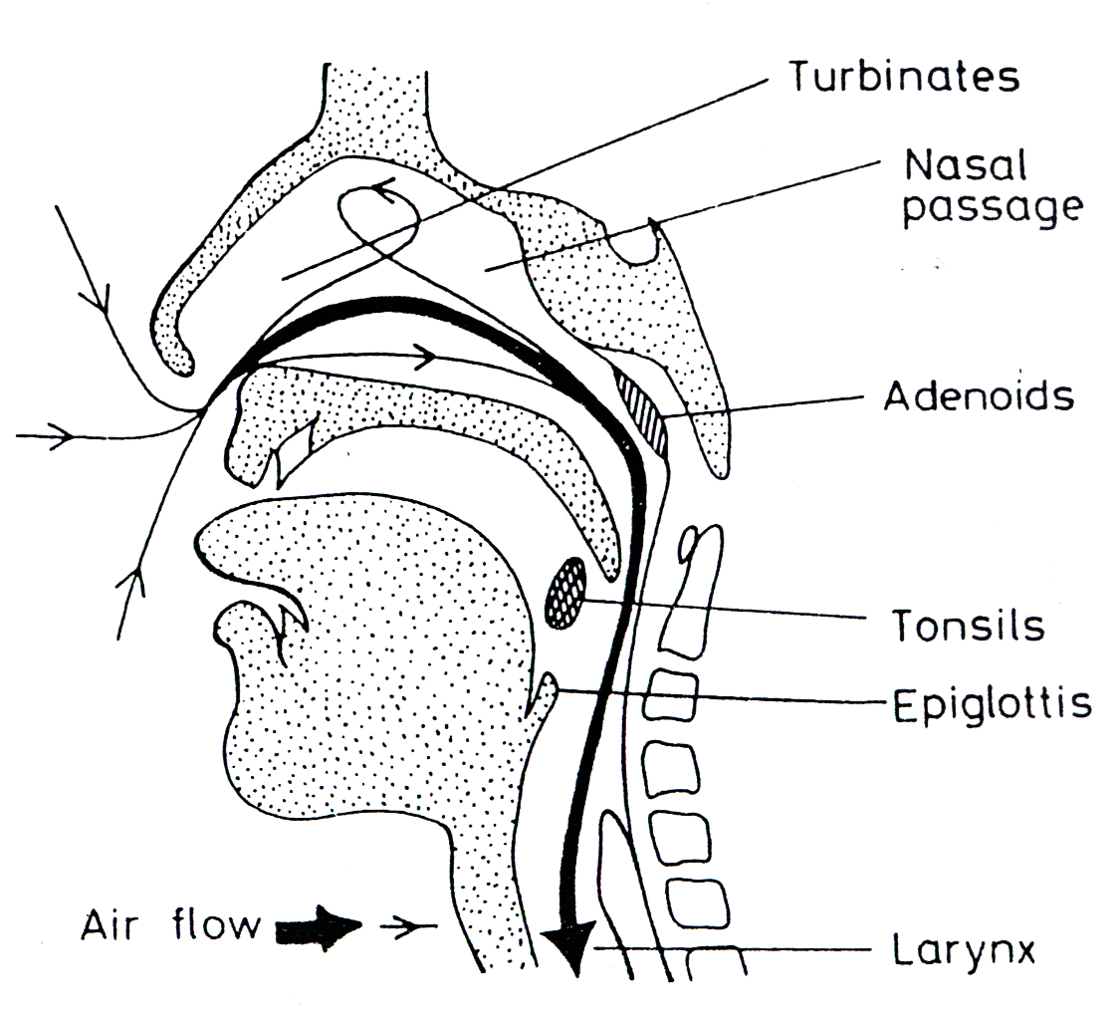
Figure 1. Common anatomical structures of the upper airway

Lower air way

Having reminded yourself of the upper airway it is necessary to learn how it is connected to the lower airway. This is mainly meant to give you a mental picture since you will concentrate more on the upper airway.
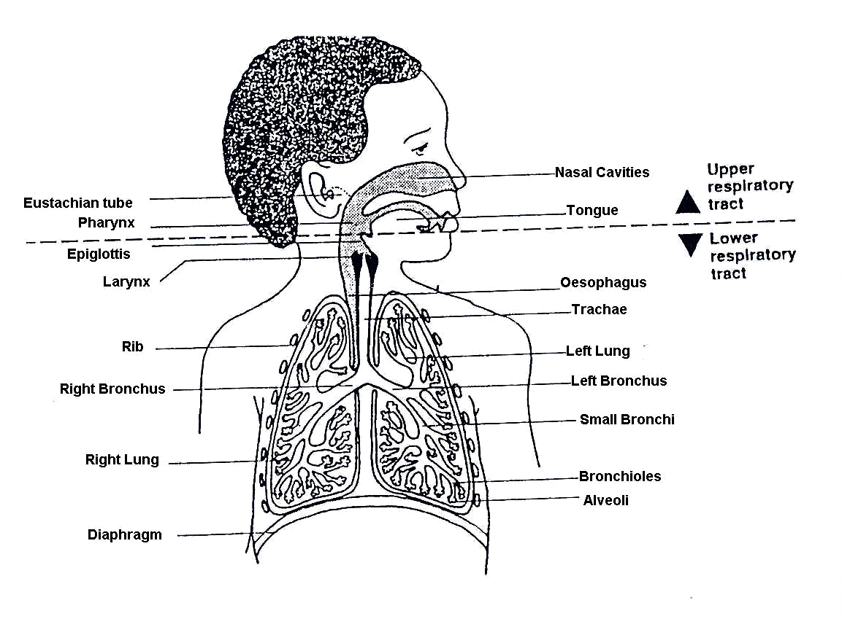

Figure 2: Common anatomical features of the respiratory tract

 | Name any three main structures of upper and three of the lower respiratory tracts.

Having reviewed the common structures of the respiratory tract, let us know look at the common conditions of the upper respiratory tract.

General description of URI

Symptoms of URI's commonly include
- Congestion;
- cough;
- running nose;
- sore throat;
- fever;
- facial pressure and;
- sneezing.

These symptoms may occur in isolation or in various combinations. They usually begin after 1-3 days after exposure to a microbial pathogen, most commonly a virus. The duration of the symptoms is typically 7 to 10 days however it may persist longer.
It is important to mention that up to 15% of acute pharyngitis cases may be caused by bacteria, commonly Group A Strep ("Strep Throat"). Generally, patients with "Strep Throat" start with a sore throat as their first symptom and usually do not have runny nose or cough or sneezing.
Pain and pressure of the ear caused by a middle ear infection (Otitis media) is often associated with upper respiratory infections.
Influenza (the flu) is a more systemic illness, which can also involve the upper respiratory tract, and which should be recognized as distinct from other causes of URI.

Coryza (Common Cold)

Did you know that common cold is also called CORYZA? The name sounds funny and so does most other names of common illnesses. What other local names do you use for this illness ?

List both traditional and scientific causes of the common cold. Read the content below to compare with what you have written.

Cause

Common cold is a mild, self limiting viral infection. It spreads by direct contact with infectious secretions and inhalation of droplets of infected respiratory secretions. This is the reason why it spreads fast from a person to another, especially those within close proximity with an infected person.

Clinical features
Clinically, many people are aware of the signs of this illness or so they think they do. Below are some of the common signs that will help you make a clinical diagnosis of coryza.

- Sneezing, headache, malaise, nasal discharge and sore throat. Adults may not have fever but young children frequently do.

Can you describe the type of nasal discharged in common cold?

Initially it is clear, watery and profuse but later becomes thick

- These initial symptoms may last up to 3 days. Cough and hoarseness may also occur early and persist for about a week.
Diagnosis
How would you diagnose this illness?

The fact is that presentation of the common cold is so typical that self diagnosis by the patient is usually correct. As a clinician most of the time the client will have already done a self clinical diagnosis but it is always necessary to conduct an assessment to rule out other illnesses. Diagnosis of the specific virus is not possible on clinical observation alone.

Are there any complications of the common cold that you know? Write them on a piece of paper before reading the text below. Then compare what you have written with what is in the text below

Complications of Coryza
These complications usually are as a result of secondary infection and include;

- Secondary bacterial sinusitis
This causes blocked noses and plenty of thick mucus discharge from the nose. Normally it is a main cause of nuisance, since one has to keep blowing nose. In children it may cause blocked nose hence difficulty in breathing hence need to watch over then closely.

- Otitis media
This is the infection of the middle part of the year, may cause itchiness and discomfort to the affected ear.

To detect these you should examine the pharynx, nasal cavity, ears and the sinuses. The areas will appear inflamed. Detailed examination of these areas may be hindered by unavailability of equipment since they are expensive.

Treatment
Various approaches have been proposed for the treatment of coryza, you may be aware of several conventional and also non conventional approaches. There are however basic rules to managing the condition.

- Antibiotics are not needed for uncomplicated colds;
- Symptomatic treatment is used for common colds. That is you treat fever, headache, running nose or any other symptom with medications suitable for the symptoms.

What symptomatic treatments are available for common cold? Write this down on a piece of paper then compare with what is written below.

Symptomatic Treatment

Nasal obstruction:
This can be treated with:
- Decongestant nasal drops. This is useful especially for young children who experience nasal block.
- Antihistamines like piriton (sedating) or cetrizine (nonsedating). This reduces the amount of mucus in the nose.

Cough:
Cough can be irritating and if unchecked could lead to further damage of the mucus membranes lining the upper air way, resulting to secondary infections. It can be treated with:

- Preparations containing codeine or dextromethorphan. This minimizes the irritation that leads to cough reflex.

Sore throat:
A sore throat is a nasty experience and in some people it may be painful to swallow and at time may lead to voice alteration or reduction. Various localized remedies have been tried some successfully others may be psychological. To treat this symptom you can use:

- Warm saline gargles: You can request the patient to prepare it domestically by using warm water and a tinge of salt in a glass/cup. Then gurgle for a couple of minutes two to three times a day. Usually it should clear in a day or two.

- Lozenges containing a topical anaesthetic: These help to ease the soreness resulting to relative comfort within a couple of hours.

- Drinks: A sore dry throat can be due to a blocked nose causing you to sleep with your mouth open - probably snoring.
- Drink lots of fluids - water or orange juice are good.
- Sip warm drinks like a honey, lemon juice and hot water mixture

Headache

Have you ever had a headache? If you have, then I am sure you can relate with how the man in figure 3 below feels.

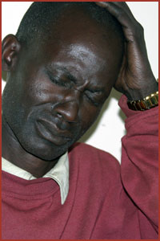

Figure 3: A patient suffering from a headache

A Headache is a symptom that no one wishes to have at all. Iit leads to pain, inability to perform routine duties, absenteeism from work or school and tension among others.

Headache resulting from coryza may not be severe and can easily be treated, however if untreated it can be worse. The most common treatment for this is;

- Paracetamol
The drug is available in both liquid and tablet form. Liquid form is the best for children while tablets are good for adults. Most patients actually treat themselves with this medication and already know how to use it. It is however important to advise them on safety measures such as:

- Not to overdose – take only three times a day
- Keep it away from children
- take only the recommended dose

Paracetamol poisoning is common among children and young adolescents who attempt to commit suicide.

Malaise
Malaise is the feeling of tiredness and unwillingness to do anything. It is a common feeling experienced when one has common cold. It may lead to reduced productivity although normally most people are able to continue with their usual activities. The best way to handle malaise is by resting.

Prevention and control of coryza

Get a piece of paper and write down the various measures you know for prevention and control of coryza. Then compare that with the content below.

You can give others your cold when you cough or sneeze into the air around them, or if the droplets from your nose or mouth fall onto something that they then touch, handle. Hands are thus common culprits in many of the colds that we get!

Prevention of transmission from person to person

1. Direct hand contact.
There are various ways to prevent transmission of coryza through hand contact. Due to cultural and ethical reasons one can not totally avoid hand shaking especially in Africa. The best measure to minimize transmission is to practice good hygiene as follows:

- Hand washing: This should be done as often as possible using soap and flowing water. Washing should concentrate more on the palm, nails and back of hand. Rinsing should be done thoroughly. The process help in minimizing the amount of virus in the hands of the infected person who may have used the hand to cover the mouth while sneezing or removing the mucus discharge form the nose.


Figure4: Prevention through handwashing

- Avoid finger – to – nose and finger – to eye contact after exposure to a person with cold. It may b difficult to know who has a cold hence in addition to avoiding touching the nose and eyes the public should be encouraged to always wash their hands as often as possible.

- Continuous health education to the public is important so that people can openly let others know they have a cold.

2. Inhalation of infected secretions

It is a good habit to cover coughs and sneezes with a handkerchief or disposable tissues. You should remind members of the public to continuously practice this without fail. This hygienic practice should be taught to all especially children in schools and other forum so that they grow up practicing it.

Flu (Influenza)

Cause
The flu (full name is influenza) is caused by one of several different influenza viruses. The viruses are spread in the same way as those that cause common colds.

Transmission
The flu is transmitted in the same way as the common cold through:

- Sneezing,
- Coughing and
- Touching.
To prevent its spread you have to avoid visiting crowded sites if you are affected. Avoid contact with an infected person, especially if they are sneezing or coughing since this is when they are highly contagious.

What are the symptoms?

Write the symptoms of flue then compare with what is in the content below

The flu is different from colds since it comes on more quickly and there is more:

- Fever;
- Headaches;
- Aches in the rest of the body;
- Shivering and;
- Feeling hot and cold than with colds;
- Body aches;
- Nose is not all drippy and runny like with a cold.

You can have a test to show if it is influenza but this is rarely needed.
Now you can differentiate the two, in many cases people are not in a position to detect which is which, but now you know.

How to avoid it spreading to others
- Preventive and control measures are similar to those of cold.
- Wash your hands every time you sneeze or cough into your hand, to wash away the droplets that carry the virus.
- Throw out those damp, germ-laden, used tissues as soon as you use them.
- Stay away from school or work until you feel better;
- No kissing on the mouth! Especially not those long passionate kisses.
- The mouth and nose areas are where all the germs are concentrated;
- You can be immunised against the flu but this is mainly recommended for older people (over 65), people with on-going illnesses and people taking medication that weakens the immune system in the body.

Treatment

As with a cold, there is no cure, you can only treat the symptoms. Get plenty of rest, drink a lot and eat soft foods if there is a sore throat. Avoid alcohol and other drugs - they only make it harder for your body to fight this off. Have a few early nights until you feel better. Going out partying will mean you feel ill for longer. Just like colds, the flu can have complications like pneumonia and ear infection, so you should educate your clients to seek medical advice if they feel unwell, if they have a high temperature, bad cough or if the flu symptoms don't go away in a few days.

Acute Sinusitis

Sinuses are empty spaces in the skull. They are found behind the nose, behind the cheeks, and above the eyes. See figure 5.

What are sinuses?
What is there role in the respiratory system?
Refer to your basic anatomy to be able to answer this question.

Definition
Acute Sinusitis is the inflammation of the sinuses lasting up to three weeks. Beyond that time it may be subacute or chronic.

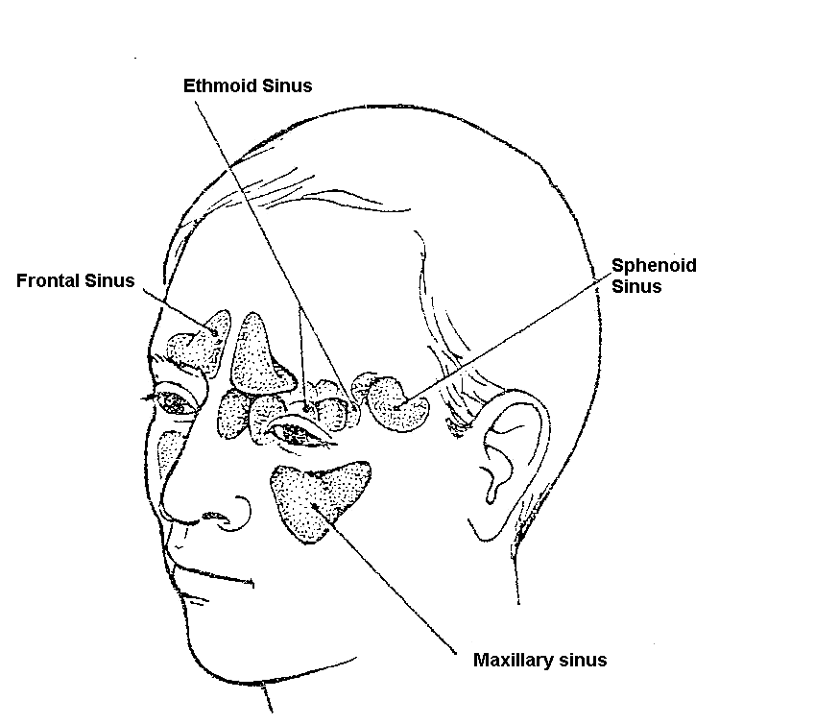

Figure 5: Sinuses

The sinuses are lined with mucous membranes. Normally the sinuses produce a small amount of mucus that drains into the nose. A bacterial infection of the upper respiratory tract can spread to the sinuses. When this happens, the mucous membranes in the sinuses become inflamed and produce large amounts of mucus. We call this sinusitis.

The outlet of the sinus may become blocked. This causes a build-up of mucus and pus in the sinus.

Symptoms of sinusitis include:
- a recent cold or allergic rhinitis;
- a purulent nasal discharge and often nasal blockage;
- a feeling of fullness in the cheeks and head, especially when leaning forward;
- a headache;
- a cough.

Signs of sinusitis include:
- fever and the person feels ill;
- tenderness on palpation over the sinuses and on pressing gently on the eyes and above the eye;
- red and inflamed mucous membranes of the nose;
- A yellow green (purulent) discharge in the nose or a post nasal drip.

Management of Sinusitis:

The aims of treating sinusitis are:
- Clearing any blockage so that the sinuses will drain;
- Treating the infection.

These aims are achieved through:
- Regular steam inhalation which helps to clear the blocked sinuses and to drain the mucus.
- Giving decongestants to improve the drainage of mucus.
- Giving antibiotics, such as cotrimoxazole to treat the infection
- Following up the patient in two days.
- Referring the patient to a doctor if the sinusitis does not clear up

Complications of sinusitis:
If sinusitis does not clear up, it can lead to some dangerous complications. These complications result from the spread of the infection to the neighbouring tissues and include:
- Orbital cellulitis that is infection of the orbit;
- Periorbital cellulitis which is infection of the tissues surrounding the eye;
- Osteomyelitis, that is, infection of the bone surrounding the sinuses
- Brain abscess or meningitis.

Some of these complications may require surgery. A complication must be suspected if a patient with sinusitis develops any of these symptoms:
- Severe headaches
- A stiff neck
- Severe swelling in the face
- Swelling of the eyelids
- Restricted movement of an eye

Give the patient an injection of benzyl penicillin, and REFER him to a doctor immediately.

Acute Pharyngitis (Sore throat)

What is pharingitis?

Acute pharyngitis is inflammation of the pharynx, the cavity behind the mouth. Pharyngitis infection is commonly called sore throat. It is caused by either viruses or bacterial. In Figure 2 on common features of respiratory tract you can locate the pharynx, which is the region around the throat.

Classic symptoms

How would you know that some one is suffering from pharyngitis?

Write down the symptoms of pharyngitis on a piece of paper then compare with what is in the content below.

Classic symptoms of pharyngitis include acute onset of:

- Pharyngeal pain,
- Dysphagia,
- Fever
- Rhinorrhea,
- Cough,
- Hoarseness,
- Conjunctivitis and diarrhea are rare, and, if present, strongly suggest a viral etiology.

On examination, the pharynx may be erythematous, and have a patchy exudate on the posterior pharynx and tonsils. Anterior cervical lymphadenopathy is common.

Cause
A variety of microorganisma are responsible for causing pharyngitis. They can be categorised in to those that are common and others that are not common.

Most cases of pharyngitis are caused by viruses. The most common infections are due to:
- Rhinovirus,
- Coronavirus,
- Influenza A and B,
- Coxsackievirus and
- Parainfluenza virus.

Group A beta-hemolytic Streptococcus (S pyogenes, GABHS) accounts for 10%-15% of cases of pharyngitis in adults. GABHS can be cultured from about 30% of cases of sore throat in children, and about half of these children (15%) have a significant bacterial infection on the basis of serological studies.

Other causes are:
- cytomegalovirus,
- Epstein-Barr virus (infectious mononucleosis),
- adenovirus,
- herpes simplex virus, and,
- less commonly, group C and G Streptococcus, Neisseria gonorrhoea, Mycoplasma pneumoniae, and Chlamydia pneumoniae.

As with the viruses, the other beta-hemolytic streptococci (group C and G) have a self-limited course, and do not cause Rheumatic Fever.

Clinical Manifestations.

It is important to differentiate the two categories of pharingitis based on their causative agents. These are:

- Viral pharingitis
- Bacterial pharingitis

Viral Pharyngitis

Viral infections begin gradually, cause less intense inflammation, produce a milder degree of illness, last a shorter period and produce fewer complications than the bacterial infection.

Viral infections manifest with fever, refusal to feed, general malaise, headache and moderate throat pain:

- The fever is highest on the third or fourth day.
- Throat pain may be absent at the beginning.
- In some cases, throat pain appears early but is rarely as severe as in the bacterial pharyngitis.

Strongly suggestive of viral pharyngitis is presence of conjuctivitis, rhinitis, cough, hoarseness, anterior stomatitis, discrete ulcers, viral exanthems and diarrhoea.

The cervical lymph nodes are moderately enlarged and may or may not be tender. The throat and the tonsils are moderately red with or without follicular exudate on the throat, the tonsils or both places.

Unlike that of the bacterial pharyngitis, the exudate in the viral pharyngitis never joins to form one whole patch. The white cell count and the differential may be normal, show leukopenia or show leukocytosis.

Bacterial Pharyngitis

Bacterial pharyngitis differs with the viral pharyngitis in the following characteristics:

- Begins more abruptly;
- Higher rise of fever than the viral pharyngitis;
- Refusal to feed, headache, and general malaise characteristically occur early;
- Sore throat may be absent on the first day or there may be a feeling of dryness in the throat. Later the throat may become very painful during swallowing;
- The throat and the tonsils appear mildly red or fiery red. Sometimes the soft palate and the uvula are also red;
- There is often an abundant yellow exudate or coating that spreads to coalesce (come together and form one whole);
- The cervical lymph nodes are characteristically enlarged and tender with a tendency to form abscess.

In infants, bacterial pharyngitis may present with refusal to feed, drooling, fever and diarrhoea.

Most suggestive of bacterial pharyngitis are diffuse redness of the throat and the tonsillar pillars with petecchial mottling of the soft palate, absence of an upper respiratory infection symptoms, vomiting in ages 5 to 15 years

Gonococcal pharyngitis is usually asymptomatic but may present with a high fever and gingivostomatitis.

Allergic rhinitis with non-purulent postnasal drip may also cause sore throat.

Diagnosis
Where possible, leukocytosis, rapid test to identify streptococcal antigen and throat culture for bacteria may be useful investigations. Table 2 gives the differential diagnosis

Table 2: Differential diagnosis for sore throat
Diseases | Signs and Symptoms
Tonsillitis | Redness most marked on or around the tonsils  Often yellow spots on tonsils  Cervical glands enlarged and tender
Pharyngitis, due to the common cold or other virus | All throat equally red, no exudates  Glands not enlarged  Little tenderness
Diphtheria | Whitish membrane on tonsils and palate, difficult to remove and bleeding on removal (refer any suspected patients)
Leukaemia | Sore throat for more than a few days  White count shows very many cells
Agranulocytosis | Sore throat for more than a few days  White count shows very few polymorphs

Treatment
Treatment of GABHS should be with:
- Penicillin (dosed 2-3 times daily) for 10 days,
or
- a single IM injection of benzathine penicillin.
- Amoxicillin is an acceptable alternative,

It is recommended a second line status for amoxicillin in pharyngitis because of greater selective pressure for resistant flora:

- To date no GABHS resistance to beta-lactam antibiotics have been identified.
- Erythromycin is the drug-of-choice for penicillin allergic individuals and cephalexin can be used for patients with non-anaphylactic penicillin allergy

It is recommend to treat only individuals with a positive laboratory test with antibiotics. Newer higher sensitivity tests (e.g., newer optical immunoassays) do not change the recommendations to culture individuals with a negative rapid test and a clinical picture strongly suggesting GABHS

 | If a sore throat lasts for more than a few days, do a white blood cell count.

Diseases That Present With Pharyngitis

Several other illnesses present with sore throat. They include;

1. HERPANGINA

- This is an uncommon type of sore throat, which is viral in origin. It primarily affects children.
- Small vesicles in the pharynx or ulcers are seen on examination and also presents with headache, poor feeding vomiting, abdominal pain, fever and sore throat are present .in some cases the abdominal pain may mimic acute appendicitis

2. HIV -
- In HIV cases fever with pharyngitis may occur soon after infection with the virus sets in.
- Fungal infection with Candida is common in HIV infection and presents as whitish areas on the tongue and pharynx

3. DIPTHERIA
This condition may occur in unvaccinated populations. It is characterized by tonsillar or pharyngeal membrane. The disease is associated with consumption of raw milk.

4. INFLUENZA
- Influenza is a contagious disease occurring in localized outbreaks. It may involve many people in many parts of the world if it occurs as a pandemic.
- After an incubation period of 1-3 days the illness will present with fever, sweating, headache, sore throat and Muscular aches. A non productive cough and nasal obstruction may be present.

The main danger of influenza is the complication of staphylococcal pneumonia

Complications
Viral infections have no complications except paving the way for secondary bacterial infection. The complications of bacterial pharyngitis include:

- Otitis media,
- Retropharyngeal abscess,
- Lateral pharyngeal abscess
- Sinusitis,
- Acute cervical adenitis,
- Septicaaemia
- Acute rheumatic fever,
- Glomerulonephritis
- Meningitis (rarely)
- Large chronic ulcers in the pharynx in both viral and bacterial pharyngitis.
- Pneumonia
- Rheumatic fever

In view of the above complications, we should make every effort to recognize and treat acute pharyngitis timely and properly.

There are two important complications of sore throat infections that you should be able to recognize: peritonsillar abscess and epiglottitis.

1) Peritonsillar abscess (Quinsy): Peri means around, so a peritonsillar abscess is an abscess around or near the tonsils. A large swelling forms around the tonsils. The patient usually cannot open the mouth very widely. You may see pus on the very swollen area around the tonsils. Give the patient procaine penicillin and REFER URGENTLY to a doctor. The danger is that the swelling may grow so large that the patient will have difficulty in breathing.

2) Epiglottitis: Epiglottitis is the infection of the epiglottis, the flap of tissue that covers the larynx when we swallow food. If the epiglottis is swollen it can seen at the back of the throat, looking like a small red marble.

Epiglottitis is very dangerous, because the swollen epiglottis can block the airway and cause the patient extreme difficulty in breathing. It can also cause death.

A patient with epiglottis looks very ill, has a high fever and may have saliva dripping out at the side of his/her mouth. As the patient breathes, he/she produces a stridor as if he has croup.

If you suspect that the patient has epiglottitis, do not make the situation worse by looking repeatedly at his throat. This might cause more swelling. Give the patient chloramphenical and REFER URGENTLY to hospital

How can we prevent influenza?

Vaccination is available and is recommended for patients who are prone to influenza e.g. those with chronic bronchitis and emphysema other chronic respiratory disease and valvular heart disease.

However, the vaccines have to be prepared annually as the virus tends to form new strains

Specific antiviral agents are available for treatment but these have to be given very early in the illness to have any effect.

The antiviral agent may also be given for prevention for people who have been exposed to patients with influenza.

Now you can see that pharyngitis is a complicated disease since it has several causative organisms. It is also a complication of several other diseases that affect the pharynx.

- Describe how pharingitis is transmitted
- Differentiate between viral and bacterial pharyngitis
- Explain how you would treat pharyngitis.

Acute Laryngotracheobronchitis (Croup)

You have just gone through the inflammation of the pharynx in the content above. Next you will focus on the infections of the structure below the pharynx namely the larynx, trachea and bronchi (hence the name laryngotracheobronchitis).

Causes
Many of the viral infections of the upper respiratory tract may be complicated by tracheitis and bronchitis. Acute respiratory failure may occur due to narrowing of the airways especially in children whose airways are generally narrow.

Clinical features
- A characteristic brassy cough;
- Stridor;
- Wheeze and;
- Fever.

Treatment
For effective management of this condition the following is appropriate:
- good supportive care is important;
- humidification may be provided by steam inhalations, oxygen;
- systemic steroids, like dexamethasone 0.3 – 0.6mg/kd every six hours for two to four doses have been used;
- Antibiotics are used if a bacterial infection is suspected; most of the cases of croup are of viral origin;
- tracheostomy or nasotracheal intubation is required if there is respiratory failure.

Now you have gone through the common upper respiratory tract infections. You can remind your self the key highlights of the content by going through the summary below.

What have we learnt?

- Upper respiratory tract infections are common and cause a lot of absenteeism from work and schools
- Many of them are viral in origin and antibiotics therapy is not required.

- Streptococcal sore throat requires antibiotics to prevent rheumatic fever

- Vaccination is available for influenza virus. Influenza virus can cause localized outbreaks and rarely pandemics throughout the world.
- Croup may cause respiratory failure and early referral to a centre with the required facilities is important.

Did you find the upper respiratory tract infections content interesting and informative?
Next you will look at illnesses affecting the lower respiratory tract.

Section Two: Acute Lower Respiratory Infections

Lower respiratory tract infections place a considerable strain on the health budget and are generally more serious than upper respiratory infections. Since 1993 there has been a slight reduction in the total number of deaths from lower respiratory tract infection. However in 2002 they were still the leading cause of deaths among all infectious diseases.

Lower respiratory tract infections are often endogenous - caused by microbes in the patient's commensal flora. Usually, the lower respiratory tract is sterile. Sterility is maintained by the mucociliary escalator. Particles that land in the lungs become entrapped in mucus that is constantly being swept up out of the lungs by the cilia. When this mechanism breaks down, infection may ensue.
There are a large number of microbes that can cause infection in the lower respiratory tract. Initial diagnosis of lower respiratory tract infections includes a clinical examination and chest X-ray. The pattern of consolidated or inflamed lung tissue revealed in these examinations will yield invaluable clues as to the most likely causative agent.
In this section the diseases that you will learn about include;

- Acute bronchitis
- Bronchitis
- Bronchiolitis
- Acute pneumonia
- Pleural effusion and emphysema
- Lung abscess

Bronchitis

Bronchitis results from the infection of the bronchi. The figure below will remind you that anatomically the bronchi is the section of the respiratory tract that lies below the trachea.
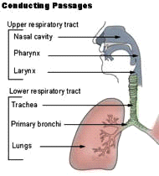
Figure 5: Upper and lower respiratory tract

Bronchitis is classified in to two:

- Acute
- Chronic.

Acute bronchitis
Acute bronchitis can be defined as acute bacterial or viral infection of the larger airways in healthy patients with no history of recurrent disease.
It affects over 40 adults per 1000 each year and consists of transient inflammation of the major bronchi and trachea. Most often it is caused by viral infection and hence antibiotic therapy is not indicated in immunocompetent individuals.
Treatment
You should note that like any other viral infection there are no effective therapies for viral bronchitis.
Treatment of acute bronchitis with antibiotics is common but controversial as their use has only moderate benefit weighted against potential side effects (nausea and vomiting), increased resistance, and cost of treatment in a self-limiting condition.
Cough in bronchitis is treated symptomatically with Beta2 agonists which serve to relieve the cough associated with acute bronchitis. How ever some studies indicate that there is no evidence to support their use.
Antibiotics have only been shown to be effective if all three of the following symptoms are present:-
- increased dyspnoea,
- increased sputum volume and
- purulence.
In these cases 500mg of Amoxycillin orally, 8 hourly for 5 days OR 100mg doxycycline orally twice a day for 5 days should be used.

- Describe the difference between upper and lower respiratory tract infections.
- List the infections in the lower respiratory tract
- Describe the management of bronchitis

Acute Exacerbation of Chronic Bronchitis

This is a serious condition usually occurring in people who have smoked for a long time. During an exacerbation, there is increased difficulty in breathing, increased sputum volume and greenish yellow colouration of the sputum.

Cause
The most common cause is bacterial and viral infections of the tracheobronchial tree. Air pollution is also another important cause of the exacerbations. Occasionally no cause is found.

Diagnosis
This requires specialised tests that are found in large centres. Such tests include spirometry and arterial blood gases.

Treatment
These patients may require early referral to bigger centres where facilities exist to treat them safely.

Patients will require drugs that dilate the narrowed airways (bronchodilators) antibiotics and oral or injectable steroids. They may also need oxygen which should be given in a controlled fashion as too much oxygen may be harmful.

Occasionally, ICU admission may be necessary.

Which bronchodillators are used in acute exacerbations of chronic obstructive airway disease?

- Inhaled anticholinergic bronchodilators like ipratropium bromide;
- Short acting β2- organists like salbutamol;
- Theophyllines may be used in some situations;
- Combination of long-acting β2 agonist with inhaled steroids e.g. Seretide, Symbicort are useful in more severe cases.

Antibiotics are given if the sputum is yellow or green::

- Amoxicillin/clavulanic acid (Augmentin, clavulin),
- Erythromycin or other macrolides (clarithromycin, azithromycin),
- Cephalosporins e.g. cefaclor may be used.

Prevention
As smoking is the major cause of chronic bronchitis, never starting to smoke is the best way to prevent it.

For those who smoke, they must be helped to quite smoking. In the rural areas another cause of chronic bronchitis is use of wood fuel in poorly aerated houses. Better design of the cooking area will minimize this.

Pleural Effusion, Empyema And Lung Abscess

Pleural effusion refers to a condition where there is fluid in the chest cavity but not in the lung. This is a common presentation of tuberculosis as you shall see in the unit on tuberculosis.

Cause
These conditions may occur as complications of severe pneumonia especially staphylococcal pneumonia.

Empyema means pus in the chest cavity but not in the lung. Surgery is required for the treatment of empyema.

Lung abscess is pus in the lung tissue and will also require referral for specialised treatment.

Treatment
Referral for specialised care will be required once these conditions are diagnosed.

- Describe what is chronic bronchitis
- State the factors that cobtribute to chronic bronchitis
- Explain what is ; lung absess, empyema and pleural effusion

Bronchiolitis

What is bronchiolitis?
Bronchiolitis affects the bronchioles, the smallest airways in the lungs. It is usually caused by the;
- respiratory syncytial virus (RSV) but can be caused by
- influenza viruses,
- rhinoviruses,
- adenoviruses and
- other viruses.

It affects children under 2 years, most frequently between 1 month and 6 months of age. Young babies can become seriously ill with the infection.

Premature babies and babies with congenital heart disease or cystic fibrosis are at greater risk of becoming ill with this infection.

Nearly all young children will have an RSV infection in the first 2 years of their life but only about 10% will get bronchiolitis.

Signs and symptoms
The infection causes the linings of the airways to swell, narrowing the airways, and causing breathing difficulties, wheezing and coughing. Babies usually develop the symptoms of a cold e.g. stuffy nose, sneezing and a mild temperature. After 1 to 3 days this develops into a cough, wheezing, rapid breathing, flaring of the nostrils and signs that breathing is hard work (for example the ribs move in and out more than usual). The baby may be coughing so much and having such difficulty breathing that it is hard for him to drink. There is a risk of dehydration if children do not get enough drinks.

Treatment
Often the illness is mild, and does not need any special treatment. If a baby is very distressed, and having trouble feeding, he may need to be admitted to hospital where he can be closely observed, given oxygen and sometimes fluid through a drip (intravenous therapy). Vaporisers, humidifiers, or using other ways to put steam into the air, have not been shown to be helpful for babies with bronchiolitis. Bronchiolitis looks like and sounds like asthma, but the treatments that work for older children with asthma usually do not help with bronchiolitis.

Prevention and control
The public should be educated on the following;
- Seek urgent medical help if a child has difficulty breathing, if breathing fast or if unable to feed normally because of coughing and wheezing.
- Seek medical help if the baby does not start to get well after a one or two days.
- Give your baby extra small feeds while he is working hard at breathing, and keep things quiet for him (don't take him out if possible).
- Because bronchiolitis is caused by a virus, the infection can be passed on to other young children, so keep him home from child care or other places where there may be young children.
- Older children and adults can also catch the viruses that cause bronchiolitis and develop a bad cold and often bronchitis.

Other health problems from bronchiolitis
- Children usually recover fully from bronchiolitis within a week to 10 days. If your child does not seem to be getting better, it may be because she has another infection on top of the bronchiolitis (such as pneumonia) which can need extra treatment.
- After having bronchiolitis some children are more likely to wheeze when they get other virus infections such as colds. They may also be more likely to have allergy symptoms.
- Many children who develop asthma have had bronchiolitis as babies. It is not clear whether the child developed bronchiolitis because that child was at increased risk of developing asthma, or bronchiolitis increased the risk of asthma.

- Describe what is bronchiolitis
- Explain the main signs and symptoms of bronchiolitis
- Describe the control and prevention measures of bronchiolitis

Pneumonia

Pneumonia is an acute respiratory infection with fever, cough and dyspnoea. Pneumonia should be strongly suspected in an acutely ill patient with severe dyspnoea and tachypnoea. Pneumonia is a common disease of infancy, old age, or among people whose systems are immunosuppressed.

An acute onset of pneumonia may occur with:

- Streptoccocus pnuemoniae,
- Haemophilus influenzae,
- Streptoccocus aureus
- Other gram negative and anaerobic bacteria.

A subacute onset is common in:
- Mycoplasma pneumoniae,
- Chlamydia pneumonia and occasionally
- Legionalla species.

Forms of the disease
Pneumonia occurs in two forms based on the source of the micro organism. That is;

- Hospital acquired (which is more serious form of the disease)
- Community acquired pneumonia.

Hospital acquired pneumonia
This type of acquired pneumonia occurs after 48 hrs of hospital admission. Hospital acquired pneumonia usually occurs if the host defence mechanisms against pulmonary infection are impaired. Immunocompromised patients, e.g. those with HIV have a high incidence of pneumocystis pneumonia and tuberculosis.

Community acquired pneumonia
This form of pneumonia is acquired by members of public as they interact with causative organisms in the environment other than the hospital setup. Unlike the hospital acquired form this one responds to medication much better, as the microorganisms are not as resistant to treatment compared to those found in the hospital.

Clinical features community acquired pneumonia
The key symptoms of pneumonia are cough, fever and tachypnoea (respiratory rate of over 50). Key signs are indrawing of intercostals muscles and flaring of the alae nasi in children.

- Fever in younger patients > 37.8º C; less common in patients older than 76 yrs;
- Cough with increased sputum production, change in colour or haemoptysis;
- Pleuritic chest pain;
- Dyspnoea;
- Altered mental attention especially in the elderly;
- Crackles on auscultation with a stethoscope. Bronchial breathing may not be present.

Chest X-rays

Chest X-ray is used to give an idea of the cause of the pneumonia. The actual cause can only be confirmed when organism is isolated.

What are the X-ray appearances in community acquired in pneumonia?

Lobar pneumonia
- involves an anatomically recognised lobe of the lung;
- pneumonic consolidation of the airspaces usually sparing the major bronchi;
- commonly seen with streptococcal .pneumoniae.

Bronchopneumonia
- both lungs involved in a patchy manner;
- disease spreads from the airways to the airspaces;
- may occur in mixed infection with H. influenza and streptococcus pneummoniae;
- can also occur in staphylococcus pneumonia.

Interstitial pneumonia
- initially presents as the fine reticular pattern usually bilaterally but not symmetrical;
- may progress to consolidation;
- common in mycoplasma, reckettsiae and viral infections.

Complications of pneumonia
- Pleural effusion;
- Lung abscess, epmpyema
- Heart failure and trial fibrillation
- Pneumococcal meningitis, percarditis or arthritis

Pneumococcal Pneumonia ( Streptococcal pneumonia)

This is the most common bacterial pneumonia, affecting all age groups. The elderly have a higher incidence.

Other risk factors are:
- alcoholism,
- smoking,
- chronic obstructive pulmonary disease,
- chronic congestive heart failure and
- overcrowding

Treatment

Streptococcal pneumonia responds very well to:

- Penicillin 600mg of benzyl penicillin four times a day for 48 hours, followed by 250mg of phenoxymethyl penicillin by month four times daily for 10 days
- You may use ampicillin or erythromycin.

Response should be obvious within 48hrs.

- Pain control will require paracetamol or other analgesics.
- Oxygen may be required in patients who appear dyspnoeic and admission is advised for such patients.

Prevention and control
- Vaccination may confer immunity against Streptococcus pneumonia infection lasting for 5 yrs
- vaccination is advised in high risk patients

Can you recall all what you have read so far? To refresh your mind try and list 5 risk factors for Streptococcus pneumonia infection

Staphylococcal Pneumonia

This is a major cause of death during influenza epidemics as it is a secondary invader. The infection causes the patient to be:

- Severely ill
- Cyanosed (bluing due to lack of oxygen)
- Hypotensive.

Complications
Multiple abscess formation and subsequent development of thin walled air spaces in the lungs is common. Pleural effusions and empyema are common complications.

Treatment
The following drugs are effective in treating this illness:

- Flucloxacillin or cloxacillin
- Ampiclox

Referral for admission is required as the patient will require oxygen and skilled monitoring.

You have now come to the end of the section dealing with lower respiratory tract infections. Go through the summary below for key highlights.

Summary

- Acute lower respiratory infections may be community acquired or hospital acquired.
- The elderly and patients with chronic disease are at a high risk of getting pneumonia
- X-ray is useful in the diagnosis of pneumonia. Isolation of the causative organism may be possible and will allow specific treatment to be given.

- Some patients will require referral to bigger centres for proper care.

You have also come to the end of this unit on respiratory tract infections. We hope you have learnt a lot and are now able to manage common RTI conditions. You can now take a well deserved break before you proceed to complete the attached tutor marked assignment.

Good luck!



DIRECTORATE OF LEARNING SYSTEMS
DISTANCE EDUCATION COURSES

Student Number: ________________________________  Name: _________________________________________  Address: _______________________________________  _______________________________________________ | 

COMMUNICABLE DISEASES COURSE
Tutor Marked Assignment

Unit 13: Respiratory Tract Infections

Instructions: Answer all the questions in this assignment.

- A mother brings her 30 month old child to your clinic because she has had a sore throat and fever for 3 days. The child has refused to eat and has vomited a few times. When you examine her, you find she has a fever of 40 C. Her eyes are clear, her ear drums look normal, the throat is very red and the tonsils are swollen with pus on their surface. The neck is not stiff, but there are big tender lymph glands near the angles of the jaw. The mother tells you that this is the third time this year that the child has had this problem.

a) What do you think is wrong with the child?
________________________________________________________________
________________________________________________________________
_______________________________________________________________
_______________________________________________________________
______________________________________________________________
________________________________________________________________

b) How would you manage this child?
_____________________________________________________________________
_____________________________________________________________________
_____________________________________________________________________
_____________________________________________________________________
_____________________________________________________________________
_____________________________________________________________________

- Most of the upper respiratory tract infections are caused by bacterial infections.

- True
- False

- The following are true about the upper respiratory tract infections. Circle the correct statements

- They begin 1-3 days after exposure
- They begin 7 to 10 days after exposure
- The duration of the symptoms is typically 1-3 days
- The duration of the symptoms is typically 7-10 days
- The duration of the infection may persist for more than 10 days.

- List any four anatomical structures of the upper airway.

_____________________________________________________________________
_____________________________________________________________________
_____________________________________________________________________
_____________________________________________________________________
_____________________________________________________________________
_____________________________________________________________________

- Name any five symptoms of upper respiratory tract infection.

_____________________________________________________________________
_____________________________________________________________________
_____________________________________________________________________
_____________________________________________________________________
_____________________________________________________________________
_____________________________________________________________________

- Briefly describe the type of nasal discharge that characterise a common cold.

_____________________________________________________________________
_____________________________________________________________________
_____________________________________________________________________
_____________________________________________________________________
_____________________________________________________________________
_____________________________________________________________________

- Name any two common complications of coryza.

_____________________________________________________________________
_____________________________________________________________________
_____________________________________________________________________
_____________________________________________________________________
_____________________________________________________________________
_____________________________________________________________________

- Describe how you would treat sore throat symptomatically.

_____________________________________________________________________
_____________________________________________________________________
_____________________________________________________________________
_____________________________________________________________________
_____________________________________________________________________
_____________________________________________________________________
- Out line the key factors you will emphasise on while educating a client on Prevention of common cold.

_____________________________________________________________________
_____________________________________________________________________
_____________________________________________________________________
_____________________________________________________________________
_____________________________________________________________________
_____________________________________________________________________
_____________________________________________________________________
_____________________________________________________________________
_____________________________________________________________________
_____________________________________________________________________

- Flu is different from cold in the following ways (Indicate True or False).

- ______ headache is common in flu than in common cold
- ______ Shivering is common in common cold than in flu.
- ______ Body aches are common in flue than in common cold
- ______ Nose is all drippy in flu than in common cold.

- State any five approaches you would apply in control of flu spread.

_____________________________________________________________________
_____________________________________________________________________
_____________________________________________________________________
_____________________________________________________________________
_____________________________________________________________________
_____________________________________________________________________

- Which of the following statements are TRUE about Sinusitis? (Circle the correct responses)

a. It is an inflammation of sinuses lasting up to three weeks
b. the infection may arise from the nose or the teeth
c. Pain located around the area of the cheek is common
d. Nasal discharge is yellow or greenish.

- Indicate True or False next to the following statements about pharyngitis.

Anterior cervical lymphadenopathy is a common sign.

Cytomegalovirus and adenovirus are among the common causes of the condition.

Beta hemolytic bacteria may cause pharingitis

- The following are signs/symptoms of pharyngitis. Indicate whether they are VIRAL or BACTERIAL in origin.
- Begins more rapidly _______________________
- High fever on the third day _____________________
- Throat and tonsils appear inflamed _____________________
- Cervical lymphadenopathy and abscess are common ______________

- State other illnesses that present with a sore throat

_____________________________________________________________________
_____________________________________________________________________
_____________________________________________________________________
_____________________________________________________________________
_____________________________________________________________________
_____________________________________________________________________
_____________________________________________________________________
_____________________________________________________________________
- Describe how you would manage Acute Laryngotracheobronchitis (CROUP)

_____________________________________________________________________
_____________________________________________________________________
_____________________________________________________________________
_____________________________________________________________________
_____________________________________________________________________
_____________________________________________________________________
_____________________________________________________________________
_____________________________________________________________________

- Which of the following structures belong to the lower respiratory tract?
  - Pharynx
  - Trachea
  - Larynx
  - Bronchi

- Which symptoms of bronchitis would cause you to consider antibiotics treatment.

_____________________________________________________________________
_____________________________________________________________________
_____________________________________________________________________
_____________________________________________________________________
_____________________________________________________________________

- What health education would you give to clients in relation to acute exacerbation of chronic bronchitis?
_____________________________________________________________________
_____________________________________________________________________
_____________________________________________________________________
_____________________________________________________________________
_____________________________________________________________________
_____________________________________________________________________
_____________________________________________________________________
_____________________________________________________________________
_____________________________________________________________________
_____________________________________________________________________
- List any four causes of bronchiolitis.
_____________________________________________________________________
_____________________________________________________________________
_____________________________________________________________________
_____________________________________________________________________
_____________________________________________________________________
_____________________________________________________________________

- Which of the following statements are correct about pneumonia? (circle all the correct responses)
- Sub acute pneumonia may be caused by haemophilus influenzae
- Hospital acquired pneumonias is a serious form of the disease
- Hospital acquired pneumonia occurs before 48 hours of admission
- The community acquired pneumonia respond to medication poorly compared to hospital acquired pneumonia
- Community acquired pneumonia is characterized by crackles on auscultation with stethoscope.
- What is the preferred treatment of streptococcal pneumonia?
_____________________________________________________________________
_____________________________________________________________________
_____________________________________________________________________
_____________________________________________________________________
_____________________________________________________________________
_____________________________________________________________________

Congratulations! You have now come to the end of this unit. Remember to indicate your Student Number, names and address before sending the assignment. Once you complete this assignment, post or bring it in person to AMREF Training Centre. We will mark it and return it to you with comments.

Our address is:
AMREF Distance Education Project
P O Box 27691-00506
Nairobi, Kenya
Email: amreftraining@amrefhq.org

