

AMREF DIRECTORATE OF LEARNING SYSTEMS

DISTANCE EDUCATION COURSES

CHILD HEALTH COURSE

Unit 10:
Malaria

 | Allan and Nesta Ferguson Trust

UNIT 10: MALARIA

A distance learning course of the Directorate of Learning Systems (AMREF)

© 2007 African Medical Research Foundation (AMREF)

This course is distributed under the Creative Common Attribution-Share Alike 3.0 license. Any part of this unit including the illustrations may be copied, reproduced or adapted to meet the needs of local health workers, for teaching purposes, provided proper citation is accorded AMREF. If you alter, transform, or build upon this work, you may distribute the resulting work only under the same, similar or a compatible license. AMREF would be grateful to learn how you are using this course and welcomes constructive comments and suggestions. Please address any correspondence to:

The African Medical and Research Foundation (AMREF)
Directorate of Learning Systems
P O Box 27691 – 00506, Nairobi, Kenya
Tel: +254 (20) 6993000
Fax: +254 (20) 609518
Email: amreftraining@amrefhq.org
Website: www.amref.org

Writer: Dr Daniel Njai
Cover Design: Bruce Kynes
Technical Co-ordinator: Joan Mutero

The African Medical Research Foundation (AMREF wishes to acknowledge the contributions of the Commonwealth of Learning (COL) and the Allan and Nesta Ferguson Trust whose financial assistance made the development of this course possible.

UNIT 10: MALARIA

INTRODUCTION:

Welcome to Unit 6 on Malaria. In Unit 1, you learnt the principles of clinical problem solving. You will be using those principles in this unit with special reference to malaria. Malaria is a complex problem that requires a variety of interventions if it is to be properly handled. In order to control and prevent malaria, there should be proper case management, vector control, and education of communities. To achieve control of malaria, any activity should be geared towards breaking the man-mosquito cycle of transmission and its achievements must be sustained.

In this unit, you will learn about malaria with emphasis on its early recognition (diagnosis), case management, control and prevention, especially in children under 5 years of age and in pregnant women.

LEARNING OBJECTIVES:

By the end of this unit, you should be able to:
- Describe the malaria situation in Kenya.
- Describe the cause and mode of transmission of malaria.
- Explain the clinical features of malaria.
- Identify other diseases that present like (or mimic) malaria.
- Describe the treatment of mild (uncomplicated) malaria.
- Describe the common complications of malaria.
- Describe the criteria for referral of severe (complicated) malaria.
- Describe the treatment of severe (complicated) malaria
- Explain how malaria can be prevented.
- Describe possible causes of treatment failure to malaria.

10.1: DEFINITION OF MALARIA:

What is malaria?

Malaria is a febrile disease often manifesting with cough and vomiting, caused by unicellular parasites of the genus Plasmodium which invade and destroy the red blood cells. Four species, Plasmodium vivax, Plasmodium falciparum, Plasmodium malariae and Plasmodium ovale, infect man. They cause the four forms of malaria bearing the names of the species of the infecting parasite. Mixed infections also occur. A malaria attack may be mild (uncomplicated) or severe (complicated). In Kenya, as in the rest of the sub-Saharan Africa, falciparum malaria is the most common form. Falciparum malaria is also the form most commonly associated with severe complications such as cerebral malaria.

Life Cycle of the Malaria Parasite:

Malaria parasites are transmitted or spread from person to person by the bite of an infected female Anopheles mosquito. The parasites grow and mature in the red blood cells. At maturation, the parasites destroy the red blood cells. The parasites multiply 10 times every two days and invade new cells. This eventually causes fever or more severe illness, such as anaemia or coma. The simplified life cycle of the malaria parasites is shown in Figure 10.1

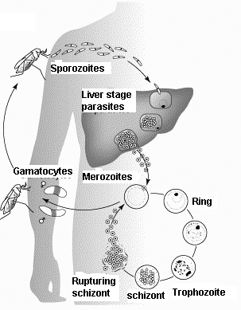
Figure10.1 Life cycle of malaria parasites

The source of malaria infection is either a sick person or a carrier with no symptoms.

Three factors are necessary for the spread of malaria:
- Human beings as the reservoir for human plasmodiae (malaria parasites)
- Parasite (plasmodium) as the infecting agent.
- Anopheles mosquito as the vector from one person to the other.

In falciparum malaria, the incubation period, that is the time between the infective mosquito bite and the disease manifestation, is 10 to 15 days. In vivax, ovale and malariae infections, the incubation period is 10 – 30 days and it may be longer in some strains of P. vivax and P. ovale. The incubation may be prolonged by inadequate use of antimalarials, incomplete prophylaxis and partial immunity.

Any non-immune person who is bitten by an infected mosquito can get severe malaria. If bitten by a mosquito, a partially immune person gets a mild form of malaria.

Naturally, some people are born with some characteristics that protect them from severe malaria. But the most important resistance to the parasite occurs as the body learns to fight the infection. The body fights the malaria parasites by producing antibodies and cells that kill and remove the parasite. This is called immunity. Unlike in other diseases, immunity in malaria is short lived and partial, but it limits the severity of the disease.

In endemic areas with heavy transmission of malaria, such as most parts of Kenya, immunity develops quickly. In such areas, young children have the most frequent and severe attacks of malaria. The young children have not yet developed immunity to malaria. The older children and adults still get malaria, but the attacks become less frequent and less severe as immunity builds up with advancing age.

In non-endemic areas, such as the highland areas, malaria is less common. Therefore, little, if any, immunity develops with advancing age. In such areas, serious attacks of malaria occur at any age.

Pregnancy reduces some of the acquired immunity to malaria and to other diseases. This reduction of immunity exposes the pregnant women to serious malaria attacks. The risk of suffering severe malaria is highest in the first pregnancy.

We hope you know understand what malaria is and its life cycle. Next let us look at its magnitude and effects on our population.

10.2: MALARIA IN KENYA

Malaria remains a serious public health problem worldwide, but more so in sub-Saharan Africa. The grim reality is that in this region malaria kills over 2 million people, including one million young children, every year. Most of the deaths occur in infants, young children and pregnant women.

In Kenya, malaria is the leading cause of morbidity and mortality. It accounts for 30 % of all outpatient attendance, 19% of admissions into the hospitals inpatient, and 30 % of all deaths in children under 5 years of age. The disease tends to be severe in children under five years of age and in pregnant women, especially during the first pregnancy.

Recurrent epidemics of malaria occur in certain parts of the country, such as highland areas of Kisii and Trans-Nzoia districts, (See Figure 10.2 for distribution of malaria in Kenya). Altogether, besides killing many people, malaria contributes greatly to low economic development since work and school time is lost as a result of illness and malaria related health costs are high.

Endemic Areas | Highland malaria districts
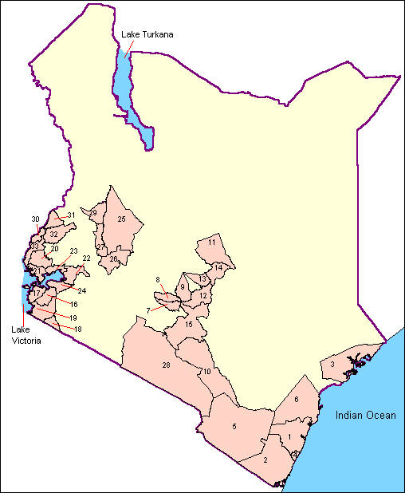 | 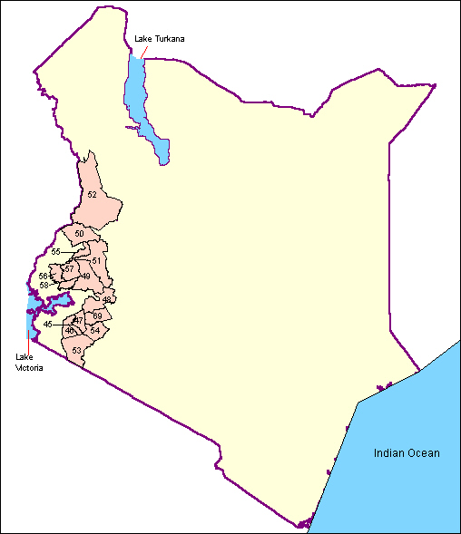
Figure 10.2. Endemicity of malaria in Kenya (Source, Division of Malaria Control Programme

Having learned about the malaria situation in Kenya as a whole, you should now assess the malaria situation in your catchment area. Do the following activity.

ACTIVITY 1

If you are at a health unit, get the outpatient register and calculate the percentages of the top 5 health problems. Do the same with the inpatient register if your health unit admits for inpatient care. Or, if you are a community health nurse, talk to a few families to find out the number of people who have been sick in the past 2 weeks and what diseases they were suffering from.

Then write the top five diseases in the relevant category in the table below.

OPD Attendance | Inpatient Admission | Community members
1. | 1. | 1.
2. | 2. | 2.
3. | 3. | 3.
4. | 4. | 4.
5. | 5. | 5.
What percentage of families said they were sick with malaria?
_________________________________________________________

If you come from one of the areas where malaria is endemic or there is highland malaria, I am sure you found that malaria is the leading cause of sickness in your community. Indeed, malaria is a leading cause of illness and death in this country. This is because, in Kenya, there are many environmental and social factors that facilitate the transmission of malaria. These factors include the:

- Presence of the Anopheles mosquito which transmits the malaria parasites;
- Favourable climatic conditions: temperature, rainfall and humidity;
- Socio-economic/development activities: deforestation, swamp reclamation, brick-making, irrigation schemes, fishing and construction works. All these favour mosquito breeding;
- Migration of people from one area to another;
- A reservoir of malaria infection;
- Susceptible non immune and partially immune hosts.

In addition, certain behaviours of individuals and the community contribute to maintain the high rates of the disease. These behaviours include:

- Late treatment seeking behaviour;
- Non-compliance with treatment schedule;
- Misuse of antimalarials;
- Little or no preventive measures being instituted by the individuals, community and government.

It is evident that human activity has created and continues to create more breeding sites for mosquitoes and yet little or no preventive activities are being carried out. The availability of many brands of antimalarials in the market promotes self-medication. This has greatly encouraged late treatment seeking behaviour as well as misuse of antimalarials by the community and health workers. The previously recommended antimalarials (chloroquine, sulphadoxine, pyrimethamine, and quinine) have been used unjustifiably and indiscriminately. The effect of these practices is the emergence of sulphadoxine-pyrimethamine and chloroquine resistant strains of Plasmodium falciparum.

The interventions employed in the prevention of malaria in Kenya are:
- Early diagnosis and prompt correct treatment.
- Vector control including use of personal protective items.
- Health education.
- Early detection and proper control of malaria epidemics in areas where they occur.

10.3: CLINICAL FEATURES OF MALARIA

You have learned in the first part of this unit that early diagnosis, prompt and correct treatment is a major strategy in controlling and preventing malaria.

How well do you know the symptoms of malaria? Find out by completing the following activity.

ACTIVITY 2

What are the common signs and symptoms of malaria? List them down below.

Signs Symptoms
____________________________ _________________________________
____________________________ _________________________________
____________________________ _________________________________
____________________________ _________________________________
____________________________ _________________________________
____________________________ _________________________________
____________________________ _________________________________
____________________________ _________________________________

As we said earlier, malaria can vary from mild to severe disease. Most people with malaria have complain of the following:

- Fever (hot body) or a history of fever lasting a few days.
- Headache.
- Body and joint pains.
- Feeling cold and sometimes shivering.
- Loss of appetite.
- Sometimes-abdominal pains, diarrhoea, nausea and vomiting.

Whether a patient develops mild or severe disease depends on the following:

- The species of the parasite present.
- The patient’s state of immunity.
- The intensity of the infection.
- The presence of accompanying conditions such as malnutrition, anaemia and other diseases.

We also mentioned earlier that malaria tends to be particularly severe in infants, young children and pregnant women, especially in the first pregnancy.

Let us look at the manifestation of mild and severe malaria.

Manifestations of Mild Malaria.

- Fever is the most common presenting sign. The fever may persist for several days and may be accompanied by headache, aching of joints and general discomfort. The classical presentation of malaria with chills, shivering, high fever and sweating is unusual in infants and young children. You should, therefore, not wait for the classical malaria attack before considering the diagnosis of malaria.

In older children, the classical malaria attack is characterized by 3 distinct stages:

- Cold stage: chills, weariness, headache, nausea, and vomiting.
- Hot stage: Patient feels warmth then changes to intense heat, (temperature 40- 41.1⁰C), severe headache, nausea, vomiting, epigastrial pain, and delirium are common.
- Sweating stage: Profuse sweating occurs as the temperature drops rapidly to normal and the skin becomes cool and moist for 2-3 hours.

The whole attack lasts about 10 hours.

Between the attacks, the patient is afebrile (without fever) for a period of 48-72 hours. The duration of the afebrile period varies with the species of parasites present.

In P. falciparum infections the headache, nausea and vomiting are usually more severe than in P. vivax and other malarial infections. There is also greater tendency towards development of complications such as impaired consciousness, convulsions, heamolytic jaundice and anaemia.

Mortality, therefore, is much higher in P. falciparum than in other forms of malaria. The survivors with a continuing infection because of inadequate or no treatment may suffer for several weeks or months. Such persons usually experience numerous febrile episodes, anaemia and weakness.

- Vomiting and mild diarrhoea. Vomiting is more frequent in acute malaria in childhood than mild diarrhoea. Severe diarrhoea is more likely to be caused by gastrointestinal infections.

- Cough is a common symptom in malaria. The combination of fever, vomiting and cough is very common in acute malaria.

- Convulsions

- Pallor

- Unconsciousness, heart failure and dehydration.

Physical signs of malaria include anaemia, jaundice and hepatosplenomegaly.

Now do the following activity.

ACTIVITY 3

List other diseases that present like or mimic malaria:

What common underlying factors influence the severity of malaria in a child?

Review all the malaria cases, you have seen for the previous 3 months. Record separately all the clinical malaria cases in one column and in another record malaria in combination with other diseases.
What is the percentage of the clinical malaria alone?

The findings from your homework may have revealed that the majority of children with malaria are also suffering from some other diseases. These, as we have mentioned earlier, contribute to the severity of the disease.

In such a situation, malaria or any other disease or even the two diseases together may be missed. This can be detrimental to the child as it may lead to death. This is so because the missed disease or diseases will not be treated in time or will not be treated at all. How, then, can you ensure that malaria and other important diseases are not missed? Correct! Through correct diagnosis.

Diagnosis of Mild Malaria
You should suspect mild malaria in a child who has any of the following:
- fever or history of fever,
- chills,
- splenomegaly,
- anaemia,
- decreased level of consciousness,
- headache,
- vomiting,
- Cough or diarrhoea.

The likelihood of mild malaria is considerably increased by a history of travel or residence in a malaria endemic area, history of recent blood transfusion or intravenous drug use.

If the child is afebrile at the time of examination, a history of recent fever may suggest the possibility of malaria. This is because, in malaria, the fever may be periodic. Malaria can mimic almost any febrile infection and especially Acute Respiratory Tract Infection (ARI), gastroenteritis and meningitis. Both malaria and ARI may cause cough, fever and rapid breathing especially in young children. In infants, the symptoms may be limited to poor appetite, restlessness, and loss of normal interest in the surroundings. Malaria commonly causes vomiting and mild diarrhoea, but severe diarrhoea is more likely to be caused by a gastrointestinal infection. A child with impaired consciousness or convulsions may be suffering from either malaria or meningitis.

You will realise that malaria cannot be diagnosed accurately on the basis of the above signs and symptoms alone. Yet, it is not always possible to take blood films. This means that you, the health worker, will be uncertain at times whether or not a child has malaria.

To help us out of this difficulty, our national guidelines stipulate that all children who have fever or history of fever must be treated for malaria, in addition to treating other present illnesses. An Integrated Management of Childhood Illnesses (IMCI) flow chart is shown in Figure 10.3.

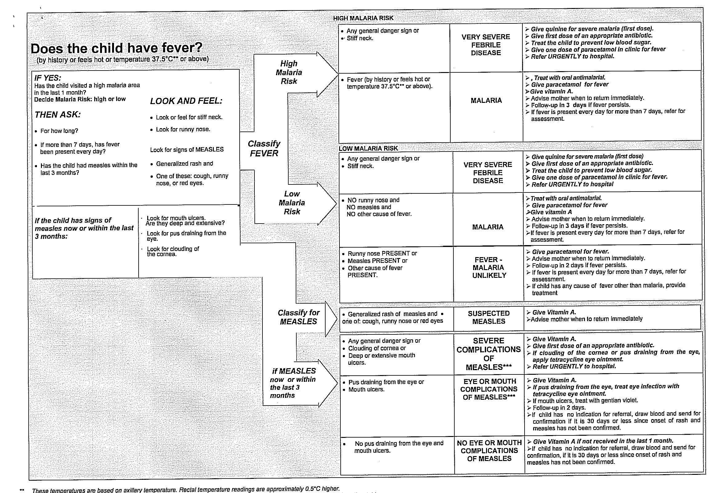
Figure 10.3.Does the child have fever?

ACTIVITY 4

Think about a time when you had to care for a child with severe malaria. What prompted you to decide that it was severe malaria?

What steps did you take in handling the sick child?

Now compare your answers with the information in the following discussion.

Manifestations of Severe (complicated) Malaria.

In our study of the malaria parasite, we mentioned that P. falciparum is one of the four parasites causing malaria in this country. It is this parasite that is responsible for 90% of the malaria cases and it is also the only parasite that causes severe (complicated) malaria. It is, therefore, important for health workers and the community to be clear of the signs and symptoms of severe malaria in order to minimise delays in referring this medical emergency which is most likely to occur in infancy, young children and in pregnancy, especially the first one.

Malaria is severe if a child has one or more of the following complications:

- Repeated vomiting and inability to retain oral medication.
- Inability to eat or drink.
- Failure to respond to initial treatment.
- Difficulty in talking, sitting up or walking (without obvious cause).
- Unexplained heavy bleeding.
- Passage of little or no urine, or passage of dark urine (Black Water Fever).
- Multiple convulsions (2 or more in a 24 hour period).
- Altered consciousness level ranging from drowsiness to coma.
- Jaundice.
- Severe anaemia (Haemoglobin level <5 g / dl, Haematocrit <15%).
- Circulatory collapse or shock.
- Difficult breathing.
- Hypoglycaemia.
- Heavy parasitaemia (parasitaemia >200,000/ ul in high transmission area or 100,000/ ul in low transmission areas).

None of these complications is specific to malaria. Therefore, for each complication always take a case history, examine the child carefully, think of other possible causes and assess the child carefully.

If you happen to have access to laboratory facilities, you can request for either thick or thin films to be done. This will confirm the existence of parasites in the blood although it does not prove that the parasites are causing the illness.

Other important investigations you can rely on include lumbar puncture, which may distinguish malarial coma from meningitis. Also, careful re-examination may distinguish deep breathing from the shallower, laboured breathing of pneumonia.

When assessing a child with severe malaria, ask about:

- Past history including previous malaria attacks.
- Known allergy to antimalarials.
- History of present attack, onset of fever, general condition, convulsions at home, liquid and food intake, urine output and medication taken prior to reporting to you.

You should also check for:

- Clinical signs: pulse, respiratory rate and rhythm, hydration status.
- Signs of other diseases such as meningitis or pneumonia.
- Level of consciousness or alertness.

 | If a child presents with one of the listed complications, you should refer immediately to a more appropriate level of management

Differential Diagnosis
We have already stated that there are many other diseases that present like malaria. The most common of these diseases are:
- Meningitis
- Pneumonia
- Measles
- Otitis media
- Typhoid fever
- Tuberculosis
- Urinary Tract Infections (UTI)
Bearing in mind that fever is common, especially in children and that it has many causes, we should endeavour to identify its most probable causes by careful history taking and examination. Laboratory investigations, where possible, can help in establishing the diagnosis.

10.4: MANAGING MALARIA

Prompt and proper treatment of malaria can avert deaths. Children with mild malaria can develop severe malaria very rapidly. Correct management can prevent children with mild malaria from developing severe malaria. Remember that inadequate treatment, delayed treatment or no treatment at all are the major causes of deaths in severe (complicated) malaria. Lastly, correct treatment can resolve symptoms and reduce parasitaemia rapidly.

What is correct management?

Correct management of malaria is giving the following to the patient, from the moment of presentation:

- the appropriate advice,
- the right drug,
- at the right time,
- in the right dose and
- For the right duration.

This statement implies that once you diagnose malaria, you should advise the patient appropriately, you should prescribe the correct antimalarial drug, administer it in the right dose using the right route and for the right duration until a course is completed. This applies to both oral and injectable drugs. Table. 10.1 gives the artemether-lumefantrine dosage schedule for treating malaria.

To be able to manage malaria properly, you must be able to differentiate mild malaria from severe and know when to refer. This is because each category of malaria requires different treatment.

Management of Mild Malaria:

Children with mild malaria are treated as outpatients. The currently recommended first line drug treatment for mild (uncomplicated) malaria in Kenya is a 6 dose regimen of artemether-lumefantrine tablets given over 3 days following the dosage and the timing schedule in Table 10.1. Each artemether-lumefantrine tablet contains 20 mg of artemether and 120 mg of lumefantrine. The first dose of artemether-lumefantrine is given at the time of diagnosis (0 hour). The second dose can be given between 8 and 12 hours after the first dose. In the second and third day, the tablets are given twice a day (morning and evening). Where malaria is diagnosed in infants below 4 kg (under 2 months of age), the recommended treatment is oral quinine, 10 mg/kg every 8 hours for 7 days

Table 10.1. Dosing schedule of artemether-lumefantrine for treating mild malaria.
Number of tablets per dose to be taken at 0, 8, 24, 36, 48 and 72 hours.
Weight (kg) | Age of patient in yrs | Number of tablets per dose | Content of artemether(A+Lumefantrine(L)
5-<15 kg | <3 yrs | 1 | 20 mg A + 120 mg L
15-<25 | 3-8yrs | 2 | 40 mg A + 240 mg L
25-<35 kg | 9-14yrs | 3 | 60 mg A + 360 mg L
Above 35 kg | >14 yr | 4 | 80 mg A + 480 mg L

The illness and the intended treatment should be explained to the parent or caretaker of the child. The health worker should instruct the mother or caretaker how to give the medicine, demonstrate how to give the medicine and give the mother or caretaker a chance to practise giving the medicine while they observe. The health worker should always watch as the mother gives the first dose of an antimalarial drug and correct any mistakes before the mother or caretaker leaves the health unit. It is very important to observe whether the child vomits the drug or not. If the child vomits, he or she may not get enough treatment and may go on to develop severe malaria.

All children with a high fever (above 38.5°C) should first receive paracetamol (See Table 10.2 for dosage). When the fever has reduced and the child is calm, give the antimalarial with a spoon, cup or syringe (without a needle) after the tablets have been crushed and mixed with water. If possible, a sweet drink or breast milk should be given immediately after the medicine has been swallowed. The child should then be observed for one hour. If the child vomits, the treatment should be repeated (a full dose if the drug is vomited before 30 minutes, a half dose if vomited between 30 minutes and 1 hour). If the child vomits repeatedly, he/she MUST be hospitalised.

If the conditions are such that the treatment can be continued at home, do not forget to teach the parent or caregiver how to give the drugs at home.

TEACH THE PARENT/CARE GIVER TO GIVE ORAL DRUGS AT HOME: Follow the instructions below for every oral drug to be given at home. Also follow the instructions listed with each drug's dosage table.

GIVING ORAL ANTIMALARIALS:
The child must be given 6 doses of artemether-lumefantrine in 3 consecutive days

Table 10.2 Dosage of paracetamol for high Fever

Give paracetamol for high fever (above 38.5°C
 | PARACETAMOL
 | AGE or WEIGHT | TABLET (100 mg) | TABLET (500 mg)
 | 2 months to 3 years  (4 to 14 kg) | 1 | ¼
 | 3 years up to 5 years  (14 to 19 kg) | 1 ½ | ½

Remember to first ensure that you give the correct dose of the prescribed antimalarial for the correct length of time and ask the mother to continue breastfeeding and fluid intake,

Then teach the parents or caregivers the importance of returning immediately if:

- The child's fever persists beyond 2 - 3 days.
- There are signs of severe illness, convulsions, fast breathing, pallor, or jaundice appear.

Management of Severe Malaria:

The ability to manage severe (complicated) malaria differs at various levels of health care. This ability depends on the degree of training and competence of personnel as well as the availability of:

- Laboratory services
- Equipment
- Supplies
- Parenteral medication.

At the community level, the management of severe (complicated) malaria comprises provision of oral therapy, if possible, as well as urgent referral to the nearest appropriate health facility.

At the first level of referral health facilities, such as aid posts and sub dispensaries, it is often difficult to manage severe cases adequately. This is because of unavailability of appropriately qualified and trained personnel, drugs, supplies and equipment. Before urgently transporting the children with severe malaria to the nearest hospital, the health worker at the clinic should:

- Give pre-referral intramuscular injection of diluted quinine 20 mg/kg. (See Table 10.3). The dilution is done because diluted quinine is better absorbed and is less painful. The dilution is done using a 10 ml syringe into which 5 ml of water for injection is drawn. Into the same syringe, 300 mg (1 ml) of quinine is drawn to obtain 50 mg of quinine per ml. The drug is mixed by shaking before injection. Not more than 3 ml is injected into one injection site. One to 4 injection sites may be required for amounts more than 3 ml. (See Table 10.3);
- Treat convulsions with intrarectal diazepam (0.4 mg/kg);
- Give oral fluids and advice on adequate nursing care during transportation;
- Write a referral note clearly stating the drugs already given, dosage, route, date, time of administration, a brief description of the child's clinical history and examination findings.

.
Table 10.3.Dosage of intramuscular injection of quinine after dilution

Body weight | Volume of diluted quinine  to be injected | Number of injection sites
Under 5 kg | 1.0 ml | One
5.1- 7.5 kg | 1.5 ml | One
7.6 -10 kg | 2.0 ml | One
10.1-12.5 | 2.5 ml | One
12.6 -15 | 3.0 ml | One
15.1 -17.5 kg | 3.5 ml | One
17.6 -20 kg | 4 ml | Two
20.1 -22.5 kg | 4.5 ml | Two
22.6 -25 kg | 5.0 ml | Two
25.1 -27.5 kg | 5.5 ml | Two
27.6 -30 kg | 6.0 ml | Two
30.1 -32.5 kg | 6.5 ml | Three
32.6 -35 kg | 7.0 ml | Three
35.1- 37.5 kg | 7.5 ml | Three
37.6 – 40 keg | 8.0 ml | Three
40.1 -42.5 kg | 8.5 ml | Three
42.6 -45.0 kg | 9.0 ml | Three
45.1 -47.5 kg | 9.5 ml | Four
47.6 -50 kg | 10.0 ml | Four
50.1-52.5 kg | 10.5 ml | Four
52.6 -55.0 kg | 11.0 ml | Four
55.1 -57.5 kg | 11.5 ml | Four
57.6 -60 kg | 12.0 ml | Four
60.1 -62.5 kg | 12.5 ml | Four
62.6 -65.0 kg | 13.0 | Four
65.1 -67.5 kg | 13.5 ml | Four
67.6 -70.0 kg | 14.0 ml | Four
70.1- 72.5 kg | 14.5 ml | Four

In the absence of quinine, give a pre-referral intramuscular injection of either artemether 3.2 mg / kg body weight or artesunate 2.4 mg /kg body weight or give rectal artesunate 10 mg /kg body weight (see tables 10.4 for dosage of artesunate suppositories). If the suppository is expelled within one hour, another suppository should be reinserted and a second dose given after 24 hours if referral for parenteral therapy is not possible.

Table 10.4. Dosage Schedule for Artesunate Suppositories.
Weight | Age | Number of 100mg  Suppositories | Number of 400 mg  Suppositories
10 – 19 kg | 1 -5 yrs | 1 | -
20 – 29 | 6 –7 yrs | 2 | -
30 – 39 | 8 – 12yrs | 3 | -
40 – 49 | >12 yrs | - | 1
50 – 92 | >12 yrs | - | 2
Above 92 | >12 yrs | - | 3

Management of Severe (Complicated) Malaria at Hospital:

On admission, assess the child's condition according to the guidelines given below:

Ask about:
- Past history including previous malaria attacks, known allergies to antimalarials.
- History of present attack, including onset of fever, general condition, convulsions at home, liquid and food intake, urine output, self-medication prior to being admitted.
Check:
- Clinical sings: pulse, respiratory rate and rhythm, hydration status.
- Signs of other diseases such as meningitis or pneumonia.
- Level of consciousness using a coma scale you are familiar with.
- For example:
A = 0 Is the child Alert?
V = 1 is the child responding to Voice?
P = 2 Is the child responding only to Pain?
U = 3 Is the child Unresponsive to stimulation?
- Laboratory findings: parasite counts, haemoglobin or haematocrit, glucose level.

Monitor the child carefully. Place the child in bed where the nurses can observe easily and frequently.

Give intravenous quinine 20 mg / kg loading dose in 15 ml/kg of normal saline or 5 % dextrose to run over 4 hours. 12 hours after the start of the loading dose, give more quinine 10 mg / kg in 10 ml/kg of normal saline or 5 % dextrose to run over 4 hours. Repeat the same dosage 12 hourly until the patient can take the medication orally. Complete the treatment with a full course of artemether-lumefantrine (See Table 10.1) or oral quinine 10 mg /kg twice daily to complete a total of 7 days of quinine. (See Table 10.5).

Table 10.5.Dosage schedule for quinine tablets.
Quinine 300 mg salt (sulphate, dihydrochloride hydrochloride)

WEIGHT IN KG | NO OF TABLETS
6-11 kg | ¼
12-17 kg | ½
18 -23 kg | ¾
24-35 kg | 1
36-47 kg | 1 ½
48 and above | 2
Quinine sulphate salt 200 mg
WEIGHT IN KG | NO OF TABLETS
4-7 | ¼
8-11 | ½
12-15 | ¾
16-23 | 1
24-31 | 1½
32-39 | 2
40-47 | 2 ½
48 and above | 3

Check:
- IV drip rates and site hourly until the child is stable, then reassess fluid requirements.
- Urine output and hydration status hourly during the start of treatment and then twice hourly until the child is stable.
- The pulse, respiratory rate and rhythm, coma score every two hours until the child wakes up and is stable.
- Haemoglobin or haematocrit after 3 to 4 hours if the child had severe pallor on admission, or at any time if signs of heart failure appear.
- The child's blood sugar level: at the end of the quinine loading dose and if there is any deterioration in the level of consciousness or any convulsion.

A doctor should review the child at least twice a day or any time the child's condition deteriorates. If coma and fever persist, be aware of other conditions that are associated with severe malaria, for example, meningitis, pneumonia or sepsis.

The Principles of Management of Severe Malaria.

The principles of managing severe malaria include the following:

- Giving appropriate dosages of antimalarials. In this country the treatment of choice is intravenous infusion of quinine. Intramuscular injection is given where intravenous route is not possible.
- Close monitoring and nursing of the child to recognise, prevent and treat complications such as severe anaemia, convulsions and hypoglycemia.

Children with severe malaria often have other infections at the same time, especially meningitis and pneumonia. They should also be treated for these diseases. Such children should be carefully examined twice a day or any time that their condition does not improve or gets worse.

Supportive Care
Nurse an unconscious child on his or her side. Encourage the parent or carer to turn the child every 2 - 3 hours and to change soiled or urine soaked linen. Clean the child's eyes and mouth regularly. And when the child is conscious, encourage liquid intake or breastfeeding.

ACTIVITY 5

Give a reason why it is important to treat malaria in pregnancy as an emergency:

Describe three possible effects of malaria in pregnancy:

The health of the unborn baby depends on the wellbeing of the mother. List four things you should do during antenatal care to safeguard the unborn baby and the mother from the effects of malaria:

10.5: MALARIA IN PREGNANCY:

Falciparum malaria in pregnancy carries a high mortality for the foetus and in areas of low communal immunity also for the mother. For this reason, malaria in pregnancy is regarded as a serious illness and should be treated as an emergency. Malaria in pregnancy, therefore, is managed as severe (complicated) malaria especially in first-time mothers.

As health workers caring for pregnant women, we must know how malaria affects a woman and her unborn child. The pregnancy, especially the first one reduces a woman's ability to fight malaria. As a result malaria attacks are common in pregnancy. Women with reduced immunity are at a particularly high risk of getting:

- Cerebral malaria.
- Complications associated with high fever.

Pregnant women even those with immunity, have attacks of malaria more often and more severely than non-pregnant women in the same area. Pregnant women are also more likely to die from malaria if they are not well managed. The effects of malaria on pregnancy are summarized in Table 10.6 below. .

Table 10.6 Effects of Malaria in Pregnancy
Condition | Possible Effect | Notes
Severe Anaemia | Heart failure, poor fetal growth, premature labour, stillbirth, shock, more risk of infection, slow recovery after birth | Usually occurs before 30 weeks of pregnancy. A woman with pregnancy-induced hypertension may have similar symptoms, but it is more likely to occur later in pregnancy (after 30 weeks).  Malaria parasites in the placenta ‘block’ the flow of oxygen and nutrients from the mother to the baby.  Anaemic women are more prone to shock if they bleed heavily during delivery.
High fevers | Miscarriage, premature labour, stillbirth | High fever during labour can cause complications.
Cerebral malaria | Confusion, coma, convulsions | These signs may also be caused by meningitis, epilepsy, hypertension or eclampsia.
Transmission to the foetus | Congenital malaria | Babies can be born with malaria or develop it very soon after delivery due to parasites passing through a damaged placenta before or during delivery.

The adverse effects of malaria on pregnant women and their babies can be averted through timely prevention of malaria in pregnancy. In the prevention of malaria in pregnancy, the health workers involved in antenatal care should play four important roles:

- Screening: At the beginning of pregnancy or each time a pregnant woman is referred to a different health worker, ask:

- Where she lives;
- Where she has come from;
- How many pregnancies she has had.

A woman is most at risk of malaria infection during her first pregnancy. She is also at risk if she has moved from an area with little malaria to an area where malaria is endemic.

Check for the following:
- Check if the woman is already anaemic. Does she have pale conjunctiva or palms? Does she have a history of previous pregnancies or illness that suggests anaemia? A woman may be anaemic before she starts her pregnancy due to poor nutrition, frequent pregnancies, malaria or hookworm. A pregnant woman with these conditions is likely to develop severe anaemia if she suffers repeated malaria attacks.
- Check haemoglobin level and where appropriate do a sickling test and examine the stool test for hookworm.
- Check if she has fever. If a pregnant woman has fever or a history of fever, malaria should always be suspected along with other pregnancy related causes of fever such as urinary tract infection. If possible, a blood slide for malaria parasites should be taken.

- Monitoring: At every visit:
- Examine the mother for signs of anaemia and malaria.
- Monitor foetal growth by examining the abdomen.

- Treat complications:
- At all stages of pregnancy, problems found through screening, monitoring or mentioned by the mother should be treated.
- Pregnant women with convulsions, high fever or severe anaemia should be referred for more specialised care. Treat malaria as you detect it in all pregnant women in malaria endemic area. All pregnant women with mild malaria should get a 7 day course of oral quinine in all trimesters. Artemether-lumefantrine can be given in the first trimester if quinine is not available. Further, in malaria endemic areas, all pregnant women should get intermittent preventive treatment with 3 tablets of sulphadoxine 500 mg pyrimethamine 25 mg at the beginning of their third trimester (28 – 34 weeks) and one month thereafter. Women known to be HIV infected and women with unknown HIV status but living in areas of high HIV prevalence (>10 % among pregnant women) should receive at least 3 doses of intermittent preventive treatment at intervals of at least one month.
- Supplements of folic acid, zinc and iron should be given.

- Give Health education: In areas where malaria is endemic, pregnant women should be warned that they are at a high risk of anaemia and fever. Use of personal protectors, such as sleeping under a mosquito net (insecticide impregnated or not) prevents mosquito bites. Anaemia is a potential risk for all pregnant women. Encourage them to eat more locally available foods rich in iron such as:
- Dark green leafy vegetables
- Egg yolk
- Meat (liver & kidney)

They can, in addition, eat peas, peanuts, sweet potatoes that are rich in folic acid.

10.6 CONTROL AND PREVENTION OF MALARIA IN THE COMMUNITY

As a health worker, you must have realised how dangerous malaria is. It causes a lot of absenteeism in school and in work places. I suppose you have also experienced how difficult it can be to manage a child with severe or complicated malaria. Worse still, malaria can kill. It is therefore important that we try to control malaria transmission and if possible prevent it.

At the beginning of this unit, you learnt that malaria is transmitted by a mosquito. There are over one hundred different species of mosquitoes in Kenya. However, only the Anopheles mosquitoes transmit malaria. To distinguish Anopheles from nuisance mosquitoes, look at how the mosquito rests on the wall. The Anopheles holds its abdomen in the air and flies soundlessly. This is important because when you see many Anopheles mosquitoes, you should inform the Public Health Officer or Public Health Technicians so that appropriate action can be taken. Remember that the number of cases of malaria is related to the number of malaria transmitting mosquitoes. The number of mosquitoes, too, depends on the temperature, rainfall and mosquito control activities such as spraying.

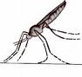
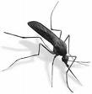

Anopheles
Other Mosquitoes

Fig. 10.4: Resting Positions for Anopheles and Other Mosquitoes

For breeding, mosquitoes need water. This is why the rainy season is so important for transmission of malaria. During the dry season, there is little surface water for mosquitoes breeding.

Activity 6

From the records in your health unit, calculate the percentages of malaria occurring in each month for the past one year. On a separate piece of paper, plot this on a bar chart.

Which months have the highest transmission? _____________________________
Which months have the lowest transmission? ______________________________
When is the rainy season? _________________________________________
When is the dry season? ___________________________________________
What is the relationship between malaria and the seasons of the year?
_______________________________________________________________
_______________________________________________________________

From your bar chart, you may have noticed that malaria peaks at the beginning and the end of the rainy periods. You should note that very heavy rainfall tends to wash away the immature stages of the mosquito. You should use this information to help you plan your malaria control activities at the health facility and in the community.

For example, you can order enough stocks of antimalarials for the health unit depending on the period of the year, if your local climatic conditions do not vary much from year to year.

You also learnt earlier in this unit that epidemics of malaria occur in the highlands of this country. This is because malaria is affected by altitude. High altitude is usually associated with low temperatures that do not favour mosquito breeding. Environmental degradation, coupled with climate change in these areas, has raised overall temperatures to levels favourable for mosquito breeding. This mosquito breeding in the highlands has introduced malaria in once malaria-free areas. Communities in these areas are now at risk of having many people suffering from malaria at the same time.

ACTIVITY 7

Why is it important to cover water containers?

The life history of a mosquito is very short, which is why mosquitoes increase rapidly when it starts to rain (see figure 10.5). The female mosquito lays 40 to 200 eggs in or near clean water. The eggs hatch after 24 hours and turn into larvae. The larvae mature and turn into pupae (4 – 5 days). The adult insect forms inside the pupae. When the adult is ready to emerge, the skin of the pupae ruptures and the mosquito flies away. The whole cycle takes seven days in ideal conditions, although it can take as long as 21 days.

The adult mosquitoes mate immediately after emerging out of the pupa. The female will then seek a blood meal (preferably human) to help the eggs to mature. If she succeeds in feeding on a person, the eggs mature and she will begin laying eggs in 3 days.

Anopheles mosquitoes become infested with malaria parasites by feeding on a person who has malaria. The malaria parasites develop for 10 days before the mosquito can transmit them during the next bite. Therefore, the mosquitoes have to live for 2 to 3 weeks before they can transmit malaria. Spraying of walls and the use of other methods of killing the mosquito adults destroys them before they are able to spread the malaria parasites.

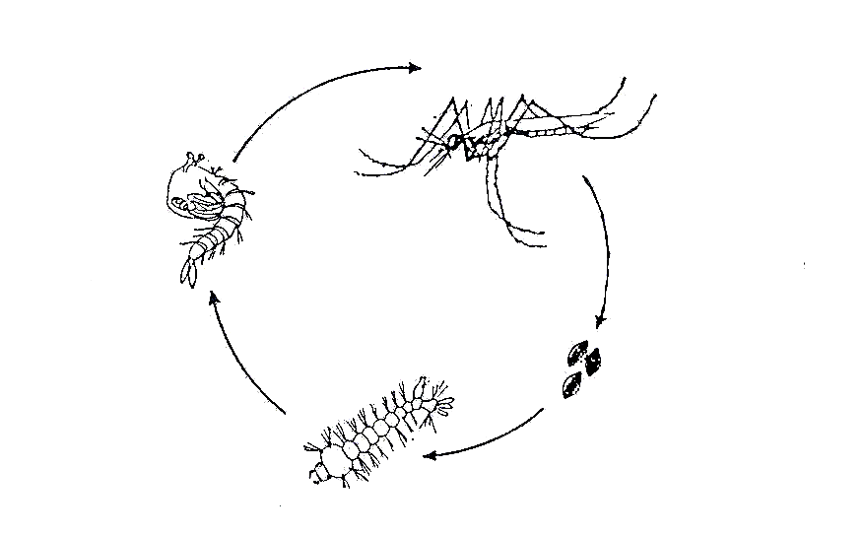

Fig. 10.5: Life cycle of a mosquito

Now that we know the life cycle and habitats of mosquitoes, we can carry out certain control measures directed at killing the immature stages and the adult mosquitoes. We can also prevent mosquitoes from biting people. This can be done by an individual, a household, or the community.

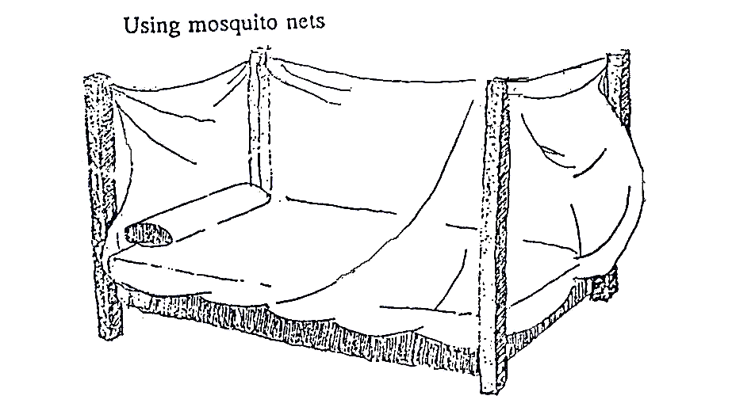

Fig. 10.6: Use of Insecticide Treated Mosquito Nets to avoid mosquito bites

What can the individual do?

- An individual can prevent mosquitoes from biting him/her and his/her family by:
- Wearing protective clothing to minimize the exposure of the skin to the mosquitoes
- Using mosquito nets, insecticide treated or not
- Netting especially of the windows
- Indoor spraying
- Use of insect repellents such as mosquito coils
- Limiting outdoor activities from dusk to dawn, the time when transmission mostly occurs

- An individual can also seek treatment early to destroy or eliminate the malaria parasites.

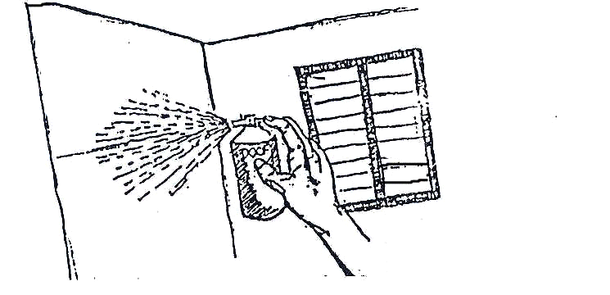
Fig. 107: Spray against Mosquitoes

What can the community do?

A community can:
- Fill in potholes, drain swamps, remove water containers (cans, tyres, etc), control water weeds and improve water courses to prevent or reduce the breeding of mosquitoes.

- Destroy the larvae of mosquitoes in possible breeding sites by applying larvicides. This can be done in towns or urban centres but it is not cost effective in rural areas.

What else can be done?

- In collaboration with other relevant actors, you the health worker can plan educational programmes to make the community aware of the measures they can take.

- Chemoprophylaxis is very effective but is not a replacement for the above measures. The current situation in Kenya is that:

- There is no need for a person who has always lived in a malaria area to take chemoprophylaxis. This lowers his resistance to the disease.
- People who travel from malaria free areas to malaria infested areas must take either mefloquine, atovaquin-proguainil or doxycylene .( See Tables 10.7, Table 10.8 and Table 10.9 for dosages)
- Children with sickle cell disease should be given chemoprophylaxis with proguanil, available under the brand name Paludrine, for life. (see Table 10.9 )
- Patients with tropical splenomegaly (hyperimmune malaria splenomegaly) should also take proguanil;
- In the endemic areas, intermittent preventive treatment should be given to the pregnant women at the beginning of the 2nd and third trimesters as discussed earlier.

Below are the formulations and dosage schedules of the chemoprophylactic agents.

Mefloquine is available in two formulations: mefloquine hydrochloride 274 mg containing 250 mg of the base and mefloquine hydrochloride 250 mg containing 228 mg of the base. Mefloquine is administered once weekly at a dose of 5 mg/kg body weight to a maximum of 250 mg (see table 10.7). Mefloquine is started 2-3 weeks before departure, taken during the whole stay in the malaria endemic area and continued for 4 weeks after leaving the malaria endemic area.

Table 10.7 Dosing schedule of mefloquine.

Weight | Age | No of tablets per week
<5 kg | <3months | Not recommended
5-12 kg | 3-23 months | ¼
13-24 kg | 2-7 years | ½
25-35 kg | 8-10 years | ¾
36 and above | 11 years and above | 1

The most common side effects of mefloquine include nausea, vomiting, abdominal pain and diarrhoea; these side effects are dose related and self-limiting. Central nervous system related side effects include dysphoria, dizziness, ataxia, headache, some visual and auditory disturbances, sleep disturbances, nightmares and convulsions.

Mefloquine is contraindicated during the first trimester of pregnancy and in infants less than 5 kg.

Atovaquone-Proguanil
Atovaquone-proguanil is available in two formulations. The adult tablets are film coated and contain 250 mg of atovaquone and 100 mg of proguanil hydrochloride. The paediatric tablets contain 62.5 mg of atovaquone and 25 mg of proguanil hydrochloride.

Atovaquone-proguanil is taken daily starting 1 day before departure to a malaria endemic area, taken throughout the stay and continued for 7 days after leaving the malarial area (see Table 10.8 for dosage).

Table 10.8 Dosage of atovaquone-proguanil 62.5 mg and proguanil 25 mg tablets

Weight | Number of tablets | Daily dose  Atovaquone(A)+proguani(P)
<11 kg | Not recommended
11-20 kg | 1 | 62.5mg A+ 25 mg P
21-30 kg | 2 | 125mg A + 50 mg P
31-40 kg | 3 | 187.5 mg A+ 75 mg P

Atovaquone-proguanil should be taken with food or milk at the same time daily. Its side effects include abdominal pain, nausea, vomiting, diarrhoea, headache, anorexia and coughing.

Atovaquone-proguanil is contraindicated in pregnancy, in persons with hypersensitivity to atovaquone and or proguanil and caution is indicated in patients with renal failure.

Doxycyclene
Doxyclene is available in two formulations: tablets containing 100 mg of doxycylene hydrochloride and capsules containing 100 mg of doxyclene hydrochloride.
Doxyclene is taken daily starting 1 day before departure to a malaria endemic area, taken throughout the stay and continued for 4 weeks after leaving the malarial area (see 10.9)
Table 10.9 Dosing schedule of doxyclene.

Weight in kg | Age in years | No of tablets
<25 | <8 | Contraindicated
25-35 | 8-10 | ½
36-50 | 11-13 | ¾
50 and above | 14 and above | 1

Proguanil
Proguanil is available in tablets of 100 mg of proguanil hydrochloride containing 87 mg of proguanil base. It is taken daily at a dose of 3 mg/kg starting 2 days before travel and continued for 4 weeks after leaving the malarial area. In sickle cell disease patients proguanil is administered for life. Table 10.10 shows the dosing schedule of proguanil.

The side effects of proguanil, when given at low dose, are most commonly nausea, and diarrhoea and rarely hair loss and mouth ulcers. At high doses, proguanil may cause abdominal pain, vomiting, and haematuria.

The use of proguanil is contraindicated in patients with liver or kidney dysfunction. Antiacids, for example, magnessium trisilicate, decrease the absorption of proguanil.

Table 10.10 Dosage schedule of proguanil.

Weight | Age | Number of tablets per day
5-8 kg | <8 months | ¼
9-16 kg | 8 months-3 years | ½
17-24 kg | 4-7 yrs | ¾
25-35 kg | 8-10 yrs | 1
36-50 kg | 11- 13 yrs | 1½
50 + kg | 14+ yrs | 2

Chemoprophylaxis and other preventive measures are not 100% effective. It is still possible for people to develop malaria 3 months after travelling to an an endemic area. That is why history of travel is important when taking the history of a patient who presents with malaria like symptoms. These people should seek medical care immediately.

SUMMARY

In this unit we have learnt that children and pregnant women are most vulnerable to malaria. We have emphasised the need for early diagnosis and adequate treatment of children with malaria with the recommended antimalarials in the country. We also have pointed out the fact that children with malaria may also be suffering from diseases like diarrhoea, acute respiratory infection, or anaemia. We should, therefore, also treat these diseases while we treat malaria.

Well done! You have now completed this unit on malaria. I hope you have benefited and that you will improve your performance as far as malaria management, control and prevention is concerned. I suppose you now know which role to play and you can now identify people with whom to work in the fight against malaria in your home, place of work and community.

Take a rest. But before going on to the next unit, please complete the Tutor Marked Assignment and send it to us for marking and comments.

Best wishes.


DIRECTORATE OF LEARNING SYSTEMS
DISTANCE EDUCATION COURSES

TUTOR MARKED ASSIGNMENT

 | Student Number: _______________________________  Name: ________________________________________  Address: _______________________________________  _______________________________________________

CHILD HEALTH COURSE
Unit 10: Assignment
MALARIA

Read the instructions attached to each question carefully and answer all the questions.

1. Circle The Best Answer:

- Which is not true about malaria in Kenya?
- It is the leading cause of morbidity and mortality
- It kills more children < 5 years and pregnant women
- It is an immunisable disease
- Its endemicity levels range from meso endemic to hyper endemic in some parts

- Severe malaria in children is caused by:
- Late treatment
- Plasmodium falciparum
- Wrong treatment
- Other infections present
- Mosquito bite

- A 4-year-old child is brought to you with convulsions. When his temperature is taken, it is found to be 40° C.

- What history would you take in the above case?

- What examination would you do?

- What conditions could this child be suffering from?

- Suppose you have ruled out all other conditions and you think it is malaria. What treatment would you give this child?

- Name two groups for whom prophylaxis are desirable:

- What advice can you give to the following to prevent attacks of malaria?

- Parents:

- Pregnant mothers

Congratulations! You have now come to the end of this unit.

Should you have any question regarding this unit write to your tutor for clarification. Remember to indicate your Student Number, name and address before sending this assignment to us at the following address:

Directorate of Learning Systems
Distance Education Programme
AMREF Headquarters
P O Box 27691-00506
Nairobi, Kenya
Email: amreftraining@amrefhq.org

