# Module 5

## Database Management using OpenOffice Base

### 

### Module Overview

Welcome to Module 5 - Database Management using OpenOffice Base.

This module explores the building of a database using the OpenOffice 3.0 Base software application. The module is intended to be very hands-on and focus upon two primary areas: the **how** and **why** of designing and implementing a database, and to develop a basic understanding of relational database theory.

This balance of practice and theory is intended to bring greater design strength and data integrity to your database applications.

|  |  |
| --- | --- |
| Outcomes | Upon completion of this module you will be able to:   * Describe a database and how it can be utilised * Discuss the difference between a database and the other applications * Understand how databases are organised and operated * Create a simple database and view database content in various modes * Create a table, define and modify fields and their properties; enter and edit data in a table * Sort and filter a table or form: create, modify and run queries to retrieve specific information from a database * Understand what a form is and create a form to enter, modify and delete records and data in records * Build queries to retrieve and sort data * Create routine reports * Build and print reports for regular and ad hoc reporting of data   **Terminology** |



|  |  |  |
| --- | --- | --- |
|  | **Database** | A database is a collection of related information which is organised into a series of rows (called records) and columns (called fields) that are populated with data. |
| **Data** | Data is a series of individual facts. |
| **Information** | Information is the result of the organisation, processing, and interpretation of data. |
|  | **Database Management System (DBMS)** | The computer program used to manage and query a database. |
|  | **Data Normalisation** | A method used in designing the structure of your database. In its simplest form database normalisation is meant to increase the accuracy and consistency of the data stored in the database. |
|  | Database Keys | A field in a database that is unique for each record in the database. |
|  | **Database Indexes** | A database index is a data structure that improves the speed of operations on a database table. |
|  | **One-to-One Relationships** | One-to-One table relationships exist when two tables are related by a single row. For every row in one table there can be either zero or one row in the other table. |
|  | One-to-Many Relationships | One-to-Many table relationships exist when many records in one table relate back to a single row in another table (the parent). For every row in one table there can be either zero or many rows in the other table. |
|  | Many-to-Many Relationships | Information is the result of the organisation, processing, and interpretation of data. |

#### 

#### Preknowledge

Before beginning this module, we recommend you:

* study modules 1, 2, and 3 before this one, because they provide the essential knowledge for you to work with databases, including saving files, formatting text and retrieving information from other files
* in specific, complete module 4 before this one, as it will provide you a deeper understanding of how to identify and organise elements of data. Knowledge of spreadsheets is required as during this module we discuss the similarities and differences of databases and spreadsheets
* think about an environment where databases are needed to manage learners, customers, friends, CDs, etc.
* gather some written or printed copies of forms and reports from within the above environments to use as reference when you think about building a database

### Introduction to Databases

#### Section Overview

The focus of this section is on the difference between data and information and an understanding of a database and how it can be used to gather, store and report on data.

OutcomesUpon completion of this section you will be able to:

* understand what a database is and how a database is organised (tables, records and fields)
* describe the difference between data and information
* understand the roles in the design, development, and maintenance of databases
* explain how databases are used within different domains
* compare and contrast the database from other OpenOffice applications

#### Data and Information

You have used the following table in Module 4.

##### What is Data?

This is an example of **data** collected at Vancouver International Airport.

**Data** is a collection of facts.

**Precipitation for Vancouver International Airport**

| **Year:** | **2005** | **2006** | **2007** |
| --- | --- | --- | --- |
| **January** | 249.6 | 283.6 | 181.4 |
| **February** | 45.8 | 57.0 | 116.0 |
| **March** | 132.8 | 92.4 | 214.8 |
| **April** | 90.2 | 70.0 | 76.2 |
| **May** | 68.6 | 42.8 | 37.0 |
| **June** | 49.6 | 54.4 | 80.0 |
| **July** | 43.6 | 25.2 | 53.0 |
| **August** | 28.6 | 4.8 | 8.4 |
| **September** | 53.6 | 39.4 | 73.6 |
| **October** | 155.4 | 57.8 | 155.2 |
| **November** | 136.6 | 350.8 | 116.2 |
| **December** | 160.8 | 146.0 | 210.6 |

In module 4 you have taken this data and calculated the average precipitation at Vancouver International Airport and produced a graph that illustrated which months get the highest and which months get the lowest rainfall.

When you did the calculations and draw the graph, you have changed the data to **Information.**

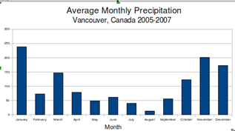

#### Database Concepts

##### What is Data?

Data is a collection of facts. Data is the lowest level facts from which information and knowledge are derived.

##### What is Information?

##### Information is the result of processing, manipulating and organising data in a way that adds to the knowledge of the person receiving it.

##### What is a Database?

If you are familiar with spreadsheets, you will understand databases very easy.

A database is an integrated collection of logically related data and consists of objects such as tables, queries, reports, and forms.

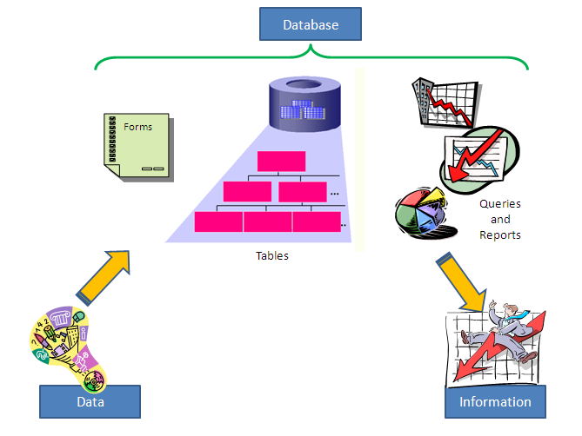

##### What is a Table?

A table in a database contains data to a single subject type.

A table consists of a series of rows (called records) and columns (called fields) that are populated with data. You use tables to store data about a specific category, such as customer or employee details (remember how you did it in a spreadsheet).



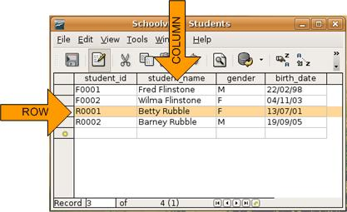

Record

Databases use a series of tables to store the data.



A table simply refers to a two dimensional representation of data using columns and rows.

For example:

|  |  |  |
| --- | --- | --- |
| Peter | Posthumus | peterp@huh.com |
| Paul | Murray | paulm@concorde.com |
| Mary | Daniels | mdaniels@caddy.com |
| John | Rosthom | rosthom.j@maddog.com |

Each database **table** must have a **unique name**. Without a unique name the DBMS (DataBase Management System) would get very confused and not find the data in a table.

Each **column** in the table is also given a **unique name**. In the example above it would be something like **first_name, last_name, email**. This doesn't mean each column name has to be unique within the entire database (collection of tables). It only has to be unique within this table.



Also notice that the names don't use any spaces. **When naming tables and columns be sure to keep it simple with letters and numbers**. Spaces and symbols can be illegal characters, so if you need to clarify a name use the "_" instead of spaces.

**Table name:** contacts

|  |  |  |
| --- | --- | --- |
| **first_name** | **last_name** | **email** |
| Peter | Posthumus | peterp@huh.com |
| Paul | Murray | paulm@concorde.com |
| Mary | Daniels | mdaniels@caddy.com |
| John | Rosario | rosario.j@maddog.com |

##### What is a record and what is a field?

Record

Each table row that contains several data entries related to each other represents a record. That means a row consisting of a person’s name, address, telephone number and age can be seen as a record.

The table above consists of 4 records.



Each piece of information in a record is called a field. You can identify a field by a field name, such as Name or Address. Each field contains the same attributes.

In the example above, the table contains 3 fields viz.: first_name; last_name and email.

The content in each field can be of a certain **type.** The main types are:

| Data Type | Description |
| --- | --- |
| Text | You cannot perform calculations on numbers stored in a text field. Each number is regarded as a character, therefore if you want to store a telephone number then use a Text field - 0 at the beginning will be displayed). Normally the size is 255 characters. |
| Memo | If you want to type long text, use the memo field. It is normally used for storing comments and general notes. Memo fields can hold up to around 64,000 characters. |
| Number | Entering numeric values only and with the view to calculate with other numeric fields, such as quantities or prices. Different number sizes can be chosen for varying ranges. |
| Date/Time | Enter valid dates and times only. The format can be modified. This type of data is numeric and therefore can be calculated too, e.g. to calculate a time period. |
| Currency | Enter currency or monetary values. The currency style format can be modified. |
| AutoNumber | Automatically generate the next number when a new record is added. This field is useful for creating a unique record ID. *You cannot edit this type of field*. |
| Yes/No | Enter fields that can only use one of two values. For example, whether a product is discontinued is either true or false, so a Yes/No field would be a good choice. This is a logical value and is deemed numeric *(True = -1 and False = 0)*. |



This allows consistency in size (you can set the number of characters per field) and format (to keep consistency in date/time/currency/number). This makes it possible to search, sort and to link data.

You can also set the **default value** for a field, e.g. you can choose a default for a field as **No**, and then you can change it to **Yes.** It makes the input of data easier.

To summarise, the data is the raw information that is entered and makes up the records and fields in the database while the resulting information is the processed data.

At this point, you’re probably asking an obvious question – if a database is so much like a spreadsheet, why can’t I just use a spreadsheet?

Databases are actually much more powerful than spreadsheets in the way you’re able to manipulate and report on data. Here are just a few of the actions that you can perform on a database that would be difficult if not impossible to perform on a spreadsheet:

* Retrieve all records that match certain criteria
* Update records in bulk
* Cross-reference records in different tables
* Perform complex aggregate calculations

The purpose of organising data into a database is to answer queries and write reports, therefore turning the data into information.

**Key Point:**

**Data** is a series of individual facts – for example, the annual average global temperature readings for the past 60 years are data.

**Information** is the result of the organisation, processing, and interpretation of data – for example, the annual average global temperature has shown a rising trend over the last 60 years.

The computer program used to manage, query and report a database is known as a database management system (DBMS). A well constructed database should make it easy to manage information quickly and effectively, and to ensure the data stays accurate over a period of time.

It should be noted that database records have existed for ages in non-electronic forms, any form of recording data in ledgers, notebooks and other collections of data could also be considered databases.

There are two categories of databases:

* A **flat file** database contains all the data in a single table. All the information of for example learners in a school is contained in one table with multiple fields. This makes a database very big and slow to run queries and reports.
* A **relational database** stores data in multiple tables. In relational databases, you can store data in categories using multiple tables. For example, you can keep all the basic information of learners in one table, the information on their subjects in another, and parent data in another. You can create a link between these three tables by using a common field, such as Learner ID, contained in all the three tables. You can use the database to create a mailing list of all the learners who are in a specific class. You can then send circulars for a specific grade to them. The database assembles the appropriate data from the tables to give you the information as a single report.

##### Database Development/Use Roles

Professional databases are designed and created by database specialists. Common roles in the design, development, and maintenance of databases are:

###### Database Designer/Database Analyst

Traditionally, databases were designed by a database designer or database analyst. More and more, these roles have been taken or by the database administrator, who has a great understanding of the database management system (DBMS) in use by the organisation.

###### Database Developer

These are the programmers who actually build the database based on recommendations of database designers, analysts, and administrators.

###### Database Administrator

In addition to database design, the database administrator is responsible for:

* installing new versions of the database software on users’ computers
* monitor and administer database security
* analyse the data and recommend changes to data organisation
* data modeling and optimisation
* disaster recovery in the event of a system crash or major errors in the DBMS

###### User

Database users carry out the data entry, data maintenance, and information retrieval from the database.

##### Domains and Uses of Large-Scale Databases

Databases are used in many different domains, a few worth considering would be:

1. **Personal Banking** - whenever you use a counter, bank machine or ATM all the data regarding your transaction is saved to a database. This makes it more efficient for creating bank statements, reports and for auditing bank accounts.
2. **Health Care** - It is normal that all the data from your visits to the doctor or clinic are recorded in a database. This makes it easier for doctors and health care workers to see your health history and make better decisions regarding treatment and advice. Governments are looking into a national health care system that contains data of all patients. It would be much easier and accurate to track the medical record of a patient.
3. **Education** – All education systems make use of integrated data from an Educational Management Information System (for planning and management purposes for example where to build new schools), Integrated Examination System (for examination results and promotion of learners), Learner Tracking System (to track learner performance and progression through the system) and Personnel and Human Resource Systems (to track teachers, their qualifications, their years of service, and their payroll).
4. **Airline Booking System** (Computer Reservations System) - A computerised database system is used to store and retrieve information and conduct transactions related to air travel. Most airlines, travel agents, hotels and car hire companies make use of this system and allow users to book air tickets, hotel rooms and rental cars through one database system that is also linked to major financial institutions for payments of the transactions.
5. **Government Records** – most governments are moving towards e‑Government systems to provide and improve government services, transactions and interactions with citizens, businesses, and other arms of government through integrated database systems.
6. **WikiEducator -** behind this educational wiki is a database. All the data about user accounts, wiki pages and their change history, etc. is all stored in a database. This allows for considerable flexibility when it comes to organising and reporting on the activity within a wiki.

When we look at the above systems, it is important that the data contained in the databases must be relevant, accurate, updated and useful. In database we are using two terms, viz.:

* **data integrity** we mean the accuracy and reduced duplication required to keep data healthy; and
* **longevity of usefulness** we mean the database design has considered many of the future data needs.

##### Reflection

Identify another domain where a database could be used. Ask yourself if having a database available could improve the data management for the domain. Also ask yourself what other important factors would determine if using a database would be appropriate for the identified subject domain.



##### Databases vs Other Applications

To better understand what the OpenOffice database is (and databases in general) it is good to understand the difference to other applications. In the following table we compare and contrast a database with the other applications:

| **Application** | **Compare and Contrast** |
| --- | --- |
| Database  vs Spreadsheet | A spreadsheet provides the ability to store and organise numeric data and allow calculations to be performed upon the data. Like a database a spreadsheet stores data in columns and rows.  How these two differ is the data in the spreadsheet is in one or two related sheets of columns and rows. With a database these columns and rows can be related to many other sheets or tables (in database terminology). And the way you join the sheets or tables together allows for a rich query and reporting environment for creating information.  A spreadsheet is focused on organising and graphically representing numeric data. A database is focused on organising both textual and numeric data and providing abilities to query and report upon this data. |
| Database  vs  Word Processor | A word processor provides the ability to store text and graphics used to document, communicate and correspond with individuals, teams and groups. A word processor is an excellent tool for writing and publishing data. In general, the data within a word processed document is unstructured. As unstructured we mean that the data is more free flow and sometimes accompanied with graphics and pictures. Unstructured data is not categorised at the field of 'word' level.  A database contains structured data, for most, every word in the database is categorised by an attribute or field name. |
| Database  vs Presentation | Presentation software provides the ability to present information and graphics. Presentation software is an excellent tool for giving presentations, facilitating discussions and organising the visual content for group activities.  Sometimes the information found in a presentation has been derived from database queries and reports.  A database is not meant as a presentation tool, though it does contain data that can be presented. A presentation tool is not meant to store, organise and report on data, it is meant to present already existing information. |

#### Database Design

##### Introduction to Relational Databases and Database Normalisation

As explained on page 8, a relational database stores data in multiple tables. When you have a number of related tables, it can complicate your database structure if you are not cognisance of the design.

Database normalisation is a method used in designing the structure of your database. In its simplest form database normalisation is meant to increase the **accuracy** and **consistency** of the data stored in the database (by eliminating duplication).

Normalisation is the process of efficiently organising data in a database to ensure accuracy and consistency of data.

To normalise a database you have to:

* eliminate redundant data (for example, storing the same data in more than one table); and
* ensure that data dependencies make sense (only storing related data in a table).

A simple example of normalisation is to think about a family living in one home (at one address), see the table below of how this data may be organised. As you can see the table contains duplicate address data. If the family moves you would need to change the same address data in more than one record.

Consider the following scenario:

**Families**

|  |  |  |  |  |  |  |  |
| --- | --- | --- | --- | --- | --- | --- | --- |
| **first_name** | **last_name** | **birth_date** | **street_address** | **city** | **province** | **country** | **postal_code** |
| Peter | Rawsthorne | 28/12/1963 | 1234 Millar Rd. | Vancouver | BC | Canada | V0N1B0 |
| David | Rawsthorne | 26/10/1961 | 1234 Millar Rd. | Vancouver | BC | Canada | V0N1B0 |
| Lisa | Rawsthorne | 11/03/1965 | 1234 Millar Rd. | Vancouver | BC | Canada | V0N1B0 |
| Malcolm | Rawsthorne | 03/05/1987 | 1234 Millar Rd. | Vancouver | BC | Canada | V0N1B0 |
| Hannah | Pringle | 23/09/1989 | 1234 Millar Rd. | Vancouver | BC | Canada | V0N1B0 |

Consider the above **Families** table as **not normalised**. It contains duplicate data, and if the family moved the address of the five records would have to be updated. And if one record was updated incorrectly, the data would be inaccurate and inconsistent. Now consider the two tables below:

**People**

|  |  |  |  |
| --- | --- | --- | --- |
| **first_name** | **last_name** | **birth_date** | **address_id** |
| Peter | Rawsthorne | 28/12/1963 | 0062 |
| David | Rawsthorne | 26/10/1961 | 0062 |
| Lisa | Rawsthorne | 11/03/1965 | 0062 |
| Malcolm | Rawsthorne | 03/05/1987 | 0062 |
| Hannah | Pringle | 23/09/1989 | 0062 |

**Address**

|  |  |  |  |  |  |
| --- | --- | --- | --- | --- | --- |
| **address_id** | **street_address** | **city** | **province** | **country** | **postal_code** |
| 0062 | 1234 Millar Rd. | Vancouver | BC | CANADA | V0N1B0 |

When you normalise a database design you increase the **accuracy** and **consistency** of the data because you do not have to retype/replicate data.

As you can see in the above two tables the address was moved out of the Families table and created in a new table called **Address**. These two tables (People and Address) are linked via the address_id. If you change the address at address_id = 0062, the address would be changed for all the family members.

The Families and Address tables in this example would be joined via the address_id and you can build a query upon this joint.

This is the fundamental concept of normalisation.

A series of guidelines for ensuring that databases are normalised, were developed. These are referred to as **normal forms** and are numbered from one (the lowest form of normalisation, referred to as first normal form or 1NF) through five (fifth normal form or 5NF).

In practical applications, you'll often see 1NF, 2NF, and 3NF along with the occasional 4NF. Fifth normal form is very rarely seen.

Before we go deeper into **Normal Form,** you have to understand what is meant by a **Database Key** and an **Index.**

##### Types of Database Keys

There are many types of database keys. The two most important are the **Primary Key** and the **Foreign Key.**

**Primary Key**

A primary key is used to **identify** the records in the table and must be **unique** for each record. It is a field or combination of fields that uniquely identify a record in a table, so that an individual record can be located without confusion.

You can choose whether you want to make a specific field the primary key or whether you want a separate id field created. You can also choose whether you want to auto-generate the number or type it in manually for each record. A table can have only ONE primary key.

**Foreign Key**

A foreign key (sometimes called a referencing key) is a key used to link two tables together. You take the primary key field from one table and insert it into the other table where it becomes a foreign key (it remains a primary key in the original table).

For interesting sake, other types are:

**Candidate Key**

Any **unique identifier** or **compound key** that guarantees the uniqueness of a record can be considered a candidate key.

In some circumstances a table may have more than one unique identifier; each of these identifiers is considered a candidate key.

**Compound Key**

A compound key is a unique identifier formed by concatenating (linking) two or more fields into a key that guarantees uniqueness.

**Alternate Key**

An alternate key (or secondary key) is any candidate key which is not selected to be the primary key.

##### Database Indexes

###### What are Database Indexes?

Think about a drawer with different files in it. We normally would use index tabs so that we can find the folder that contains the record we are looking for.



An index in a database allows quick access to table data when the fields in the query have an index. The index reduces the amount of work the database has to do to find a record in the database.

Without an index the database would have to look at EVERY record until it found the one it was looking for. When an index is applied to a field the database can use the index to significantly reduce the amount of work to find the specified record.

Primary key values in a database will have indexes automatically applied when the table is first created and most key value columns should be considered candidates for indexes (particularly a foreign key).

###### Applying Indexes

When you design a table you can define the indexes on one or more columns. These indexes will be utilised when you build database queries and reports. They will decrease the amount of time it takes for the specific data to be retrieved from the database.

**Note:**

Indexes speed up searching and sorting – you should only index the fields you frequently use to search or sort.

Do not index too many fields in a table. The more fields you index, the slower your searches will be.

Any field can be indexed, except ***memo, OLE*** and ***hyperlinks*** fields.

Primary key fields are indexed automatically.

You can choose if your indexed field must prevent duplication of data.



Designing indexes takes a little thought and can be done by asking yourself a few simple questions:

1. **What columns will I use when I am searching/sorting?** (for example a last_name column is often used in identifying a record, it would therefore be a good candidate for an index).
2. **Is there a variety of values in the column I am considering for an index?** (for example if your table has a column named country and 90% of the records were from the same country, an index on the country column wouldn't help performance because most of the time it would still have to scan through almost all the records)

###### What do we mean by a Scan?

The term scan refers to a table scan and this occurs when a database search looks at every record in a table to find the record it is looking for. It is like having to read every page of a book to find an item/phrase/subject you are looking for. In most situations you would look in the book’s index to find a reference to the subject and use the page number to find the information you seek.

Try the following:

Using the People and PhoneNumbers tables:

**People**

|  |  |  |  |  |
| --- | --- | --- | --- | --- |
| **person_id** | **first_name** | **last_name** | **birth_date** | **gender** |
| 001 | Bill | Smith | 28/12/1963 | M |
| 005 | Fiona | Jones | 26/10/1961 | F |
| 012 | Lisa | Ballard | 11/03/1965 | F |

**PhoneNumbers**

|  |  |  |
| --- | --- | --- |
| **phone_type** | **phone_number** | **person_id** |
| home | (604) 555-1234 | 001 |
| fax | (604) 555-2345 | 001 |
| cell | (778) 555-2333 | 001 |
| home | (604) 555-4455 | 005 |
| Fax | (604) 555-9988 | 005 |
| home | (604) 555-6543 | 012 |

1. Can you identify columns that would be good candidates for indexes?
2. Would it make sense for any indexes to be applied to two or more columns?

Check your answers:

1. There are **five columns** that would be candidates for indexes;

* The **person_id** field in the People table is a primary key and by default is indexed.
* The **person_id** field in the PhoneNumbers table is a foreign key and by default is indexed.
* The **last_name** field is a good candidate for an index for it is common to search a database table on **last_name**. However in the case where a lot of duplicate last names occur, it would not be a good choice.
* The **birth_date** field would also be a good candidate for often searches are date based.
* The **phone_type** field is also a good candidate for an index.

1. Yes, because indexes are the easiest way to improve the performance of long running queries with full table scans. Indexes allow the database to search the smaller indexes as opposed to searching the large table. However, we must remember that too many column indexes can slow the operation of the database down.

###### Test Your Knowledge

**Database indexes**

1. A **gender** field is a good candidate for an index?

* TRUE
* FALSE

1. The **person_id** column in the above example will/should be an index because?

A. it ends in "_id"

B. it is a primary key for the people table

C. it is a foreign key for the PhoneNumber table

D. it is the first column in the people table

E. both b and c

**Answers**

1. FALSE, Gender fields usually are split 50/50, so an index wouldn't avoid a table scan on half the data.
2. E

##### Normal Forms

If you understand what a primary key and an index are, you can look at different levels of normalisation:

##### First Normal Form (1NF)

The first normal form (1NF) adheres to the very basic rules for an **organised** database:

* eliminates duplication of columns in the same table
* creates separate tables for each group of related data and identifies each row with a unique column or set of columns (the primary key).

##### Second Normal Form (2NF)

Second normal form (2NF) meets all the requirements of the 1NF and addresses the concept of **removing duplicative data** and **separate tables of related data**. It further:

* removes subsets of data that apply to multiple rows of a table and places them in separate tables
* creates relationships between these new tables and their predecessors through the use of foreign keys

##### Third Normal Form (3NF)

Third normal form (3NF) takes 2NF further, thus meet all the requirements of the second normal form by removing columns that are not dependent upon the primary key.

There are two basic requirements for a database to be in third normal form:

* already meets the requirements of both 1NF and 2NF
* removes columns that are not fully dependent upon the primary key.

To know in which Normalised Form a database is, answer the following questions:

* Are there any duplicative columns? No
* Do we have a primary key? Yes
  + **We satisfy the requirements of 1NF**
* Are there any subsets of data that apply to multiple rows? No
  + **We satisfy the requirements of 2NF**
* Are all of the columns fully dependent upon the primary key? Yes
  + **We satisfy the requirements of 3NF**

###### Try out an Example

In which normal form is this database?

**Classrooms**

|  |  |  |  |  |
| --- | --- | --- | --- | --- |
| **classroom_id** | **class_name** | **teacher_id** | **teacher_name** | **hire_date** |
| 100A | physics | 2002-0911 | Jenny Jones | 28/12/1963 |
| 100B | languages | 1998-3412 | Martin Clark | 26/10/1961 |
| 100D | arts | 2003-6788 | Bob Williams | 11/03/1965 |

Consider the "Classrooms" table whose attributes are **classroom_id**, **classroom_name**, **teacher_id**, **teacher_name**, and **hire_date**; and suppose that each teacher can teach in one or more classrooms.

* Are there any duplicative columns? No
* Do we have a primary key? Yes, the unique one is **teacher_id** (remember, a teacher can teach in more than one classroom, so **classroom_id** would not be unique)
  + **We satisfy the requirements of 1NF**
* Are there any subsets of data that apply to multiple rows? No
  + **We satisfy the requirements of 2NF**
* Are all of the columns fully dependent upon the primary key? No, {classroom_id} is not dependant on the {teacher_id}. Although all the others are.

This means the table is not in 3NF but in 2NF.

##### Test Your Knowledge

**Database keys and third normal form**

1. A primary key is used to uniquely identify a record?

* + TRUE
  + FALSE

2. A compound key uses two or more fields to uniquely identify a record?

* + TRUE
  + FALSE

3. From the above example, to achieve third normal form you could?

* Move the teacher_name and hire_date columns into another table
* Move the teacher_id, teacher_name and hire_date columns into another table, while leaving a foreign key reference in the classroom table
* Rename hire_date to class_start_date
* Concatenate the teacher_name and hire_date fields
* Move the teacher_id, teacher_name and hire_date columns into another table

**Check your answers**

1. TRUE
2. TRUE
3. Move the teacher_id, teacher_name and hire_date columns into another table, while leaving a foreign key reference in the classroom table

(The last bullet is almost correct)

##### Tables and Relationships

###### Relating Tables

When you're working with data in a database, you rely on relationships between the tables to pull the data together in meaningful ways. A database system relies on matching values found in both tables to form relationships. When a match is found, the system pulls the data from both tables to create a virtual record.

The purpose of relating tables in a database is therefore to pull the correct data together in meaningful ways.

For example, you can have 2 tables, one of **Authors** and one of **Books**. If you want to see all the books written by a particular author, the system would take the specific Author’s primary key, match it with the foreign keys in the Books Table and identify all the books linked to the specific author, therefore match values between the **Books** and the **Authors** tables.

Those matching values/joins are the primary and foreign key values. (A primary key uniquely identifies each record in a table. A foreign key is, simply put, one table's primary key in another table).

It is important to understand the importance of maintaining the **integrity** of relations between tables, or else the data sets emerged out of your database will not be accurate.

##### Where do you Start when you want to Develop a Database?

Before starting to develop a database, first have a look at the diagram from page 4 again:



A database consists of tables that are linked to each other (relationships)

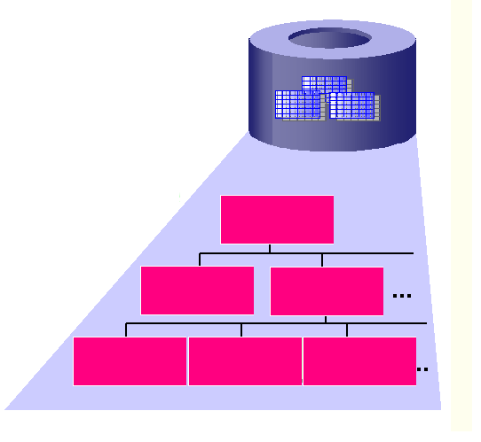



You feed data into a database by using forms:

From a database you can generate queries and reports:

A query is a question you ask the database on the data (and save the answer) and a report is a presentation of the information. A query is a tool that pulls data out of a database and a report is a tool that allows information from a database to be printed in a useful format.

There are several approaches to develop a database.

Most important is to **plan well.** Take some time and work out your database on paper. Work through certain steps and check each item when completed.

**You do not plan a database on a computer, you do it on paper. A database Management Application is a tool for database management and it is a tool in your hands, not the developer of your thinking.**

##### Steps in Developing a Database

You can start with the data, determining the fields and develop different tables. Then you think of the kind of form that you need to put the data in and the kind of reports that you want at the end.

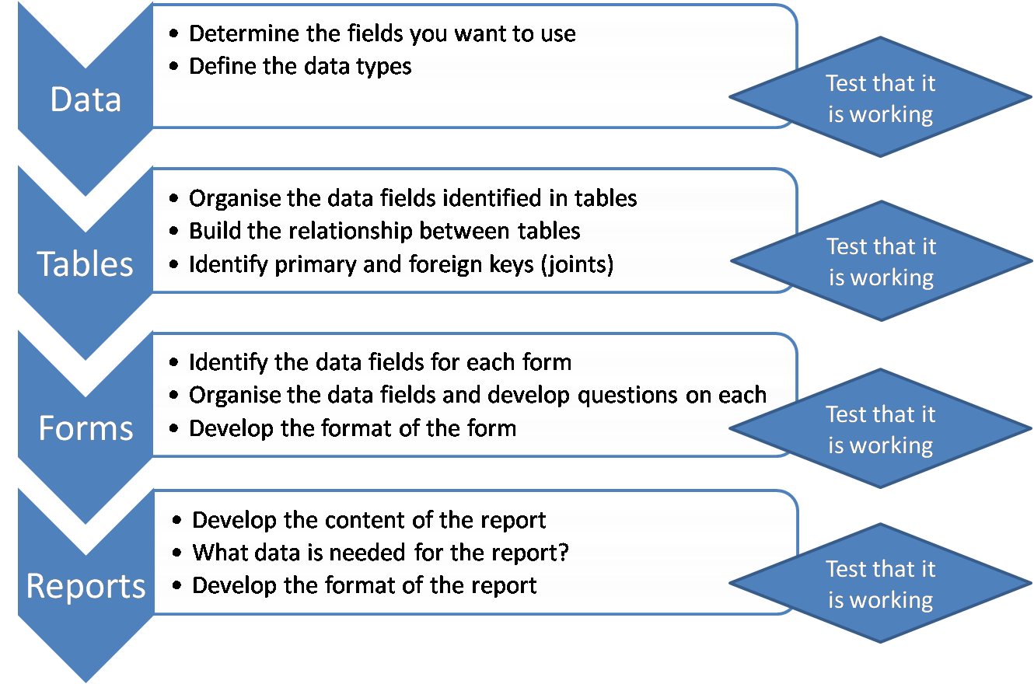

Another approach is called **reversed engineering** where you start with the type of reports you have in mind. Think about the content of the report and come up with kind of data needed for the report.

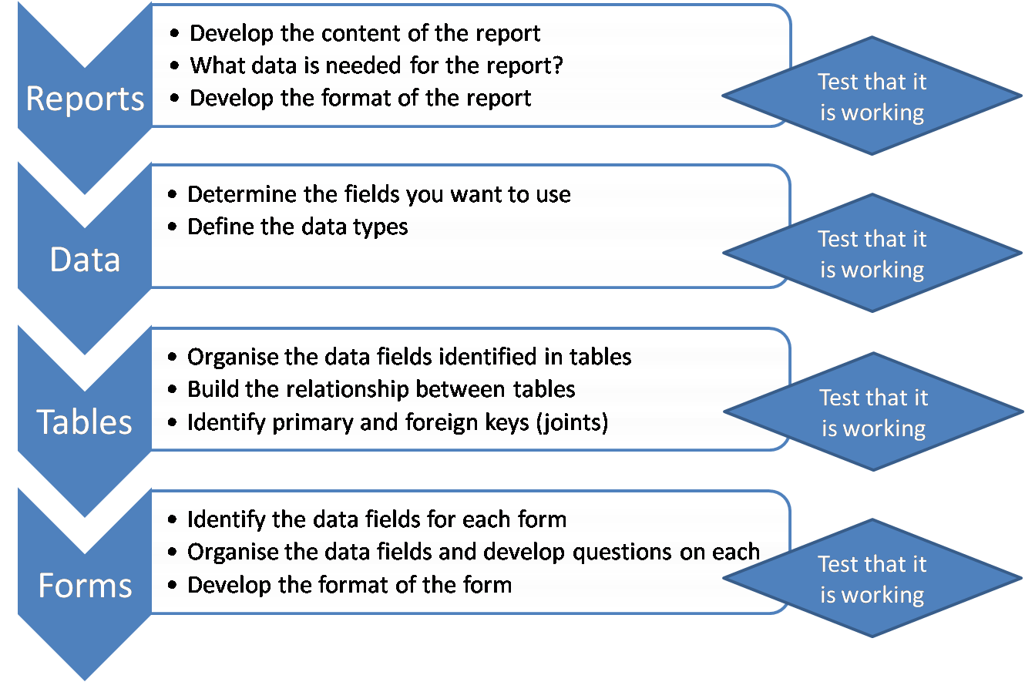

You then build the tables, fields and define the data types. You then build the relationships between the tables. You have to test some sample data to validate these relationships between the tables.

A well designed database also needs to include **optimisation** techniques (the process of speeding up and increasing performance). There i**ndexing** comes in handy. The larger the data set, the slower your database will perform without some form of indexing.

If your database is working well, you design the forms to input your data.

summary

##### Summary

Make sure that you can do the following:

* normalise a database to third normal form
* identify a key field; in particular, a primary key
* describe an index, its purpose, and how it is implemented
* discuss the purpose of relating tables in a database
* discuss the way you plan and design a database

### Using the Database Application

#### Section Overview

In this section you will be introduced to how to work with databases and perform common tasks. In specific you will:

* access an existing database
* learn how to create and save a new database
* explore the application settings available within OpenOffice Base

Outcomes

Upon completion of this section you will be able to:

* open and close a database and work within the database application
* create a new database and save it
* use available help functions
* understand the difference between a table, query, form and report, open, close, delete each one of them and navigate between them
* sort records

##### Working with Databases

For the purpose of this module, you will make use of OpenOffice 3.0 Base.

You must be able to:

* start OpenOffice 3.0 Base and close it
* open an existing database
* create a new database
* connect to another data source with OpenOffice 3.0 Base

L:\COL\images\coputerbasedlearning.PNG

###### Starting OpenOffice Base

###### Open OpenOffice Base

From the **Applications** menu in the top left of the Ubuntu Desktop select **Office** then **OpenOffice.org Database**:

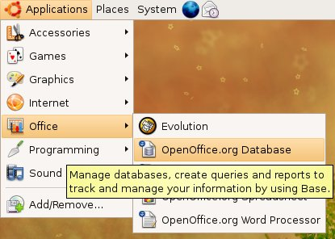

###### L:\COL\images\coputerbasedlearning.PNGSelecting an Action

Once the OpenOffice database software has finished loading you will be prompted to select an action. You can either:

* **Select database** - which means:
  + create a new database
  + open an existing database file already created and saved
  + open an existing database in other formats
* **Save and proceed** - which means, register your database and save it or start working with it

You have to start with clicking on **Select database.**

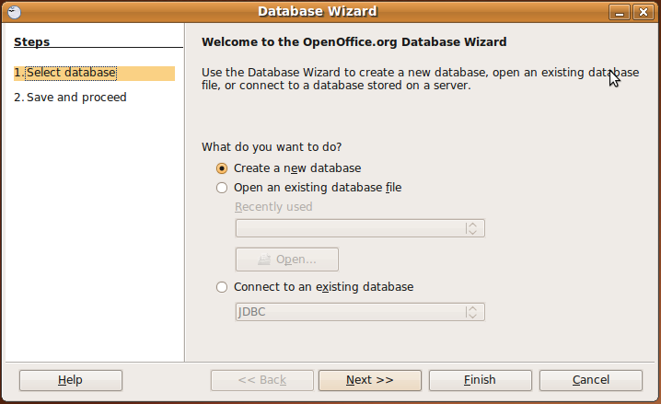

###### Opening an Existing Database File

To open an existing database file:

1. Choose the **Open an existing database file** option (activate the radio button).
2. Expand the drop-down list and select the database from the list of available databases.
3. Hit **Open.**

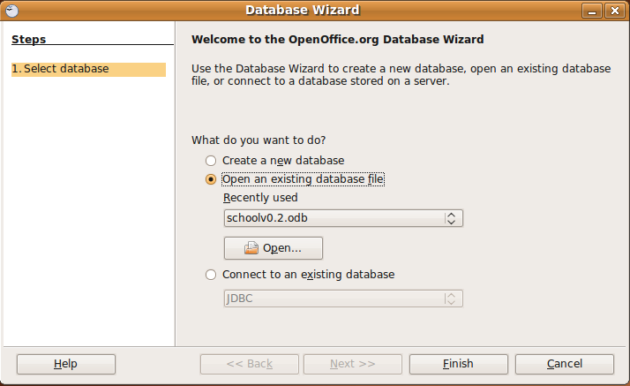

Alternatively if OpenOffice base cannot find the selected database you will be prompted with the open dialog.

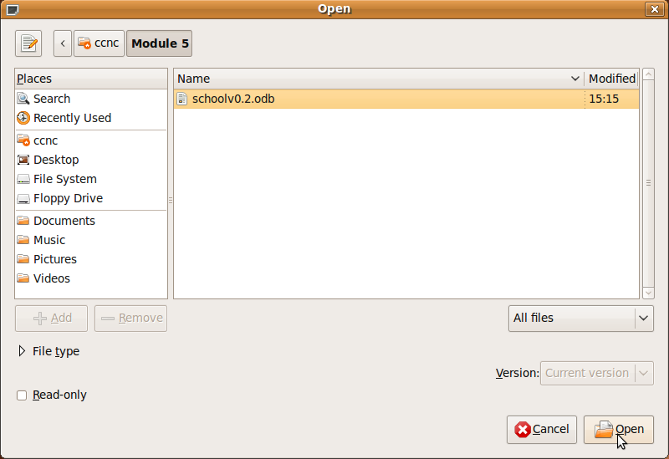

After selecting the open button on the dialog box the OpenOffice 3.0 Base software will open the requested database in the application main window.

Familiarise yourself with the **Database Window**.

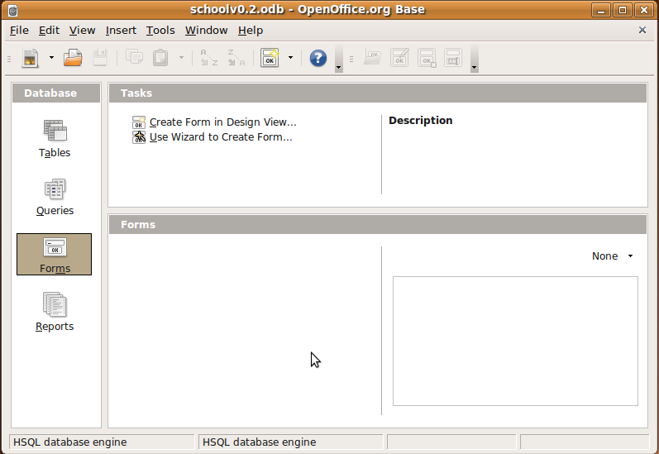

Identify the following:

* Title Bar
* Minimise Button
* Maximise Button
* Close Button
* Menu Bar
* Tool Bars
* Database Pane with 4 buttons:
  + Tables Button
  + Queries Button
  + Forms Button
  + Reports Button
* L:\COL\images\coputerbasedlearning.PNGTasks Pane. Reflects the activities related to the button that was clicked on the Database pane.
* Workspace. The pane that is active in the workspace is activated by clicking on the buttons in the database pane.

###### Creating a New Database

If you know you want to start a new database select the option to **Save and proceed**. This will locally register your database and prompt you for the location to save this new database.

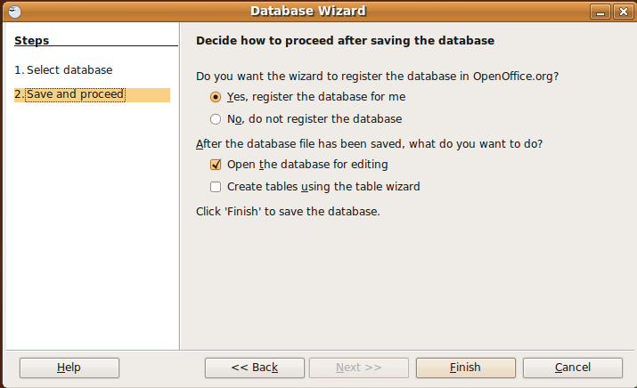

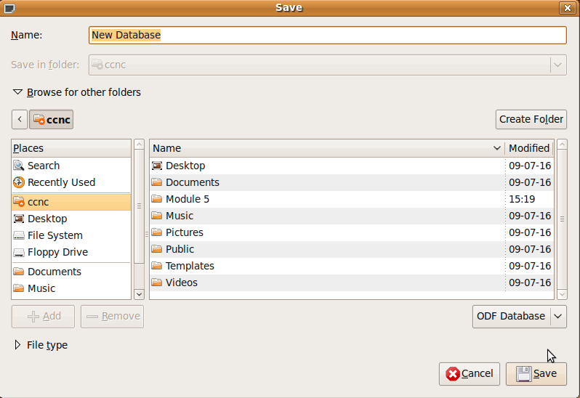

###### Connecting to an Existing Database (Non-OpenOffice Files)

You may also want to use OpenOffice 3.0 Base against another data source other than the OpenOffice databases. OpenOffice 3.0 Base provides access to a large selection of data sources including, but not limited to: Address Books, MySQL, MS-Access, dBase, ODBC, JDBC, Adabas, etc.

L:\COL\images\coputerbasedlearning.PNGTo open any of these data sources select one of the available data sources and follow the prompts to enter the required connection settings.

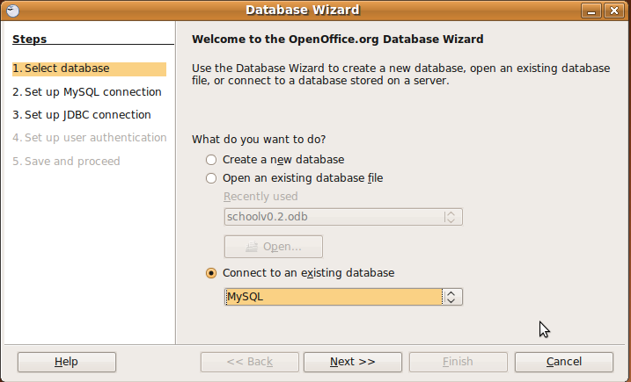

On choosing this option, the Wizard prompts you to 5 steps:

###### 1. Select a data base - OpenOffice 3.0 Base allows you to connect to many different data sources. Base natively supports some flat file database formats, such as the dBase format. You can also use OpenOffice 3.0 Base to connect to external relational databases, such as databases from MySQL or Oracle (existing databases in different formats).

You can now continue with steps 2 – 5. It is important to remember that this describes connecting to a non-OpenOffice database.

For the remainder of this module you will not use this option, but create and use an OpenOffice 3.0 database.

##### Create a New Database

Always remember to follow the steps on the left side of the screen.

1. **Select database -** To create a new database select the **Create a new database** option. Then press the **Next >>** button.



L:\COL\images\coputerbasedlearning.PNGThe Wizard will go to **Step 2. Save and proceed**

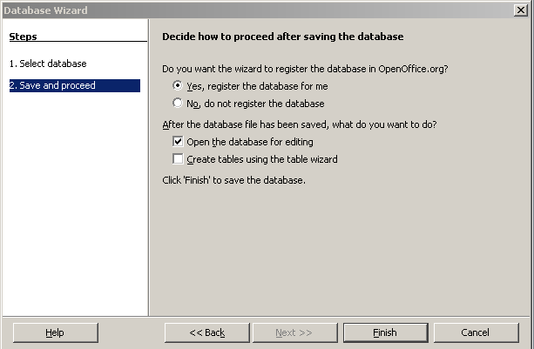

Choose the appropriate radio buttons to register the database (save it). You have to make decisions in the tick boxes.

It is advised that you only tick the **Open database for editing** first. It will prompt for a "New Database" name. Enter a unique new name in the Name field.

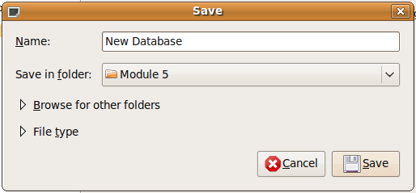

You also have to navigate to a folder location by selecting the "Browse for other folders" option.

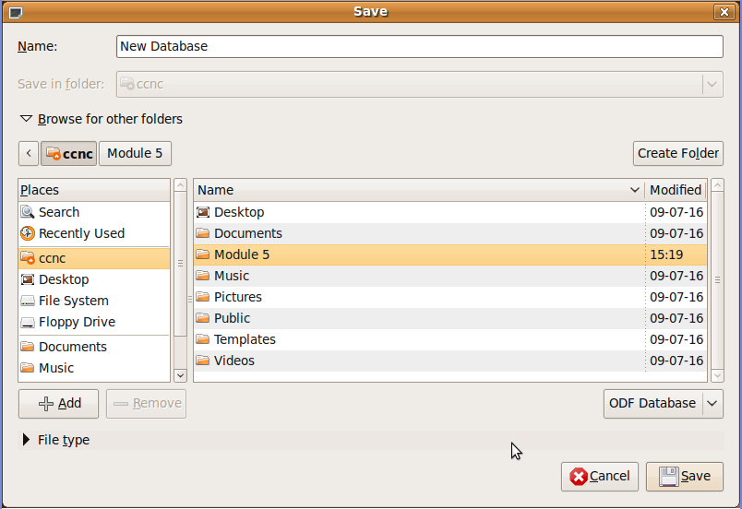

Once finished you will have a new database that is saved in the folder of your choice.

L:\COL\images\coputerbasedlearning.PNGThe following screen will be displayed.

Familiarise yourself again with the Database pane and the related tasks for each button in the Tasks pane.

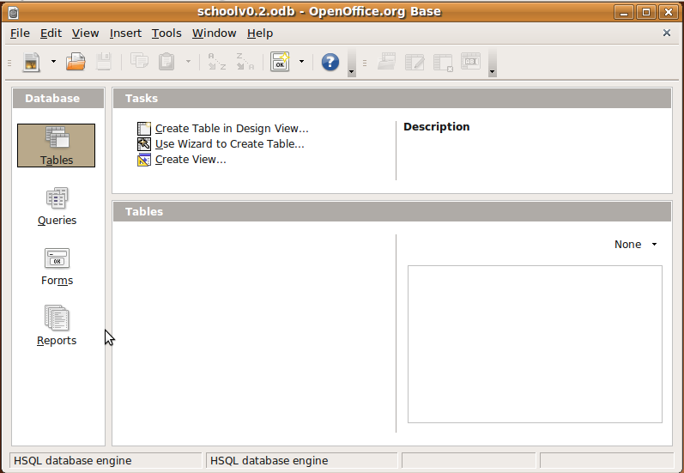

##### Save a Database

While you are working with your database, as with other documents, save regularly. To save a database, select the **Save** or **Save As** option from the **File** menu. As you know, to **Save** will save the current database using its existing name. The **Save As** will prompt you to save the database using a different name.

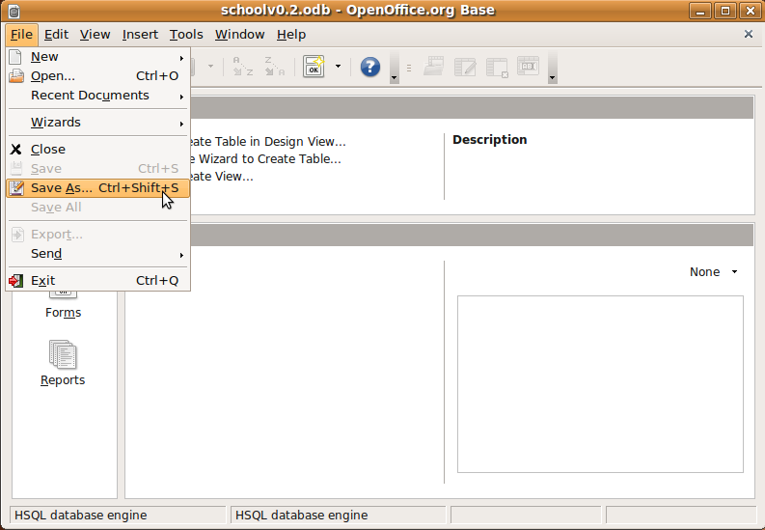

When you are developing a new database it is sometime useful to "Save As..." different version names. This allows you to save a version at a state of design you are happy with. Then you can continue development. If you make a series of changes you are not happy with having multiple versions allows you revert back to the previous state you liked. You may want to consider a versioning number system similar to the following:

* L:\COL\images\coputerbasedlearning.PNGDb-Namev0.1 - minor changes
* Db-Namev0.2 - minor changes
* Db-Namev1.0 - MAJOR RELEASE
* Db-Namev1.1 - minor changes
* etc..

##### Getting Help

OpenOffice 3.0 has a good help system. You can get help by selecting from the Help menu or pressing F1 on the keyboard.

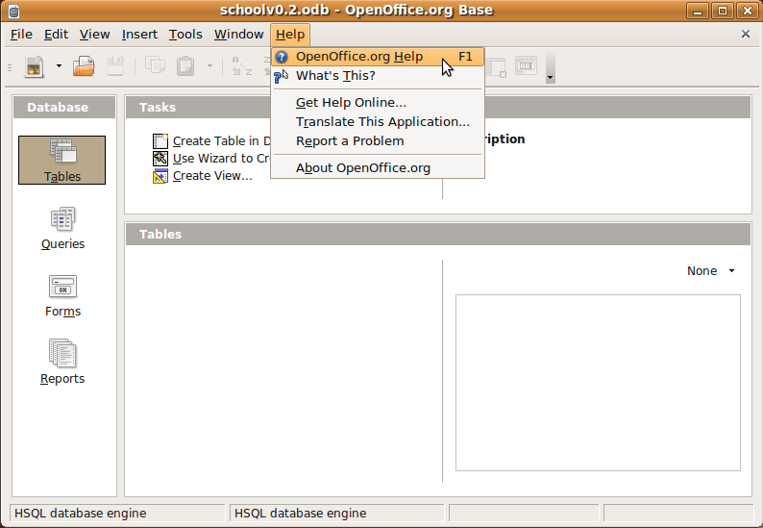

Once the OpenOffice 3.0 help system appears you can navigate, read the index or search for the information you require.

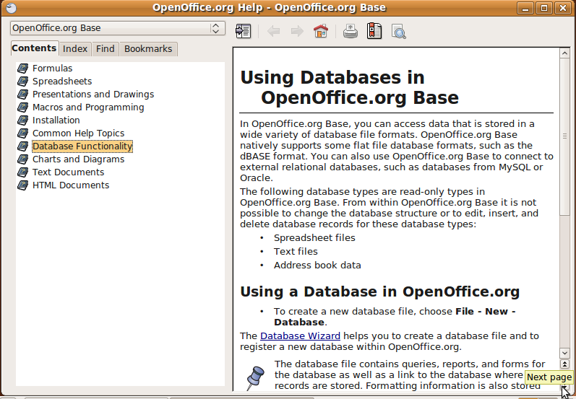

##### L:\COL\images\coputerbasedlearning.PNGClosing a Database

To close a database, go to the **File** menu and select **Close.**

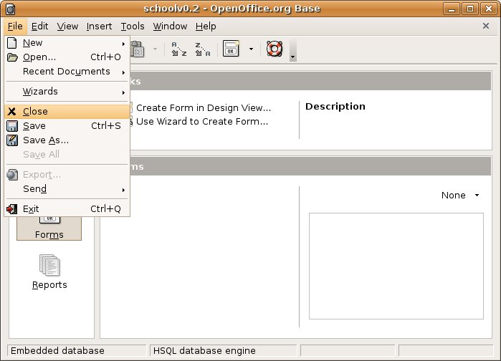

#### Adjust the Application Settings in the Database Window

##### Changing the View

As you know, a database consists of tables, queries, forms and reports. You are familiar with the **Database Window** with the buttons in the **Database pane** that change the views (tasks and workspace).

You can also access the different views by selecting **View🡪Database Objects🡪** and choosing the relevant view.

You are now going to explore each of the different views and how to change from one to another.

###### Working in Table View

In Tables view you work with your data in tables.

You have completed your database plan on paper:

* what tables you are going to use
* what fields will be in each table
* data types for each field
* primary keys and foreign keys for tables
* relationships

L:\COL\images\coputerbasedlearning.PNGYou can now create new tables from scratch or use a wizard to prompt you design decisions. You can also create a view that allows you to put "filters" on existing tables.

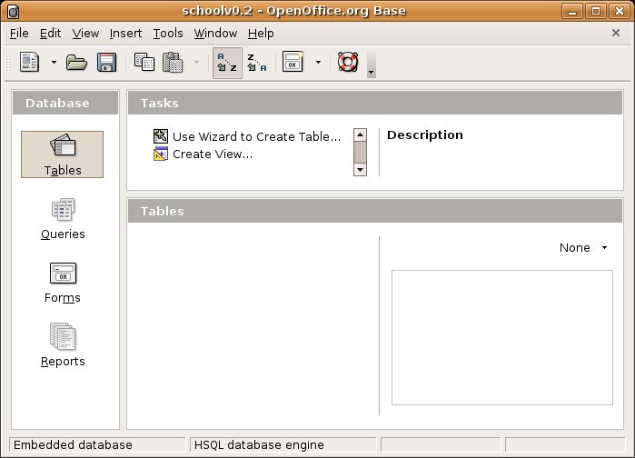

###### Working in Forms View

After your planning you will also know:

* the data fields for each form
* the data fields you are going to use, in which order and the question related to each field
* the format of the form

In **Forms** view (press the **Forms** button in the **Database** pane) you can create forms for data entry and viewing. You can also use a wizard to guide you through the process of creating a form.

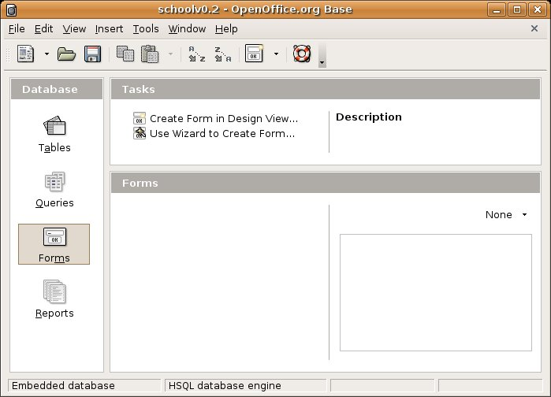

###### L:\COL\images\coputerbasedlearning.PNGWorking in Queries View

In **Queries** view you can create queries that filter data, join together tables and specify which fields are to be displayed and specify the properties for sorting the data.

You can also use a wizard to guide you through the process of creating a query.

And later, if you feel comfortable using the Structured Query Language (SQL) you can create your queries by hand using only SQL syntax (not required for this certificate).

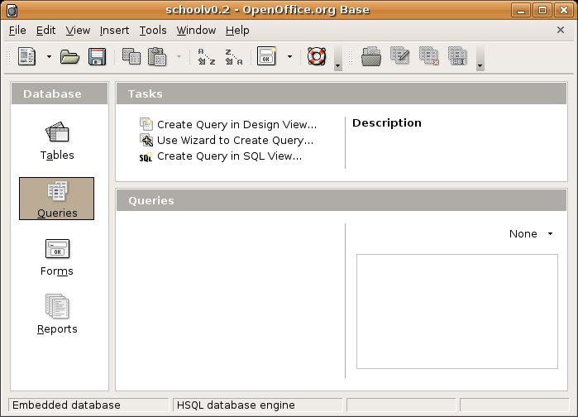

###### Working in Reports View

After your planning you will also know:

* the content of your report/s
* what data is needed for the report
* the format of the report

In **Reports** view you will be guided by a wizard to create new views or you can select existing views to edit, delete or run.

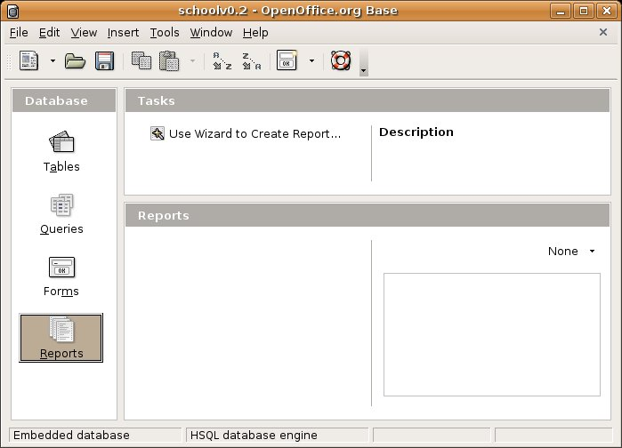

###### Test Your Knowledge

**Open Office Base Views**

1. Open Office has five views within to work?

* TRUE
* FALSE

2. A form is used for data entry?

* TRUE
* FALSE

3. In which view would you enter SQL Syntax?

* The Table view
* The Form view
* The Query view
* The Report view
* None of the above

**Answers**

1. FALSE - Open Office Base has four views

2. TRUE

3. The Query view

##### L:\COL\images\coputerbasedlearning.PNGToolbars

###### Working with Toolbars

As you know, you get different toolbars. Toolbars are displayed on your screen as a series of related icons. You can easily select an action without using a drop down menu.

You can add, move and take away toolbars from your desktop.

To access, go to **View🡪 Toolbars** on the menu bar. When a toolbar is selected it has a check mark to the left of the item.

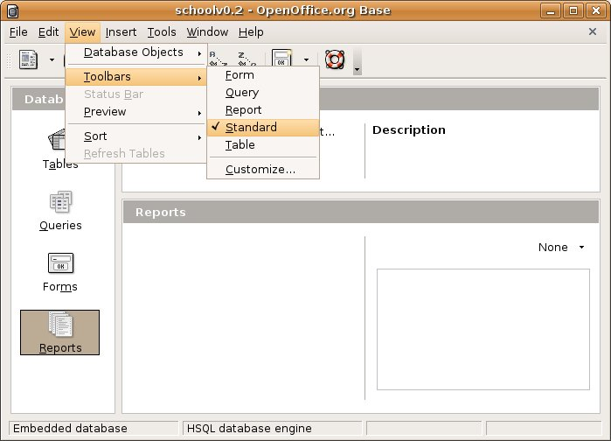

L:\COL\images\coputerbasedlearning.PNGWhen you have NO toolbars selected, the desktop will look as follow:

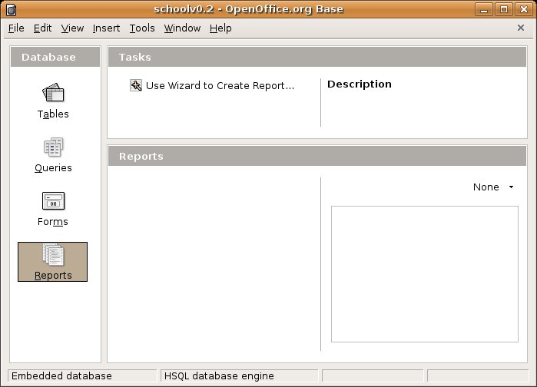

For ease of use, select the toolbars you want to use, move them and place them at a place where you feel comfortable with. You must be able to minimise them too.

Remember, you can work quite successfully within OpenOffice Base with no toolbars activated by using menu commands and view buttons. (Using toolbars is a matter of personal preference)

##### summarySummary

Upon completion of this section you should be able to:

* start OpenOffice Base and close it
* assess your ability to create and save a new database
* open an existing database
* save a database under a different name
* demonstrate how to use a version numbering technique
* close a database
* get help
* understand the purpose of each view and know how to change the views on your desktop
* change your desktop’s toolbars to your preference

### Designing and Building Database Tables using OpenOffice 3.0

#### Section Overview

The focus of this section is to build a database containing a number of tables representing relationships. The section has four subsections that progress through:

* the creation of database tables
* identifying and adding keys and indexes
* building out the number of tables
* complete the definition of relationships.

Outcomes

We will also focus on entering data and use strategies to test the data integrity of you newly implemented database design.

Upon completion of this section you will be able to:

* perform common tasks on tables, queries, forms and reports
* design tables
* perform different tasks on records and in a table
* save your data

#### Basic Table Operations

L:\COL\images\coputerbasedlearning.PNG

##### Creating a New Table

The first step to a database is to create the tables that are needed. You can design a table from scratch or you can activate the Table Wizard which allows you to choose formats that have been pre-defined and are available to use.

Keep your database plan ready.

L:\COL\images\coputerbasedlearning.PNGTo create a new table, in the **Database Window**, click on the **Tables** button in the **Database** pane. In the **Tasks** pane, choose **Create Table in Design View**. The **Task** pane provides you with a description of the task at hand.

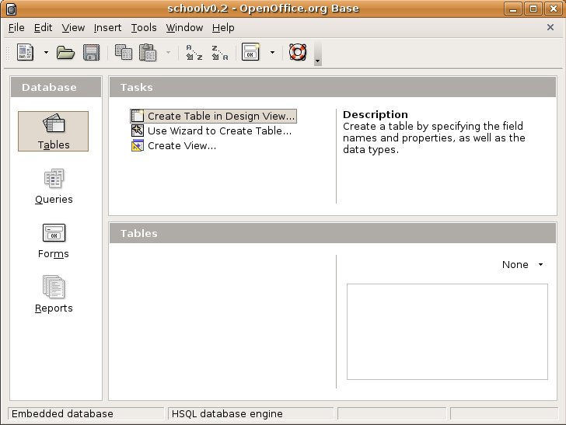

###### Designing the Table in Design View

If you choose to **Create Table in Design View** you will get a list where you can fill in the field name and field type. Remember this is not the table, it is a list of the field names (column headings) and the data type in the field.

Here you enter the field names underneath each other. The green arrow to the left of a row shows the active row. You can specify a Field Type in the next column which can be either a Text field or a Date, Time, Number, various types of Integers etc. (see page 6-7) If you do not specify a Field type it will default to Text.

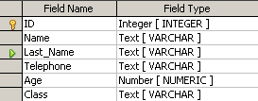

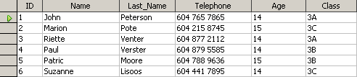

Table

L:\COL\images\coputerbasedlearning.PNGThe screen to put in the field name and the field type will look as follow:

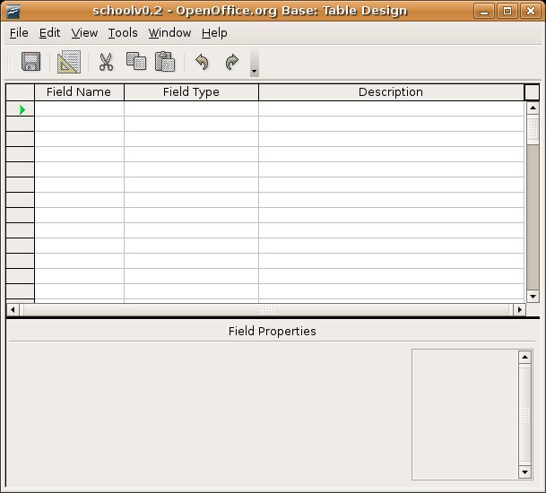

1. Type in the fields as the example on the previous page.
2. To exit this view and go back to the **Database Window** press the **Close** button  or press **File🡪Close.**
3. Confirm your changes by pressing **Yes.**

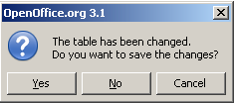

1. This takes you back to the **Database Window.**
2. If your table has not been named properly, you can change the name of the table by right-click on the table and rename it to **Personal_Info.**
3. Open the table by double clicking on the relevant table in the **Tables** pane.
4. You can now enter the data of the 6 records in the fields created.
5. Close the view and go back to the **Database Window.** Remember to confirm your changes.

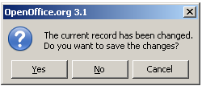

1. Close the database by first saving it.

###### L:\COL\images\coputerbasedlearning.PNGDesigning a Table by using the Wizard

You are now going to design a new table, using the Wizard. By this time you are familiar with the working of a Wizard. You can follow the instructions:

1. **Select fields**

* Choose the category
* Choose the sample table
* Select the fields require from the available fields

When you finish, press the **Next>** button.

1. **Set the types and format**

Create a **personal** table called **ExerciseLog_Gr3**  with the following fields (in the same order):

* Activity - Text - Entry Required - 10 characters
* Exercise Type - Number - Entry Required - 2 characters - no decimals
* TimeExercised - Number - Entry Required - 5 characters

- 2 decimals

* MaximumPulse - Number - Entry Required - 3 characters

- no decimals

* RestingPulse - Number - Entry Required - 3 characters

- no decimals

Choose the appropriate Field information as above.

1. Set the primary key automatically using an auto value.
2. Create the table and name it **ExerciseLog_Gr3**
3. Create the following records and save the table:

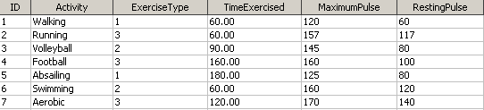

###### Deleting a table

If your planning of your database was done well, it will not be necessary to delete a table.

However, it is possible to delete a table that you have created by:

1. Open the **Database Window.**
2. Activate the **Tables View.**
3. L:\COL\images\coputerbasedlearning.PNGIn the **Tables** workspace, mark the table you want to delete, right click and press **delete.**

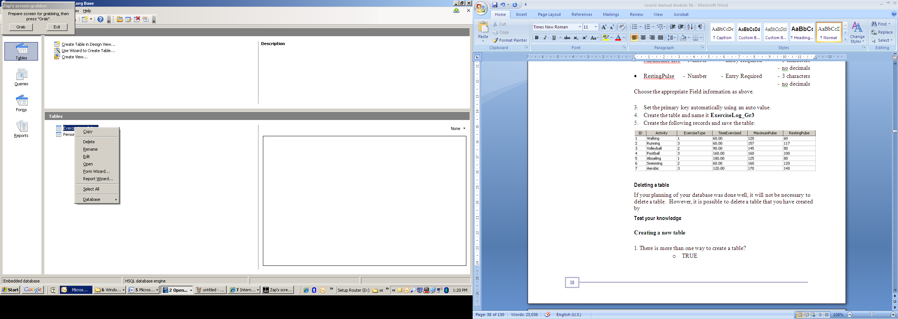

1. Confirm the deletion.

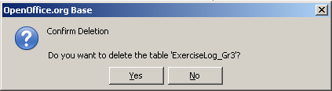

You can also use the **Edit🡪Delete** option from the Menu bar.

###### Test Your Knowledge



**Creating a new table**

1. There is more than one way to create a table?

* TRUE
* FALSE

2. What is the default field type when creating a table?

* Integer
* Date
* Text
* Currency
* Auto Number

**Answers**

1. TRUE, you can use either design view or a table wizard.

2. The default type is Text.

#### Defining Keys and Indexes

##### Creating Primary Keys

###### What is a Primary Key?

As we have learnt in the previous section, every table needs to have a primary key defined.

The primary key is a field (or fields) that uniquely identify a record. In other words no two records can contain the same number in the primary key field.

###### Creating a Primary Key

To set a field as a primary key, you have to access the list of fields again. Activate the **Table View** and right click on the table you want to set the primary key of in the **Tables pane.** Click on **Edit.**

You are now able to see the list of Field Names that you created.

Right click on the grey button to the left of the field name to activate the popup menu. Click on **Primary Key** to mark it. You will see a small yellow key appearing next to the field name 

###### 

**Tip:** Always include an AutoValue field.  
  
It is recommended that an AutoValue field be added to every table regardless of whether it is a part of your table design. This AutoValue field will automatically contain unique values for the life of the table. These values may become very useful some point in the future when you want to alter your database design.



##### Indexes

###### What is an Index?

You have learnt that an index improves performance by providing an alternate path to access data and speeds up searches, sorting, queries etc. An index can be applied to any data type. Indexes are applied to fields that are commonly used in searching for data (like a last name) or where data needs to be grouped together for a report.

It is not good practice to apply indexing to all fields of the database, only the ones that you want to sort by.

###### L:\COL\images\coputerbasedlearning.PNGCreating an Index

In the field list view, select **Tools 🡪 Index Design.**

.

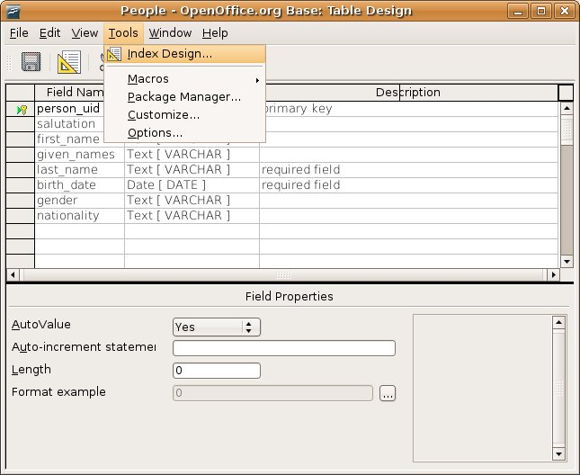

You will get another dialogue box:

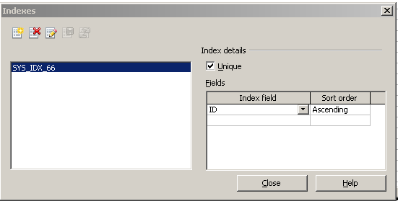

Notice that there is an option to make this a unique index (tick the box). In other words if you do not want duplicate entries here you would tick the box on **Unique**.

Ask yourself the following two questions?

* Will this field be an index? – Do I want to sort this field?
* Will this field be a unique identifier? – No duplication can occur.

L:\COL\images\coputerbasedlearning.PNGLet’s go back to the table you have created called **Personal_Info**.

Which one of the fields would be your primary key? – ID

Which of the fields would be indexed?

* ID
* Last_Name (You would like to sort according to the children’s surname)
* Class (You would like to sort according to the children’s class)
* Age in this case is not a good field to index, because all the kids are either 14 or 15 years old

Now you can ask yourself which ones of the above three, identified as indexes, would be unique?

* ID – definitely
* Last_Name - This would not work here as there are going to be instances where children have the same surname. However, if you were creating the index on a field like an account number you would then choose not to allow duplicates by activating the Unique option.
* Class – This would not work because it is not unique

###### Index Actions

Take a good look at the dialogue box:

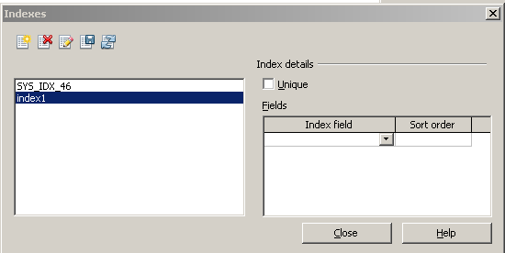

In the upper left of the Indexes dialog are five buttons.



L:\COL\images\coputerbasedlearning.PNGThe meanings of the buttons are as follow:

|  |  |  |
| --- | --- | --- |
| Create a New Index | Oo-dbms-table-index-new.jpg | This button creates a new index by prompting you for the field names you would like indexed. Give this some thought and think about the discussion of table scans covered previously. |
| Delete an Index | Oo-dbms-table-index-delete.jpg | This button deletes the highlighted index. |
| Rename an Index | Oo-dbms-table-index-rename.jpg | This button renames the highlighted index. |
| Save an Index | Oo-dbms-table-index-save.jpg | This button saves the new, renamed and changed indexes. |
| Reset an Index | Oo-dbms-table-index-reset.jpg | This button resets the index. |

Now it is a good time to apply the primary key and indexing in the table called **Personal_Info. Remember to open the field list.**

Your results will look like this:

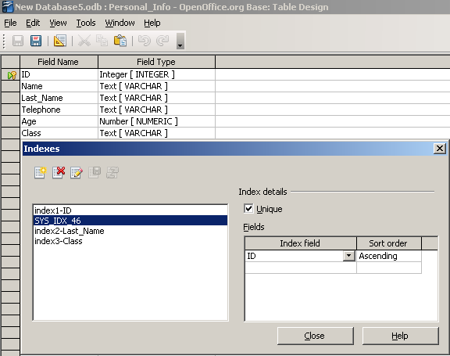

Save your file.



**Note**

It is important to note that if you try to put a duplicate entry into the field you have indexed to be unique, you will get an error message and it will not accept the record.

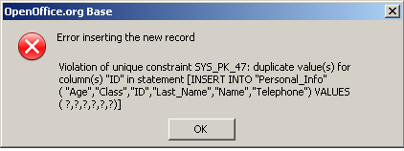

L:\COL\images\coputerbasedlearning.PNGAfter adding new fields you can add indexes to certain fields by going back to the index design and adding it.

Once the Index design dialog is available the new index button should be pressed to create a new index.



###### Test Your Knowledge

Study the following table and answer the questions on the next page:

**Addresses**

|  |  |  |  |
| --- | --- | --- | --- |
| **Field Name** | **Data Type** | **Required** | **Description** |
| address_id | Integer | Yes | An AutoValue field for uniqueness. |
| address_line1 | Text | Yes | First line describing an address. Could be street name or suite number. |
| address_line2 | Text | No | Second line describing an address. |
| city_name | Text | Yes | The name of the city |
| region | Text | Yes | The name of the region. Could be province, state, etc. |
| country | Text | Yes | The name of the country |
| postal_code | Text | Yes | The localised postal code or equivalent |

**Questions**

1. Indexes can only be applied to text fields?

* TRUE
* FALSE

2. From the Addresses table design above which fields would you apply indexes?

* address_id, country_name
* city_name, country_name, postal_code
* address_id, address_line1, postal_code
* city_name, region, country_name, postal_code
* address_id, region, country_name, postal_code

3. Indexes can be applied to enforce uniqueness?

* TRUE
* FALSE

**Answers**

1. FALSE, they can be applied to any data type.

2. city_name, region, country_name, postal_code

3. TRUE, they can be applied to enforce uniqueness by ticking the **Unique tick** box

#### L:\COL\images\coputerbasedlearning.PNGTable Design and Layout

By now, you must be familiar with the layout of a table, what a record is and what a field is. It is important that you are also familiar with switching between the Field List and the Table.



1. Close the table
2. In table view, right click on the table
3. Choose **edit**
4. Close the Field List



Table

##### Field Design and Modification

###### Exploring the Data Types

On page 6, you were introduced to the basic set of data types.

It is good to familiarise yourself with all the different data types available when adding fields to a table.

L:\COL\images\coputerbasedlearning.PNGThe following screen shot provides a list of all the data types.

Add all these fields in a new database table. Once you have added the different fields, click on each one and view the field’s properties. Feel free to play around and get a sense of the differences and similarities among the different data types.

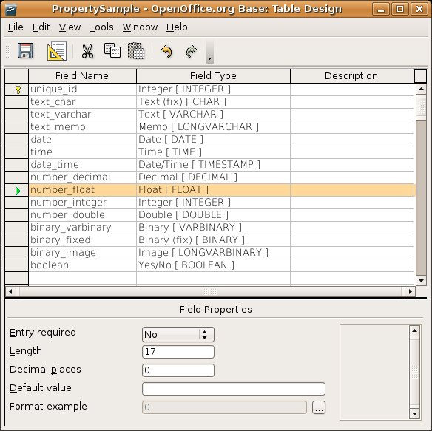

###### L:\COL\images\coputerbasedlearning.PNGModifying Fields Properties

When you create the fields you will notice the field properties section at the bottom of the screen that allows you to change the field properties such as the size of the field, the number and date format, etc. To change these attributes you will need to click on the field at the top which will give you access to its properties displayed in the bottom section of the screen.

To change the field size, click on the field to select it. A green arrow will appear to indicate that it has been selected. Then click in the white box next to Length. Type in the number of characters you want the field to be restricted to.

If you want to change the number or date format click on the grey button next to Format example. This will bring up a dialog box which will allow you to choose a format for the number or date.

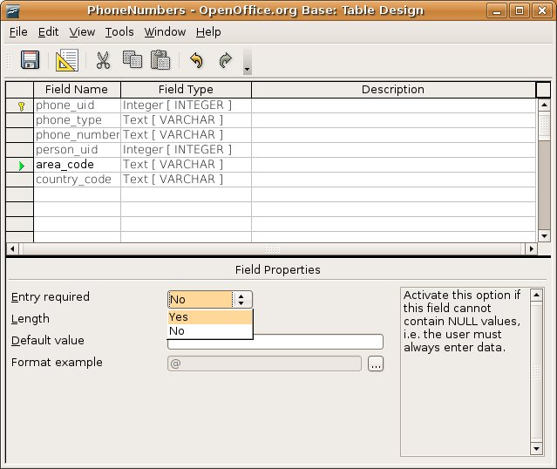

**Note - Consequences of change**

It is important to note that if you change the field size in a table and there is already data in the table you may lose some of that data. For example, if you change a field size from 50 characters long to 10 characters long and there is a record that already contains 20 characters in that particular field you will lose (or truncate) the data; so be very careful.

###### L:\COL\images\coputerbasedlearning.PNGModify Fields

###### Insert New Fields

You can at any time, insert a new field at the bottom of the Field List. You can either right click on the grey bar to the left of the fields and select **Insert Rows** or just start typing in a new field at the first open space at the bottom of the list.

Be aware, if you make this column mandatory to enter data, you will receive an error message, because the current table does not have data in these fields.

To overcome this problem, design the field first as non-mandatory for data entry. Go to the table, enter data in all the records and go again back to the Field List and change the field to mandatory.

###### Moving the Fields within a Table

Being able to re-order the fields or columns within a table is a useful feature. This feature is only available when you are first designing the table. Once the table has been saved the field order is also dependent on the data stored in the table. Changing the order of the fields would also mean the database would have to re-order the data.

The data re-organisation would have dependencies on the table’s rules, therefore making it a complicated process. This re-ordering should be done with careful consideration and with the assistance of a database administrator so no data is lost.

IT is therefore very important to do thorough planning of the database tables and the order of fields before you start entering data.

###### Widening the Columns (Fields)

Sometimes the columns containing the fields are not wide enough to display the data fully on the screen.

You can widen the columns by opening the table. Click on the table heading (Field name) you want to widen, right click and select **Column Width** from the pop-up menu and type the width in.

You can also move your mouse up between the field names in the grey area (as you would to widen columns in a spreadsheet), until you get the vertical line separator, . Hold down the left mouse button and drag the column width to be wider or narrower.

If you would double click on the vertical line separator, the width will be adjusted to the length of the field.

###### L:\COL\images\coputerbasedlearning.PNGChanging the Format of a Column

To change the field format (Column format), right click on the column header and choose **Column Format.** You can change the general format of the field (depending on the format you have chosen) as well as the alignment.

###### Updating the Data

You can add new records, update data in records and delete records from your table.

To add a new record, enter it at the bottom of the table. The **New Record** row to enter it is indicated by  and the row that you are working in (active), with a .

To change a record entry, just activate the cell by clicking on it, and enter the data.

To delete a row, activate the row by clicking on the row header (grey block to the left), right click and delete. Note that the numbering will change and you will lose the number of this row.

You can also change the table format (font and font effects) by right click on the row headers and choosing **Table Format.** You can change the font of the data.

Take the same database that we have worked on previously and change the table as follow:

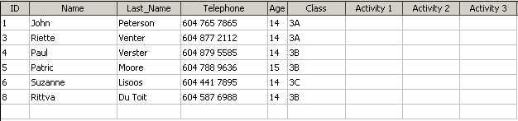

Save your table.

###### Sort Records in a Table

You can also sort the records in your table in ascending, descending, numerical or alphabetical order.

For example to sort the above table according to class, then surname and then name, you click on the sort button .

L:\COL\images\coputerbasedlearning.PNGYou have an option of 3 levels of sorting (you can choose up to 3 fields to sort by) and you have also an option of ascending or descending to choose to order them by. Ascending and descending works for both numerical and alphabetical sorting.

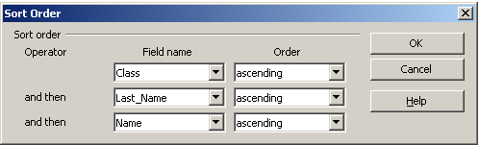

###### Copy Data from One Table to Another

Sometimes it is necessary to copy data from one table to another. For example, if you have a database of names and addresses of people and you want to create a new table with only their names with other information, it would be time effective to copy the names to the new table without retyping all the data.

* 1. First create the new table you want to copy to. This will be your **Destination Table.** Create the fields you want to copy to (in accordance with the fields from your table you want to copy from).

Both the name of the table you are copying from (**Source Table)** and the table you want to copy to (**Destination Table)** are appearing in the **Tables** pane of the **Tables View**.

* 1. In the Tables pane right-click on the name of the table that you want to copy from (**Source Table)**.
  2. Choose **Copy.**
  3. Right-click on the name of the table you want to copy to (**Destination Table).** Hit **Paste.**

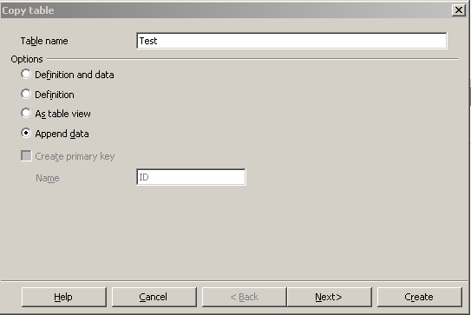

* 1. Because you want to copy only selected data, choose **Append data.** Hit .
  2. L:\COL\images\coputerbasedlearning.PNGTick the fields from the **Source Table** that will appear in your **Destination Table.**

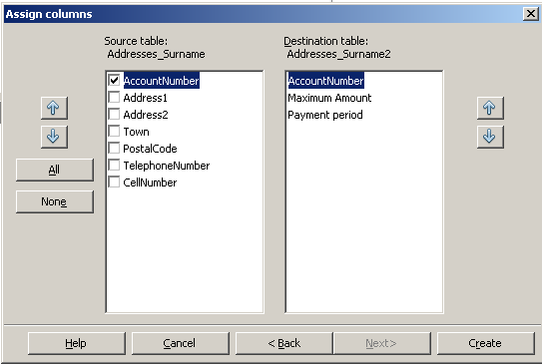

* 1. Hit .

In this example you have copied the Account Numbers to the new table.

###### Test Your Knowledge

1. Making a field longer is different than making it wider?

* TRUE. they are different.
* FALSE, longer and wider is the same in a database field.

2. A LONGVARBINARY data type can be used as the field to store an image?

* TRUE
* FALSE

3. Which data type would be best to store a single character?

* BOOLEAN
* CHAR
* DECIMAL
* INTEGER
* VARCHAR

4. A table design should never be changed?

* TRUE
* FALSE

5. Which is NOT a step when adding a new mandatory field to a table that already has data?

* Setting the primary key
* Changing the 'Entry required' field back to 'Yes'
* Adding data to the columns that will be mandatory
* Saving the modified table
* Open the table for editing

**Answers**

1. TRUE, longer means the field has more characters, wider means more characters are displayed on the screen.
2. TRUE, the image data type is a LONGVARBINARY
3. CHAR
4. FALSE, however to change the order of fields is not possible. It is better to plan thoroughly and then create the database to avoid changes.
5. Setting the primary key, it was already set in the original design.

#### Table Relationships

##### Database Schemas (Relationships)

In your planning you have designed a set of tables and identified the relationships between them.

###### Preparing to Create Table Relationships

One of the early steps in creating a database is in designing as many of the tables as can be identified through analysis/planning. Once the databases table designs have begun to form the **collection of tables and their relationships** becomes known as the **database schema**.

Designing, adding and modifying a database schema becomes a task that occurs whenever the business information requirements change. This change can happen either frequently or infrequently, this depends on how much the information requirements change. In our small school example once the database has been designed we would expect very little change to the database schema.

**To build a relationship you must ensure that the two tables have both a field with the same name and data format. In one of the tables, this field must be the primary key (unique field) and in the other one the foreign key. These two fields will be used to link the two tables.**

###### L:\COL\images\coputerbasedlearning.PNGDesigning the Relationship

Let’s look at the two tables we have created:

Personal_Info:

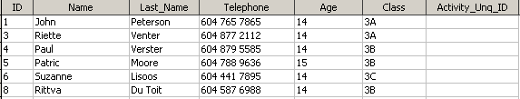

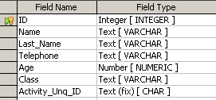

Foreign Key

ExerciseLog_Gr3:

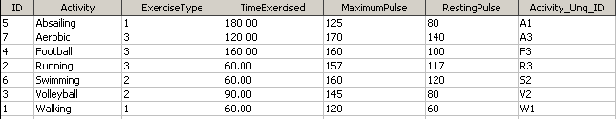

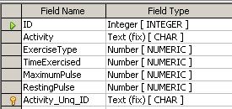

Primary Key

The Personal_Info table gives the names of 6 Grade 3 learners who will participate in activities of their choice.

The ExerciseLog_Gr3 table gives the selection of exercises offered, their type (1/2/3), how long an exercise will take place and what the ideal pulse-rate for each exercise is (before and after exercising).

Let us sketch a scenario:

* Grade 3 learners will attend an Activity Day.
* Each learner can choose from the list of activities for the day.
* We will now link the two tables with each other.

###### L:\COL\images\coputerbasedlearning.PNGAdding the Tables for the Relationship

The first step in setting the rules of a relationship is to open the Relationships designer in the **Database Window**.

This is done through the **Tools 🡪 Relationships** menu.

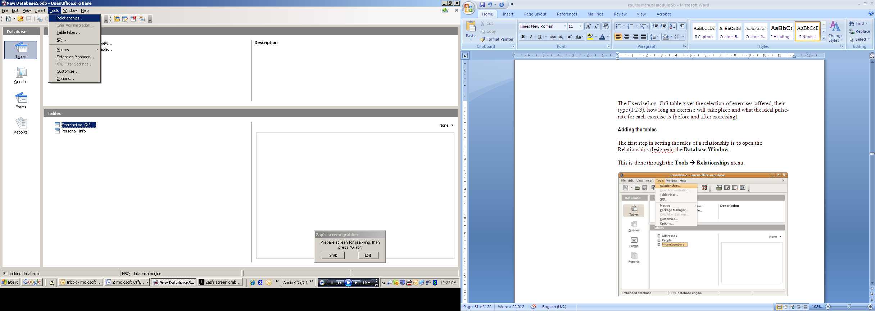

The relationship designer will start with either; a dialog prompting to add tables or a display of the existing relationships. Which gets displayed depends if there are already existing relationships.

You will be prompted to add tables.

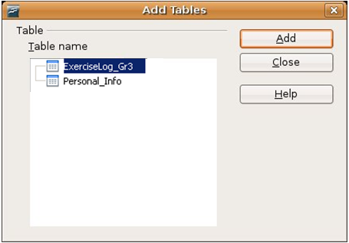 or 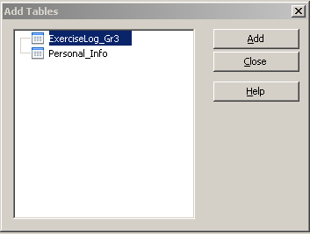

Add both the tables you want to link.

Two screens appear that give the fields of each table called the **Relationship Design Screens**:

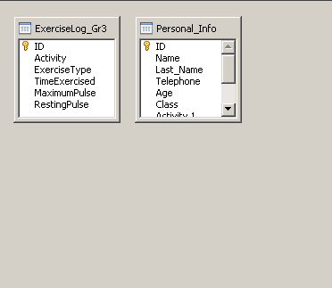

Close the add tables dialog and only the **Relationship Design** screen will be displayed. It is within this window that you will design the relationships.

L:\COL\images\coputerbasedlearning.PNGThe toolbar of the relationship designer has two important buttons:

* Add tables

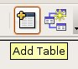

* Add new relationships

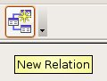

###### Defining the Relationship

First drag the bottom border of the field lists to see all the fields.

To define a new relationship just drag and drop the foreign key field from one table over top of the primary key of the other table (the two keys that will link the tables).

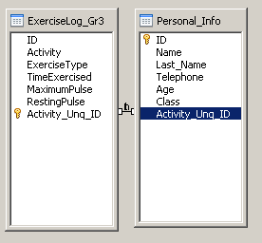

Let’s go back to the Personal_Info table and complete the following section for the learners (Activity_Unq_ID):

* John will do walking
* Riette will do abseiling
* Paul will do football
* Patrick will do football
* Suzanne will do swimming
* Rittva will do walking

Your table will look like this:

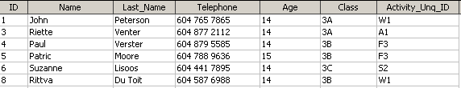

You have now successfully linked the two tables and build a relationship between the tables.

###### L:\COL\images\coputerbasedlearning.PNGEdit the Relationship

To edit the properties of the relationship right click the line between the two filed lists in the **Relationship Design** screen and chooses the **Edit** option.

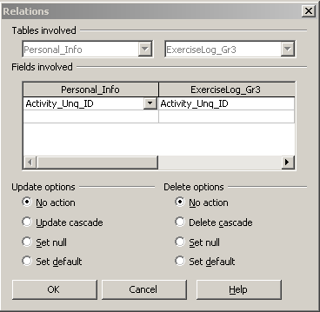

Through this action you can also delete the relationship.

###### Setting the Rules

You want to make sure that the records between tables remain accurate once a relationship has been created. The way to do this is to enforce referential integrity. Editing the relationship properties is how referential integrity is enforced. By default no action is taken on relationships.

By clicking on the **Update cascade** radio button, you are ensuring that if a change is made in the Primary Key field it will make the changes in the other tables that that field is linked to.

Clicking on **Delete cascade** ensures that Base will delete all the records that are linked to that field. If this option is not selected you will not be allowed to delete a record that is linked to other records.

###### Test Your Knowledge

**Table relationships**

1. The query designer is used to create relationships?

* TRUE
* FALSE

2. Which of these choices best describes the update options for a relation?

* No action
* Update Cascade
* Set null
* Set default
* All of the above
* None of the above

**Answers**

1. FALSE, the relationship designer is used.

2. (e) All of the above

summary

##### Summary

During this section you were introduced to the design of a database containing a number of tables representing relationships.

You can now:

* Create indexes on the fields identified most appropriate for indexes.
* Identify a field that requires a uniqueness constraint and add a unique index to this field.
* Rename the new indexes to a meaningful name.
* Save the new indexes and close the Index Designer.
* Add data to the table(s) with new indexes.
* Create relationships between tables.

### Data Entry using Forms

The focus of this section is to develop an introductory understanding of building forms for data entry. Forms will be built upon existing database tables using the OpenOffice Base forms wizard. The form will be used to navigate the available data to view the records in the database table. Saving new and altered forms will be discussed along with deleting forms for application maintenance.

Outcomes

Upon completion of this section you will be able to:

* create a form for data entry
* use a form to retrieve information
* navigate the records within a database
* delete a form
* save and close a form

##### Working with Data Entry Forms

On pages 18 – 19 the construction of a database was explained.



Forms are primarily used to enter data and to retrieve information.

###### L:\COL\images\coputerbasedlearning.PNGUsing the Database Pane Buttons to View Forms

The OpenOffice Base **Database** pane has a button that can be used to view all the existing forms (Forms View).

###### Using the Menus to View the Forms

Navigate the menus to view all the existing forms. Select **View🡪Database Objects🡪Forms** to see the forms in the current database.

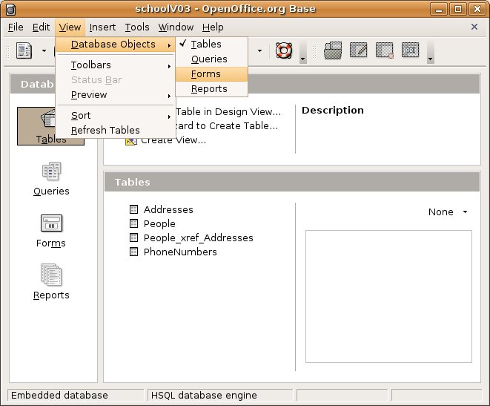

###### Opening a Form

To open an existing form - in **Forms View** double click on the name of the form you wish to open. Alternatively you can right click on the name of the form and then click on **Open**.

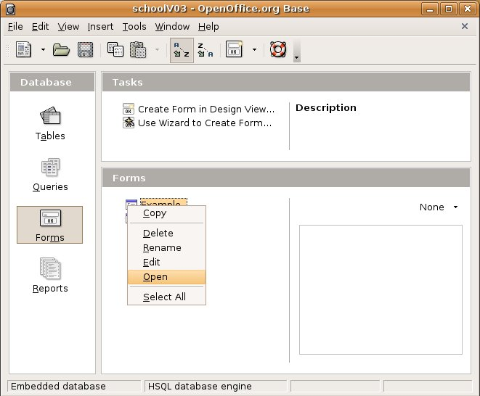

Or you can highlight (select) the form to open and use the **Edit**🡪**Open Database Object** to open the form as a database object.

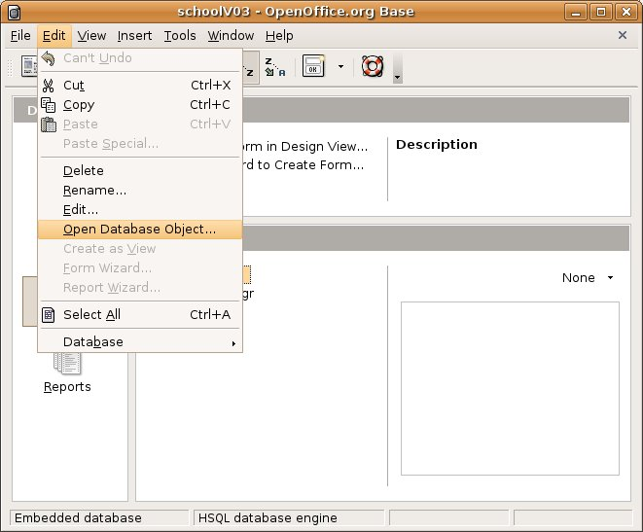

###### Test Your Knowledge

**Viewing and opening forms**

1. There is more than one way to open a form?

* TRUE
* FALSE

2. How many forms will be displayed when viewing the list of forms.

* Five
* None, forms can't be viewed
* As many as have been created in the database
* Ten
* Thirty

**Answers**

1. TRUE

2. As many as have been created in the database

###### L:\COL\images\coputerbasedlearning.PNGUsing the Wizard to Create a Form

To create a form based on a table, first activate the **Forms view**. Click on **Use Wizard to Create Form** in the **Task** pane.

This will start the forms wizard, which will prompt a step-by-step building of a form.

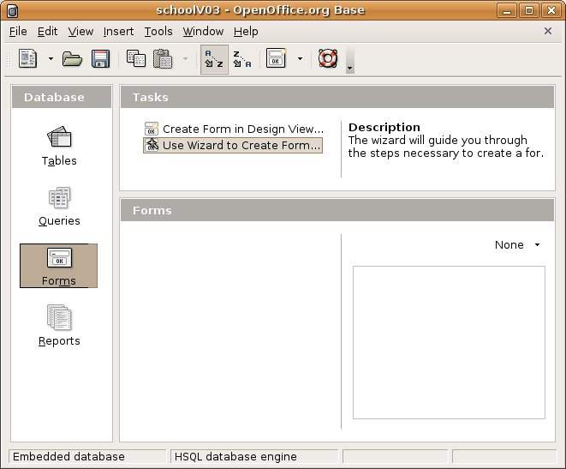

###### L:\COL\images\coputerbasedlearning.PNGStarting the Wizard

The wizard consists of 8 steps to follow:

1. **Field Selection**

First select the table you wish to base the form on by selecting it from the drop down box under **Tables or queries**.

When choosing the table it is best to start with building forms for all the parent tables, and builds forms for the child tables later.

If you have identified the table, you will use the fields in that table to build your form.

Remember, when selecting the fields that will be available of the form, use only the fields that can be edited/filled in. Fields that has values added automatically (like the auto-numbered PK field) should not be put on the form to avoid incorrect values being entered.

Now you can select the fields you want the form to contain from the **Available fields** list. Click on the field and click on the  button to move the field to the **Fields in the form** list. You can continue selecting the fields one by one and repeat the action.

If you want to select all fields click on the  button.

To remove a field/fields, use the  or  buttons.

Ensure that you have selected all the fields from your table that you want to put on the form.



**Note – Using information from both tables**

If you want to input data from both tables in your form, you also have to select the primary/foreign key that links to the other table.

L:\COL\images\coputerbasedlearning.PNGClick the button to move to step 2 of the wizard. Remember to repeat this action at the end of each step.

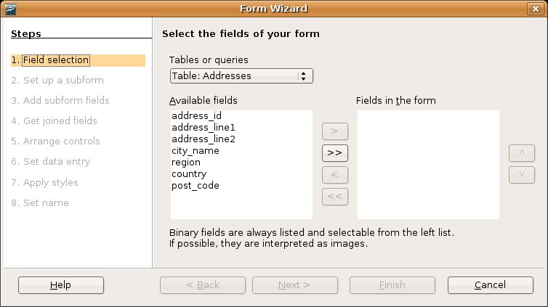

1. **L:\COL\images\coputerbasedlearning.PNGSet up a subform**

In some situations you want to include data from another table in the same form. You will make use of a sub-form. A subform is a form that is inserted in a form using data from other tables or queries This relationship will be put onto the form using a subform. It is specifically used when you have many relationships with the fields in the second table.

For example, one person can have many phone numbers or in our example, one child could choose two or more activities.

You can skip this step by untick the **Add Subform** tick box.

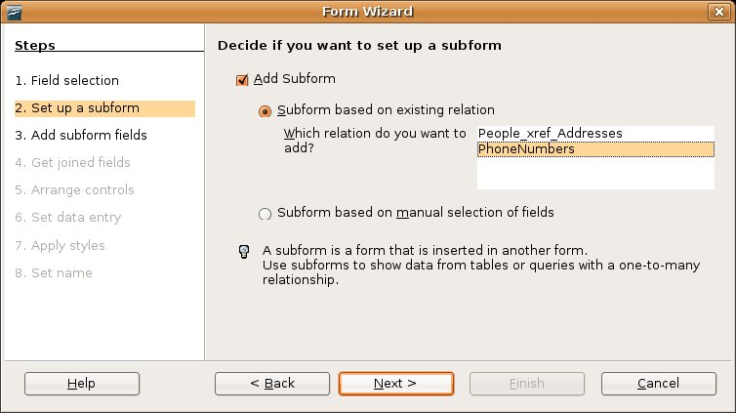

1. **Add subform fields**

Selecting the table and fields for the subform follows the same path as the fields for the original form.

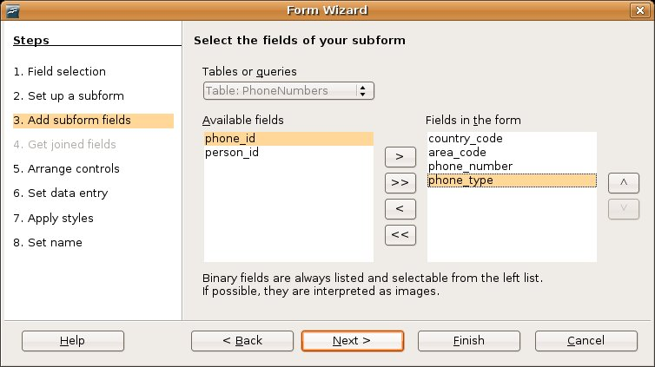

1. **L:\COL\images\coputerbasedlearning.PNGGet joined fields**

In this step you have to identify the fields that are joining the tables.

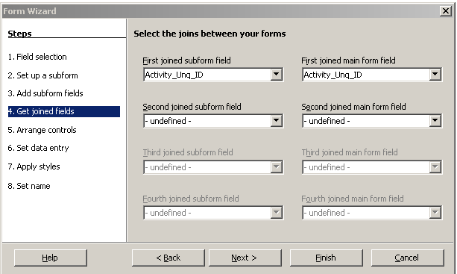

1. **Arrange controls**

In this step you are looking at the layout of the form and the subforms.

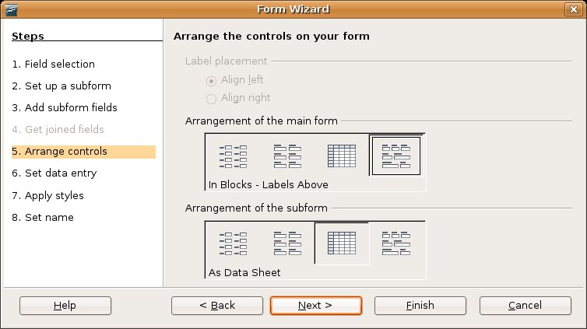

You have a choice of 4 layouts (also choose the alignment):

* In columns with the labels on the left hand side (hit ):

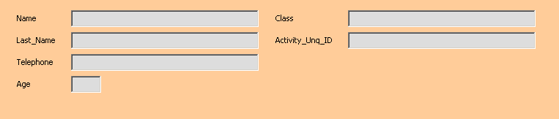

* In columns with the labels on top (hit ):

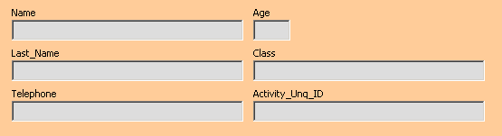

* L:\COL\images\coputerbasedlearning.PNGAs a datasheet (hit ):

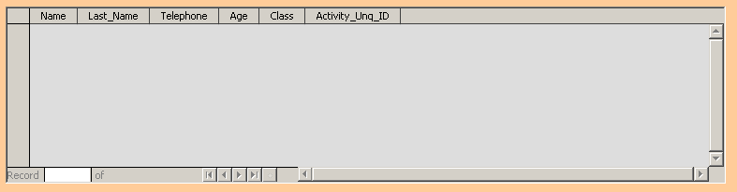

* In blocks (hit ):

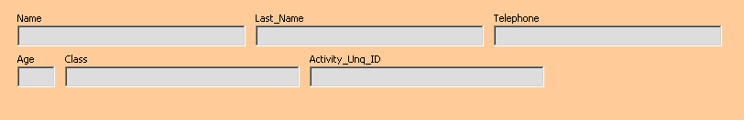

Choose the label placement and layout that you want and click **Next**.

1. **Set data entry**

A form is mostly be used for data entry. It can however also be used show data in a specific format (read only). In this step you will make a choice by selecting a radio button.

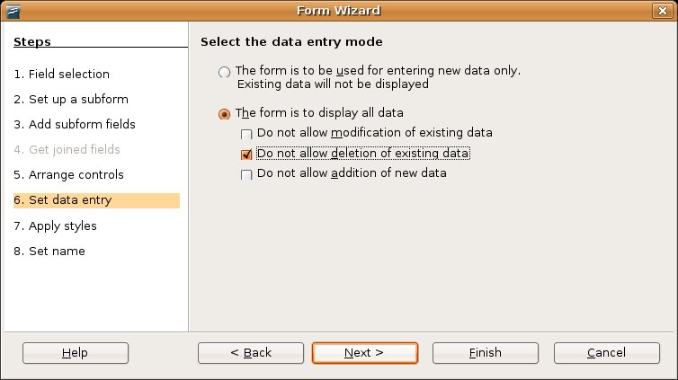

If you choose to use the form for entering new data only, you will not be able to see existing data of that specific record.

If you choose to display data, you can select what action can be possible (you can select more than one), viz.:

* Do not allow modification of existing data (Read Only)
* Do not allow deletion of existing data (input is possible, but not deletion)
* Do not allow addition of new data (deletion is possible).

1. **L:\COL\images\coputerbasedlearning.PNGApply styles**

You have the opportunity to set the colour and style of a form.

It is useful to change the style to best suit the user group and their preferences. The style may set (or changed) after the users have had their first review of the new database system.

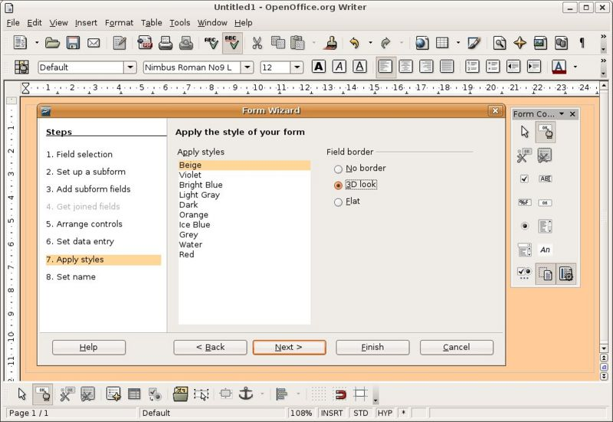

1. **Set name**

The last step is to name the form you have created. Providing a descriptive name can be beneficial as the number of forms increases. Well named forms aid in user, administrator and developer comprehension.

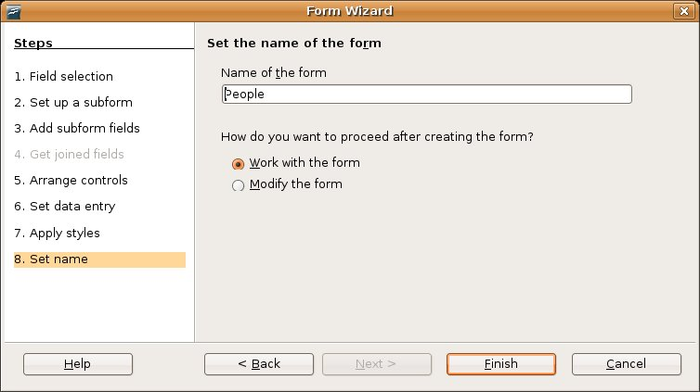

Now you will hit 

L:\COL\images\coputerbasedlearning.PNGOnce the form is finished it is a good idea to test the form.

Your form will be displayed with the subform in datasheet format at the bottom.



###### Test Your Knowledge

**The forms wizard**

1. A data entry form can be read only?

* TRUE
* FALSE

2. A form can include:

* A subform
* A colour
* Field borders
* An alignment
* All of the above
* None of the above

**Answers**

1. TRUE

2. All of the above

**L:\COL\images\coputerbasedlearning.PNG**

###### Creating a new form in design view

If you do not want to use the wizard, you will be able to create a new form in **Design View**. In design view the form is created from scratch without any of the automations provided by the forms wizard.

In the **Database Window,** activate the **Forms** view and select **Create form in Design View** in the **Tasks** pane.

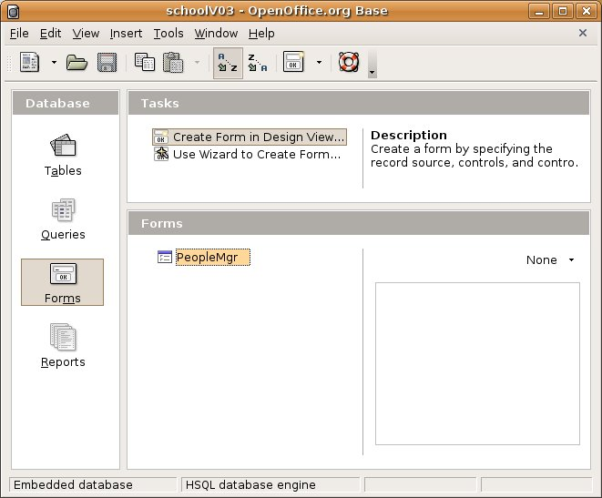

###### L:\COL\images\coputerbasedlearning.PNGThe Design View



In a form, the above consists of 2 parts:

* The word **Name** represents the **Label**
* The data that will be entered will go to a specific **data field.**

You have to create both to appear on your form.

Furthermore, in **Design View** the forms fields and buttons are added as controls. The controls are added to the form by selecting the control from the toolbar and "drawing" them on the new form.

**Note:**

Ensure that the **Form Controls** and **Form Design** toolbars are activated. Place them on your desktop where you feel comfortable. Just note where you put each one.

Also note that some of the icons are duplicated on the two toolbars. Whenever you are referring to use one of these, you can choose from which toolbar you are activating the icon.

L:\COL\images\coputerbasedlearning.PNG

Your screen will be marked with blocks and you will see the above two toolbars.

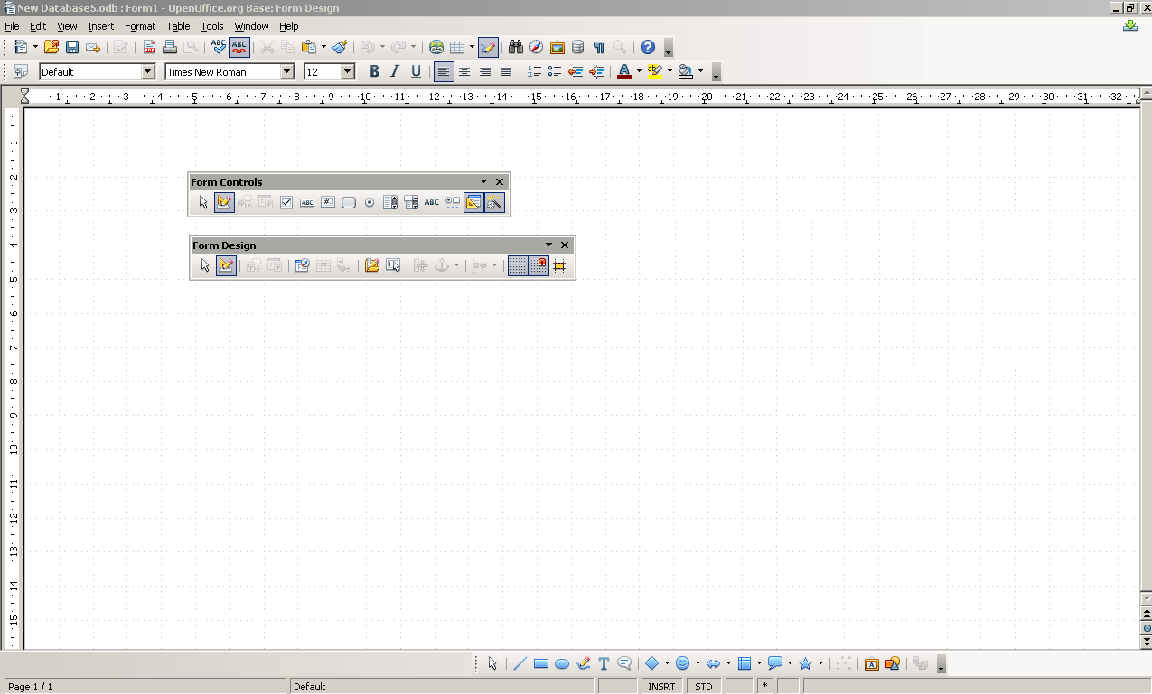

Now you are ready to start designing your form. It is good to include the design of your form in your planning and do a rough plan on paper, before you start with putting the controls in place.

L:\COL\images\coputerbasedlearning.PNG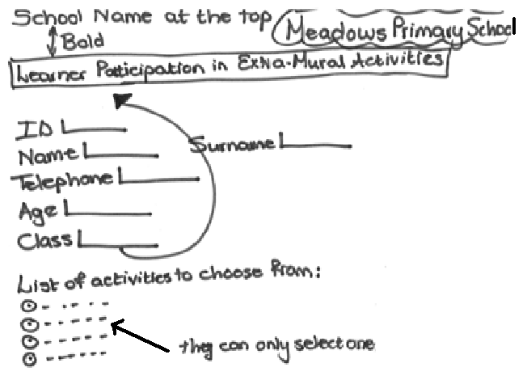

You first need to **identify the Table** that you want to use:

1. Click on the form button on the **Form Design** toolbar (If it is not activated, ensure that the **Design Mode** is on by clicking on the on the same toolbar.
2. In the Form Properties window, click on Content drop-down menu and select the table you want to use.

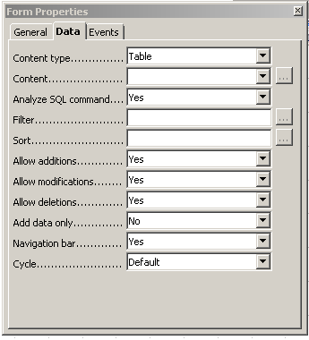

1. Close the window.
2. L:\COL\images\coputerbasedlearning.PNGThen you type the structure of your form (without the controls) as you have planned. Check font and spacing.

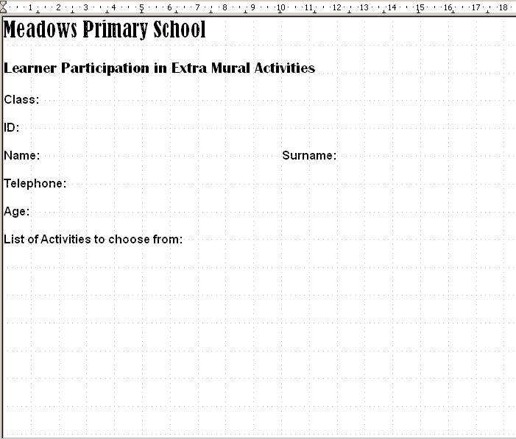

Now you can insert the fields. For each item on your form you have to insert a **label** and a **datafield**

Use the **Forms Control** Toolbar and create each item.

For the following you want a text box:

**Label:** ID Name Surname Telephone

**Datafield:** <ID> <Name> <Last_Name> <Telephone> etc.

1. Click on text box and pull your space with your mouse on your form.



1. Right click on the box that you have dragged and choose **Control…**

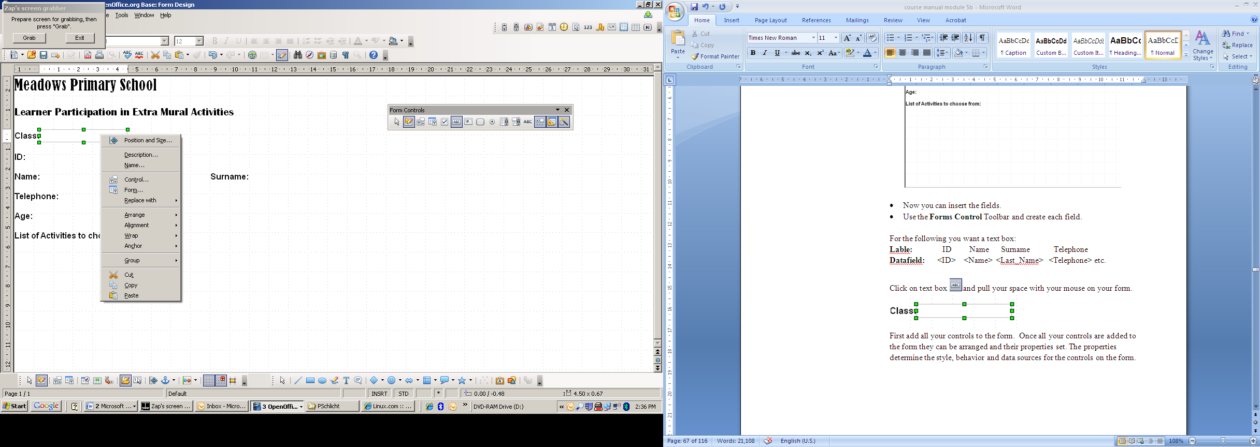

1. L:\COL\images\coputerbasedlearning.PNGClick on the **Data** tab in the **Properties: Text Box** and add the **Data Field** through the drop down menu.

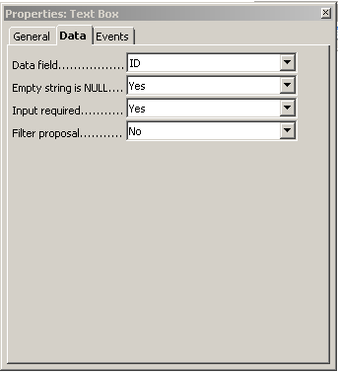

Close the window.

1. To add the label, you click on the label field button  and add the label.
2. Right click and enter the label in the **Properties: Label Field**

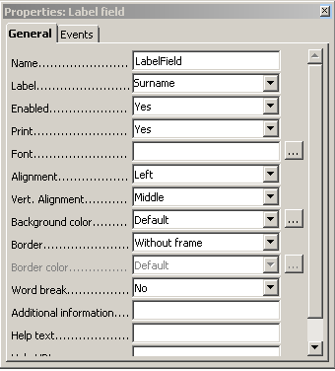

1. Repeat with all the fields that need a text box.
2. To do the list, choose the **List** Box from the **Form Controls** Toolbar. Various windows will lead you through the process of selecting the **ExerciseLog_Gr3** table and the **Activities field**.
3. You can now resize your boxes, move them around in your window until you are satisfied with the design of your form.

L:\COL\images\coputerbasedlearning.PNGYour form will look like this:

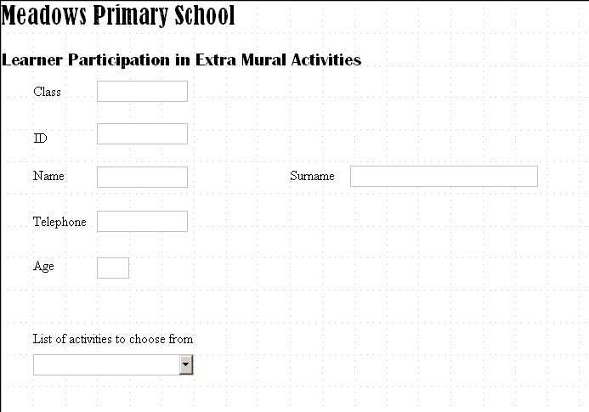

1. Give the form a proper name and save the form. If the form is new, a prompt will ask for the name of the new form. A good naming convention will help manage the forms, make sure the name is unique and represents what the form is used for.

Play around with the design of forms. You must be comfortable with designing forms for different purposes. A well designed form, create a sense of pride and purpose in the work it is attached to.

##### Open, Navigate in and Save a Form

###### Open a Form

To open a form, double click on the name of the form in **Forms** view. It will open the form displaying the fist record in the table it is attached to.

###### Navigate between Records using a Form

Activate the **Form Navigation** toolbar.



To navigate between the various records using a form, use the arrows on the Form Navigation toolbar. , meaning go to the FIRST – PREVIOUS – NEXT – LAST record.

The record that is displayed in the form is recorded in the box to the left.

To enter a new record, press . An empty form will be displayed.

L:\COL\images\coputerbasedlearning.PNGTo delete a record, press . The record that was displayed will be deleted.

You can also sort records by pressing the button and define the sorting criteria.

If you press the button, you will get the table (data source) of the form displayed at the top of your desktop.

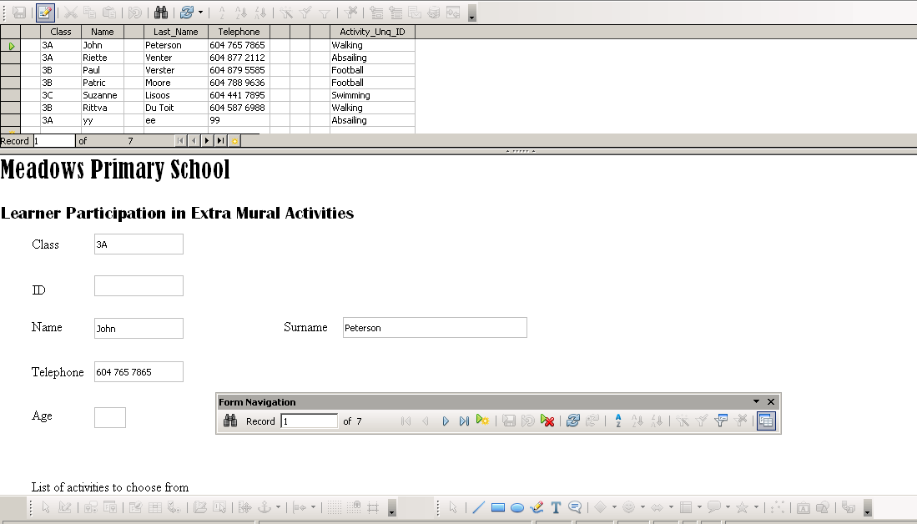

###### Save a Form

To save a form, close the form. It will prompt you to save the form. If you have not given it a name, it will ask you for the name. Remember the naming convention we discussed on page 69.



###### Test your knowledge

**Navigating and saving a form**

1. Forms can have duplicate names?

* TRUE
* FALSE

2. The form navigation buttons allow;

* To move forward one record
* To move backward one record
* To move to the end of the records
* To move to the beginning of the records
* All of the above
* None of a, b, c or d

**Answers**

1. FALSE

2. All of the above

##### L:\COL\images\coputerbasedlearning.PNGDeleting a Form

If you want to delete an existing form, go to the **Forms View,** right-click on the form you want to delete and select **Delete** from the drop-down options.

If the toolbar is open you could also select the delete button or use the **Edit 🡪 Delete** on the menu bar.

You can also mark it and press the **Delete** button on your keyboard.

Each time you will be asked to confirm the delete:

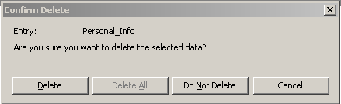

##### summarySummary

During this section you were introduced to forms through:

* Creating a form for data entry
* Using a form to retrieve information
* Use a form to navigate the records within a database
* Delete a form
* Save and close a new and existing form

### Retrieving Information using Queries

The focus of this section is to develop an understanding of querying the database to gather specific information from an area of the database.

The purpose of this section is twofold:

* First you will build an understanding of searching and applying filters to the database and how to sort data for simplified review. You will also build a query using the query wizard.
* The second part of this section is dedicated to using the query designer to build and save queries that can be saved and used again.

Outcomes

At the end of this section you will be able to:

* search for information based on a query parameter
* use filters to find select information from a table or form
* sort information using a variety of methods
* apply sorting to a query
* remove filtering and sorts from tables and forms
* use the query wizard to build a query

#### What is the Difference between Sort, Filter and a Query?

One of the major confusions in databases is the difference between SORT and FILTER.

It is important to know that both SORT and FILTER are **temporary** actions.

When a table is closed, the filter criteria and/or sorting instructions will be gone. Therefore, in order to retrieve the same records again, the filter has to be recreated.

* To SORT means to put the records in a database table in a specific order (ascending or descending) using a specific field. It can be alphabetical or numerical values. A SORT changes the structure of the table, so the records are in a different order according to the sorting criteria. Sorting is a quick and **temporary** tool that is created for one-time use on a specific table.
* To FILTER a database table means to show only the data that fits a certain filter criteria. It’s important to know that filters DON’T reorder the underlying data like a SORT does. The records are still in the same way, it’s simply being displayed on screen according to your criteria. It is also important to know that no record is deleted during filtering. A filter is a quick and **temporary** tool that is created for one-time use on a specific table.

The biggest difference between sorting and filtering on the one hand and queries is that sorting and filtering are **temporary** tools and a query is reusable (can be saved and used again).

A query gathers, collates and presents data from tables in usable forms (another table). Queries are capable of performing the functions of filters and sorting. A query can also perform “aggregated functions” (Summary Query) such as calculating the sum, average, maximum or minimum value of data.

In contrast to a filter, a query is **reusable**. A query allows the selection criteria and/or sorting instructions to be saved and reused.

#### L:\COL\images\coputerbasedlearning.PNGBasic Operations – Searching, Sorting and Filtering

##### Searching a Table for Data

A good way to search for data is from the database table directly.

When a table is opened a number of buttons are available on the toolbar that facilitate searching, filtering and sorting data. To open the table for searching - in the **Tables View,** right-click on the table and select open.

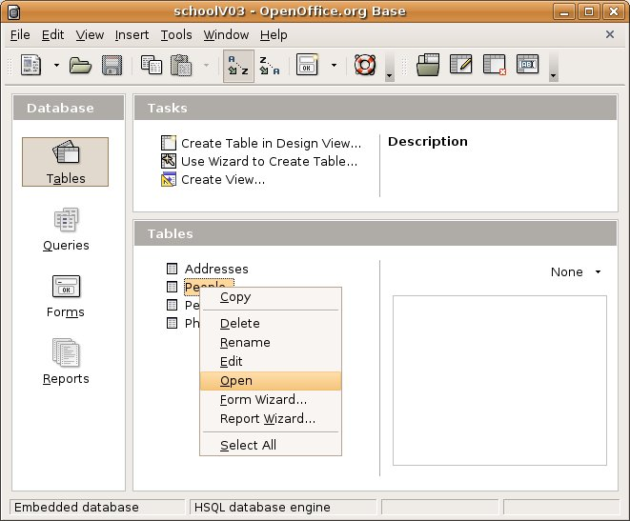

###### Opening the Search Dialog

To search for a specific word, number or date in a record or a set of records within a specific column press the **Find Record** button on the **Table Data** toolbar (There are two versions of this button -  or ).

L:\COL\images\coputerbasedlearning.PNGIf you cannot see this button, activate the **Table Data** toolbar through the **View🡪Toolbars** option on the **Menu bar.** This will present the Record Search dialog.

###### Setting the Search Parameters

The **Record Search** dialog box will appear and you can enter the word, number or date you want to search for and select which field to look in.

Click on the Search button and the value being searched will be highlighted when it is found.

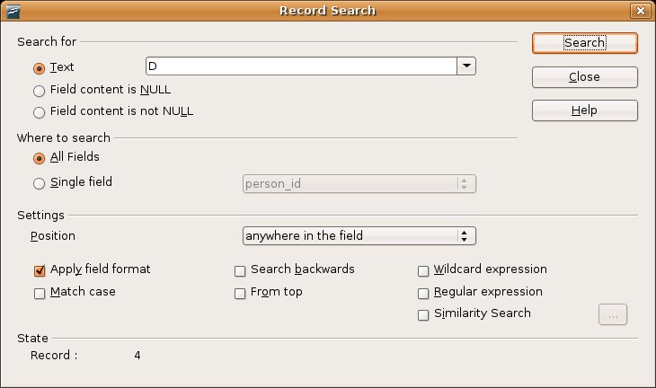



###### Test Your Knowledge

**Searching...**

1. Searching data can be done from within an open table or query?

* TRUE
* FALSE

2. Which of the following is not a valid data type for a search?

* Number
* Binary
* Text
* Date

**Answers**

1. TRUE

2. Binary

##### L:\COL\images\coputerbasedlearning.PNGUsing Filters

###### Applying Filters

Filtering allows you to work with selected records (you can only see the filtered data). In other words the rest of the database remains hidden while only the records you want to work with are visible.

To apply a filter, open the table to be filtered in **Tables View**.

There are four icons for filtering on the Standard Toolbar.

 or 

These are:

1. **AutoFilter** - which filters the whole table for the value that is highlighted.
2. **Apply Filter** - which applies the filter currently active.
3. **Standard Filter** - which sets the filters parameters.
4. **Remove Filter** - which removes the currently applied filter.

###### Approaches to Filtering

**The AutoFilter** filters the whole database table for the value that is highlighted. This can be very useful when looking for individual or sets of records for a given value.

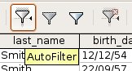

In your table you highlight the value (text or numerical) that you want to filter and click the **Auto Filter** button.

It will immediately give you a table that displayed only the values in the table you have identified.

**The Remove Filter** will return the table to include all the data as it was before the filter was applied. Keep in mind filters do not delete (remove) the data they just keep in hidden. (Note: The Remove Filter button is also used to remove a sort.)

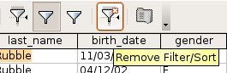

**L:\COL\images\coputerbasedlearning.PNGThe Apply Filter** uses the last applied filter and runs it again. This is useful when looking for specific values and need to refer back to all the data in the table. This used in combination with Remove Filter allows you to "toggle" between the filtered data and all the data.

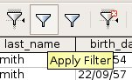

###### The Standard Filter

The Standard Filter presents a dialog which allows the entry of parameters to create a multi-field and multi-value filter. It could be considered an advanced filtering capability.

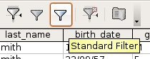

In the Standard Filter dialog fields to be filtered can be chosen, criteria can be selected and values can be set on more than one and up to three fields.

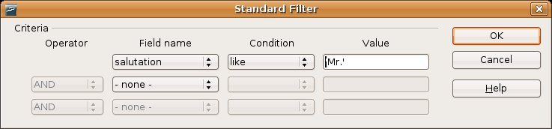

###### Test Your Knowledge

**Filtering…**

1. Which of the following is not a filter activity?

* Standard Filter
* Remove Filter
* Assign Filter
* Apply Filter
* Auto Filter

1. The standard filter allows for only one criterion?

* TRUE
* FALSE

**Answers**

1. Assign Filter
2. FALSE

##### L:\COL\images\coputerbasedlearning.PNGSorting Data

###### Simple Sorting

Records can be sorted according to numeric or alphabetical order of a specific field/s.

To sort data open the table to be sorted.

On the table toolbar there are three buttons that can be used for sorting. These are:

* Sort Order - which opens the Sort Order dialog.
* Sort Ascending - which sorts the records A to Z or if numbers, lowest to highest.
* Sort Descending - which sorts the records Z to A or if numbers, highest to lowest.

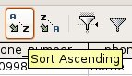

Oo-dbms-Queries-Sort-Buttons.jpg or 

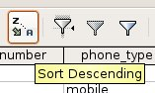

###### Opening the Sort Dialog

To create a more advanced sort that uses more than one column within the sort, click the Sort button on the toolbar.

Oo-dbms-Queries-Sort-Buttons.jpg or 

This will present the **Sort Order** dialog.

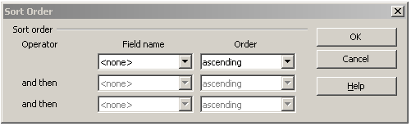

The Sort Order dialog allows a sort to be created with up to three fields using either an ascending or descending order. After choosing the sort fields and the order click **OK** to run the sort, the records in the table should then be sorted based upon the sort order entered. (Remember: to remove the sort order, use the "Remove Filter / Sort" button on the toolbar.)

##### L:\COL\images\coputerbasedlearning.PNGQuery Operations

##### Creating a Query using the Query Wizard

If you want a reusable sort/filter, you build a query and save it to be used at a later stage.

A query is a table that you have sorter and filtered according to certain criteria you have set and saved it. It is always linked to your table. Any changes you make in your table will be reflected in your query. **If you ever change data in your query, it will also be changed in your table**.

###### Starting the Wizard

Using the query wizard can be a very helpful way to quickly build a query. To start go to the **Query View** and select the **Use Wizard to Create Query...** task.

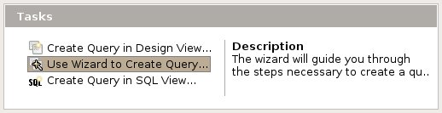

The wizard follows 8 steps to create a query. Follow these steps and press  when you want to move to the next step.

1. **Field selection**

In the first step you choose the table and the fields to build your Query on.

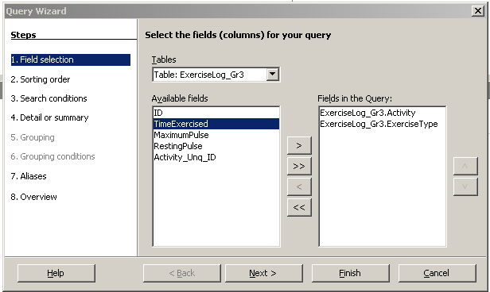

Select the fields from the selected table to display in your query. Once all the query fields have been selected click the  button to continue with the wizard.

1. **L:\COL\images\coputerbasedlearning.PNGSorting Order**

To assign sort orders to the query select up to four fields to sort upon. Choose the **field** to be sorted and the **order**, either ascending or descending.

The sort will occur with the first field being the priority sort with the subsequent fields sorting within the first sort.

As an example if **class** was the first sorting field and **last_name** was the second, the query will ordered in classes, and within each class sort the surnames.

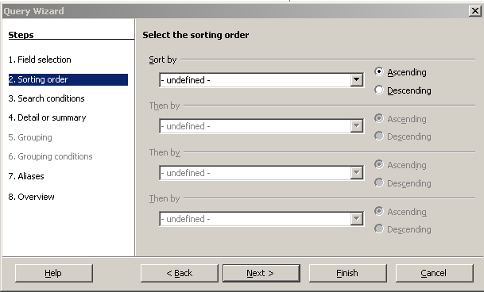

1. **Setting the criteria/Select the search conditions**

Setting the criteria/setting the conditions is like using a filter.

The criteria will filter the data and "hide" some of the data from the query results.

To set the criteria:

* select a field,
* choose a condition, and
* enter a value to compare.

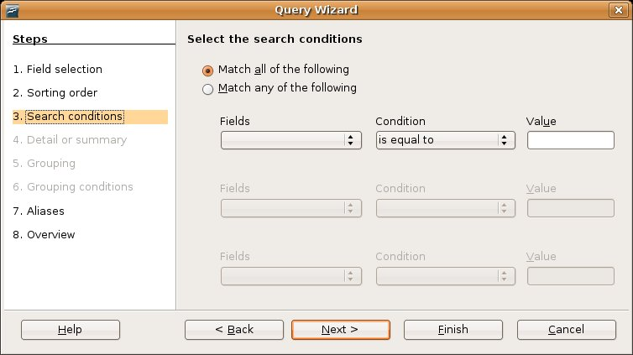

You can skip this step by selecting **Match all of the following.**

1. **L:\COL\images\coputerbasedlearning.PNGDetail or summary**

###### Here you will be indicating if you want to show the query in detail (as a table showing all the records of the query) or in summary (showing only the results of aggregated functions – sum, average, maximum, minimum)

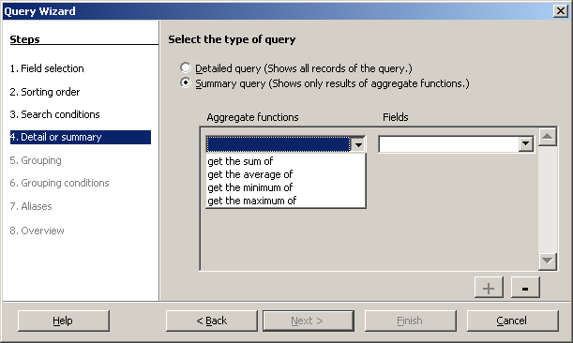

###### If you have selected the Summary query, you will be prompted to the grouping and grouping conditions steps (Steps 5 and 6). Follow the instructions to refine your query further.

If you want to assign aliases, you can follow the instructions in step 7.

It can be useful to change the name of the column when it is displayed in the results. The aliases step of the wizard allows this change, in the right column enter a new name to be displayed.

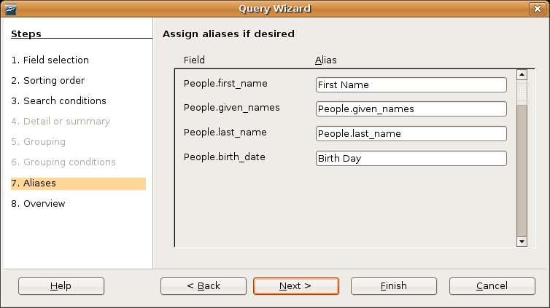

**L:\COL\images\coputerbasedlearning.PNG8. Overview**

The last step of the wizard prompts for a query name. This name will be saved to the database for later retrieval and will be displayed as a saved query.

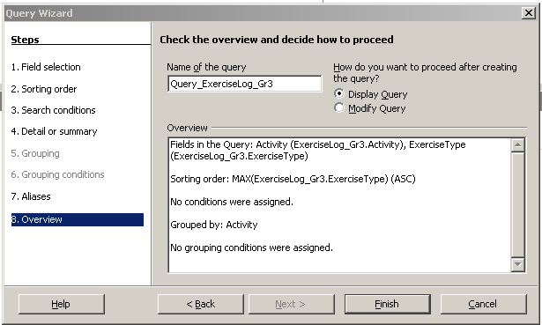

This step also provides a summary of the query, selecting the "Modify Query" option would allow editing of the query summary text. If changes to the query are required it would be better to use the "Back" button of the wizard and make the changes using the wizard.

If you are satisfied with your query, hit the  button.

###### Running the Query

To run the query, go to the **Query View** and right-click on the query name and select **Open**. You can follow any of the other means to open the query viz. the menu bar or by double clicking on the name.

Review the results to confirm they are what were desired. If changes are required the query will have to be opened in design mode.

The query will be displayed as a table or as a summary table depending on the selection maide in step 4 above.

###### Test Your Knowledge

**Using the Query Wizard**

1. Setting the criteria in the wizard is like using a query filter?

* TRUE
* FALSE

2. Which step of the query wizard CANNOT be ignored?

* Field Selection
* Sorting Order
* Search Conditions
* Grouping Conditions
* Aliases

**Answers**

1. TRUE

2. Field Selection

L:\COL\images\coputerbasedlearning.PNG

##### Creating a Query using the Design View

Creating queries in design view allows the most amount of flexibility when building a query. In design view the query is built from scratch.

The designer selects the data source [table(s)] and creates joints between tables (if necessary), adds fields to the query, sets sort order and criteria, adds aliases for column names and other design features.

###### Starting a New Design

To create a new query in design mode select the **Create Query in Design View...** task in the **Query View**.

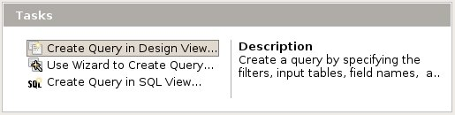

###### Setting up the Query

Remember when developing a new query in design view it is useful to incrementally test that the query is providing the results required. To run the query in design mode press the run query button.

Oo-dbms-Queries-Design4-run.jpg or 

L:\COL\images\coputerbasedlearning.PNGThe first step in designing a new query is to **add the tables** that the query will be based upon. Because queries are also tables, you are able to select existing saved queries or tables to base your new query on.

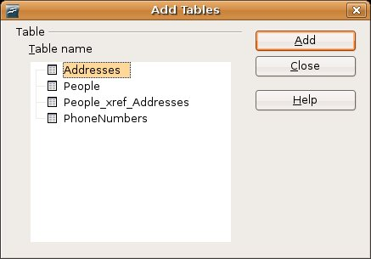 or 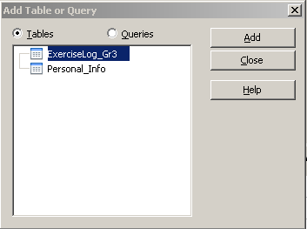

Once the tables have been added to the query designer the fields need to be selected.

You can use the query designer at the top and double click on each field you want to put in your query.

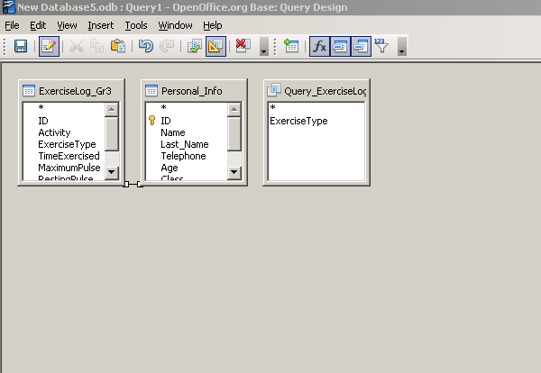

OR

You can use the table at the bottom of your screen. Click on the first cell in the **Field** row. A  indicates that you have access to a dropdown list of all the fields in the selected tables and queries. Select a field to include in your query.

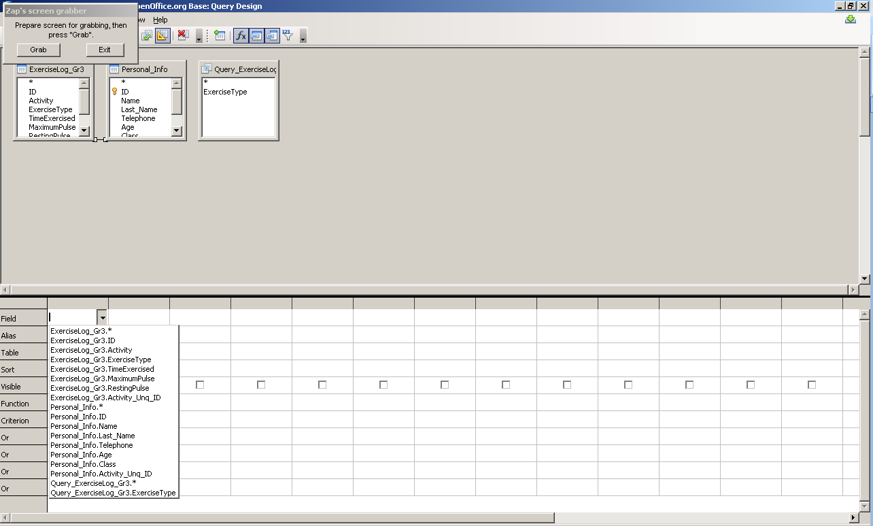

L:\COL\images\coputerbasedlearning.PNGContinue adding the fields by selecting them from the available drop-down menus in the subsequent **Field** row. If more than one table is a part of the query it is also a good idea to review if the table relationship(s) have become a part of the query.

Confirm the relationships can be done by looking for a line joining the two tables in the query designer at the top. If no line exists one of the two fields that create the join can be dragged and dropped on top of the other. This should create the join/relationship.

Remember every action that you are doing in the query will be reflected in your original table too.

After you have selected all the fields for your query, you will see that the table of origin has also been indicated as well as the visability of your field in the query.

Once all the fields have been added to the query:

* aliases can be added for the fields;
* sort orders can be applied the fields of the query. It’s a good idea to limit the number of sorts to three. You can choose between not sorted (default), ascending and descending.

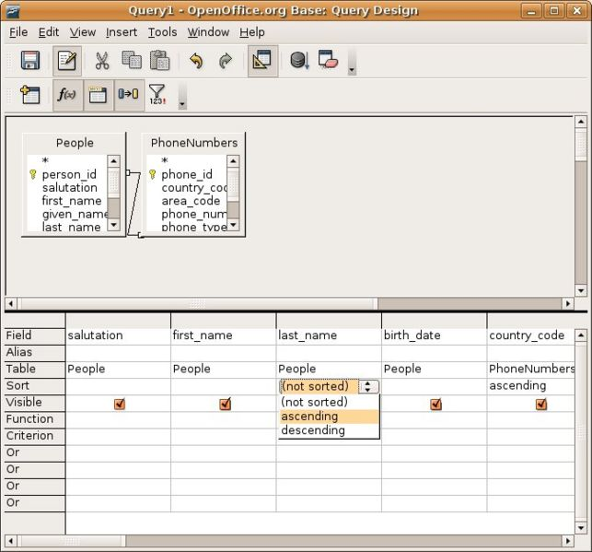

You can also define the criterion for the specific field.

In closing the query you will be prompted to save the query under a new name.

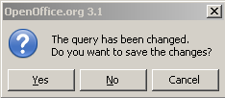

###### Test Your Knowledge

**Designing a new query**

1. A query can include more than one table?

* TRUE
* FALSE

2. Joins can be created while in the query designer?

* TRUE
* FALSE

**Answers**

1. TRUE, a query can include many tables, these tables should be joined by a relationship.

2. TRUE, joins can be created by dragging and dropping the required fields.

**L:\COL\images\coputerbasedlearning.PNG**

##### Running the New Query

###### The Run Query Button

As you have learnt in the previous activity, when developing a new query in design mode it is useful to incrementally test that the query is providing the results required. To run the query in design mode press the run query button.

Oo-dbms-Queries-Design4-run.jpg or 

###### L:\COL\images\coputerbasedlearning.PNGQuery Results in Design View

After the query has run, the results will be displayed in a split window above the two query design windows. To iteratively build the query, make changes to the design and run the query again.

Keep making changes and running the query until it provides the results desired.

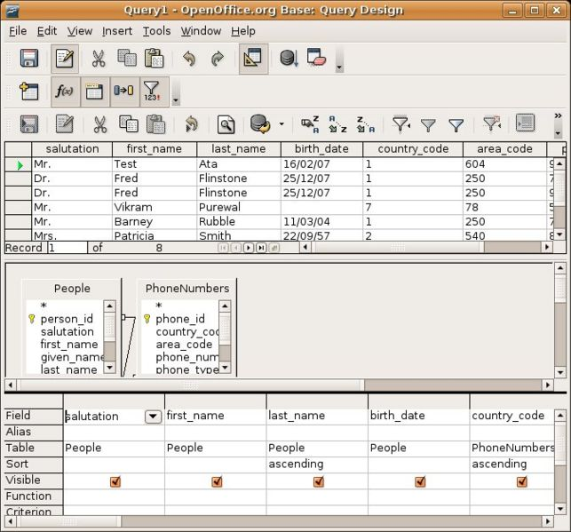

##### Saving, Opening, Deleting the Query

###### Saving, the Query

To save the query in design mode select **File 🡪 Save...** from the menu bar. Alternatively, you can close the window and if there are pending changes be prompted by the **Save As...** dialog.

In the **Save As...** dialog enters a meaningful name. Naming is important, for through time many queries may get built and having a meaningful name will make query identification easier.

###### L:\COL\images\coputerbasedlearning.PNGOpening the Query

To open a query, right-click on the query name to run and select open. This will run the query and present the results. You can also double-click on the name or use the menu bar.

Once the result window is open the sort and filter buttons are available allowing further organising of the data to better suit the results being sought.

###### Deleting the Query

There are three methods to delete a query.

* Right-click on the query name and select **Delete** from the drop-down menu.
* Select **Edit 🡪 Delete** from the menu bar.
* Mark the query and press the **delete** key on the keyboard. The delete operation will prompt to confirm the deletion.

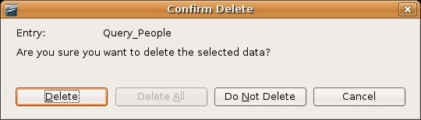



###### Test Your Knowledge

**Query Management**

1. There are three methods to delete a query?

* TRUE
* FALSE

2. Which activity CANNOT be done in the query results window?

* Sorting
* Filtering
* Aliasing
* None of the above

**Answers**

1. TRUE

2. Aliasing

##### summarySummary

During this section you were introduced to basic querying through:

* searching for information using a query parameter
* the use of filters to find information from a table
* sorting information using a variety of methods
* apply sorting to a query
* removing filters and sorts from tables
* using the query wizard to build a query

You were also introduced to the querying designer through:

* designing a new query that included the fields from multiple tables
* added criteria to queries by using operators
* altered the fields (columns) presented in the query
* ran the query
* saved and reused the query
* Deleted a query.

### Creating Reports

The focus of this section is to develop an understanding of reports. Reports are used to print selected information from a table or query.

Reports will be built upon existing database tables using the OpenOffice Base reports wizard.

Outcomes

By the end of this section you will be able to:

* create a report using the report wizard
* use a report to retrieve information
* identify the difference between static and dynamic reports
* delete a report
* save and close a report
* select the reports data source
* add fields to the report
* change the display order of the fields
* assign labels to the reports fields
* name a new report
* save a report
* discuss static and dynamic reports
* delete a report

#### Basic Reporting

The first question you have to ask yourself is what is the difference between a query and a report?

A query is a tool that pulls data out of a database. A report is a tool that allows data from a database to be printed in a useful format.

You can create Static and Dynamic reports. A static report captures the report for a given point in time. So every time you open a static report it displays the results based upon the data in the database when the report was first created (date specific).

The Dynamic report displays the results based upon the data in the database at the time the report is run. With a dynamic report if the report data in the database changes daily so will the report.

A good practice is to first develop a query with the data you want to display in your report. The creation of the report is then very easy.

**L:\COL\images\coputerbasedlearning.PNGCreate a Report using the Report Wizard**

Open the **Reports View.**

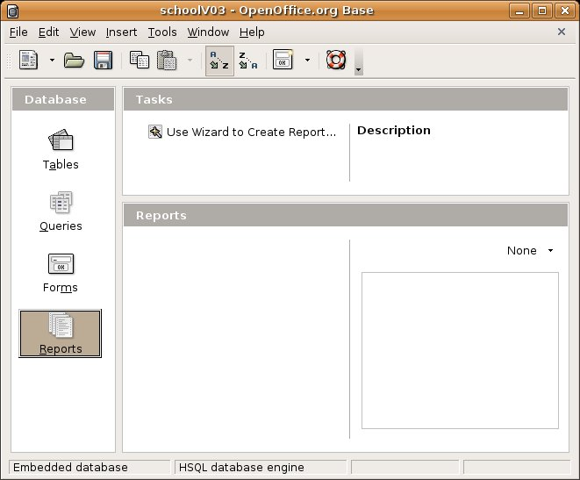

The Reports Window has only one task that will start the Reports Wizard.

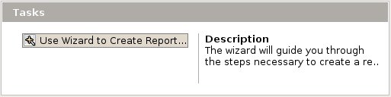

It will prompt you to the 6 steps to create a report.

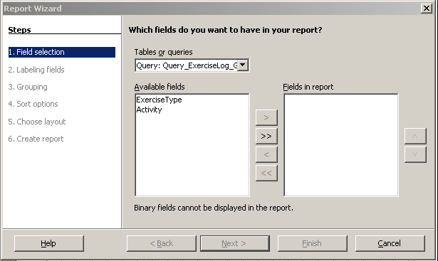

###### L:\COL\images\coputerbasedlearning.PNGField selection

Select the source table. The available fields can then be moved to be fields in the report by selecting the field and then selecting the  to move the field into the report. The option available in the Field Selection step of the Report Wizard allows the following actions:



move the highlighted field

move all the fields

remove the highlighted field from the report

remove all the fields from the report

###### Labeling fields

In this step you have to give the fields in your report the desired names to display in your report. Sometimes it is useful to add labels to the fields. This is particularly true when the field names of the table are not easily understood or an existing database is being used with a different country and language. Labels can be associated with every field on the report to assist in the reports comprehension.

These names can contain spaces.

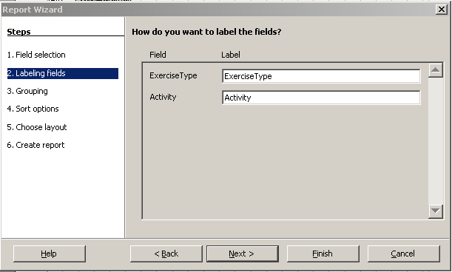

###### Grouping

In this step you can add one or more grouping levels for the report. This is done to refine the order in which our report data is presented.  For example, we may wish to break down a telephone directory by area so that all of the members of each area are listed separately. Grouping is normally used in large tables.

You select the fields by clicking on them and clicking the arrow **>** to move them into the Groupings box. You can group up to four fields in a report.

If you do not wanting Grouping leave this box as it is and click on **Next**.

###### L:\COL\images\coputerbasedlearning.PNGSort options

You have the ability to sort your data for presentation in the report.

The ability to sort data in the report is also useful. During the sorting step the report wizard will prompt for the fields and the order to base the reports sort. The sorting step of the wizard lets you choose how you want the data to be sorted based on specific fields.

If you don't need to sort the data into any particular order then leave this screen as it is and click on **Next**.

###### Choose layout

In this step you can choose the layout of your data and the layout of headers and footers.

OpenOffice Base provides a number of report layouts, depending on the usage of the report or the audience who will be looking at the report different layouts can be more effective.

Investing some time to review the different report layouts will be very useful as more reports are developed. Choose the appearance for the report by selecting the layout of the data and the layout of the headers and footers. It can also be chosen whether the report will print in Portrait or Landscape by clicking on the relevant option.

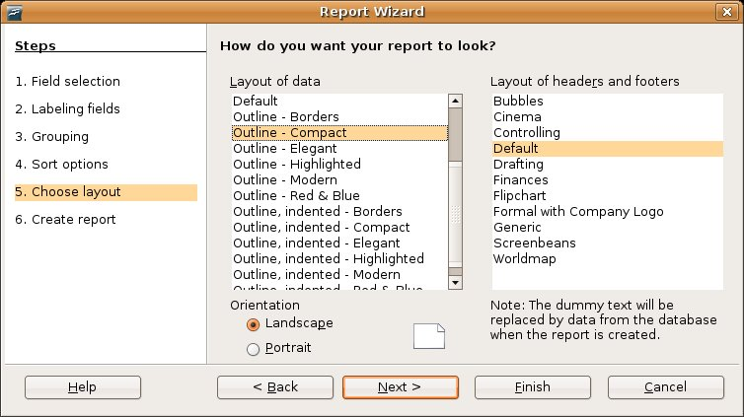

###### Create report

The final step of the wizard is to name the report and save the report. When you hit the **Next** button, you will be prompt to give your report a title.

When saving the report the option to make the report either **static** or **dynamic** is available.

Remember, the static report captures the data based upon when the report was created, the dynamic report captures the data based upon each time the report is run.

L:\COL\images\coputerbasedlearning.PNG

You can also choose to modify the report layout by clicking on the radio button. You will see a report layout with the fields indicated as highlighted.

You can change the layout as you would have done to a table in Word processing. Make use of the **tab** key to align fields, drag the lines around, put spaces between words/fields, change fonts and sizes, and even delete some of the default fields that were put into the report such as author, date and page numbers.

If you are satisfied with the selection, click on **Finish** and OpenOffice Base will create the report.

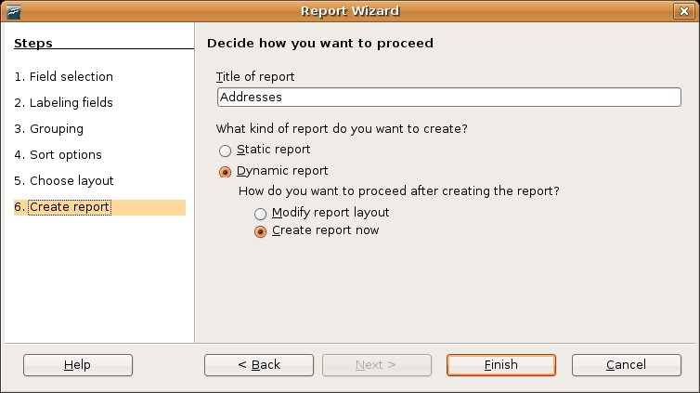

You can now open the report by one of the 3 means you know by now and look at the final version. If you are not 100% satisfied, you can right-click on the name of the report in the **Report View** and edit the layout of your report.

You can even go back to the wizard by clicking on .

###### Deleting a Report

There are three ways to delete a report. After selecting the report to delete, choose either:

* from the menu bar select **Edit🡪Delete**
* right-click on the report name and select **Delete** from the pop-up
* highlight the name of the report and press the **Delete** key on the keyboard

Any of the methods will prompt to confirm the delete.

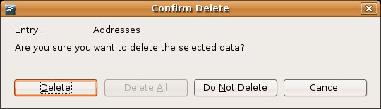

###### Test Your Knowledge

1. The display order of the fields can be changed?

* TRUE
* FALSE

1. Fields can be relabeled for the report, identify the possible reason for this activity.

* Database table field names are hard to comprehend
* Report needs to be in a different language than the database fields are currently in
* The audience uses words which meaning does not match the database field names
* All of the above
* None of the above

1. A report can be based on a query?

* TRUE
* FALSE

1. The OpenOffice 3.0 Base reporting has two available tasks?

* TRUE
* FALSE

1. A static report will display.

* All the static data in the database
* A list of the static query parameters
* The data for a when the report was first run
* The data for each time the report is run
* None of the above

1. Grouping and sorting are two ways to say the same thing?

* TRUE
* FALSE

1. Sorts can include up three fields?

* TRUE
* FALSE

1. Reports cannot be printed using a landscape page orientation?

* TRUE
* FALSE

1. Which of the following is NOT a layout for the headers and footers?

* Controlling
* Executive
* Finances
* Generic
* Worldmap

1. The only way to delete a report is to select it from the main reporting screen, right-click and select delete?

* TRUE
* FALSE

**Answers**

1. TRUE
2. All of the above
3. TRUE
4. FALSE
5. The data for a when the report was first run
6. FALSE
7. FALSE
8. FALSE
9. Executive
10. FALSE

##### summarySummary

During this section the learner was introduced to the reporting through:

* creating a report using the report wizard
* using a report to retrieve information
* identify static and dynamic reports
* deleting a report
* saving and closing a report

### Outputting and Sharing Data

The focus of this section is to output data in printed and file formats.

OutcomesUpon completion of this section the learner will:

* print forms and reports
* print the result of a query
* apply appropriate print options
* output data to other formats

##### L:\COL\images\coputerbasedlearning.PNGPreparing to Print

You can only print forms and reports and not queries and tables directly from your database.

You have to open the report or form from the appropriate view. You can either use the print button 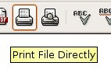 or the menu bar **File🡪Print.**

Like in any other application, you can also have a preview of your print by pressing the page preview button, 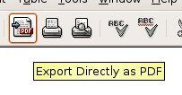 or select **File🡪Page preview** option from the menu bar.

Remember that you can also set the printer options like other applications.

###### Print Selected Record(s) or a Table

To print selected records in OpenOffice.org you would have to run a report that would select the required records and then print it. The same would apply if you wanted to print the complete table.

###### Print a Query

To print the result of a query you would have to create a report based on that query and then print it.

###### Print a Report

First generate the report and then print as normal by clicking on **File🡪Print** form the menu bar. If you want to print a specific page, type it into the dialog box and click OK or else simply click on OK to print the entire report.

###### L:\COL\images\coputerbasedlearning.PNGPrinting

There are two options when printing a report or form, either select the **Print File Directly** button from the toolbar or use the **File🡪Print** from the menu bar.

|  |  |
| --- | --- |
| Oo-dbms-Print-Button.jpg | *Oo-dbms-Print-Menu.jpg* |

###### Printing Options

Once printing has been selected a dialog will appear prompting for the destination Printer and providing the ability to set some properties for the selected printer. The ability to set the number of pages and the number of copies is also available on the **Print** dialog.

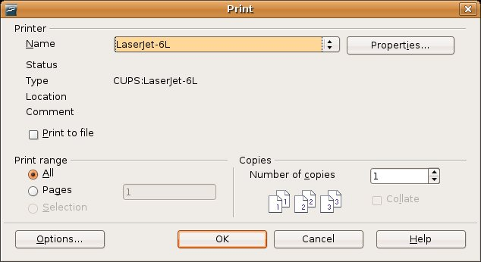

The **Properties** dialog will prompt to set the properties of the selected printer. Keep in mind that the properties will be printer specific, though many similar properties are held by most printers. The properties dialog will prompt for items like; Page Size, Orientation (portrait or landscape), Print tray (which paper source in the printer), etc.

###### Test Your Knowledge

1. The three print buttons are; 'Print Settings', 'Print File Directly' and 'Page Preview'?

* TRUE
* FALSE

1. There are two print orientations; portrait and legal?

* TRUE
* FALSE

1. Which of the following cannot be printed directly?

* Form
* Report
* Query
* None of the above

**Answers**

1. FALSE
2. FALSE
3. Query

L:\COL\images\coputerbasedlearning.PNG

###### Export to Another File Format

###### Export a Form or Report to Text, XHTML and PDF

OpenOffice provides the ability to output to other sources than just the printer.

Two other available output sources are XHTML (.html or.xhtml files), PDF files or Mediawiki (text) (.txt) files.

To export to one of these formats select **File🡪Export...** form the menu bar and save it.

###### Export a Report or Form to directly to PDF

Use the  button or **File🡪 Export to PDF…** to export a report or form to PDF. You need Acrobat Reader to open the file.

###### Export a Table or Query to a Spreadsheet

A query and a table are in a format similar to a spreadsheet and can be easily exported to Calc.

You have to copy a table from Base to a new Calc sheet, then you can save or export the data to any file format that Calc supports.

1. You first have to open the table/query **view** you want to export.

Click on the database table/query name to be exported.

1. Right click on the name and select **Copy** from the menu to select the whole table/query.
2. L:\COL\images\coputerbasedlearning.PNGNow you have to open the Calc spreadsheet.

Choose **File🡪New🡪Spreadsheet**  from the menu bar.

You have both applications open on your desktop.

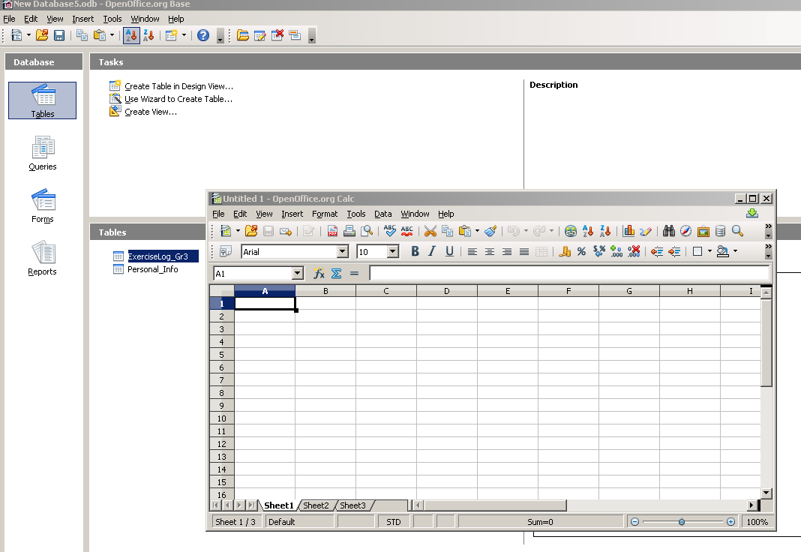

1. Click on cell A1 in the new Calc window, then paste the content into the spreadsheet by either press **Ctrl V** or choose **Edit🡪Paste** from the menu bar or right click en choose **Paste**.

Now you have the data in a spreadsheet that you can perform any action as has been discussed in Module 4.

##### summarySummary

After completing this unit, the learner is able to:

* print forms and reports
* print the result of a query
* apply appropriate print options
* output data to other formats

### 

### Scenario - A Database for a Small Business

# 

# 1. Aim

After you have completed module 5, the following scenario must be studied. It will apply the knowledge and skills you have acquired in this module.

You have started a small business. Please get a concept of your business (what your business is all about)

* 1. What is your business’ name?
  2. Make a list of at least 10 customers that you will supply goods to/render a service to your business.
  3. Choose a date when your business has started (in the past).

You will now create a database with several tables for your business. You will create a database called **YourSurname_YourBusinessName**.

When you create a database planning is essential. You must decide:

* What you want the database to do
* What questions do you want to answer from your data
* What data fields will you need
* How will you enter data
* What do you want your reports to contain or show
* How do you want to sort or group your data

# 2. Tables

## 

## 2.1 Customers Account Table

1. Initially you need one table of all your customers with just their Account numbers, name of the business, title, first names and surnames of the contact persons.
2. Create a table and call it **Cust_No_YourSurname**.
3. Use the table structure as indicated below.
4. Fill in the details of Account numbers, name of the business, first names and surnames. You should have at least 10 records.

Structure of Cust_No table

|  |  |  |  |  |  |
| --- | --- | --- | --- | --- | --- |
|  | **Data type** | **Primary key** | **Field size** | **Format** | **Description** |
| AccountNumber | Text | Primary key | 5 |  |  |
| BusinessName | Text |  | 50 |  |  |
| Title | Text |  | 4 |  | Prof/Dr/Mr/Ms |
| FirstName | Text |  | 50 |  | Call Name |
| Surname | Text |  | 50 |  | Last Name |

**Questions**

1. Why is AccountNumbers the primary key?

## 2.2 Basic Table

1. You need a table with the details all your customers, called **Basic_YourSurname**.
2. To type the whole thing over again is a waste of time.
3. Copy the Account Numbers and to the new one **Basic_YourSurname**.
4. Use the structure below to guide you with the requirements.
5. Do not add any information – that will be added via a form.

Structure of Basic table

|  |  |  |  |  |  |
| --- | --- | --- | --- | --- | --- |
|  | **Data type** | **Primary key** | **Field size** | **Format** | **Description** |
| AccountNumber | Text | Primary key | 5 |  |  |
| Date_of_First_Transaction | Date/Time |  |  | December, 31 1999 | Transaction must be after start date |

## 2.3 Addresses Table

1. You need another table of the customers list with their account numbers in which to add their address details.
2. To type the whole thing over again is a waste of time.
3. Copy the Account Numbers to a new table called **Addresses_YourSurname**.
4. Add the fields as indicated below.
5. Do not add any information – that will be added via a form.

Structure of Addresses table

|  |  |  |  |
| --- | --- | --- | --- |
|  | **Data type** | **Primary key** | **Field size** |
| AccountNumber | Text | Primary key | 5 |
| Address1 | Text |  | 50 |
| Address2 | Text |  | 50 |
| Town | Text |  | 50 |
| PostalCode | Text |  | 6 |
| TelephoneNumber | Text |  | 20 |
| CellNumber | Text |  | 20 |

**Questions**

1. Why is PostalCode a text field and not number field?
2. Why are the names of the businesses and the names and surnames of contact persons not in this table?

## 2.4 Credit Table

1. You need another table of the customers with their account numbers in which to add their account limits (maximum amount to allow for credit per month) details.
2. To type the whole thing over again is a waste of time.
3. Copy the Account Numbers to the new table named **Credit _YourSurname**.
4. Add the fields as indicated below.
5. Do not add any information – that will be added via a form.

Structure of Credit table

|  |  |  |  |  |
| --- | --- | --- | --- | --- |
|  | **Data type** | **Primary key** | **Field size** | **Format** |
| AccountNumber | Text | Primary key | 5 |  |
| Credit limit | Numerical |  | 10 | With 2 decimal places |
| PaymentSchedule | Numerical |  | 1 | When is payment due. Use the following codes:   * 1 – 1st of the month * 2 – 15th of the month * 3 – 25th of the month * 4 – last day of the month |

# 3. Relationships

1. Our goal is create a form to enter data that will go to the correct tables. So we must first link the different tables.
2. First check that the field which we are going to use to link, is the same in each table. Check that AccountNumber field is spelt the same in each table and has the same format.
3. In the Relationship window add all the tables.
4. Create a link between the …
   1. Cust_No table and the Basic table
   2. Cust_No table and the Address table
   3. Cust_No table and the Credit table
5. Save the Relationships.
6. Print the relationships window.

# 4. Get Ready to Enter Data and then Enter Data

1. Using the Wizard create an Input Form for Clients with all of its fields.
   1. Use Cust_No as the Main Form with the Addresses tables as sub-form.
   2. Join the main form and sub-form with the account number.
   3. The account number must just appear once on the form.
   4. Arrange the main form in blocks, labels above and the subform in columns with labels on the left.
   5. Allow changes and display to the form.
   6. Choose a style colour other than beige with no field border.
   7. `Name the form **Cust_Input_YourSurname**
2. On the same form, use the Design View to insert your business name and Customer Input Form in 2 lines at the top. Use another font than Times New Roman or Arial and use 20 pt font size. Change the layout as follow and save the form:

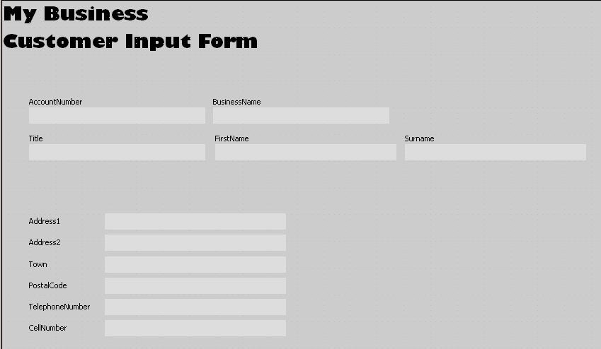

1. Create the following form in design view (Name: **Credit status_YourSurname**):

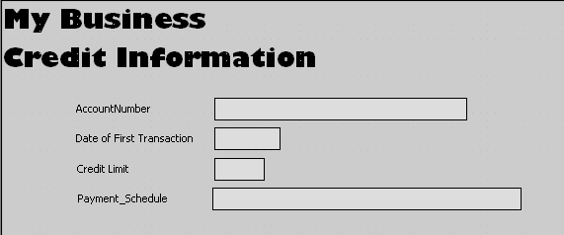

Add basic, credit and address details of all the customers through the forms.

# 

# 5. Analysing Collected Data

## 

## 5.1 Queries

All the information has been added via the form. Before we start analysing the information look at the tables.

### 5.1.1 Queries on the Basic Table

Perform the following queries on the **Cust_No_Surname** table. Save each query with the number and a short description.

1. How many contacts have the title, Mr ? …
2. Perform an update query to show the number of customers (sum of) based on their title.
3. Perform a select query to show the number of customers signed up for the first 2 weeks of your business.

### 5.1.2 Queries on the Credit Table

Perform the following queries on the **Credit_Surname** table. Save each query with the number and a short description.

1. How many contacts are paying at the end of the month? …
2. What is the average credit limit for your customers? …
3. Perform a query to show the number of customers by their payment schedule.

## 5.2 Reports

Create the following reports based on the different tables. Save each report with the number and a short meaningful description.

1. List the customers with all the names of the contact persons, the names of the Business and their account numbers.
2. List the customers with all the names of the contact persons, the names of the Business with their account numbers sorted alphabetically according to Business Name.
3. List the customers with all the names of the business, contact persons, full address with their account numbers.
4. List the customers with all the names of the business with their account numbers sorted in ascending Date of First Transaction.
5. List the customers with all the names of the business with their account numbers sorted and grouped by payment schedule showing the number of businesses paying at a certain date of the month.
6. List the customers with all the names of the business with their account numbers sorted grouped by payment schedule showing the average credit limits for each of the 3 dates.

# 6. Output Data

* 1. Print an empty form to be duplicated for your business so that the secretary can fill it in before entering data.
  2. Print a full set of filled forms for the secretary to check the data entered. Change the page orientation.
  3. Print the content of the full **Cust_No_Surname** table.
  4. Print the first query that you have run.
  5. Print the first report that you have compiled.
  6. Select any 2 records from the **Cust_No_Surname** table and print them.
  7. Export the first report you have created to a PDF file and save it.
  8. Export the **Adressess_Surname** table to a spreadsheet, name it and save it.

# 7. Evaluation

|  |  |  |  |  |  |  |
| --- | --- | --- | --- | --- | --- | --- |
| Name of Student: |  |  | |  | Date of Assessment: |  |
| Type of Assessment: |  |  | |  | Assessor: |  |
| **Assessment Criteria** | **Level 1 (0)** | **Level 2 (1)** | | **Level 3 (2)** | **Level 4 (3)** | **Assessment** |
| **Conceptual Skills** | | | | | | |
| **Creating a database on a defined subject** | Unable to create a useful database at all. | Attempts to select fields, queries and reports, and create a switchboard with errors evident. | | Can create some useful queries and reports. | Expertly selects fields, queries and reports, and creates switchboard to solve a need. | X10 |
| **Practical Skills** | | | | | | |
| **Creating a form** | Unable to create a form at all. | Attempts to create a form but with either errors of formatting or structure evident. | | Can create a simple form without errors. | Expertly creates a detailed form with advanced features. | X7 |
| **Creating a sub-form** | Unable to create a sub-form at all. | Attempts to create a sub-form but with either errors of formatting or structure evident. | | Can create a simple sub-form without errors. | Expertly creates a detailed sub-form with advanced features. | X6 |
| **Printing a form** | Unable to print a form at all. | Attempts to print a form but with errors. | | Can print a form without errors. | Expertly print a form with advanced layout features. | X2 |
| **Printing a record in a form** | Unable to define and control printing of records from a form at all. | Attempts to print a record in a form but with limited success. | | Can define and print a required record showing basic skills. | Expertly defines and prints a record in a form showing advanced skills. | X5 |
| **Performing an update query** | Unable to perform an update query at all. | Attempts to perform an update query but with errors evident. | | Can perform a simple update query successfully. | Expertly performs an update query with advanced formulae. | X5 |
| **Performing a select query** | Unable to perform a select query at all. | Attempts to perform a select query with only one criteria but with limited success. | | Can perform a select query with more than one criteria and showing basic skills. | Expertly performs a select query showing advanced skills. | X5 |
| **Creating a report** | Unable to create a report at all. | Attempts to create a report but with either errors of formatting or structure evident. | | Can create a simple report without errors. | Expertly creates a detailed report with advanced features. | X5 |
| **Creating a report based on two tables** | Unable to create a report based on two tables at all. | Attempts to create a report based on two tables but with either errors of formatting or structure evident. | | Can create a simple report based on two tables without errors. | Expertly creates a detailed report based on two tables with advanced features. | X5 |
| **Assessment Criteria** | **Level 1 (0)** | **Level 2 (1)** | | **Level 3 (2)** | **Level 4 (3)** | **Assessment** |
| **Adding controls, calculations and formulae to a report** | Unable to add any controls, calculations or formulae to a report at all, or gives a repot an unsuitable heading. | Attempts to add controls, calculations or formula, or a heading to a report but with errors evident. | | Can add controls, calculations or formulae, or a heading to a report. | Expertly adds controls, calculations and formulae, and a heading to a report. | X5 |
| **Printing a table** | Unable to print a table at all. | Attempts to print a table but with errors. | | Can print a table without errors. | Expertly print a table with advanced layout features. | X5 |
| **Printing a form** | Unable to print a form at all. | Attempts to print a form but with either errors. | | Can print a form without errors. | Expertly print a form with advanced layout features. | X5 |
| **Exporting a report to PDF** | Unable to export a report to PDF at all. | Attempts to export a report to PDF but with errors. | | Can export a report to PDF without errors. | Expertly export a report to PDF with advanced layout features. | X5 |
| **Exporting a report to a spreadsheet** | Unable to export a report to spreadsheet at all. | Attempts to export a report to spreadsheet but with errors. | | Can export a report to a spreadsheet without errors. | Expertly export a report to a spreadsheet with advanced layout features. | X5 |
| **Work Skills** | | | | | | |
| **Personalising a database** | Unable to personalise a database at all. | | Can simply personalise a database with a basic name and or icon. | Can simply personalise a database with a basic name and icon. | Expertly personalises a database with a suitable name and effective icon. | X5 |
| **Outward appearance of forms and reports** | No attempt to improve the appearance of forms and reports | | Lacks design and purpose. | Outward appearance is purely functional with necessary details. | Outward appearance professional with selected details. | X5 |
| **Initiative** | Never showed any initiative. | | Showed limited initiative. | Showed a fair amount of initiative. | Showed a great deal of initiative. | X5 |
| **Neatness & visual impact** | Very untidy and making negative visual impact. | | Some effort is made to produce neat work with little success, and which is visually boring. | Good effort to produce neat work with some room for improvement, and which is visually pleasing. | Great care has been taken to produce exceptionally neat work which is eye-catching and visually exciting. | X10 |
| Total / 300 | | | | | |  |
| Total % | | | | | |  |