Module 4

Spreadsheets using OpenOffice CALC

Module Overview
In this module you will learn how to develop, work with and manipulate spreadsheets using the computer application OpenOffice Calc.

At its core, a spreadsheet is a table of rows and columns, creating a grid of cells in which numeric or text values are displayed. In most situations, spreadsheets are used for manipulating numeric data. The spreadsheet computer application is designed to enable you to model and observe the relationships among data in the respective rows and columns.

Spreadsheets can be useful in a variety of contexts, e.g., to analyse business data, to track personal finances, or to create charts for visual interpretation of data.

Upon completion of this module you will be able to:
- Develop, format, modify and use a spreadsheet
- Generate and apply standard formulae
- Create and format graphs and charts
- Output a spreadsheet to print

Terminology

 | Spreadsheet | A spreadsheet is a large sheet of rows and columns that lays out information about a financial transaction, including things like costs, taxes, income, etc., so that a business person or manager can easily make decisions
 | Worksheet | A worksheet is one page of a spreadsheet. An electronic spreadsheet document can incorporate many worksheets.
 | Cell | A cell is the area formed by the intersection of a row and a column. Spreadsheet cells contain information such as text, numbers, and formulas.
 | Toolbars | Toolbars are areas in the application that contain most of the common commands and functions you need to use the application.
 | Formulas | A formula is a spreadsheet function entered in a cell.
 | Functions | A function is a formula that is built into the Calc program.
 | Chart | A diagram that displays data in a pictorial form.
 | Relative Cell Reference | A reference to a worksheet cell that is dynamic. The reference changes with changes in the worksheet.
 | Absolute Cell Reference | A reference to a worksheet cell that is static. The reference doesn’t change with changes to the worksheet.

Study Tips

You may find it useful to skim through an entire block of content first, paying special attention to the headings and introductions, and then go through a second time for more in-depth study and practice.

However, we recommend that you do the activities as they appear. They are essential study materials, offering practice in particular skills that will build your proficiency in using spreadsheets.

Keep linking the new content that you are studying with content in this module that you have already covered and with your own general knowledge, to deepen your understanding of the operations you are learning.

If you have difficulty understanding any area, try working at it slowly. If you still do not understand, seek help.

Preknowledge

Before beginning this module, we recommend that you:

- complete the modules on Computer Applications (Modules 1 and 2) and Word Processing (Module 3)
- be skilled in arithmetic computation: addition, subtraction, multiplication, division, computation with decimal numbers, computation of percents
- be skilled at estimating the results of simple calculations, so when entering formulas the results can be mentally checked
- be a logical thinker, that is, capable of following a series of calculations from one step to the next

Introduction to Spreadsheets

More than any other application software in history, the spreadsheet has been instrumental in helping personal computers gain widespread acceptance in the business community. Called a “killer” application, spreadsheets made such an immediate impact on financial accounting that businesses couldn’t afford to not take notice.

Section Overview

This section will introduce you to the key concepts of the spreadsheet application.
By the end of this section, you will:

- appreciate the impact that the development of the spreadsheet had on growth of the personal computer industry
- become familiar with some design considerations for spreadsheet documents

Development of the spreadsheet

Spreadsheets, in their original paper form, have been used in financial accounting for hundreds of years. A spreadsheet is a large sheet of rows and columns that lays out information about a financial transaction, including things like costs, taxes, income, etc., so that a business person or manager can easily make decisions.

Electronic spreadsheets are much more recent. Their development dates back to 1978, when Dan Bricklin and Bob Frankston, two MIT acquaintances, developed a program called VisiCalc (from the words visible and calculator). VisiCalc became an instant success and convinced a lot of business people to purchase a personal computer for their business. (reference: http://www.bricklin.com/history/sai.htm)

In 1983, a new spreadsheet application called Lotus 1-2-3, designed to run on personal computers being produced by IBM, was introduced. It added integrated charting, plotting, and database features, and established the spreadsheet as a tool for data presentation and complex calculations.

The next milestone was in 1985, when Microsoft Excel was written for the Apple Macintosh personal computer. The Macintosh offered the advantage of a graphical user interface, with pull-down menus and the point-and-click capability of the mouse, which made it easier for most people to use. When Microsoft released the Windows operating system, Excel was the first spreadsheet software designed to run on it.

Design considerations for spreadsheet documents

The two features of a good spreadsheet are:
- good data, and
- good design. Good design makes it easier to enter data and retrieve valid results. Poor design can make a spreadsheet unusable despite having excellent data to work with.

The points below will help you to avoid becoming disoriented in the maze of spreadsheet cells by designing your spreadsheet so that you can navigate easily. Other suggestions will help you create a spreadsheet document that analyses data quickly and efficiently. You may not understand all of the terms described below until you work through the practical exercises, but refer back to this list often as you create new spreadsheets.

- You should start your design with an end in mind. Establish how you are going to layout the columns and rows of your spreadsheet. Spreadsheet software has far more rows than columns, so generally you should create your spreadsheet document with the headings running across the columns, and the data in rows underneath.

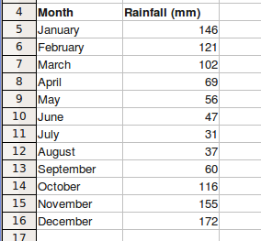

- Sometimes the number of rows or columns will increase over time, and sometimes they will remain fixed, but you should assume that you will have to add more data or formulas sometime in the future (because you probably will).
- Use descriptive labels for rows, columns, and cells in your spreadsheet.
- Use different type faces or font colours to distinguish data and highlight features of your spreadsheet, but keep it simple. Use Bold for data headings.
- All raw data should be included in a single worksheet (a worksheet is one page of your spreadsheet).
- Leave about four blank rows at the top of your spreadsheet above your column headings. These can be used for keeping totals, since this location is much easier to find than at the bottom of your data.
- Have your data sorted as much as possible. This will help keep your spreadsheet organised, but will also help speed up some calculations.
- Use a date format that the spreadsheet recognises as a date (as opposed to text). This will allow you to use this data in formulas.
- Don’t combine data into one cell. For example, a person’s name should go into at least two cells: Family Name and Given Name.
- Decide what formulas you need to use to perform the calculations in your spreadsheet.
- Decide what charts or graphs are most appropriate to display the results of your spreadsheet analysis.

The following main types of graphs/charts are possible:
Column

Bar | 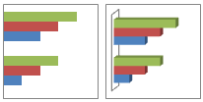
Pie | 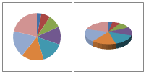
Area | 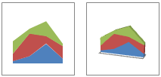
Line | 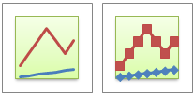
XY Scattered | 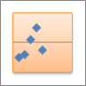

Summary

This section discussed the development of the spreadsheet application, and introduced the concept of spreadsheet design, in particular how good design makes it easier to enter data and retrieve valid results from your spreadsheets.

Using the Spreadsheet Application: The Basics

Section Overview

OpenOffice Calc is the application we will be using to develop and work with spreadsheets. Calc is similar to Microsoft Excel; in fact you can save your Calc spreadsheets in Excel format for sending to Microsoft users.

In this section we will become familiar with the basic features of the Calc application and learn how to perform basic spreadsheet operations.
Upon completion of this section you will be able to:
- open and close Calc
- identify the core components of the Calc workspace
- open one and several spreadsheets; close a spreadsheet
- create a new spreadsheet
- save spreadsheets in different locations and under different conditions
- switch between worksheets in a single spreadsheet
- use help functions in Calc
- use tools to adjust settings

Opening and closing Calc

Opening and closing OpenOffice Calc is done the same way as opening and closing OpenOffice Writer from Module 3, by using the Applications menu in the top-left of the Ubuntu desktop.

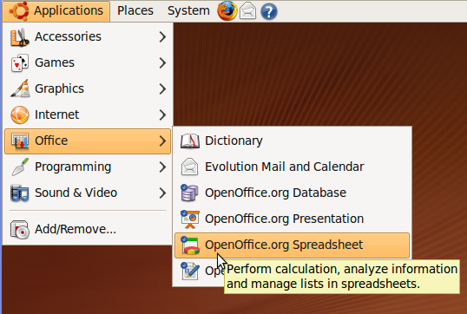

To open CALC:

- Click on the Applications menu.
- Click Office
- Click OpenOffice.org Spreadsheet.

This will present the OpenOffice splash screen as the operating system loads the Calc application.

To close CALC:

- Click on the File menu in Calc, then click Exit
or
- Click on the Exit icon in the top right hand corner of the Calc window.

Creating, opening, and closing spreadsheets

Creating a new spreadsheet

When you launch the Calc application, a blank spreadsheet is created for you automatically. To create a new spreadsheet from within the Calc application:

- Click on File on the menu Bar.
- Click on New on the drop down menu.
- Click on Spreadsheet. This will display a blank spreadsheet.

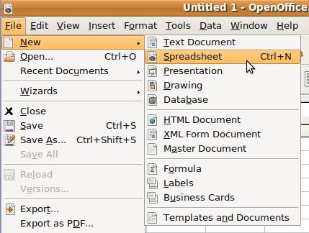

Your work area is one of the worksheets of the spreadsheet that you are working on. The tabs in the bottom left corner of the work area allow you to switch between worksheets. If the tab for Sheet 1 is highlighted, then it is the first worksheet that is being displayed. If you click on Sheet 3, then the third worksheet replaces the first on the screen. The spreadsheet consists of all these worksheets.

A spreadsheet consists of text, numbers and formulas that are entered into the cells of its worksheets. Collectively, text, numbers and formulas are referred to as data. Spreadsheets that contain data are saved as files, just as in the case of word processed documents.

Opening an existing spreadsheet from within Calc

- Click on File in the menu bar.
- Click on Open. This brings up the Open Dialogue window. The dialogue lists a series of directories and files.
- Locate the directory in which the desired file is held.
- Click on the directory to open it.
- Highlight the file.
- Click Open.

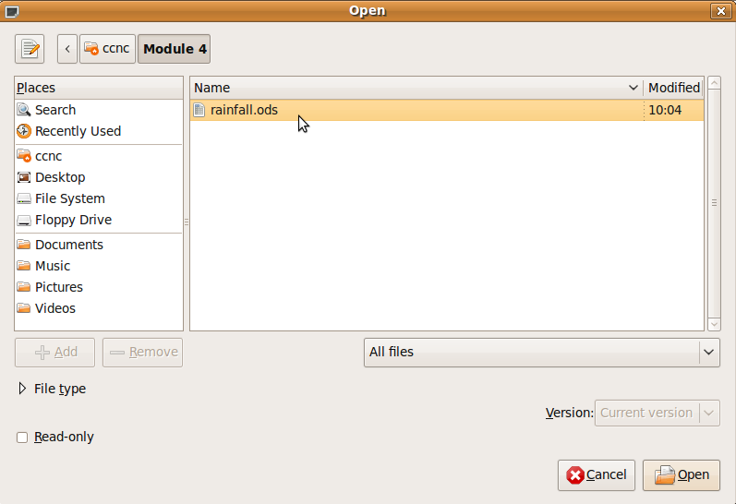
Tip: If you are not sure about the directory that contains your file and you have to search a bit, you will find the Up one Level icon useful.

Closing a single spreadsheet

Before we perform this task, we need to be clear about the difference between the 'close' and 'exit' commands. Close closes the spreadsheet, but leaves the program Calc and other spreadsheets open. Exit closes the spreadsheet you are working on, any other spreadsheet that is open, as well as Calc.

- Click on File on the menu bar.
- Click on Close. This command is in the top section of the drop down menu. Exit is in the bottom section.

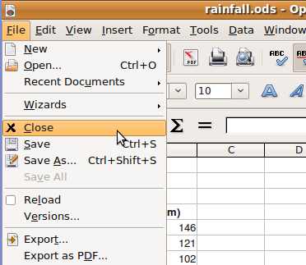
Tip: Always save your data before closing or exiting. Calc will help you here if the version of the document that you have on the screen differs from the one already saved on the hard disk. Calc will ask you whether you want to save the new version. Secondly, always close Calc before you shut down the system.

Working with multiple spreadsheets

If you need to work on more than one spreadsheet at the same time, you can open multiple spreadsheets and move between them. You may want to do this if you need to copy data from one spreadsheet to another.

- Click on File then Open.
- Locate the directory containing the files you wish to open.
- Click on the first file.
- Hold down the CTRL key and click on each of the additional files you wish to open.

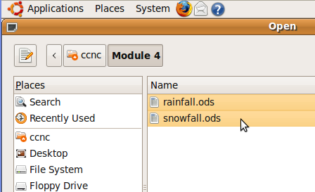

- Click Open. The last of the files loaded will appear in the window. This will be the active spreadsheet. The others are also loaded but are in the background.

You can make one of the other spreadsheets active as follows:

- Click on Window to list the spreadsheets that are loaded.
- Click on the spreadsheet that you wish to make active.

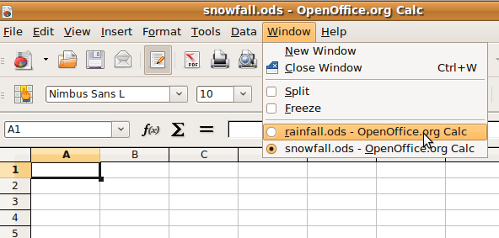

Close more than one spreadsheet

If you wish to close some but not all the spreadsheets you have loaded, then you will use the Close command for each separately. If you want to close all spreadsheets as well as exit CALC, then you will use the Exit command.

Saving spreadsheets

You will want to save your documents often so that you don’t lose data if your computer crashes or if your application is inadvertently closed. If you exit the application without saving, Calc will prompt you to save your work.

Saving on the hard drive of your computer

- Click on File, then click Save As. This will bring up the Save As dialogue.
- Locate the drive and /or the directory in which you wish to save the file. You can save files to your hard drive, floppy drive, Flash Memory stick, or many other storage memory devices.
- Enter the name of the file in the File Name window.
- Click Save.

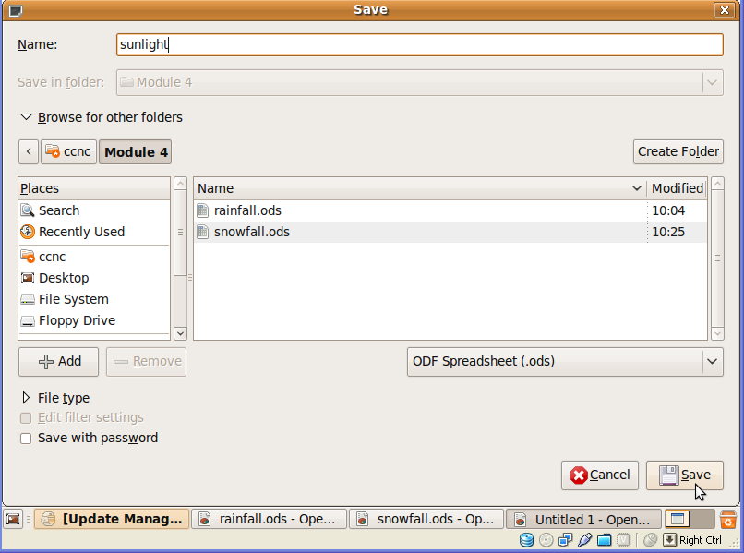

Save an existing file under another name

Sometimes we may want to have the same spreadsheet saved under a number of different names. Alternatively, we may want to save a spreadsheet before making changes. We would then have a copy of the new version as well as the version before changes were made. Suppose we have a spreadsheet loaded as shown below. In this case the spreadsheet already has the name demo.sxc.

We can now save what is displayed on the screen in two ways:

- As the existing file: After loading demog.sxc from the hard disk, we made some changes to it. Those changes exist only on the version on the screen and will not automatically be made to the file that is located on the hard disk. To replace the version on the hard disk with the contents as displayed on the screen.
Click on File, then Save.
- Under another name: Suppose we do not want to overwrite the contents on disk but would still like to save what is on the screen.
Click on File, then Save as.
This will bring up the Save As dialogue. You use this in exactly the same way as you would if you were saving a completely new file.

Save in another file type

Sometimes it is useful to convert the spreadsheet format into another format, for example, a text file that can be manipulated using a word processor. Alternatively, you may wish to save the spreadsheet in a format used by another spreadsheet program such as Microsoft Excel. To save a spreadsheet in a different format:

- Click on File, then Save as
- Click on the File Type window. This will display a list of file types
- Use the vertical scroll bar to view all the file formats.

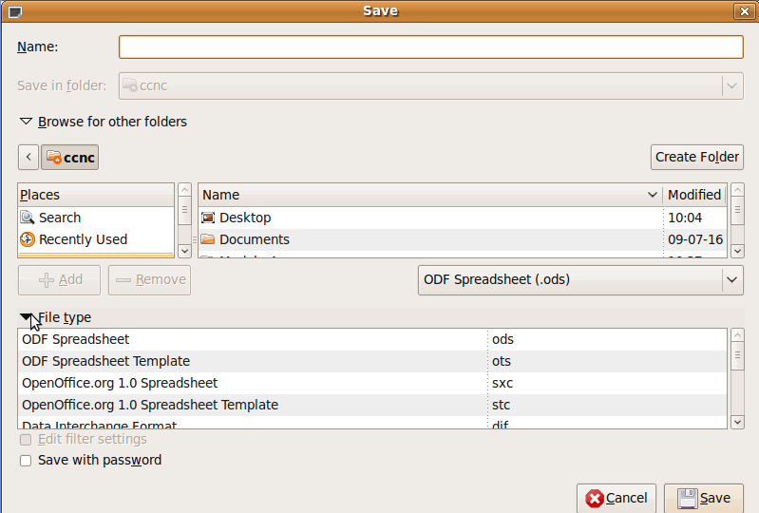

The following table lists some of the main file formats and a brief explanation of each.

File type | Extension | Explanation
OpenOffice.org Calc Spreadsheet | sxc | This is the format of Calc itself
OpenOffice.org Spreadsheet template | stc | A template is an outline for new templates. This may include text, values and formulas that are automatically inserted when a new template is created using template. It could also include formatting of cells such as font type and colour.
dBase | dbf | This would save the spreadsheet in a format used by some database programs. These databases would then be able to access the data in the spreadsheet and work with it as if it had been created by a database.
Microsoft Excel | xls, xlsx | Although Microsoft Excel is also a spreadsheet, it uses a different format. By saving the spreadsheet in the xls format, it could be opened directly by Microsoft Excel.
Web Pages | html | In order to read files, web browsers need to have them saved in a special format known as HTML or Hypertext Markup Language. Calc is able to save a spreadsheet in this format.
Text CSV | csv | This format is also called a comma delimited file. In this format, each row is converted into a paragraph. The columns of the spreadsheet are separated by commas. A word processor will read this file as an ordinary text file.
Data Interchange format | dif | A DIF is an industry standard for exchanging data between different types of application.
Portable Document Format | pdf | Pdf files are a common way of sending documents that you do not wish the receiver to be able to edit. These files can be read with Acrobat Reader. Unlike the previous formats that are created using the Save As ... function, pdf files are created using the Export as pdf ... option in the File menu.

Save different Versions

On the file menu there is an option called Version that allows you to save different versions of the spreadsheet in the same file. You are asked to give the version a name and this is recorded along with the date and time of the changes that were made. If you want to open another version of a file, simply click on File->Version and choose the Version you want to open.

Getting Help

OpenOffice has a help file for each application. The help files are searchable and can assist you with almost any OpenOffice Calc task.

- To access the help file, click on the Help menu in the Menu toolbar, and then click on OpenOffice.org Help. Alternatively, press the F1 key on your keyboard.

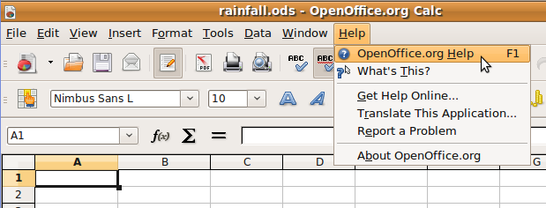
- Perhaps you are interested in getting help with inserting charts into your spreadsheet. When the Help window opens, you can browse through the Help contents by clicking on the Contents tab.

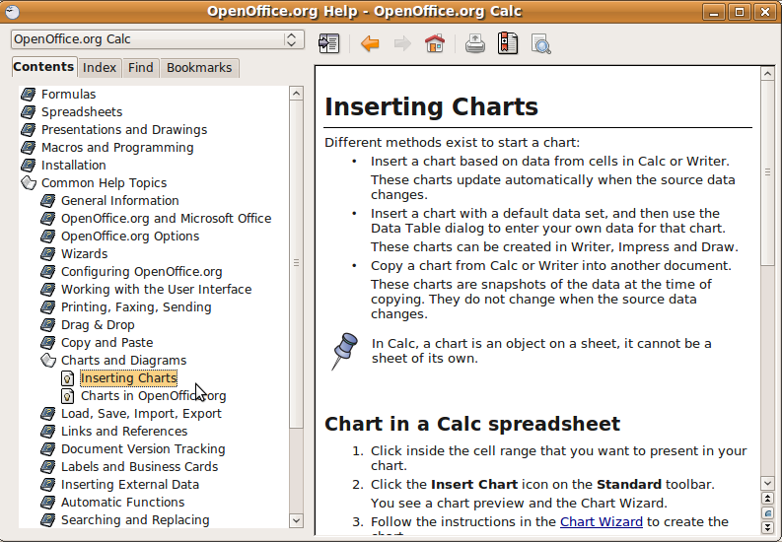

- The Index tab lets you search for specific help topics by typing a search term.

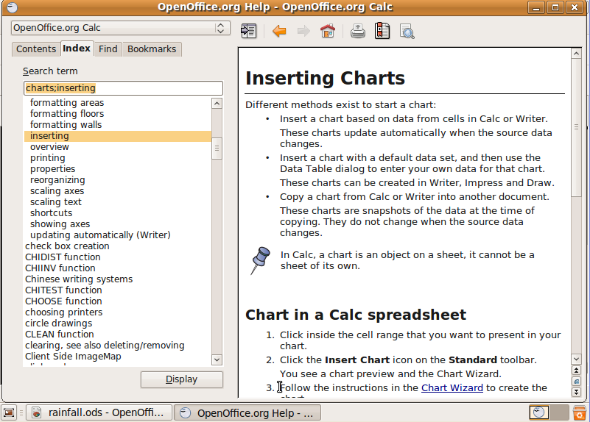

- The Find tab lets you search all of Help for specific words.

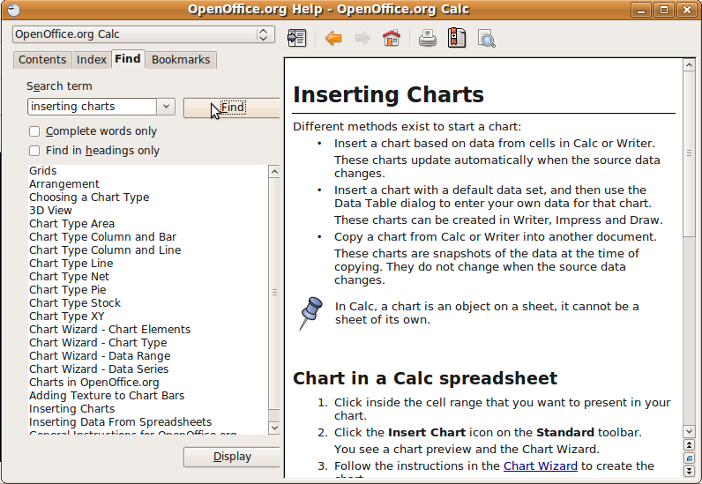

- You can bookmark Help pages that you are likely to revisit using the Bookmarks tab.

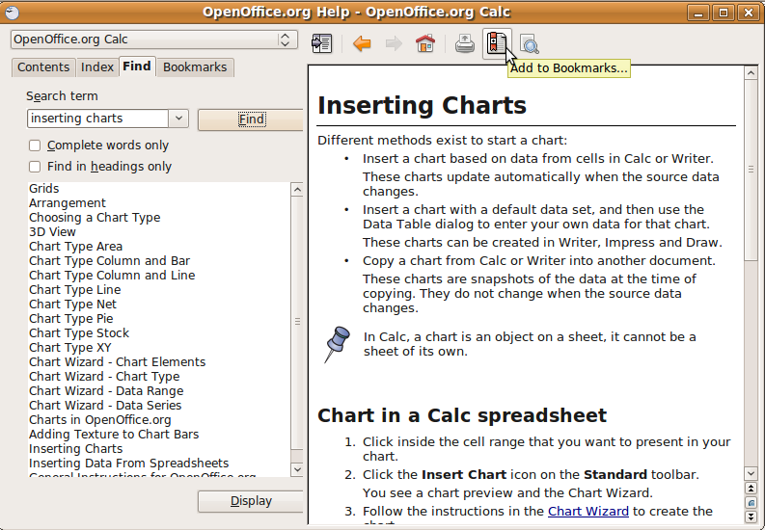

Self Assessment

To assess your learning, make sure you are comfortable carrying out the following tasks in OpenOffice Calc:

- Find and select OpenOffice.org Spreadsheet from the Applications menu.
- Create a new spreadsheet.
- Save your spreadsheet to disk as My First Spreadsheet.
- Close the spreadsheet and exit OpenOffice Calc.
- Again, start OpenOffice Calc and open your recently saved spreadsheet.
- Save your spreadsheet again under a different document format.
- Use OpenOffice Calc Help to search for help on a subject, and bookmark a help.
- Close the document and exit the application.

Summary

This section introduced the OpenOffice Calc application and described the basics steps to using Calc, including opening and closing spreadsheets, saving your documents, and using Calc functions and help.

Working with spreadsheets

Section Overview

So far in this module you have been introduced to the features of the OpenOffice Calc spreadsheet application and have learned some of the basic operations, such as opening, closing, and saving documents.

In this section we are going go further into the Calc workspace to learn how to use the toolbars and other components in Calc, and how to customise Calc for your use.
In this section, we will
- identify the core components of the Calc workspace
- learn about the Calc toolbars and their function
- perform some basic tasks with spreadsheet documents

Locating the components of the Calc window

When you open the Calc application, you will see running across the top of the Calc window a set of four toolbars each of which displays a series of icons or buttons that you can click on when you want to perform certain tasks. Beneath that you will see a worksheet window ready to receive your data, and another toolbar to provide a shortcut to perform common tasks.

The Calc window explained

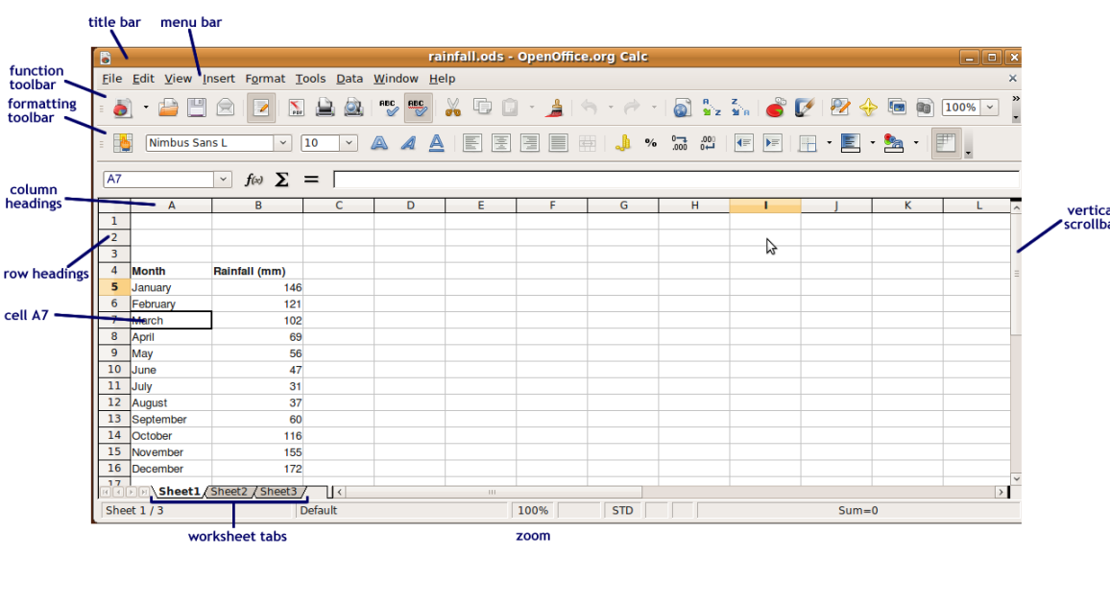

Calc toolbars

The Menu Toolbar

The menu toolbar displays the names for categories of basic commands, many of which also are found in the other OpenOffice tools. For example, the File menu consists of a set of commands related to file operations such as opening an existing file, creating a new file, closing files, and so on.

The Function Toolbar

The second bar is the function toolbar. It contains icons to provide quick access to commands found in the drop down boxes on the main menu, e.g., New, Open, Print, Copy, Paste, etc.

The Formatting Toolbar

The third bar is the formatting toolbar. It contains icons and drop down menus for commands used to format cells, e.g., to select a font, font colour, alignment, number format, border option and background color.

The Formula Toolbar

The fourth bar is the formula toolbar. It contains the Name Box drop down menu. In this dialog box you will see the address of the cell or cell range that is currently selected (e.g., C1:D5, if the block of cells from cell C1 to cell D5 is selected). Also you will see a long box called the Input Line, which serves as the entry point for all data to be entered in the highlighted cell.

Tip: When you place your mouse cursor over an icon on a toolbar, the name of the function appears on your screen.
Selecting the >> drop down menu on the far right of the function and formatting toolbars opens a menu of options for customising the toolbars.

The Calc Work Area

The work area consists of a grid formed by the intersection of rows and columns. Each grid is called a worksheet, and a spreadsheet can be made up of many such worksheets.

Columns, Rows and Cells

The main feature of a worksheet is that it is organised into columns and rows. Columns run vertically from top to bottom of the work area and are named by the letters of the alphabet seen at the top of each column. The rows run horizontally from left to right and are numbered.
A cell is the point where a row and a column intersect or cross each other. For example, cell A7 is the cell lying at the intersection of Column A and Row 7. A7 is also referred to as the address of the cell.

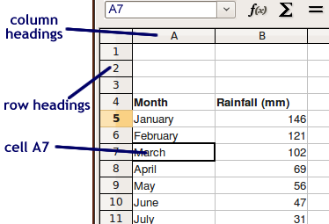

Tabs

The tabs are located at the bottom left corner of the work area. By default, there are 3 of them, named Sheet 1, Sheet 2, Sheet 3. These tabs identify the worksheets that are contained in a single spreadsheet.

When you click on a tab, its worksheet is displayed. The work area that we have been looking at thus far is essentially the work area of a single worksheet when displayed on the Calc screen.

We will look more closely at spreadsheets and worksheets in a later section.

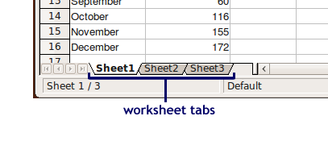

Adjusting the application settings

When you first open the Calc application, the workspace is organised so that the most used toolbars and features are available to you. As you become more proficient at using spreadsheets, you will find that you want to customise the Calc workspace to better meet your needs.

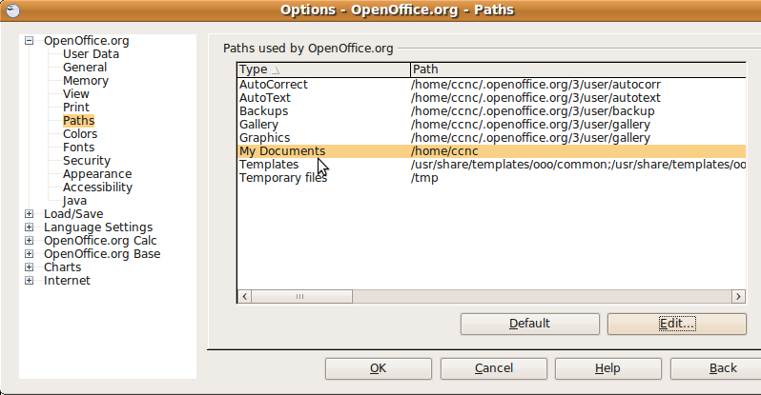

Magnification Tools

You can enlarge or decrease the screen display of the spreadsheet you have open by clicking on the Zoom tool on the Function toolbar. Choose the magnification that works best for your screen.

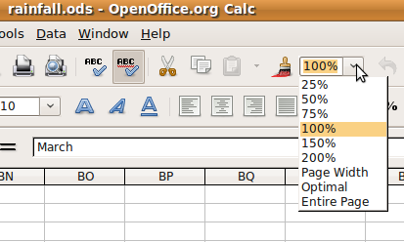

Modifying Options (show/hide toolbars)

OpenOffice Calc comes with a very large array of tools to format text and objects in your spreadsheet. When you install the application, the default toolset contains most of the tools that you will need to work on your documents, but you can also choose to show or hide toolbars or to modify toolbars if you need to.

To show or hide toolbars:

- From the View menu click on Toolbars
- Click in the boxes to either show or hide toolbars as needed.

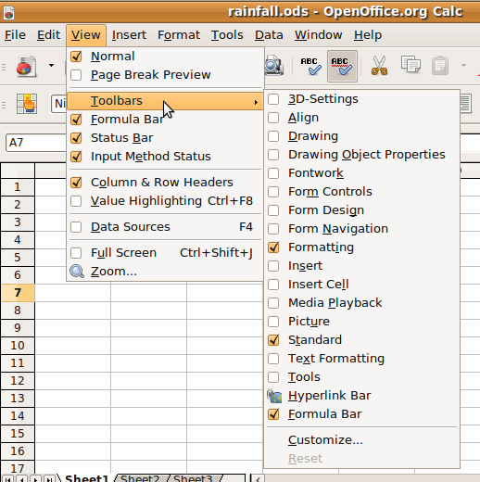

To modify a toolbar:

- From the Tools menu, click on Customize. The Customize dialogue window will open. You can use this to modify menus, keyboard functions, toolbars, or events.

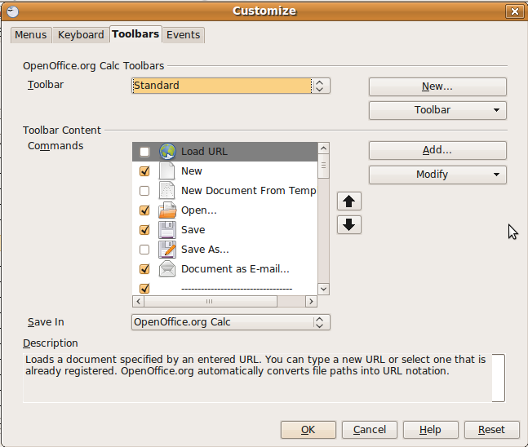

- Click on the Toolbars tab.
- Choose the toolbar you want to modify from the dropdown list.
- In the Toolbar Content Commands section, check the commands you want to include on the toolbar, and uncheck the commands you don’t want to show. If the command you want is not in the list, click on the Add button to choose from a list of other commands.
- Click OK to save your changes.

Self Assessment

To assess your learning, make sure you are comfortable carrying out the following tasks in OpenOffice Calc:

- Identify the following parts of the Calc window:
- The menu toolbar
- The function toolbar
- The formatting toolbar
- Rows and row headings
- Columns and column headings
- Worksheet tabs
- Be able to adjust the application settings such as zoom, and to modify toolbars by adding commands.

Summary

This section covered the Calc workspace, and how the workspace can be modified by hiding or showing toolbars, modifying toolbars, and changing the view settings.

Adding content to Calc spreadsheets

Section Overview

In this section you will begin to work with OpenOffice Calc spreadsheets by putting data into cells and formatting the data so that it is presented in a way that makes your spreadsheet documents easy to read and understand.
Cells are the basic building block of spreadsheets – these are the areas that hold data, functions, and formulas. A row is a group of cells adjacent to each other running horizontally in the spreadsheet. A column is a group of cells running vertically.

It’s important that you learn to enter data into cells correctly. If one cell is incorrect, it can have consequences for your whole spreadsheet.

In this section we will:
- work with cells:
  - enter and edit numerical, text, and other data into cells
  - search, sort, and manipulate data
  - format data
- work with rows and columns:
  - insert, delete, and resize rows and columns
  - format rows and columns
- learn the basic techniques to work with worksheets:
  - rename worksheets
  - insert and delete worksheets
  - copy worksheets

Scenario

In this section, we will use a real-life example to begin creating our spreadsheet, based on rainfall data for Vancouver, Canada. This data is interesting because there is a clear trend in rainfall patterns in Vancouver, and we will see how spreadsheets can be used to display and emphasise this trend.

We will work with the following sample data sample collected at Vancouver International Airport:

Precipitation for Vancouver International Airport
 | Year: | 2005 | 2006 | 2007
January |  | 249.6 | 283.6 | 181.4
February |  | 45.8 | 57.0 | 116.0
March |  | 132.8 | 92.4 | 214.8
April |  | 90.2 | 70.0 | 76.2
May |  | 68.6 | 42.8 | 37.0
June |  | 49.6 | 54.4 | 80.0
July |  | 43.6 | 25.2 | 53.0
August |  | 28.6 | 4.8 | 8.4
September |  | 53.6 | 39.4 | 73.6
October |  | 155.4 | 57.8 | 155.2
November |  | 136.6 | 350.8 | 116.2
December |  | 160.8 | 146.0 | 210.6

Do the following activities using the above file. Please remember to save the file under a name that you can retrieve the file again. Save the file after each activity.

Working with cells

Before we begin entering data into cells, we should take a little time to plan our worksheet by asking ourselves a few questions:

- What do we want the data to show us?
In this case, we want to determine the average rainfall in Vancouver for each month over a three year period. Therefore we should arrange our worksheet with a column for each month, and a row for each year.

 | Jan | Feb | Mar | Apr | May | Jun | Jul | Aug | Sep | Oct | Nov | Dec
2005
2006
2007
Avg

We enter the data this way because we want to be able to increase the length of our spreadsheet if we get more data, not the width.

In this case, there will always be 12 months in a year, so the width will stay constant, but the length will increase as we add more years.

- What formulas will we need?
The formula for finding the average.

- How will we display the results?
A column graph with one column for each month should work.

Selecting cells and cell ranges

In Calc you select cells with your mouse:

- If you want to select a group of cells in a single row, click on the left-most cell, hold the left mouse button down, and drag your mouse to the right (alternatively, click on the right most cell, hold the left mouse button down and drag left).
- If you want to select a group of cells in a column, click on the top most cell and drag down, or click on the bottom most cell and drag up.
- If you want to select a group of cells spanning a number of columns and rows, click on one of the corner cells in the range you want, and drag left or right and up or down until the range you want is selected.
- To select a whole row, click on the row heading (the number along the left side of the worksheet).
- To select a whole column, click on the column heading (the letter at the top of the worksheet).
- If you want to select the whole worksheet, click on the top left corner of the worksheet (to the left of column heading A and above row heading 1).

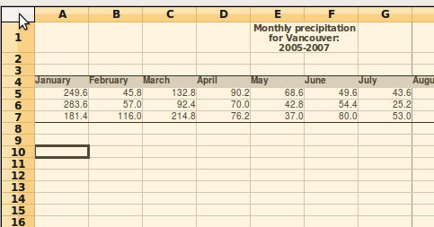

Entering data in cells

We enter data into cells by clicking on a cell and typing in our data using the keyboard. Remember that it’s good practice to leave a few blank rows at the top of a worksheet for totals, headings, etc.
- Enter the months of the year in Row 4 of your spreadsheet. These are our column headings.
- To move vertically or horizontally in a spreadsheet, either use your mouse to click on the next cell, or use the arrow keys on your keyboard.
- To enter a list of data, enter the data for the first cell and then type the <Enter> key to go to the cell directly below. Keep doing this for each column until the list is finished.
- Enter the precipitation measurement for each month in the three rows beneath the column headings. Your spreadsheet should now look like this:

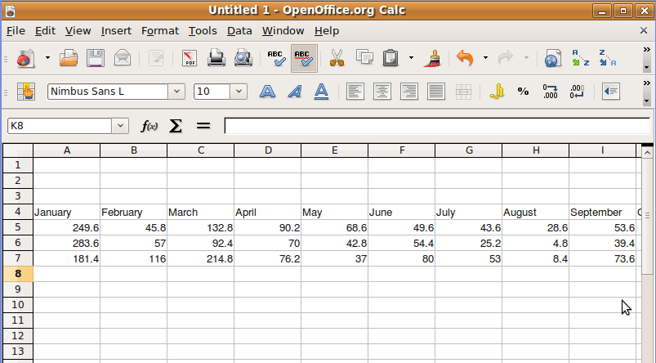

Editing data

If you make a mistake entering data into cells, you can correct it easily by clicking on the cell and typing the new data. You can do this either in the cell itself or in the input line in the spreadsheet:

To edit data in the cell:

- Double-click in a cell, and then highlight the data you want to replace.
- Type in the new data.

To edit data using the input line:

- Click inside the cell.
- In the input line, highlight the data you want to replace.
- Click on the Checkmark to accept the new data.

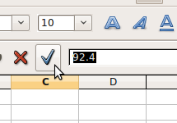

Using Undo/Redo

If you make a mistake when you are inputting data, applying formatting, or just about an other action in Calc, you can use the Undo button to go back one step.

The Redo button will take an action you have just finished and repeat it. This is handy if you need to repeat the same action on a number of cells.

Numerical data

Calc tries to interpret whether the data in our spreadsheet is numerical or text. By default, text data is aligned to the left of a cell, and numerical data is aligned to the right.

Numerical data can be formatted a number of ways, depending on the nature of the data. For example, our precipitation data is an integer with one digit after the decimal point.

To set the type of numerical data in a spreadsheet:

- Select the cells you want to format.
- Choose Format->Cells from the Calc menu.
- Choose the category:
  - Number: for general numerical data
  - Percent: display numerical data as a percent
  - Currency: for currency data. Negative values are generally displayed in red type.
  - Date: To display data as a date, in a variety of formats.
  - Time: To display data as a time, in a variety of formats.
  - Scientific: for exponent data.
  - Fraction: to display numbers as fractions.
  - Boolean value: displays True or False.
  - Text
- Choose the format. For numerical data, your choice is with or without a comma separating the hundreds, thousands, millions, etc.
- Choose the number of places after the decimal point.

We can see from the data in our spreadsheet that if the digit after the decimal point was zero, it was automatically dropped. Change the data format for all of our cells to include 1 digit after the decimal point.

Your worksheet should now look like this:

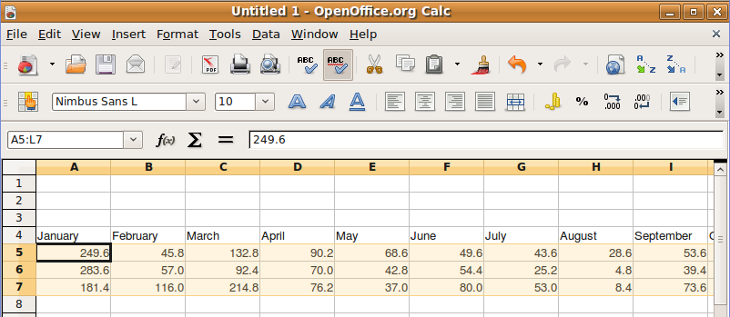

Date format of data

You can format a cell that contains date data a number of different ways:

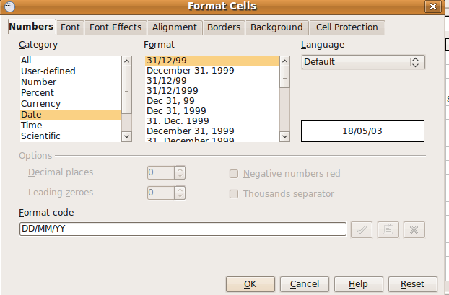

- Long text: December 31, 1999
- Abbreviated text: Dec. 31, 1999
- Numerical format: 31/12/1999
- Abbreviated numerical format: 31/12/99

Using Find and Replace

Find and replace in Calc functions much like in OpenOffice Writer.

Finding text or data:

- Choose Edit->Find & Replace from the Calc menu.

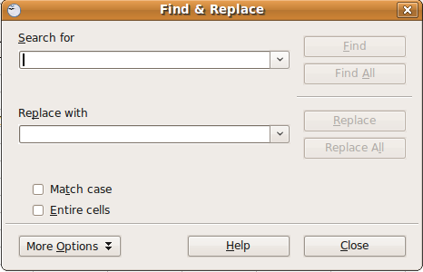

- In the Search for box type the text or data you want to search for.
- Click on the Find button to find the first instance of your search term.
- Clicking again on the Find button will search through the document to find further instances of your search term.

Replacing text or data

- Choose Edit->Find & Replace from the Calc menu.
- In the Search for box type the text or data you want to search for.
- In the Replace with box, type in the text or data you would like to replace the search term with.
- You can either replace instances of the search term all at once, or one at a time.

Sorting data

As much as possible, it is helpful to sort the data you are working with in a way that makes sense. For example, you may want to sort rainfall data from largest to smallest amount. You may want to sort birth date data chronologically. Or you may want to sort name data alphabetically.

To sort data in a Calc worksheet:

- Highlight the cells that you want to sort.

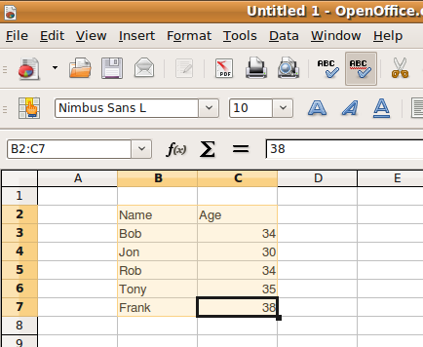

- Choose Data->Sort from the Calc menu.
- Select the sort criteria you want to use first, and then choose to sort either in ascending or descending order. If you like, set further sort criteria. These will be applied in order (e.g. first by name, in ascending order alphabetically, then by age, in ascending order).

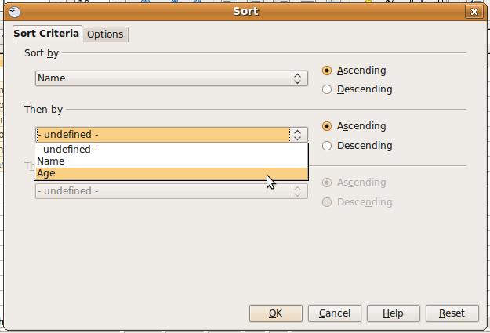
- View the results.

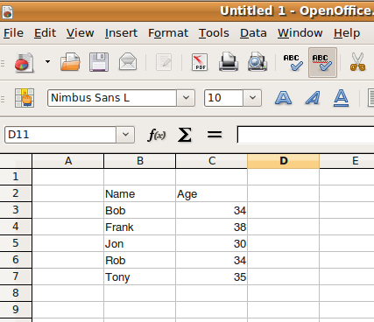

Formatting cells

You’ve already learned how to format cells for the type of data they contain (numerical, date, or text). You can also apply many of the formatting options that are available in other applications such as Writer.

As in other applications, the objective of adding formatting is to enhance the visual appearance of your documents in order to make them more readable and better understood.

Formatting appearance

You can format the appearance of cell contents by applying font choices, borders and shading, and alignment.

Font appearance

- Select the cells you want to format.
- From the formatting toolbar, apply the font formatting options you want.
For your precipitation spreadsheet, bold the column headings (months).

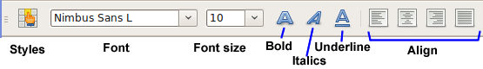

Borders and shading

Borders and shading can help make your worksheets more readable by providing emphasis to some of your worksheet cells. For example, row and column headings can be shades to set them off from the rest of the data. Cells that form a table can be enhanced by placing a border around them.
To apply shading:

- Select the cells you want to shade.
- Choose Format->Cells from the Calc menu.
- Click on the Background tab.

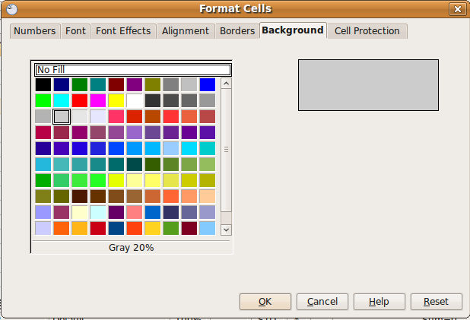

- Choose a background colour for your cells.

To apply borders:

- Select the cells you want to apply a border to.
- Choose Format->Cells from the Calc menu.
- Click on the Borders tab.
- Choose the line arrangement for borders. The default settings are no border, outside border, outside border with horizontal inside border, or outside and inside borders. Further, you can set you own borders by using the user-defined option.
- Choose the line style and colour.
- Choose the border spacing.
- If you like, include a shadow for your bordered section.

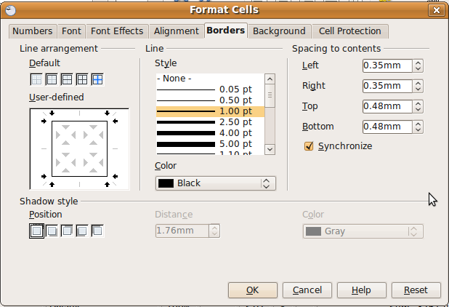
Here is what our precipitation worksheet looks like with bold, shading, and borders applied:

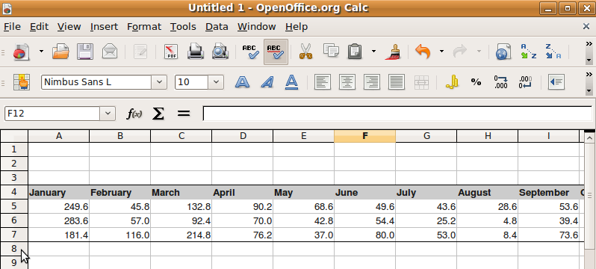

Merging cells

You may find that you want to create an area for information that is larger than a single cell. Calc gives you the option of merging cells to make a larger area. (Please do not confuse it with Mail Merge in Writer) The merged cell acts as one cell.

To merge adjacent cells:

- Select the cells you want to merge.
- Choose Format->Merge Cells from the Calc menu.
- Place your content into the merged cell.

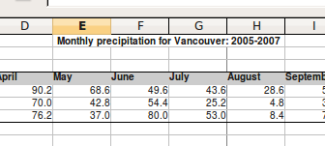

Text wrapping

If the content you want to place in a cell is too long for the cell, you can choose to wrap the text so that it will go on to a second line once it reaches the full width of the cell.

To wrap text in a cell:

- Select all the cells that you want the text to break at the right border.
- Choose Format->Cells from the Calc menu.
- Click on the Alignment tab.
- Check the box for Wrap text automatically.

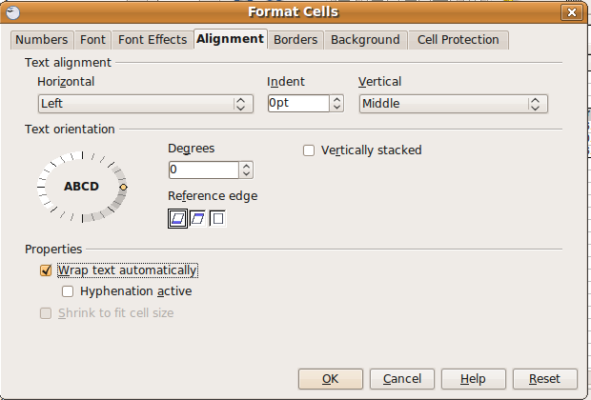

It will look like this:

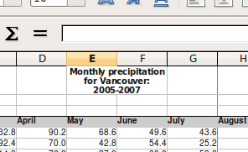

Copying and Moving cells

To copy cells:

- Select the cells you want to copy.
- Choose Edit->Copy from the Calc menu.
- Click where you want the cells to be placed.
- Choose Edit->Paste from the Calc menu.

To move cells:

- Select the cells you want to copy.
- Choose Edit->Cut from the Calc menu.
- Click where you want the cells to be placed.
- Choose Edit->Paste from the Calc menu.

Using Autofill

Autofill is useful if you are placing the same content in the cells of a column, or when you are placing incremental content (e.g. the months of the year) in the cells of a column.

To use Autofill with incremental content:

- Type the first entry into a cell (for example, January)
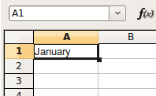

- Click somewhere else on the worksheet (click out of the cell). Then move your mouse to the bottom-right corner of the cell with the data in it, until your cursor turns to a crosshair.

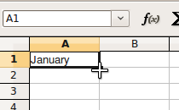

- Hold the mouse button down, and drag down the column to complete the Autofill.

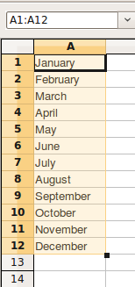

To use Autofill with repeating content:

- Type the first entry into a cell (for example, January)

- Click somewhere else on the worksheet (click out of the cell). Then move your mouse to the bottom-right corner of the cell with the data in it, until your cursor turns to a crosshair.

- While pressing the <Ctrl> key, hold the mouse button down, and drag down the column to complete the Autofill.

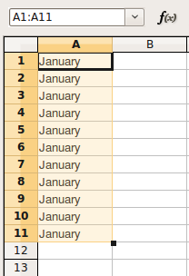

Working with rows and columns

Earlier you learned how to select a whole row or column by clicking on the row headings and column headings. When you select rows or columns, any of the formatting options you apply are applied to the whole row or column. You can also set the row height and column width to fit your data, and insert or delete columns or rows as needed.

Inserting and deleting rows and columns

To insert a row or column:

- For rows, click on the row heading where you want the new row to be created.
- Choose Insert->Row from the Calc menu.
- The new row is inserted above the row you selected.
- For columns the process is the same, using the column heading.

Exercise on the Scenario

On the Vancouver Precipitation spreadsheet, insert a column on the left of the worksheet, and add the years 2005, 2006, and 2007. Align the values to the left, and bold them. Then, change the border and shading to include these values.

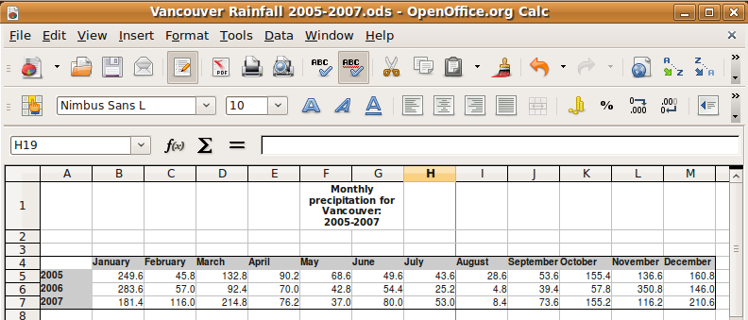

Delete a row or column

- For rows, select the row or rows you want to delete.
- Choose Edit->Delete cells from the Calc menu.
- For columns the process is the same.

Formatting rows and columns

Row height

You can set the height of a row manually by dragging on the bottom of the row header, or by using the menu options. The menu options give much greater control over the row height:

- Select the row or rows you want to format.
- Choose Format->Row->Height from the menu.
- Type in the height you want to set the rows. All of the rows you have selected will change to that height.

Column width

- Select the column or columns you want to format.
- Choose Format->Column->Width from the menu.
- Type in the width you want to set the column. All of the columns you have selected will change to that width.

Working with worksheets

We now move from working with cells, rows, and columns to working with worksheets. You can think of a worksheet as the basic functional unit of your spreadsheet – it can contain the data from cells, the functions that are used to modify the data, and graphs and charts to interpret the data. The worksheet can stand on its own as a document.

Rename a worksheet

The default names of worksheets are Sheet1, Sheet2, and Sheet3. You can change the name of a worksheet as follows:

- Select the worksheet you wish to rename by clicking on the tab for that worksheet.
- Choose Format->Sheet->Rename from the Calc menu..
- Enter the new name in the dialogue.
- Click OK.

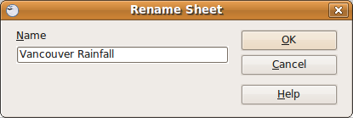

Switch between worksheets

To switch between the different worksheets, you simply click on the tab of the worksheet you wish displayed.

Insert a new worksheet

- Click on the tab next to the location where you wish to insert the new worksheet.
- Click Insert->Sheet. This displays the Insert worksheet dialogue.

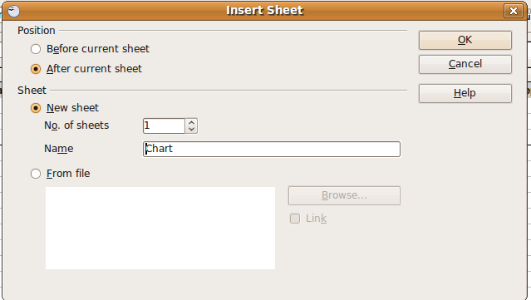

- Choose the position before or after the selected sheet.
- Choose the number of worksheets you wish to insert. If you choose only one sheet, you have the option to enter the name of that sheet in the Name window.
- Click OK

Duplicate a worksheet

You may duplicate a worksheet either within the same spreadsheet or between spreadsheets. The other spreadsheet may be one that is already open or a new one to be created. In all cases, you will use the Copy command to carry out this task.

- Right-click on the worksheet you wish to duplicate.
- Choose Edit->Move/Copy Sheet from the context menu.

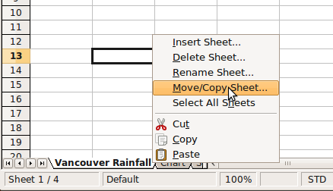

The Move/Copy Sheet dialogue box appears.
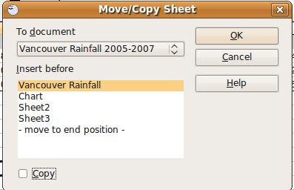

- If you want to copy the worksheet to a new location, check the Copy checkbox. If you want to move the worksheet without making a copy, leave it unchecked.
- Select the document you want to move/copy the worksheet to. The current document is the default choice.
- Select the position for the worksheet in the Insert before window.
- Click OK.
- Rename the duplicate worksheet if you wish.

Delete a worksheet

- Right click on the tab of the worksheet you wish to delete.
- Select Delete in the menu that appears. A dialogue will appear asking you to confirm that you wish to permanently delete the worksheet and its contents.
- Click Yes to confirm that you wish to delete the worksheet or Cancel if you do not wish to.

Self Assessment

To assess your learning, make sure you are comfortable carrying out the following tasks in OpenOffice Calc:
- Select a cell, a row, a column, or a group of cells.
- Enter data in a cell.
- Format the cell for the following:
  - Type of data (numerical, date, text)
  - Font style
  - Alignment
- Format cell borders and shading.
- Use Find and Replace to replace data in cells.
- Sort a group of cells
- Merge a group of cells into one cell.
- Use Autofill to input content.
- Format row height and column width.
- Insert and delete rows and columns.
- Insert, copy, move and delete a worksheet.
- Rename a worksheet.

Summary

In this section you learned some basic skills for working in worksheets, including inputting and formatting data in cells and columns, creating, deleting, and copying worksheets.

We also discussed some of the choices that should be made before we input data. When we answer some basic questions about our data and plan our spreadsheet, it makes the process of creating our spreadsheet much easier.

Formulas and Functions

Section Overview

Formulas and functions are very useful features of spreadsheets. They allow you to perform analysis on the data in your spreadsheet. Furthermore, when the data changes, the formula updates the results accordingly.

A formula is a spreadsheet function entered in a cell, complete with its arguments. A function is a formula that is built into the Calc program.

Calc has many built-in functions, but also allows you to create and apply your own formulas. This section will guide you through applying and creating formulas for your spreadsheets.
In this section you will:

- develop good practice in formula creation
- create formulas using cell references
- use arithmetic operators
- understand standard error values in formula results
- use standard functions
- use logical functions

Arithmetic formulas
Arithmetic formulas are formulas that can be carried out on numerical data. They include the everyday mathematical formulas such as addition, subtraction, multiplication, and division, as well as formulas for finding the average, mean and standard deviation.

Creating formulas

In a Calc worksheet, formulas are input into cells the same as other data like numbers and text. The difference is that formulas begin with an equal sign (=).

To input a formula into a cell:

- Select the cell you want to contain the formula.
- Begin with an equal sign.
- Type the rest of your formula. For example, =45+55 is a formula that can be used in Calc.

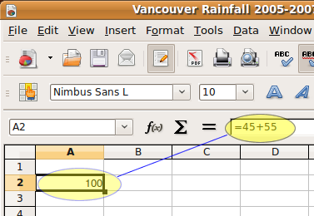

The formula appears in the cell input window, but the formula result appears in the cell itself.

Arithmetic operators

The following table lists the common in Calc. These are the symbols that should be used for creating formulas.

Operator | Name | Example
+ (Plus) | Addition | =1+1
- (Minus) | Subtraction | =2-1
- (Minus) | Negation | -5
* (asterisk) | Multiplication | =2*2
/ (Slash) | Division | =10/5
% (Percent) | Percent | 15%
^ (Caret) | Exponentiation | 2^3

Using cell references in formulas

In the last example, we input a simple formula into a cell. The formula added the numbers 45 and 55 and displayed the results in the cell.

More often we are interested in performing operations on cell contents. For example, if the content of one cell was 45, and the content of another cell was 55, we would want a formula that added the contents of each cell. More importantly, we would want the result to update automatically if the contents of either cell changed.

We accomplish this by using cell references instead of real numbers in formulas. For example, if the contents of cell A1 was 45, and the contents of cell A2 was 55, we could write a formula in cell A3 that added A1 and A2:

=A1+A2
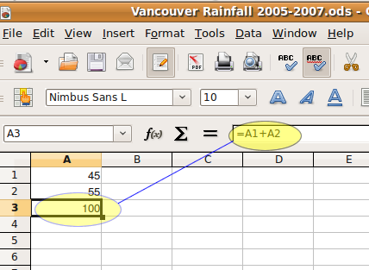

Now, if the contents of cell A1 or A2 change, the result in A3 changes automatically.

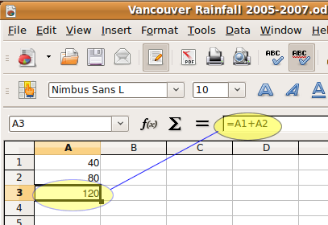

Relative cell references

The cell reference we used in the last example , =A1+A2, is called a relative cell reference. What that means is if we were to copy the cell contents to cell B3, the formula would change to =B1+B2. If we were to copy the formula to cell D5, the formula would change to =D3+D4.
If we were to insert a new row before row 1, the formula would also change automatically to reflect the change in the cell contents.

This is exactly what we want to happen when we are applying the same formula to a series of columns or rows.
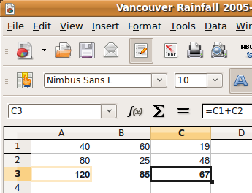

Absolute cell references

There are times when we don’t want the cell references in a formula to change when we copy the formula or when we insert cells into a worksheet. In this example, we are referencing a constant value that is in cell A1in our formula, and we use this same value throughout:

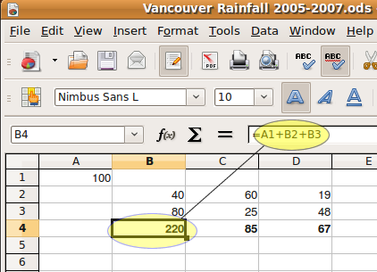

We can keep the cell reference A1 in our formula if we use an absolute cell reference. This involves simply placing a $ in front of the row and column part of the reference: A1 becomes $A$1:

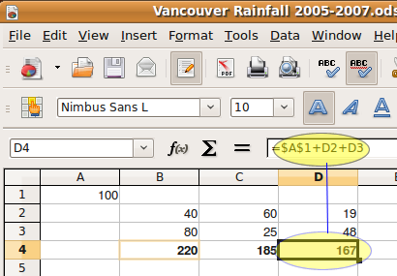

Functions

Functions are formulas in Calc that are built into the application. Typically, functions are more complicated formulas and can save us the time of developing our own formula for things such as mean or standard deviation.
Click on the Function Wizard button for a list of Calc functions:

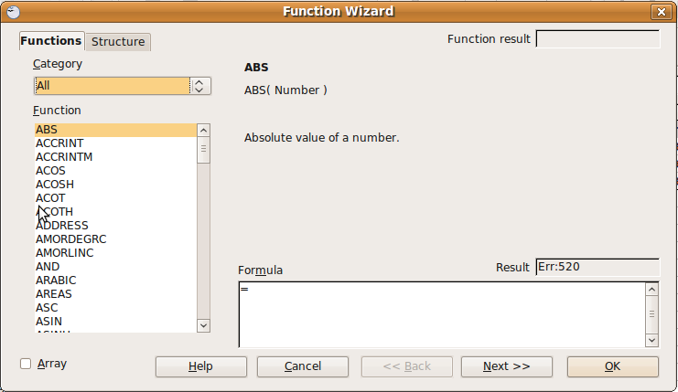

The list of functions available in Calc is very impressive. They are broken into categories so that you can more easily find the function you need.
Some of the common mathematical functions are:

- ABS –absolute value
- COS, SIN, TAN – trigonometric functions for cosine, sine, and tangent
- GCD – greatest common divisor
- LCM – least common multiple
- LOG – logarithm
- SUM – calculates the sum

Cell ranges

In a previous example, we used the formula =A1+A2 for a formula in cell A3. This is fine for adding a few numbers, but if we are adding a long column of numbers it is more useful to reference a cell range than individual cells. We reference a range of cells by specifying the starting cell and the ending cell, and separating them with a colon.
So our formula for the last example would become:
=SUM(A1:A2)

Exercise on the Scenario

Use the AVERAGE function in the Vancouver Precipitation spreadsheet to calculate the average monthly precipitation for each month over the three year period.

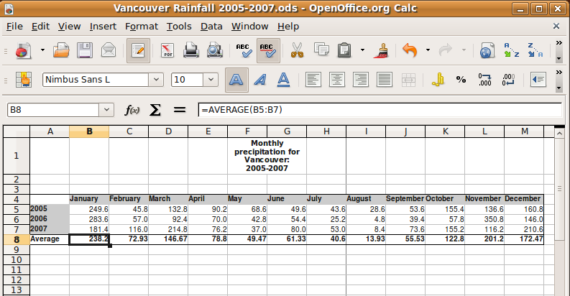

Self Assessment

To assess your learning, make sure you are comfortable carrying out the following tasks in OpenOffice Calc:

- Insert a formula in a cell that performs an operation on the contents of two or more other cells.
- Copy the formula to adjacent cells to perform the same operation.
- Use cell references for creating a formula.
- Use cell ranges for creating formulas.
- Use absolute cell references and relative cell references appropriately.
- Insert a function into a cell that performs an operation on two or more other cells.

Summary

This section discussed the importance of formulas and functions in spreadsheets. You learned how to input formulas and functions to perform mathematical operations on the contents of worksheet cells. You also learned the difference between relative and absolute cell references and how each can be used effectively.

Charts and graphs

Section Overview

During this section you will learn how to display worksheet data using a chart. Calc automates the creation of charts from data, and like formulas, charts automatically update when data changes.

Using the right chart can display your data in a way that makes trends obvious, thereby enhancing the quality of your document.

In this section you will:

- become familiar with the common chart types: column charts, bar charts, line charts and pie charts from spreadsheet data
- create a chart to display information
- format charts for appearance
- add data labels to charts

Types of charts

You are likely familiar with the common types of charts: bar chart, pie chart, line graph, and scatter plot. Although you can use different charts to display the same data, certain types of charts lend themselves better to certain types of data:

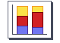 | Column (Vertical Bars) charts emphasise differences and values across multiple categories.
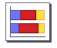 | Bar (Horizontal) charts are used to compare categories and values during a specified timeframe.
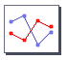 | Line charts are to display trends over a particular timeframe.
 | Pie charts are useful for showing relationship (percentage) of parts to a whole

Creating charts from cell data

This exercise will guide you through creating a chart to display the data in our Vancouver Precipitation spreadsheet scenario.

- Click on a cell below somewhere below the data in your worksheet. This is where the chart you create will be inserted.
- Choose Insert->Chart from the Calc menu. This starts the Chart Wizard.
- The first step in the Chart Wizard is to choose a chart type. For this chart we will choose the Column chart.

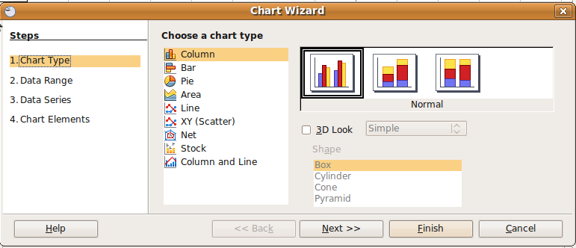

Then click the Next button to go to Step 2 of the Wizard.

- The second step is to select the data range.

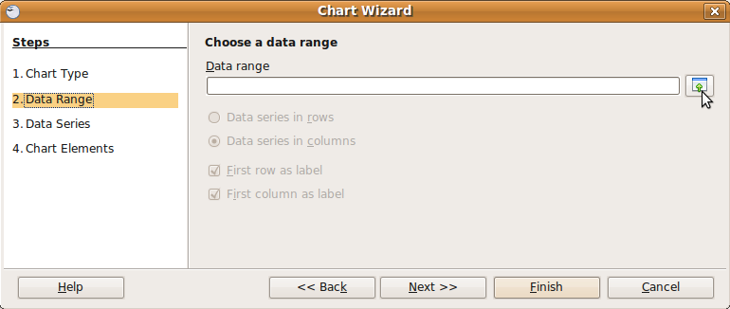

This is the data we want to display.
Click on the Select Data Range button to begin. 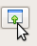

- Select the data in from the row containing the average precipitation values. In the spreadsheet below, it is the data from cell B8 to cell M8.

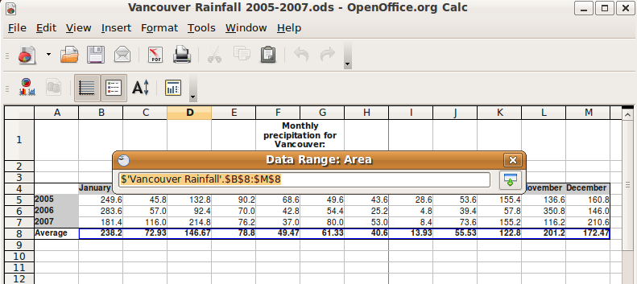

- Since the data series is part of a row, Data series in rows should be selected. Unselect the remaining choices, since the rows and columns are not acting as labels.

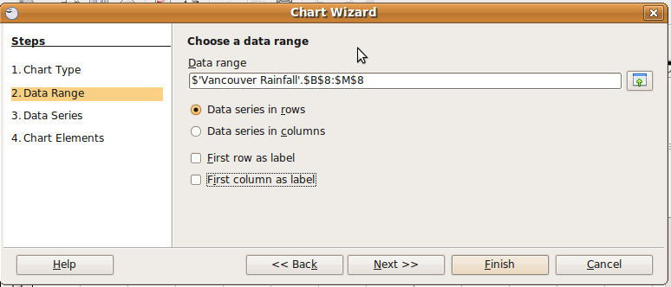

Click the Next button to go to Step 3 in the Wizard.
- We will now capture the names of the months that go with our data. These form the data categories.
In the Wizard, click on the Select Data Range button for Categories.

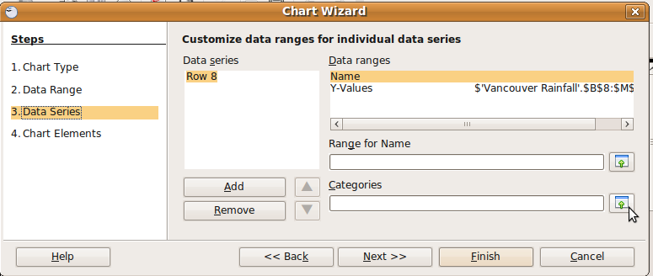

- Select the data in the row containing the names of the months. In the worksheet, this is the data from cell B4 to cell M4.

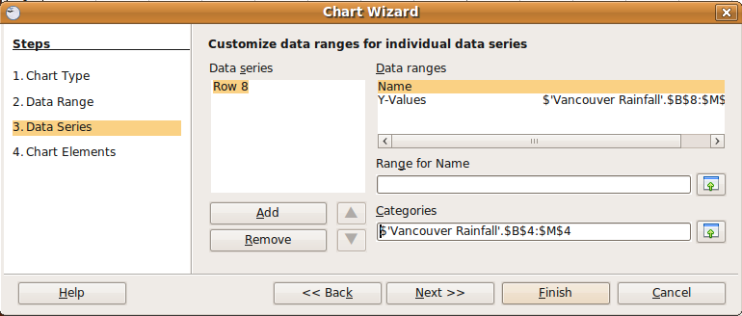

Click the Next button to go to Step 4 in the Wizard.

- Uncheck the Display legend checkbox, as we will be using the names of the months on the chart.
- Fill in the values for Title, Subtitle, and X-axis.

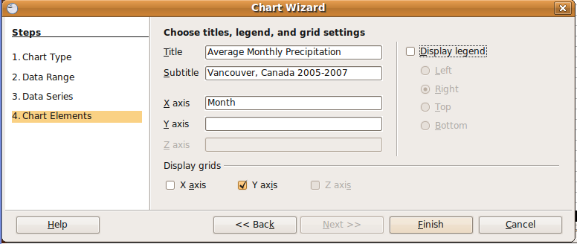

- Click the Finish button to end the wizard.

Modifying a chart

The chart, as created, is quite small. We can do a number of things to modify the chart to make it more readable.

Move the chart to its own worksheet

- Click on the chart and choose Edit->Cut from the Calc menu.
- Click on the tab for Sheet2.
- Choose Edit->Paste from the Calc menu to paste the chart.
- Rename Sheet2 to Rainfall Chart.

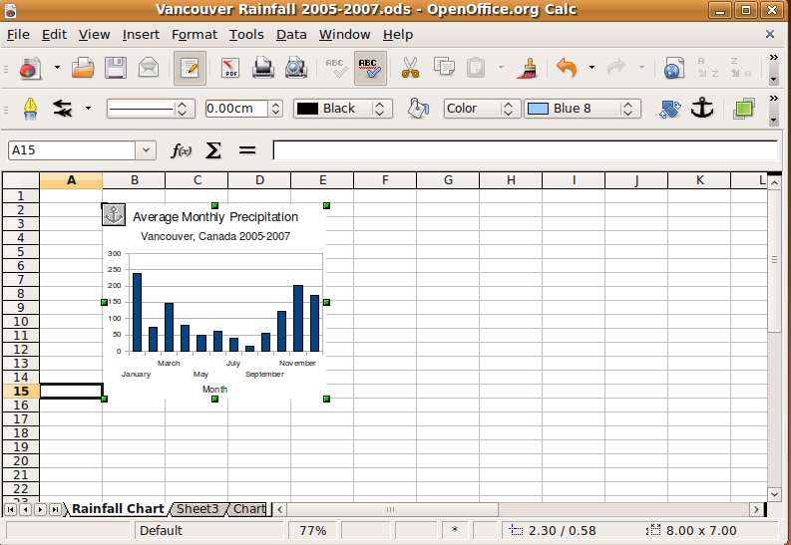

Resize the chart

- Move the chart close to the top-left corner of the worksheet.
- Click on the resize handle on the bottom-right corner of the chart and drag with your mouse to resize the chart.

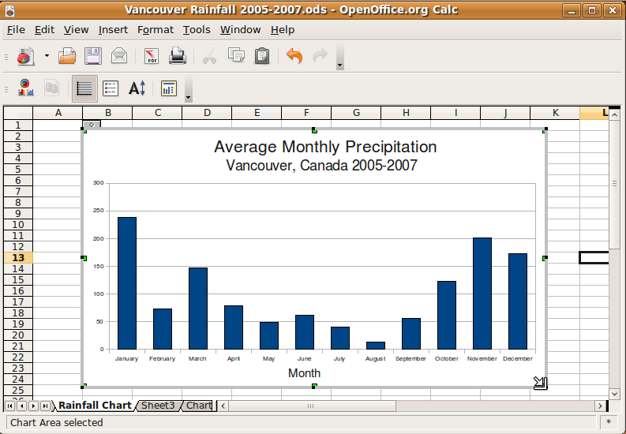

Change chart type

We can change the chart type easily without having to go through the Chart Wizard again:

- Select the chart by double-clicking on it.
- Right-click on the chart area.
- Choose Chart Type from the context menu.

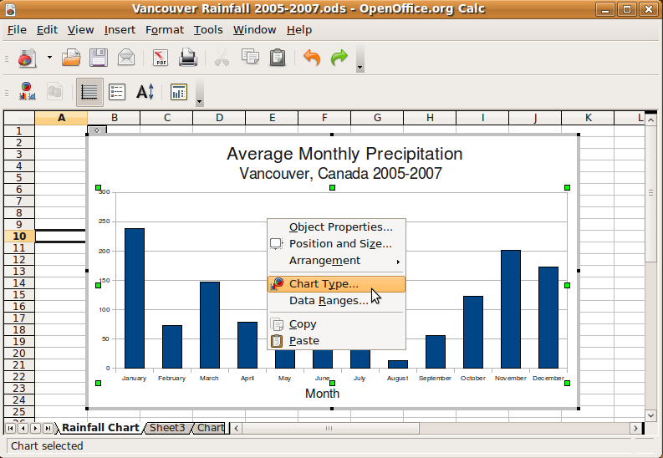

- Select Bar for the new chart type, and click the OK button.

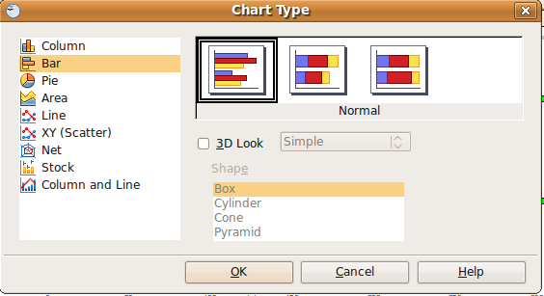

- The chart will update to the new chart type.

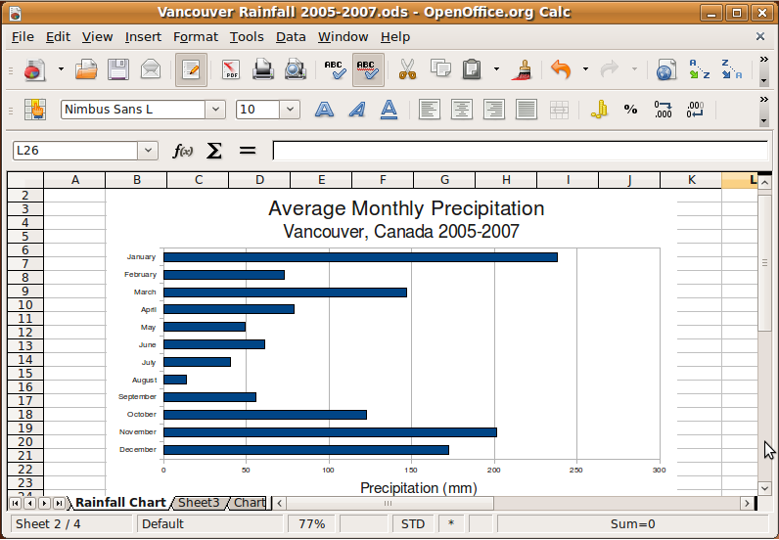

Self Assessment

To assess your learning, make sure you are comfortable carrying out the following tasks in OpenOffice Calc:

- Select an appropriate chart type to display your data.
- Create a chart from worksheet data.
- Edit the chart by adding labels, resizing, and moving it.
- Change the chart type.

Summary

This section discussed the use of charts in OpenOffice Calc to display worksheet data. The proper chart can make our data clearer by providing a pictorial representation that more clearly shows trends in data than a table or text description. The chart you created in the exercise clearly shows a trend in Vancouver precipitation towards very heavy in the winter months and relatively light in the summer.

On the practical side, you learned how to insert and modify a chart in Calc.

Preparing spreadsheets for output

Section Overview

This section discusses the steps you will take in the final preparation and printing of your OpenOffice Calc documents.

In this section you will learn how to:
- Set margins and page orientation.
- Use headers and footers.
- Set the print area of your spreadsheet.
- Print your spreadsheet.

Setting up a worksheet for printing

Worksheet orientation

Worksheet orientation is a style that applies to the whole document. By default, when you create a new spreadsheet it is oriented in portrait mode.

You can edit the orientation of your document as follows:

1. Choose Format->Page from the Calc menu.
2. Click on the Page tab.

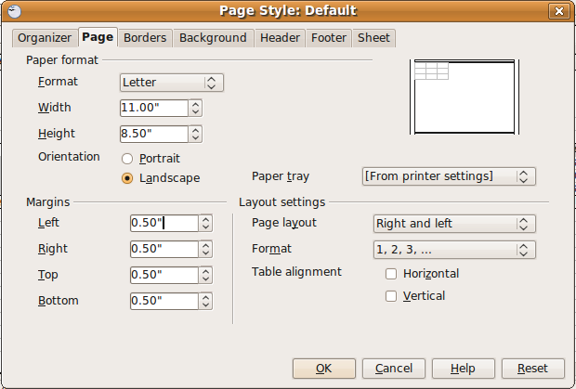

- Select the size of paper you will be printing on. If you choose one of the standard formats from the Format list, the paper size will be set automatically. You can also create a custom paper size by inputting values for the paper height and width.
- Choose Portrait or Landscape for your document's orientation.
- Set the margins to the desired width.

Headers and Footers

Headers and footers allow you to create text that will appear at the top (header) or at the bottom (footer) of every page in your document, or on every even or odd page. As you add text to your document, the header and footer don't move – they are always at the top and bottom of every page.

Examples of common header and footer information include the document title, author, date, or page numbers.

Headers

To enable headers:

- Choose Format->Page from the Calc menu.
- Click on the Header tab.
- Enable headers by checking the Header on box.
- Choose whether you want the same header content on left and right pages, or different content on each side.
- Set the margins and spacing attributes for your header.

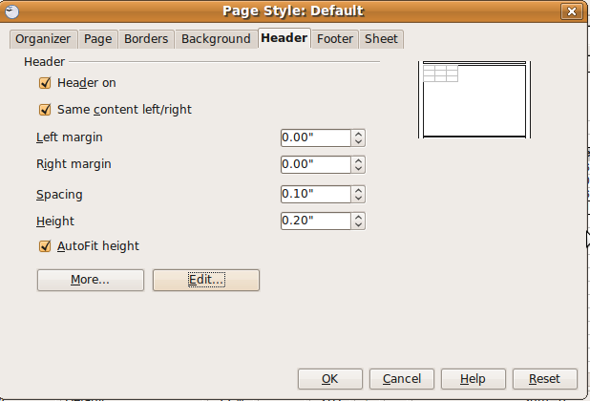

- Click on the Edit button to edit the information in the header. You can enter text in any of the three header areas, or you can use the buttons to insert fields such as the date, time, etc.

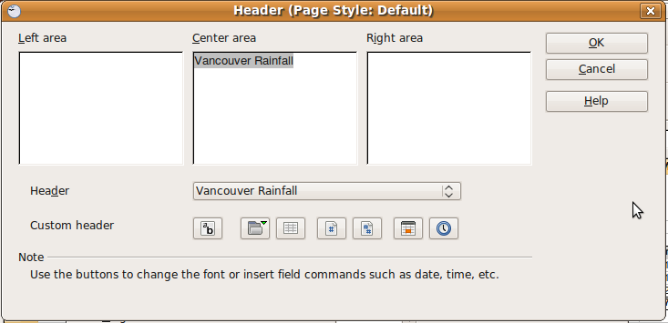
- Click OK to close the dialogue.
- You will now have a header on your spreadsheet. What you add to the header will be displayed on every page of the document, or every odd or even page if you so specified, when you send the document to print.

Footers

Setting the footer is the same as setting the header.

To enable footers:

- Choose Format->Page from the Calc menu.
- Click on the Footer tab.
- Enable headers by checking the Header on box.
- Format the footer the same was as for headers.

Printing worksheets

The steps you have gone through prior to printing your document help to ensure that your document is as polished and as correct as possible.

You are now almost ready to send your document to print. As a final step, you should preview what your document will look like when it's printed to make sure that pagination, margins, and formatting appear correctly.

To preview your document:

- Choose File->Page Preview from the Calc menu.
- Scroll through your document to view the pages as they will look when printed.

Setting the print area

- With your mouse, select the area of the worksheet you want printed.
- Choose Format->Print Ranges->Add to add your selection to the print area.

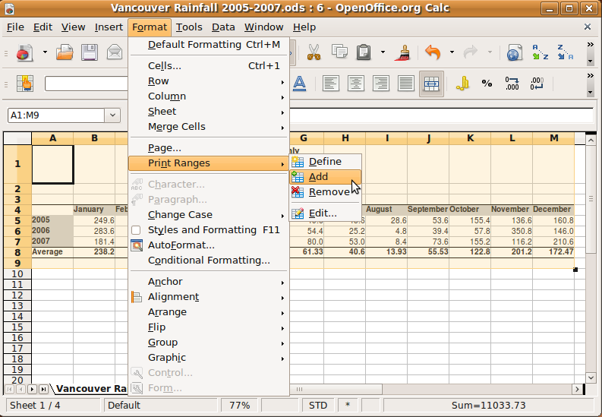

Printing

To print your document:

    - Choose File->Print from the Calc menu.
- Choose your printer and adjust the printer properties if necessary. Some printer properties are specific depending on the type of printer you are using. For example, you may need to set properties for your printer if you are printing in high quality colour.
- Choose the pages you would like printed (by default the complete document is printed).
- Choose the number of copies you want to print (by default one copy is printed).
- Click on the OK button to print your document.

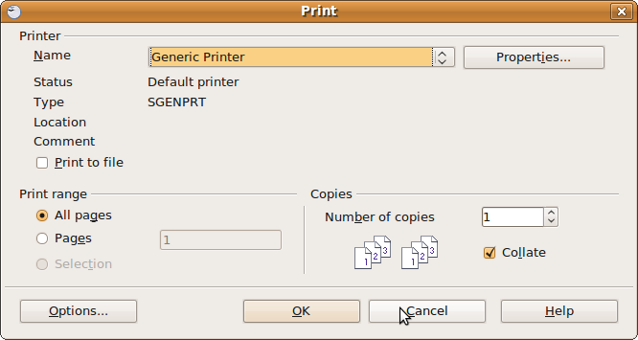

Self Assessment

To assess your learning, make sure you are comfortable carrying out the following tasks in OpenOffice Calc:

- Set the print area of your worksheet.
- Set the page options, including margins, paper size, and orientation.
- Enable headers and footers and add content to each.
- Preview the document before printing.
- Print your document.

Summary

This section outlined the options for setting your document up for printing. We discussed document formatting techniques such as setting margins, orientation, footers and headers.

Finally, this section outlined the process for previewing and printing your document.

